Past Recordings on Maddie’s Pet Forum
https://forum.maddiesfund.org/communityconversations

This meeting:
https://bit.ly/AWLeadershipRoundup91721
Box link of file recording:
https://maddiesfund.box.com/s/fi0mb24hx9ekvz6t3ojd8mn4hxrgkqgt

Friday meeting registration page
https://us02web.zoom.us/meeting/register/tZEud-2orzMrHtLTuNo0GbrSNeCQlQkdWKAp

Monday meeting registration link (for shelter staff and committed volunteers)
https://us02web.zoom.us/meeting/register/tZUqc-6spj0jHtES3GWxrpaG6L3HcbMh_dCu

Agenda

- Welcome – Kristen Hassen, Director, American Pets Alive! -
Kristen.hassen@americanpetsalive.org
bobby.mann@americanpetsalive.org
QOTD: What’s your favorite thing about autumn?
Books she is reading: Calm the F*#+# Down by Sara Knight
and
Antiracism in Animal Advocacy

- Mary's Motivation – her take-aways from Philanthropy Week: we all have to be involved in philanthropy – it’s not just about the money, it’s about building the wellsprings of support – it will happen in your own backyard.

- Dr. Levy – fire at the Pet Alliance of Greater Alliance of Orlando killed 13 cats – heroic efforts to save the dogs and a lot of the cats. Please send your good wishes – and donate/pass the word about their fundraising for a new building (already in progress): Pet Alliance of Greater Orlando
https://petallianceorlando.org/
https://www.facebook.com/PetAllianceGO

- Melanie Sadek, Executive Director, Valley Humane Society – vet clinic pushback about their fundraising for vet surgery building Please email Msadek@valleyhumane.org if you have any vet clinic pushback info or connecting social with keeping animals out of shelters.
- Brian Daugherty, Senior Vice President and Chief Philanthropy & Communications Officer, San Diego Humane Society bdaugherty@sdhumane.org

and Ashlee Droscher, Director of Development, Animal Welfare League of Alexandria
ADroscher@AlexandriaAnimals.org

"All of these ideas without the resources to execute them are just hope."
“This is not about asking for money; this is about sharing passion.”

194 attendees

List of resources referenced during today’s call

Pet Alliance of Greater Orlando (please help their fire fund)
https://petallianceorlando.org/
https://www.facebook.com/PetAllianceGO

Orange County, FL – video of first responders saving dogs in shelter fire https://www.facebook.com/OrangeCoSheriff/videos/443754553634957/

Melanie Sadek, Executive Director, Valley Humane Society – vet clinic pushback about their fundraising for vet surgery building.
Section 7 of the Access to Care report might be useful? https://pphe.utk.edu/wp-content/uploads/2020/09/avcc-report.pdf

msadek@valleyhumane.org

Best Friends Lifesaving Resiliency Grants https://network.bestfriends.org/opportunities/best-friends-partner-exclusives/lifesaving-resiliency-grants

HASS Philanthropy Working Group https://www.humananimalsupportservices.org/hass-working-group/fundraising/

HASS Philanthropy Toolkit
https://www.humananimalsupportservices.org/toolkit/philanthropy-toolkit-development-fundraising/

Join the Human Animal Support Services Philanthropy Job-Alike (Peer Group)
https://us02web.zoom.us/meeting/register/tZUvf-yspz4jHdHwPf65xcz69_mJO6LXnyHz

Culture of Philanthropy webinar ‘Tis the Season to Fundraise: How to Build Your Village of Support aka Everyone Has a Hand in Philanthropy
https://www.humananimalsupportservices.org/webinars/tis-the-season-to-fundraise-how-to-build-your-village-of-support/

Chris Fitzgerald supporting documents

https://drive.google.com/drive/folders/1nbh_S-O1ivp_58W5IRMaHbwQaeeIVVY1
https://drive.google.com/drive/folders/1nbh_S-O1ivp_58W5IRMaHbwQaeeIVVY1
https://drive.google.com/drive/folders/1nbh_S-O1ivp_58W5IRMaHbwQaeeIVVY1

Blogs/books/conferences/podcasts/events

Kristen Hassen recommends these books
Calm the F*#!^ Down, by Sara Knight
and
Antiracism in Animal Advocacy by Jasmin Singer
https://bookshop.org/books/antiracism-in-animal-advocacy-igniting-cultural-transformation/9781590566480

Jessica Schleder recommends Caste by Isabel Wilkerson

Saturday, September 18, 2pm: The Community Cats Podcast and Neighborhood Cats free webinar Colony Caretaking Tips and Tricks https://www.communitycatspodcast.com/

UF Shelter Medicine Program Compassion Fatigue Strategies Course by Jessica Dolce
8 weeks, online Oct-Nov
https://sheltermedicine.vetmed.ufl.edu/2021/09/09/cfs-2021/

CHAT SESSION

QOTD: What’s your favorite thing about autumn?

07:59:44 From kristen hassen to Everyone:
Pumpkin pie

07:59:52 From Megan Alexander to Everyone:
Cooler weather and apple cider!

07:59:52 From Becky Tegze to Everyone:
Leaves

07:59:53 From Ashley Mikulsky to Everyone:
all things cozy: fires, sweaters, cider, blankets :)

07:59:54 From Kate Meghji to Everyone:
When the kittens slow down!

07:59:57 From Rebecca Marsh to Everyone:
The sun comes out on the Coast

07:59:59 From Emily Gelb to Everyone:
apple season!

07:59:59 From Chris Fitzgerald to Everyone:
cider and fried cakes

08:00:01 From Karin Baker to Everyone:
If I had to like something it would be the color changes

08:00:02 From Jamie Fitzpatrick to Everyone:
Caramel apples

08:00:04 From Emily Klehm to Everyone:
All things pumpkin spice, all day every day

08:00:06 From Tasha Haug to Everyone:
The sky is so blue!

08:00:12 From Arin Greenwood to Everyone:
End of hurricane season!

08:00:14 From Amy Walton to Everyone:
Weather less than 100 degrees :)

08:00:17 From Maggie Tomecek to Everyone:
Only 1 shower/ day

08:00:21 From Brian daugherty to Everyone:
Fall in San Diego means the temperature goes down about 5 degrees. So it's just another amazing season here :).

08:00:30 From Karin Baker to Everyone:
Sports

08:00:34 From Tammy Fabian to Everyone:
The colors

08:00:41 From JESSICA ARNOLD to Everyone:
Hi Brian!!!!

08:01:05 From Sara Pizano to Everyone:
Good morning everyone!

08:01:14 From Sarah Aguilar to Everyone:
hoodies!!

08:01:23 From Lee Harper to Everyone:
Taking pictures of leaves. oh yeah, and hoodies is good too!

08:01:24 From Brent Toellner to Everyone:
Hiking without poison ivy and ticks

08:01:26 From JESSICA ARNOLD to Everyone:
Comfy clothes!!!

08:01:27 From Sara Pizano to Everyone:
the beautiful leaves changing color in Vermont

08:01:29 From ellen jefferson to Everyone:
Camping weather!

08:01:38 From Shelly (she/her), Maddie's Fund to Everyone:
Fall = Summer in San Francisco. :)

08:01:51 From Sarah Baeckler to Everyone:
The Green Mountains of Vermont

08:02:00 From Allie Mayer to Everyone:
Halloween

08:02:14 From Karina Exell to Everyone:
Cooler weather!

08:02:22 From Stacy LeBaron to Everyone:
I am in Vermont and it is beautiful! I can send pictures!!! I have 8 horses that live next door to me.

08:05:07 From kristen hassen to Everyone:
Stacy we need pics!!!

08:05:51 From Alison Gibson to Everyone:
HASS Philanthropy Working Group https://www.humananimalsupportservices.org/hass-working-group/fundraising/

Julie Levy announced there was a fire at a shelter in Orlando.
08:07:27 From Krista Rakovan to Everyone:
that is heartbreaking
08:07:42 From Julie Levy to Everyone:
Pet Alliance of Greater Orlando
https://petallianceorlando.org/

https://www.facebook.com/PetAllianceGO

08:08:14 From Brent Toellner to Everyone:
Go to the Orange County Sheriff Departments Facebook page -- they have the video of the officers doing rescue in the fire. It's really moving

08:08:55 From Megan Dennis to Everyone:
Could the book titles be posted in the chat? Thank you!

08:09:32 From Jessica Schleder to Everyone:
book: Caste by Isabel Wilkerson

08:09:51 From kristen hassen to Everyone:
Antiracism in animal advocacy

08:09:55 From Chris Fitzgerald to Everyone:
yes. Jessica. Caste is my top recommendation consistently

08:10:04 From kristen hassen to Everyone:
And calm the f down by Sarah. Knight

08:10:11 From Jon Dunn to Everyone: Best Friends Resliency Grants
https://network.bestfriends.org/opportunities/best-friends-partner-exclusives/lifesaving-resiliency-grants

08:10:42 From Julie Levy to Everyone:
Orange County first responders saving dogs in shelter fire video: https://www.facebook.com/OrangeCoSheriff/videos/443754553634957/

08:10:47 From Jerrica Owen to Everyone:
Good morning from NACA!! No updates but wishing everyone a WONDERFUL weekend ahead!!!

08:10:54 From Chris Fitzgerald to Everyone:
https://bookshop.org/books/antiracism-in-animal-advocacy-igniting-cultural-transformation/9781590566480

08:11:11 From Julie Levy to Everyone:
UF Shelter Medicine Program
Compassion Fatigue Strategies Course
By Jessica Dolce
8 weeks, online Oct-Nov
https://sheltermedicine.vetmed.ufl.edu/2021/09/09/cfs-2021/

08:11:43 From Sarah Aguilar to Everyone:
Midwest Animal Shelter Conference was last weekend - thank you to all the folks that came to speak and came to learn. ♡

08:12:47 From Chris Fitzgerald to Everyone:
Melanie, I'll share the PFL one-pagers for ROC, Chicago, and Salt Lake City in a sec

08:13:08 From Alison Gibson to Everyone:
Valley Humane (Melanie Sadek) https://valleyhumane.org/aboutvhs/staff/

08:13:10 From Melanie Sadek to Everyone:
msadek@valleyhumane.org

08:13:11 From Erin Celuch to Everyone:
Check with Gateway Pet Guardians in St. Louis re vet implementation

08:13:18 From Stuart Earley to Everyone:
Hi Melanie, can you let us have your email address and we will forward anything we have afterwards. My email is stuarte@thehumanesociety.org

08:13:27 From Melanie Sadek to Everyone:
msadek@valleyhumane.org

08:13:36 From Brenda Barnette to Everyone:
Melanie, this is old history in your area. They did the same thing to ARF. The vet community convinced the board that they should not even open a great new shelter clinic. We eventually did it anyway and the vets calmed down after a short time because we didn't impact their bottom line.

08:13:52 From Ashley Mikulsky to Everyone:
Stuart, can you also send those resources to me? amikulsky@berksarl.org

08:14:00 From Alison Gibson to Everyone:
Brian Daugherty, Senior Vice President and Chief Philanthropy & Communications Officer, San Diego Humane Society and Ashlee Droscher, Director of Development, Animal Welfare League of Alexandria

08:14:14 From Nancy McKenney, Marin Humane to Everyone:
Brian is a rock star

08:14:17 From Stacy LeBaron to Everyone:
The Community Cats Podcast and Neighborhood Cats will be presenting a free webinar tomorrow at 2pm- Colony Caretaking Tips and Tricks. Please share and go to www.communitycatspodcast.com for the sign-up link.

08:14:26 From Megan Alexander to Everyone:
Melanie, we had a voucher program and a 1K spay/neuter Day and had push back that we overcame. You may contact me at meganalexander@gmail.com

08:14:45 From Alison Gibson to Everyone:
Brian Daugherty, Senior Vice President and Chief Philanthropy & Communications Officer, San Diego Humane Society https://www.sdhumane.org/

08:15:29 From Chris Fitzgerald to Everyone:
Melanie, I just emailed three links. Let me know if they work and if they might help

08:15:58 From Sheila Segurson to Everyone:
Melanie, section 7 of the Access to Care report might be useful? https://pphe.utk.edu/wp-content/uploads/2020/09/avcc-report.pdf

08:16:28 From Alison Gibson to Everyone:
Ashlee Droscher, Director of Development, Animal Welfare League of Alexandria
https://alexandriaanimals.org/

08:17:42 From Tim Yeaglin to Everyone:
Had to be said.

08:17:43 From Jessica Des Lauriers to Everyone:
Brian! I grew up listening to the Eagles on family road trips. So sad :(

08:17:50 From Bill Ganley he/him San Diego Humane to Everyone:
what about House of Pain?

08:18:00 From Davyd Smith to Everyone:
Wow, Eagles shaming!

08:18:02 From Julie Levy to Everyone:
Noooo . . . the Eagles are the best!

08:18:10 From Jessica Des Lauriers to Everyone:
I agree, Dr. Levy.

08:18:10 From Ashlee Droscher to Everyone:
It’s early folks… it’s only going to get better!

08:18:11 From Sarah Aguilar to Everyone:
don't say no

08:18:13 From Stephanie Rambo to Everyone:
I thought he was talking abt the football team at first!! Lol

08:18:15 From Amy Schindler to Everyone:
Eat dessert first

08:18:18 From Sharon @MaddieFund to Everyone:
Do a Good Job

08:18:22 From Elisa Martin to Everyone:
"Are you trying to prove or improve"

08:18:22 From Joe Stafford to Everyone:
Take the road less traveled!

08:18:24 From Sharon @MaddieFund to Everyone:
Tell People About it

08:18:25 From kristen hassen to Everyone:
Tell your story

08:18:27 From Sharon @MaddieFund to Everyone:
Ask for Help

08:18:30 From Erika Leckington to Everyone:
Don't sweat the small stuff.

08:18:30 From Emily Klehm to Everyone:
You did not come this far just to come this far

08:18:31 From JESSICA ARNOLD to Everyone:
You can only stress over that which you can control....or...let that shit go!

08:18:32 From Karin Baker to Everyone:
At any moment you have the power to say, "This is not how the story is going to end." This stays in my mind all the time.

08:18:34 From Nancy McKenney, Marin Humane to Everyone:
Fall down 7 times, get up 8

08:18:37 From Ashlee Droscher to Everyone:
Love these!

08:18:40 From Ashlee Droscher to Everyone:
Keep them coming!

08:18:49 From Erin Celuch to Everyone:
You cannot go backwards, only forward. Embrace it

08:18:54 From Bill Ganley he/him San Diego Humane to Everyone:
we're only here for a short time

08:18:54 From Andrea Peterson to Everyone:
It's tough, but I'm tougher.

08:18:54 From Chetana Mirle to Everyone:
Listen to learn, not to judge.

08:19:01 From Leah Fieser, Brother Wolf to Everyone:
Focus on the good and the good gets better

08:19:03 From Diann Meiller to Everyone:
Vous et nul autre - you and no other which I think of as You and no other decide your fate and control your destiny just by controlling your thoughts

08:19:04 From Kate Meghji to Everyone:
Progress, not perfection.

08:19:14 From Nancy McKenney, Marin Humane to Everyone:
Amy - dessert is also stressed spelled backwards :)

08:19:19 From Alex James to Everyone:
FAIL is short for First Attempt In Learning

08:19:59 From Ashlee Droscher to Everyone:
The jokes are coming people… get excited!

08:20:07 From Stephanie Filer @ Shelter Animals Count to Everyone:
LOVE THIS, Brian! "All of these ideas without the resources to execute them are just hope."

08:20:20 From Stephanie Rambo to Everyone:
Forget the mistake; remember the lesson

08:20:21 From Cynthia Karsten to Everyone:
Be curious, not judgmental.

08:20:39 From Erin Celuch to Everyone:
Failing is learning and an opportunity for growth.

08:20:51 From Jennifer Walter to Everyone:
Take it easy. Don't let the sound of your own wheels drive you crazy. ~The Eagles 🤣

08:20:56 From Kathleen Olson to Everyone:
People can't give you money if you don't ask them. The worst that can happen is they tell you no.

08:21:30 From Stuart Earley to Everyone:
Agree with you 100% Kathleen

08:21:50 From Erin Celuch to Everyone:
Ask for and be willing to receive help.

08:22:48 From Alison Gibson to Jennifer Walter(Direct Message):
LOL Eagles tune - good one!

08:23:15 From Vicki Davis to Everyone:
Good one Jennifer!

08:24:51 From Ashlee Droscher to Everyone:
Does this problem resonate with you? Are you seeing these problems in your organization and community?

08:25:47 From Brenda Barnette to Everyone:
People give to organizations that meet needs, not to organizations that have needs.

08:26:13 From Stuart Earley to Everyone:
Great point Brenda

08:27:36 From Joe Stafford to Everyone:
Yes Ashlee! Biggest issue facing our organization without a doubt.

08:28:14 From Ashlee Droscher to Everyone:
Thanks Joe! You are not alone!

Poll #1
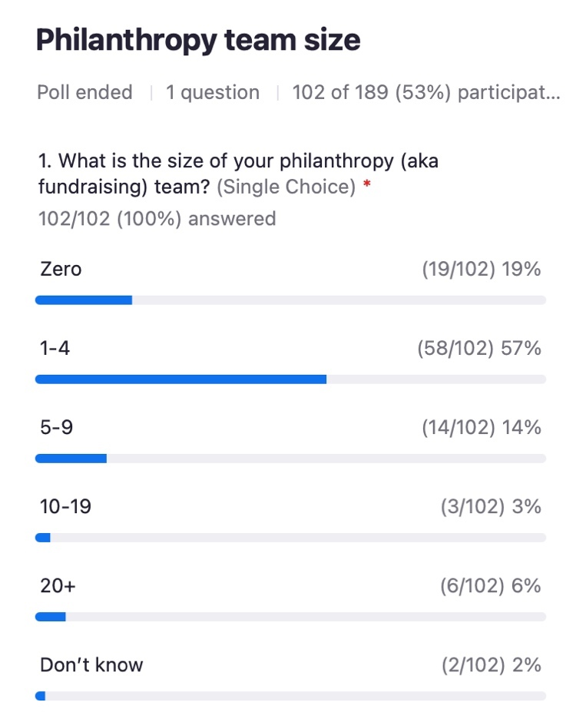

Poll #2
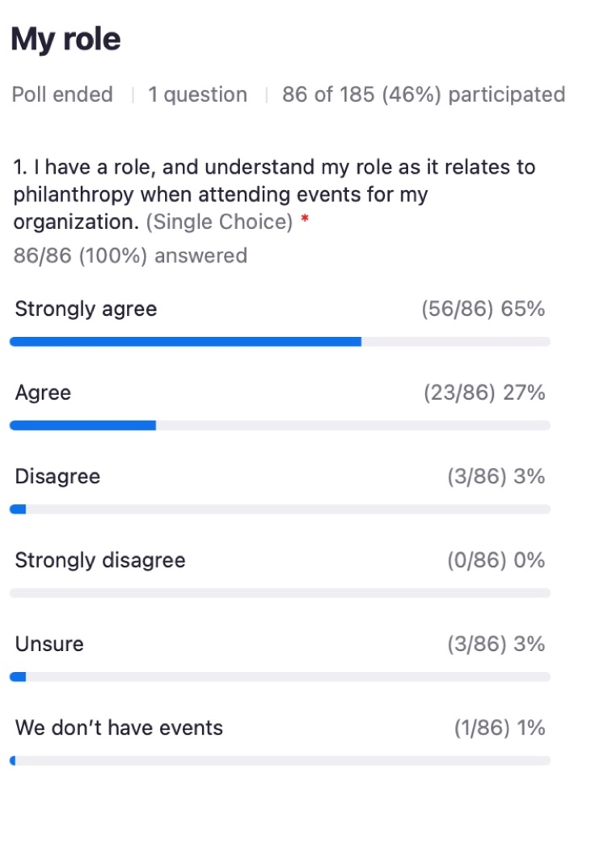

Poll #3
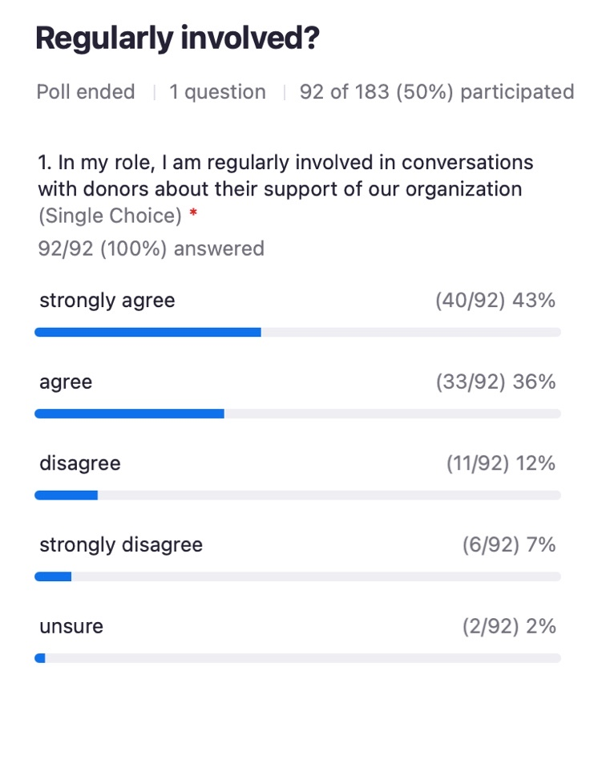

Poll #4
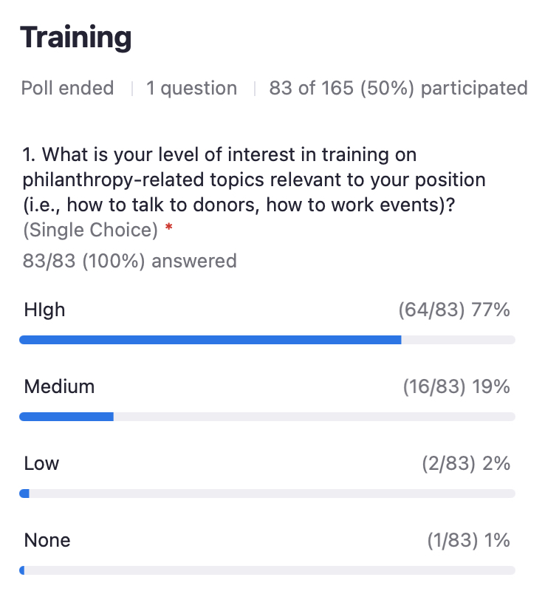

08:29:13 From Erin Celuch to Everyone:
1

08:29:29 From Jessica Des Lauriers to Everyone:
Can you sing an Eagles song?

08:29:30 From Nancy McKenney, Marin Humane to Everyone:
all staff and board

08:29:39 From Ashlee Droscher to Everyone:
Well done Nancy!

08:30:00 From Kathleen Olson to Everyone:
Nancy nailed it. Board, Staff, Volunteers are all fundraisers.

08:36:33 From kristen hassen to Everyone:
I think that’s key

08:36:43 From Ashlee Droscher to Everyone:
YES, Kristen!

08:36:58 From Ashlee Droscher to Everyone:
“Can you partner with us? Can you invest in us?” NOT - Can you give me money?

08:38:17 From Brent Toellner to Everyone:
I once thanked a donor for the donation and they in turn thanked me for the opportunity to make a difference for something they cared about but weren't in a position to help otherwise. We are giving donors opportunities to feel good about their philanthropy. It's a completely different mindset than asking for $$

08:38:23 From Ashlee Droscher to Everyone:
“This is not about asking for money, this is about sharing passion.”

08:38:28 From Maggie Lynch to Everyone:
Kristen has been talking about philanthropy all along. She just didn’t know it!

08:38:38 From Ashlee Droscher to Everyone:
Thanks Brent! That’s a fantastic example!

08:41:49 From Amy Nichols to Everyone:
And association - donors want to be associated with an organization they believe in, and “feel part of” making a difference for animals

08:42:36 From Ashlee Droscher to Everyone:
Amy - absolutely! What if every member of our staff felt compelled to welcome people to our organization?

08:42:42 From Bill Ganley he/him San Diego Humane to Everyone:
being "story tellers" is critical to our success

08:42:44 From Stacy LeBaron to Everyone:
How do you address the “role clarity” conversation in your organization? Does every job description have a fundraising/development component to it?

08:43:28 From Ashlee Droscher to Everyone:
Stacy - every job description should state that you have a Culture of Philanthropy and the expectation is that they will be part of that. Then explaining the expectations to them.

08:44:33 From Allison Mayfield to Everyone:
sure would love to see what one of those emails looks like

08:44:44 From Amy Nichols to Everyone:
An invitation to participate in your work vs asking for money

08:44:45 From Allison Mayfield to Everyone:
would love to see info on new hire orientation as well

08:44:54 From Alison Gibson to Everyone:
HASS Philanthropy Toolkit
https://www.humananimalsupportservices.org/toolkit/philanthropy-toolkit-development-fundraising/

08:46:20 From Ashlee Droscher to Everyone:
This Philanthropy Toolkit further explains how to build a Culture of Philanthropy as your first step. Then, it gives further ideas, information, resources, links to development tactics to aid your team.

08:50:00 From Bill Ganley he/him San Diego Humane to Everyone:
it also generates a lot of fun for our staff

08:50:51 From Chris Fitzgerald to Everyone:
right on

How would you feel if you were asked to DIRECTLY raise money for your organization?

08:50:55 From Joe Stafford to Everyone:
Uncomfortable

08:50:55 From Karin Baker to Everyone:
Love it!

08:50:58 From Kate Meghji to Everyone:
Totally fine with it. :)

08:50:58 From Amy Walton to Everyone:
LOVE IT

08:51:04 From Maggie Tomecek to Everyone:
A shot of liquor goes a long way.

08:51:04 From Jane McBride to Everyone:
all good

08:51:04 From Bill Ganley he/him San Diego Humane to Everyone:
let's roll!

08:51:05 From Allison Mayfield to Everyone:
Good with it.

08:51:07 From sue webb to Everyone:
so-so

08:51:11 From Chertl Jones to Everyone:
Good with doing it

08:51:15 From Kathleen Olson to Everyone:
It is part of my contract as Executive Director that I am the chief fundraiser.

08:51:16 From Mindy Tiner to Everyone:
not a problem

08:51:16 From Sarah Baeckler to Everyone:
Absolutely, that's my job!

08:51:17 From Stephanie Rambo to Everyone:
I'll give it a shot

08:51:19 From Karin Baker to Everyone:
I have contact with some big donors and am often asked to get their support. It gets old asking the same supporters

08:51:19 From Melanie Sadek to Everyone:
I'm in! I have learned to LOVE fundraising, because I really love sharing what we do and how our work impacts animals and people!

08:51:20 From AIMEE SADLER to Everyone:
It's a requirement

08:51:21 From Sally Hubbard, CAWA to Everyone:
I enjoy it but want to learn more.

08:51:23 From Jon Geller to Everyone:
not really

08:51:24 From Michelle Quigley to Everyone:
Ready to introduce this to our current team!

08:51:31 From Davyd Smith to Everyone:
Reasonable ask, but I would want guidance how to do it.

08:51:40 From Shelley Joaquin to Everyone:
Nervous

08:51:41 From Caitlin Quinn to Everyone:
This presentation definitely made me feel less intimidated and more excited about philanthropy - thank you!

08:51:43 From Bronwyn Stanford to Everyone:
Yes I agree. I think inspiring people is the way to go and would not intimidate staff

08:51:46 From Stuart Earley to Everyone:
You have to lead from the front in everything

08:51:57 From Ashlee Droscher to Everyone:
These responses are great! Keep them coming!

08:54:04 From Teresa Johnson to Everyone:
This presentation is FANTASTIC! So many great points and ideas here. Thank you for sharing this today!!

08:54:39 From Bronwyn Stanford to Everyone:
I agree...fantastic presentation...I have learned a lot...thank you!!!!

08:55:33 From Alison Gibson to Everyone:
Join the Human Animal Support Services Philanthropy Job-Alike (Peer Group)
https://us02web.zoom.us/meeting/register/tZUvf-yspz4jHdHwPf65xcz69_mJO6LXnyHz

08:55:44 From Stacy LeBaron to Everyone:
My Vermont photos for the group

08:55:47 From Alison Gibson to Everyone:
Culture of Philanthropy webinar ‘Tis the Season to Fundraise: How to Build Your Village of Support aka Everyone Has a Hand in Philanthropy
https://www.humananimalsupportservices.org/webinars/tis-the-season-to-fundraise-how-to-build-your-village-of-support/

08:55:57 From Alison Gibson to Everyone:
HASS Philanthropy Toolkit

https://www.humananimalsupportservices.org/toolkit/philanthropy-toolkit-development-fundraising/

08:56:05 From kristen hassen to Everyone:
It’s a lot of pages!!!

08:56:08 From Shelly (she/her), Maddie's Fund to Everyone:
Gorgeous, Stacy!!

08:56:14 From Ashlee Droscher to Everyone:
The “Culture of Philanthropy” webcast that Alison just put in the chat is what was presented on Tuesday

08:56:19 From Ashlee Droscher to Everyone:
The Toolkit is 48 pages long

08:56:28 From kristen hassen to Everyone:
The amazing part is the willingness to share with others!

08:56:48 From Ashlee Droscher to Everyone:
It is the braintrust of the philanthropy group! Use it, join us, let us know if we can help!

08:56:58 From Bronwyn Stanford to Everyone:
Yes...definitely!!!

08:57:05 From Chertl Jones to Everyone:
High

08:57:17 From Nancy McKenney, Marin Humane to Everyone:
Can we clone Brian and Ashlee too?

08:57:22 From Angela Marzec to Everyone:
I love sharing my passion and inspiring my community to support our work. I wish management helped interested staff of all levels to understand the budgeting process and organization financials more.

08:57:22 From Karin Baker to Everyone:
How do people join the group?

08:57:32 From AIMEE SADLER to Everyone:
It's tough...it's my responsibility to have this interest but I authentically do not :(

08:57:35 From Ashlee Droscher to Everyone:
But if we clone Brian that we have more people who don’t like the Eagles… not sure that’s a good thing!

08:57:40 From Alison Gibson to Everyone:
Join the Human Animal Support Services Philanthropy Job-Alike (Peer Group)
https://us02web.zoom.us/meeting/register/tZUvf-yspz4jHdHwPf65xcz69_mJO6LXnyHz

08:57:45 From Ashlee Droscher to Everyone:
Karin - copy the link and then join us!

08:57:47 From Joe Stafford to Everyone:
Great presentation! Thank you so much for your work and inspiration!

08:57:48 From Bobby Mann to Everyone:
Sign up here: Join the Human Animal Support Services Philanthropy Job-Alike (Peer Group)
https://us02web.zoom.us/meeting/register/tZUvf-yspz4jHdHwPf65xcz69_mJO6LXnyHz

08:57:52 From Karin Baker to Everyone:
Thanks

08:58:08 From AIMEE SADLER to Everyone:
Thank you for all of these resources to help us!

08:58:13 From Karin Baker to Everyone:
thank you!!!!!

08:58:20 From Jyothi Robertson to Everyone:
Thank you!

08:58:23 From Melanie Sadek to Everyone:
Brian - great job! San Diego has a great team!

08:58:24 From Gary Weitzman to Everyone:
Awesome Brian and Ashlee!

08:58:25 From Caitlin Quinn to Everyone:
Thank you!

08:58:25 From Brenda Barnette to Everyone:
Great presentation!

08:58:27 From Bronwyn Stanford to Everyone:
THANK YOU!!

08:58:31 From Sharon @MaddieFund to Everyone:
thank you

08:58:32 From Jessica Des Lauriers to Everyone:
Excellent Presentation Ashlee and Brian!

08:58:34 From Arin Greenwood to Everyone:
This was very helpful - thank you

08:58:36 From Megan Alexander to Everyone:
Brian and Ashlee, what are your contact emails?

08:58:37 From phablo dias to Everyone:
Thank you!

08:58:48 From Phillip Zimmerman to Everyone:
Great presentation, both today and Tuesday!

08:58:51 From Amy Nichols to Everyone:
Terrific presentation - inspiring!

08:58:59 From Ashlee Droscher to Everyone:
ADroscher@AlexandriaAnimals.org

08:59:05 From Tricia Montgomery to Everyone:
Thank you!!! So much appreciated!

08:59:35 From Ashlee Droscher to Everyone:
bdaugherty@sdhumane.org

08:59:36 From Sharon @MaddieFund to Everyone:
Continue the conversation with Brian and Ashly on the Maddie’s Pet Forum…

08:59:36 From Melanie Sadek to Everyone:
Msadek@valleyhumane.org
If you have any vet clinic pushback info or connecting social with keeping animals out of shelters.

08:59:37 From Bobby Mann to Everyone:
Happy Friday!!!!!

08:59:40 From MeLissa Webber to Everyone:
Thank you!

08:59:54 From Shelley Joaquin to Everyone:
Thank you

08:59:55 From Stacy LeBaron to Everyone:
Thank you!

09:00:11 From Jennifer Bolser to Everyone:
Thank yoU!

---------------end----------------

