Past Recordings on Maddie’s Pet Forum
https://forum.maddiesfund.org/communityconversations

This meeting:
https://maddies.fund/awleadershiproundup11521
Box link of file recording:
https://maddiesfund.box.com/s/feaxbxy0q1tsx0rjasycwwb3gqrmflxu

Friday meeting registration page
https://maddies.fund/Register_AWLeadershipRoundup

Monday meeting registration link (for shelter staff and committed volunteers)
https://maddies.fund/Register_ShelterRescueSupport

161 attendees

Agenda

- Welcome – Bobby Mann, American Pets Alive!
Kristen.hassen@americanpetsalive.org
bobby.mann@americanpetsalive.org
QOTD: What is your favorite thing to cook? Bonus points for recipes!

- Mary's Motivation –
Last week we spoke about terms that are divisive – we are hardwired to look at the negative. November for her is gratitude month and she’s focusing on the terms that unite us rather than separate us. What are the things that bring us together that allow us to feel like we are kindred spirits?
- ASV Covid Polls: Dr. Berliner
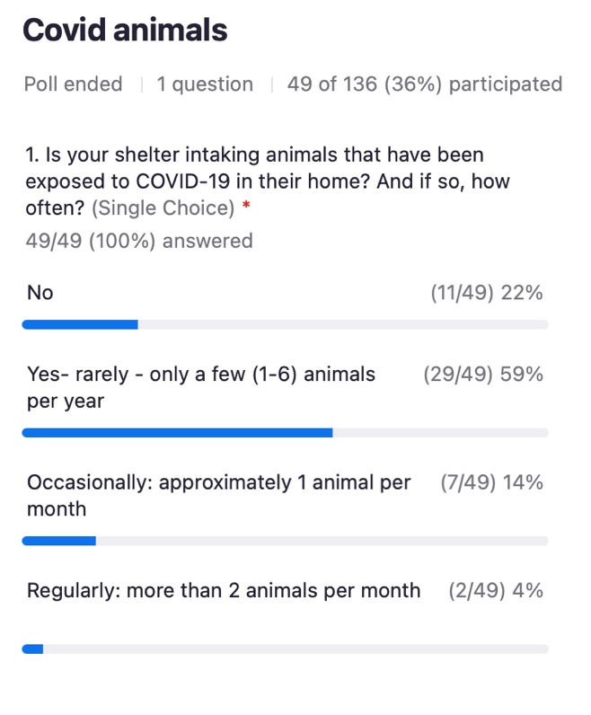
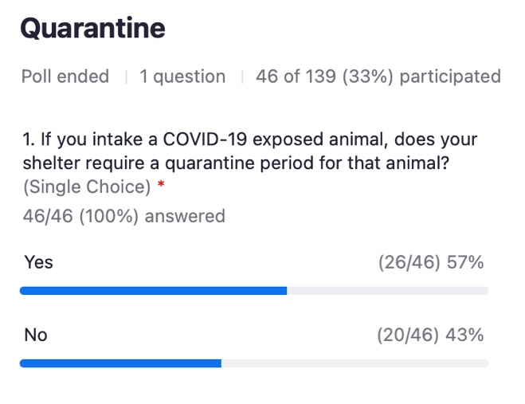
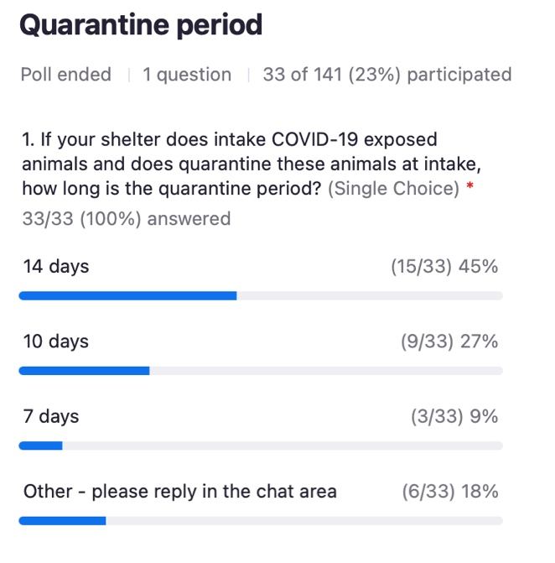

- National updates
No Friday meetings on November 12 or November 26.
Looking Forward: The Future of Animal Welfare Dec 7-9 virtual. https://theaawa.org/event/future

November 10: Maddie’s Candid Conversation with Dr. Michael Blackwell https://maddiesfund-org.zoom.us/meeting/register/tZcoc-GqpzIuE9Jx9M4ldvAeZoM3ssszZCIQ

HASS Get Involved
https://www.humananimalsupportservices.org/get-involved-animal-welfare/

Best Friends National Conference speaker proposals accepted through Nov 19th. Please submit and share with your teams! https://bestfriends.org/events/best-friends-national-conference/speaking-proposals

Book suggestion: My Dog Always Eats First: Homeless People and Their Animals by Leslie Irvine https://www.abebooks.com/Dog-Always-Eats-First-Homeless-People/30732863962/bd?cm_mmc=ggl-_-US_Shopp_Textbook-_-product_id=COM9781588268884USED-_-keyword=&gclid=Cj0KCQjwrJOMBhCZARIsAGEd4VEu4gUgyBiDMDjlKIAmV1RSVlfkfr5jWiXKwk7AkIazBdkklTUluVcaAvDTEALw_wcB

CAREawo.org/donate – Neighborhood Center in Camden, NJ Thanksgiving
www.careawo.org/donate
The Neighborhood Center in Camden NJ has an event every year on 11/24, that provides everything families need for Thanksgiving, including a turkey. The serve 500 families every year and they’ve been doing this for close to 100 years! This year, thanks to RARF CARE and Purina, we’ll have cat and dog food available to every family as well. If you’d like to donate, please got to careawo.org/donate and mention “CAMDEN” in the notes.

Bobby Mann and Kristen Hassen are developing the 2022 agenda for these meetings – please send in your ideas https://forms.monday.com/forms/03f9df7fb83ef1499b6a9215bbe8b31b?r=use1

- Learn about the animal welfare system in three different European nations (Greece, Italy, and Romania) and how their systems, as well as their challenges, are both very similar to, yet different than, those in the U.S. and Canada. The presenters will share photos, stories, and most importantly, tell us about how animal welfare works where they live (have lived).

We'll first hear from Silja Schiller-Moumtzidia, the Global Shelters and Pet Adoptions Director for Mars who led rescue and advocacy efforts in Greece,
and will share about a new law in Greece which requires pet owners to sterilize their pets or offer a DNA sample. We'll then turn to Ilaria Pesci, a veterinarian in Italy and the Regulatory and Scientific Manager for Royal Canine Italy about the animal welfare system in Italy and how animal welfare federations provide the national structure for animal welfare organizations. Finally, Mihaela Negrescu will tell us about animal welfare in Romania, where free-roaming dogs pose unique challenges for dog management.

Silja Schiller-Moumtzidia, Global Shelters and Pet Adoptions Director, Mars
https://www.mars.com/news-and-stories/articles/mars-petcare-ending-pet-homelessness
Contact Silja: Silja.schiller-moumtzidis@effem.com

Zero Stray Pawject Zero Stray Pawject http://www.zerostraypawject.org/

Dr. Ilaria Pesci, Regulatory and Scientific Manager, Royal Canine Italy
https://www.royalcanin.com/it

Mihaela Negrescu, Portfolio Manager Central Europe, Mars
https://www.mars.com/search?keywords=romania
https://ro.linkedin.com/in/mihaela-negrescu-91097915

Recipes shared
Bobby Mann - Indian Vegetable Fritters
https://www.recipetineats.com/pakora-indian-vegetable-fritters/

Arin Greenwood Pumpkin Sauce
1 can pumpkin purée (15 oz)
1 cup coconut cream (you can purchase a 13.5 oz can) - Trader Joe’s brand has no additives
1 tablespoon fresh chopped basil
1-2 tablespoons minced ginger (can add more/less to your taste)
1 leek finely chopped (the light green section) Leeks can be omitted if you’re in healing phase. You can add more ginger and/or cumin for added flavor instead.
Sea salt to taste
* In large skillet, sauté ginger and leeks in olive oil
* Add basil and mix together
* Pour in coconut cream and pumpkin purée, mix well
* Simmer a few minutes
* Pour over your favorite pasta or veggies

Steve Marrero – Sweet Potato Casserole
https://copykat.com/boston-market-sweet-potato-casserole-2/

Kristen Hassen – Vegan Pumpkin Bread
https://www.noracooks.com/vegan-pumpkin-bread/

Kim Domerofski - Warm balsamic barley salad (vegan) https://www.produceonparade.com/produce-on-parade/warmbalsamicbarleysalad

Kelly Clardy - Cake bars
https://www.foodnetwork.com/recipes/ree-drummond/cake-mix-bars-11820607

CHAT SESSION

07:57:24 From Elizabeth Berliner to Everyone:
I am 100% sympathetic and I am gen x.

07:57:32 From Elizabeth Berliner to Everyone:
Uncharged ear buds make me crazy

07:59:51 From Bobby Mann to Everyone:
Hi, Steve!

08:00:09 From Alison Gibson to Everyone:
QOTD: what is your favorite thing to cook?

08:00:09 From Johanna Humbert to Everyone:
Curried butternut squash soup with apples

08:00:32 From Bobby Mann to Everyone:
https://www.recipetineats.com/pakora-indian-vegetable-fritters/

08:00:32 From Vicki Davis to Everyone:
can't go wrong with all recipes.com

08:00:48 From Ilaria Pesci to Everyone:
Hi and nice to meet you all! :)

08:00:51 From Mary (she/her) @ Maddie's Fund to Everyone:
Just Egg - best plant based sub for eggs

08:01:01 From Kay Stout to Everyone:
My Mom's potato salad - - it's famous in my family
08:01:06 From Arin Greenwood to Everyone:
I don’t have a link to this recipe - I copy/pasted it from a FB group, so excuse this avalanche of text:
1 can pumpkin purée (15 oz)
1 cup coconut cream (you can purchase a 13.5 oz can) - Trader Joe’s brand has no additives
1 tablespoon fresh chopped basil
1-2 tablespoons minced ginger (can add more/less to your taste)
1 leek finely chopped (the light green section) Leeks can be omitted if you’re in healing phase. You can add more ginger and/or cumin for added flavor instead.
Sea salt to taste
* In large skillet, sauté ginger and leeks in olive oil
* Add basil and mix together
* Pour in coconut cream and pumpkin purée, mix well
* Simmer a few minutes
* Pour over your favorite pasta or veggies

08:01:13 From Rob Bremer - STPAS to Everyone:
Cheddar Brocolli Soup -- with bacon and garlic hunks in it.

08:01:18 From Jamie Case to Everyone:
Happy Diwali, Bobby!

08:01:20 From Mary (she/her) @ Maddie's Fund to Everyone:
Pea proteins are where it’s at. I’ve made brownies with it. Let’s cook together

08:01:20 From Arin Greenwood to Everyone:
I am an awful cook and even I can make it delicious

08:01:24 From Bethany Heins to Everyone:
Yeah I don’t use Just Egg for baking but love it scrambled!

08:01:33 From Brittany Ransonet to Everyone:
same @Bethany!

08:01:37 From Steve Marrero to Everyone:
https://copykat.com/boston-market-sweet-potato-casserole-2/

08:01:57 From Mary (she/her) @ Maddie's Fund to Everyone:
Just Egg has taken my baking to new heights. It really makes it easy to veganize any recipe

08:02:01 From Bobby Mann to Everyone:
Try it at Pete’s Coffee - they have a breakfast sandwich with Just Egg and Impossible.

08:02:08 From Vicki Davis to Everyone:
I have made good use of my green tomatoes. green tomato bread for example. as found on all recipes.com

08:02:33 From Shelly (she/her), Maddie's Fund to Everyone:
I use quinoa, butternut squash, broccoli, edamame and peanuts

08:02:35 From kristen hassen to Everyone: Recipe
https://www.noracooks.com/vegan-pumpkin-bread/

08:02:37 From Mary (she/her) @ Maddie's Fund to Everyone:
Moroccan Orange Cake

08:02:43 From Kelly Clardy to Everyone:
I made these really delicious cake bars a couple weeks ago, super sweet but you can cut them into small squares so you’re not totally overloaded with sugar. I’ll find the recipe and post it.

08:02:46 From Mary (she/her) @ Maddie's Fund to Everyone:
And it’s GF

08:02:48 From Joyce Briggs to Everyone:
Great Idea Vicki - I have green tomatoes to make use of!

08:02:51 From Kim Domerofski to Everyone:
Warm balsamic barley salad (vegan): https://www.produceonparade.com/produce-on-parade/warmbalsamicbarleysalad

08:03:06 From Mary (she/her) @ Maddie's Fund to Everyone:
I’m hungry

08:03:10 From Kelly Clardy to Everyone:
Cake bars: https://www.foodnetwork.com/recipes/ree-drummond/cake-mix-bars-11820607

08:05:43 From Jamie Case to Everyone:
This call! SO much togetherness!

08:05:55 From Alison Gibson to Everyone:
Right, Jamie?!?

08:06:56 From Laney Nee to Everyone:
These calls are SO amazing & not a small feat to organize I can only imagine so THANK YOU!!!

08:09:23 From kristen hassen to Everyone:
Thank you, Laney! So glad you’re here!

08:09:42 From Jamie Case to Everyone:
THIS! This is what makes this project so amazing. Using our united voices to guide industry next steps! That’s what I am grateful for today!

08:10:13 From Bobby Mann to Everyone:
Thank you, Alison and Kim, for your help with the poll questions!

08:10:42 From Deborah Hughbanks to Everyone:
I am here, but no video

08:10:44 From Alison Gibson to Everyone:
you got it, Bobby!

08:10:48 From Kim Domerofski (she/her), Maddie's Fund to Everyone:
It was all Alison ♥️

08:11:14 From Mary (she/her) @ Maddie's Fund to Everyone:
Thank you, Alison!

Dr. Berliner presented 3 poll questions (see results above)
08:11:22 From Christy Alford to Everyone:
That question is double sided because we require a 14-day quarantine for any animal that comes in

08:12:13 From Cindy Flauger to Everyone:
Early in the COVID pandemic, I spoke to veterinarians who indicated that animal to human transmissions were not an issue. Has the data on that changed?

08:13:19 From JEFFREY zerwekh to Everyone:
We delt with this over a recent hoarding case - threat of a COVID positive owner almost prevented rescue efforts. One or two at a time can be handled efficiently. But dozens at once...chaos.

08:13:21 From Elizabeth Berliner to Everyone:
Cindy, it has not changed. Animals are considered a very low risk to humans.

08:14:22 From Elizabeth Berliner to Everyone:
I guess the one exception is new data on the status of white tailed deer — there is some concern for hunters this fall.

08:14:42 From Alison Gibson to Everyone:
Next Wednesday November 10: Maddie’s Candid Conversation with Dr. Michael Blackwell
https://maddiesfund-org.zoom.us/meeting/register/tZcoc-GqpzIuE9Jx9M4ldvAeZoM3ssszZCIQ

08:15:03 From Mary (she/her) @ Maddie's Fund to Everyone:
Thanks Alison

08:15:09 From Valerie Sheppard to Everyone:
Looking Forward: The Future of Animal Welfare Dec 7-9 virtual. https://theaawa.org/event/future

08:15:56 From Jamie Case to Everyone: HASS Get Involved
https://www.humananimalsupportservices.org/get-involved-animal-welfare/

08:15:59 From Bethany Heins to Everyone:
Best Friends National Conference speaker proposals accepted through Nov 19th. Please submit and share with your teams! https://bestfriends.org/events/best-friends-national-conference/speaking-proposals

08:17:15 From Christopher Fitzgerald to Everyone:
Next on my list, Kristen, after Beyond Cages

08:17:19 From Alison Gibson to Everyone:
My Dog always Eats First: Homeless People and Their Animals by Leslie Irvine

https://www.abebooks.com/Dog-Always-Eats-First-Homeless-People/30732863962/bd?cm_mmc=ggl-_-US_Shopp_Textbook-_-product_id=COM9781588268884USED-_-keyword=&gclid=Cj0KCQjwrJOMBhCZARIsAGEd4VEu4gUgyBiDMDjlKIAmV1RSVlfkfr5jWiXKwk7AkIazBdkklTUluVcaAvDTEALw_wcB

08:18:16 From Sharon Fletcher to Everyone:
The author spoke at My Dog is My Home Co-Sheltering Conference last year. It was recorded. Very touching and powerful.

08:18:32 From Sharon Fletcher to Everyone:
Michael that is so amazing!!

08:18:40 From Michael Bricker to Everyone: The Neighborhood Center in Camden NJ Thanksgiving food donation including pet food
www.careawo.org/donate

08:18:44 From Jennifer Bolser to Everyone:
Leslie Irvine, the author of this book is amazing!

08:19:51 From Alison Gibson to Everyone:
Silja Schiller-Moumtzidia, Global Shelters and Pet Adoptions Director, Mars
https://www.mars.com/news-and-stories/articles/mars-petcare-ending-pet-homelessness

08:23:04 From Alison Gibson to Everyone:
Zero Stray Pawject http://www.zerostraypawject.org/

08:23:19 From Michael Bricker to Everyone:
The Neighborhood Center in Camden NJ has an event every year on 11/24, that provides everything families need for Thanksgiving, including a Turkey. The serve 500 families every year and they’ve been doing this for close to 100 years! This year, thanks to RARF CARE and Purina, we’ll have cat and dog food available to every family as well. If you’d like to donate, please got to careawo.org/donate and mention “CAMDEN” in the notes.

08:33:06 From Mary (she/her) @ Maddie's Fund to Everyone:
Greek dogs don’t jaywalk!

08:33:22 From Michael Bricker to Everyone:
He even used the crosswalk! 😂

08:33:57 From Sarah Javier to Everyone:
That is amazing.

08:34:02 From Rob Bremer - STPAS to Everyone:
Is Athens more like a large metropolitan area?

08:34:42 From Sharon Fletcher to Everyone:
Looked like a street corner in SF.

08:35:45 From Melanie Coulter to Everyone:
We met a stray dog on vacation in Greece in 2002 and ended up flying him to Canada to live with us. It was a Greek animal welfare group who helped make that flight happen.

08:36:25 From Alison Gibson to Melanie Coulter(Direct Message):
that is awesome!

08:41:43 From Stacy LeBaron to Everyone:
Question: How are you building up s/n capacity in Greece due to the new regulation. Portugal is facing challenges with the s/n regulation there for cats at least. Is there a shortage of s/n capacity like we are seeing in the US.

08:46:53 From Liam Hughes to Everyone:
Is there an English version of the laws used in Greece?

08:47:43 From Silja Schiller-Moumtzidis to Everyone:
Silja.schiller-moumtzidis@effem.com

08:48:29 From Alison Gibson to Everyone:
Dr. Ilaria Pesci, Regulatory and Scientific Manager, Royal Canine Italy
https://www.royalcanin.com/it

08:48:56 From Alison Gibson to Everyone:
Mihaela Negrescu, Portfolio Manager Central Europe, Mars
https://www.mars.com/search?keywords=romania

https://ro.linkedin.com/in/mihaela-negrescu-91097915

08:50:32 From Bobby Mann to Everyone:
We would love your help with speakers for 2022: https://forms.monday.com/forms/03f9df7fb83ef1499b6a9215bbe8b31b?r=use1

08:51:14 From kristen hassen to Everyone:
Please complete the quick speaker suggestion form if you want to make recommendations for speakers - we hope to have speakers from many different nations this year to learn more about how animal welfare works outside of the US!

08:55:54 From Jennifer Bolser to Everyone:
Can animals be adopted directly from the sanitary kennels?

09:01:21 From Alison Gibson to Everyone:
https://maddies.fund/awleadershiproundup11521

09:01:32 From Alison Gibson to Everyone:
Maddie’s Pet Forum - this meeting’s link above

09:01:40 From Kasey Spain to Everyone:
Thank you Ilaria!

09:01:54 From Arin Greenwood to Everyone:
This was great - thank you

-------------END------------

