Past Recordings on Maddie’s Pet Forum
https://forum.maddiesfund.org/communityconversations

Today’s chat and recording on Maddie’s Pet Forum
https://maddies.fund/awleadershiproundup31122

Box link of recording file
https://maddiesfund.box.com/s/62s87o06rt1mmqudidx6ws34k9pbdrui

Friday meeting registration page
https://maddies.fund/Register_AWLeadershipRoundup
https://us02web.zoom.us/meeting/register/tZEud-2orzMrHtLTuNo0GbrSNeCQlQkdWKAp

Monday meeting registration link (for shelter staff and committed volunteers)
https://maddies.fund/Register_ShelterRescueSupport
https://us02web.zoom.us/meeting/register/tZUqc-6spj0jHtES3GWxrpaG6L3HcbMh_dCu

251 attendees
Agenda
Safety Net Boarding & Foster Care/Programs to Keep People & Pets Together – 3/11/22
- Welcome – Kristen Hassen, Director, American Pets Alive! & Human Animal Support Services

Bobby Mann, American Pets Alive! Bobby.mann@americanpetsalive.org
Question of the day: COVID, 2 years later, what has it done for animal welfare? When did you realize COVID was “real”?

Everyone sends their best wishes to Mary and Jimmy ️
- National updates / shared links

Free webinar: Trapper’s Tips and Tricks on Saturday March 19th at 2pm Eastern
Register www.communitycatspodcast.com

Nancy McKenney, Marin Humane shared
https://www.marinhumane.org/get-help/safetynet/long-term-foster/

NACA updates! https://www.nacanet.org/

Kathie Duncan shared New toolkit! One Health Integration Toolkit - Getting Started https://www.humananimalsupportservices.org/toolkit/hass-one-health-integration-toolkit-getting-started/

Big Dog Master Class – free on March 29 and 30 10am PT to 5pm PT
https://maddiesfund-org.zoom.us/webinar/register/WN_uydm2Ka_RSye_dVgVJg4Bw

Full description with sessions and speakers https://maddiesmillionpetchallenge.org/big-dog-master-class/

Dr. Julie Levy and Valerie Sheppard with CAWA shared Ukraine Update with Humane Society International - How to help people and animals in Ukraine.
Tuesday, March 15 at 7pm Eastern https://us02web.zoom.us/meeting/register/tZMtduCtrDsrG9MPSwQR3wodJHjmI7Z5Efds

Maddie’s Fund Monthly Giveaways! Enter here for a chance to win CA$H in a random drawing: https://www.maddiesfund.org/friday-community-conversations-mar22-giveaway.htm

Resource drive on Maddie’s Pet Forum for the month of March around all things adoption related!
Please upload/share any resources related to adoption for a chance to be entered to win a $50 gift card! https://maddies.fund/adoptionresourcedrive

Kate McHugh-Westfall, Human Animal Support Services NEW Volunteer Coordinator Job-Alike on March 17th at 11am CT. Volunteer Coordinators/ Managers can sign up here: https://zoom.us/meeting/register/tJAodu2oqj4tE9JMZ4V5qy1b437s4D4IbgWr

Sessions:
- Follow-up discussion on how to best continue the conversation about pet supply and demand. What steps do you think we need to take next and what data do we need to get to increase transport, which is down 17% since 2019?
Last Friday’s call - with a deep discussion on this topic - can be found on Maddie’s Pet Forum
https://maddies.fund/awleadershiproundup3422
Kristen shared The Today Show: Animal shelters warn of a looming crisis and call on Americans to help
https://www.today.com/pets/pets/pet-adoptions-slow-us-heads-3rd-year-pandemic-rcna17718?fbclid=IwAR3KtrVfEHMqeKbgNvemsgIDf_cJZan5c3ACIyoNDM_kWt2ud7UcU0GgGYg
Clare Callison
clare.callison@americanpetsalive.org
Bethany Heins shared the transport connection map https://network.bestfriends.org/transport-connection-map
Bobby shared a 1-hour free course The FUNdamentals of Marketing on Maddie’s University https://university.maddiesfund.org/products/fundamentals-of-marketing
Erika Shafer shared a 1-hour free course Marketing a Foster Pet (by Caitlin Quinn and Kelly Duer): https://university.maddiesfund.org/products/marketing-a-foster-pet
Brent Toellner shared Dr. Julie Levy’s new research paper released this week
https://www.frontiersin.org/articles/10.3389/fvets.2022.847081/full
- Poll questions about safety net boarding and safety net foster care: the idea that we can care for peoples' pets for a short period in order to prevent shelter surrender.
We want to hear from those of you who are doing these programs, so instead of having one speaker, we are going to turn to you to ask questions about the number of families you're helping, how you are doing it (boarding or foster), and if you're finding people who need these services.
Kelly Duer shared safety net programs on Maddie’s Fund’s Education YouTube channel https://www.youtube.com/c/MaddiesFundEducation

Seattle Humane: Supporting Pet Owners in Transition (SPOT) jessicar@seattlehumane.org

Poll questions and results:
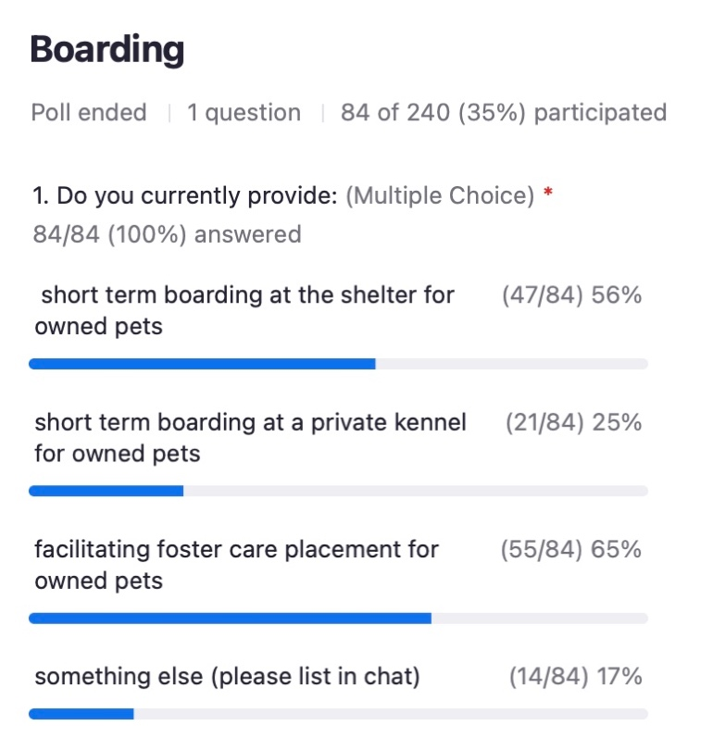
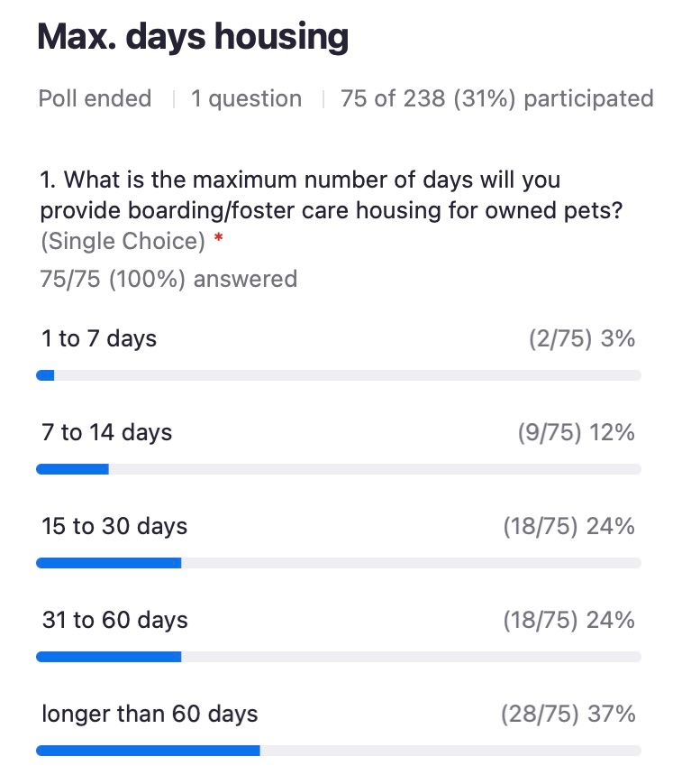

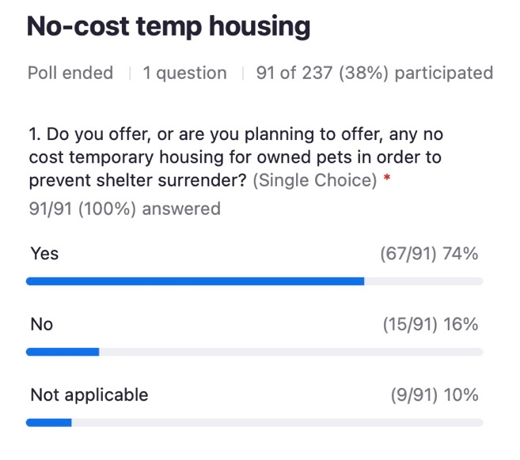
- Shannon Glenn and the team from My Pit Bull is Family have been leading the way in innovative programming to keep people and pets together since 2011 - from their national dog inclusive rental database, community partner program, and their North Minneapolis Pet Resource Center program. They're going to share their best ideas for helping pets and people together, based on their work of the past decade. You'll learn tips about overcoming housing challenges, visualizing data, community-based resources and addressing funding challenges this Friday!

Shannon Glenn, Executive Director/Board Member Shannon@mypitbullisfamily.org
Tiffany Wu, Housing Data Specialist data@mypitbullisfamily.org
Metallica Ponce, Outreach and Communications Coordinator outreach@mypitbullisfamily.org

Kristen shared Michelson Found Animals 2021 Pet-Inclusive Housing Report
https://www.foundanimals.org/pets-and-housing/2021-pet-inclusive-housing-report/
Joyce Briggs shared Functional Dog Collaborative's mission and links to FDCs position statement supporting the adoption of shelter dogs and on shelters and dog breeding: https://functionalbreeding.org/2022/02/23/position-statement-support-for-adopting-shelter-dogs/ and https://functionalbreeding.org/2022/03/07/position-statement-on-shelters-and-dog-breeding/

CHAT SESSION

07:48:31 From Clarissa Mueller to Everyone:
Good Morning and Happy Friday!

07:51:28 From Clarissa Mueller to Everyone:
Yes, lets see!

07:52:25 From Clarissa Mueller to Everyone:
Oh my goodness! He's so handsome!!😍

07:52:34 From Samantha Polen to Everyone:
Beautiful baby!!

07:53:17 From Kay Stout to Everyone:
I've made them for all my grandchildren

07:53:37 From Barbara Vass to Everyone:
Good morning - my mic does not work!! Barbara from Fort Bend County Animal Services in Rosenberg TX!

07:53:52 From Alison Gibson (she/her) to Everyone:
Hi Barbara! Welcome!

07:54:23 From Barbara Vass to Everyone:
Thank you - first time here :)

07:54:49 From Clarissa Mueller to Everyone:
I'm the Code Enforcement Director for the City of Ammon. We contract with a private veterinary hospital's boarding facility for shelter needs and that is new as of Oct. 2021. The adoptions are going well, but we need to improve on length of stay.

07:54:54 From Amber Freiwald, Maddie's to Everyone:
Kathy just reminded us that it’s about 2 years ago that we started shutting down for Covid 19

07:55:18 From Cory Ferguson to Everyone:
Good morning, everyone!

07:55:19 From Robert Gruhl to Everyone:
Howdy All - Bob G., Director, Animal Resource Center - Dayton, Oh

07:55:29 From Cynthia Bullock to Everyone:
Good morning, Cynthia from Harley's Hope, a safety net charity serving Colorado.

07:55:33 From Sarah Javier to Everyone:
Kathy, when I make it to Canada, I'm looking you up! Would love to meet you in person. :-)

07:55:55 From Alison Gibson (she/her) to Everyone:
Hi Cynthia!

07:56:02 From Mary Flores to Everyone:
Good morning from Tucson... Sol Dog Lodge and Training Center!

07:56:04 From Alison Gibson (she/her) to Everyone:
Hi Corly!

07:56:04 From Anne George to Everyone:
Good morning!

07:56:11 From Cory Ferguson to Everyone:
Wimberley Adoption Group (WAG) in Wimberley, TX.

07:56:24 From Jamie Case to Everyone:
I have a friend who was in Anguilla and he has never come back home.

07:56:32 From Samantha Polen to Everyone:
I really think this has brought the animal welfare community stronger and more information and resources available to all of us in all areas of AW and the country. I am in Tulsa, OK doing TNVR exclusively.

07:56:58 From Kathy Duncan to Everyone:
@Sarah!!! I can’t wait to meet you! If I ever hear that any of you show up in Canada and I don’t get a heads up, I’m coming for you!!!

07:57:02 From Amber Freiwald, Maddie's to Everyone:
oh wow Jamie!

07:57:19 From Alison Gibson (she/her) to Everyone:
We will be recording this call - later today find today’s chat and recording on Maddie’s Pet Forum
https://maddies.fund/awleadershiproundup31122

Question of the day: COVID , 2 years later: what has it done for animal welfare? When did you realize COVID was “real”?

07:57:21 From Cynthia Bullock to Everyone:
It became real to us when we ramped up an emergency pet food program and began delivering pet food and supplies throughout three counties in our area.

07:57:30 From Sarah Javier to Everyone:
Jamie, I have friends who ended up in Mexico and decided to stay.

07:57:39 From Kathy Duncan to Everyone:
@Bob G. I love your profile pic - from Kathy from Canada!!!

07:57:55 From Kym Iffert to Everyone:
We had just been hit by a tornado, so trying to “clean up” and “shut down” - just insane!

07:58:19 From Cory Ferguson to Everyone:
I was working as the Community Relations Manager for a major Healthcare Organization, so it became real very quickly. Whether I liked it or not!

07:58:23 From Amber Freiwald, Maddie's to Everyone:
when did you realize it was “real”?

07:58:41 From Alison Gibson (she/her) to Everyone:
Kim Iffert - wow - sending you prayers!

07:58:41 From Sarah Javier to Everyone:
In addition to the amazing changes that have happened in animal welfare, I also think it has elevated the work we do and the importance of supporting pet owners to the community as a whole.

07:58:59 From Robert Gruhl to Everyone:
Hi Kathy … Transplanted Canuck - Ontario raised.

07:59:19 From Amber Freiwald, Maddie's to Everyone:
it often takes a catastrophic event to make sweeping cultural change!

08:00:02 From Kathy Duncan to Everyone:
Woo hooo!!! Great to know Bob!! I am in Ontario and have been here in animal welfare for 30+ years. I work remotely now for Humane Canada!!

08:00:19 From Amber Freiwald, Maddie's to Everyone:
thank you Alison! <3

08:00:32 From Jamie Case to Everyone:
We were supposed to open the facility we had just finished renovating on March 28. AND the AmPA! Staff was supposed to come do a regional summit for St. Louis and all of that cancelled. THAT’S WHEN IT FELT REAL!

08:00:33 From Becky Tegze to Everyone:
First time my neighbors went out and banged pans for health care workers

08:00:54 From Kathy Duncan to Everyone:
I hear you @Becky!!

08:00:56 From Amber Freiwald, Maddie's to Everyone:
thank you @becky!!

08:01:00 From Cory Ferguson to Everyone:
I think the collaboration between organizations really stepped up much more during the pandemic as much out of necessity as anything.

08:01:06 From Laney Nee to Everyone:
Hi Everyone! Greetings from Boston

08:01:13 From Jamie Case to Everyone:
Chris, you are the best.

08:01:29 From Kathy Duncan to Everyone:
We LOVE Chris!!!

08:01:33 From Sarah Javier to Everyone:
I also want to express my gratitude to each of you. Over the past two years, I have learned so much from this group, and I am grateful because it was all of you who made the many changes and challenges of COVID manageable.

08:02:01 From Alison Gibson (she/her) to Everyone:
Hugs to Mary❤️

08:02:25 From Kelly Clardy to Everyone:
Yes, lots of hugs to Mary!

08:02:26 From Alison Gibson (she/her) to Everyone:
Thank you, Sarah - beautifully expressed.

08:02:53 From Jamie Case to Everyone:
Sarah is also the best. 🙂 Love you, my friend!

08:03:28 From Arin Greenwood to Everyone:
Hello from St Pete

08:03:36 From Amber Freiwald, Maddie's to Everyone:
Hi! if you’re new to the call, welcome!!! and please introduce yourself in the chat

08:03:40 From Sarah Javier to Everyone:
Aw, thanks, Jamie. Love you too, friend. <3

08:03:41 From Spencer Conover - Pasco County to Everyone:
What's up St. Pete!

08:03:43 From Lee Harper to Everyone:
make your background Dinos! channel Mary

08:03:53 From Alison Gibson (she/her) to Everyone:
Lee Harper love it

08:04:15 From Dianne Prado (She/her) to Everyone:
Hello! First time here- Dianne Prado, HEART L.A., Los Angeles, CA 🙂

08:04:15 From Shelby Bundy to Everyone:
Hello! I am Shelby, the Foster Program Supervisor, with the Longmont Humane Society. Happy to be here!

08:04:32 From Ariel Granat to Everyone:
Hi!! My name is Ariel and I am the Director of Operations for RSO Foundation, very happy to be apart of this chat :)

Kristen asked who has a Safety Net Foster Program

08:04:40 From Josh Fiala to Everyone:
We do!

08:04:41 From Jessica Des Lauriers to Everyone:
San Diego Humane has a Safety Net Foster Program

08:04:57 From Cynthia Bullock to Everyone:
We are 100% safety net services

08:05:07 From Steve Marrero to Everyone:
Hello From Liberty County Animal Services in Hinesville, GA

08:05:18 From John Cicolella to Everyone:
Animal Care Centers of NYC has a safety net foster program

08:05:35 From Alison Gibson (she/her) to Everyone:
Last Friday’s call - with the initial discussion - can be found on Maddie’s Pet Forum
https://maddies.fund/awleadershiproundup3422

08:05:54 From Sarah Javier to Everyone:
So much of the last two years has been about communication, which reminds me -- Since there are so many incredible leaders here, I want to ask -- does anyone have a Director of Communications job description they can share? We want to expand our team. If so, would love to receive it at sarah@apamo.org. Thanks!

08:05:57 From Stacy LeBaron to Everyone:
Our next free webinar Trapper’s Tips and Tricks will be Saturday March 19th at 2pm ET. To sign up go to www.communitycatspodcast.com

08:06:12 From Kathleen Olson, CAWA-Purrfect Pals to Everyone:
Purrfect Pals Cat Sanctuary and Adoption Centers in Arlington, WA has partnered with two other organizations serving the homeless pet owners to offer foster care for adults and free spay/neuter vouchers. Our pet food bank serves all pets and includes flea treatment.

08:06:19 From Nancy McKenney, Marin Humane to Everyone:
https://www.marinhumane.org/get-help/safetynet/long-term-foster/

08:06:28 From Mark Neff to Everyone:
Hello everyone - Mark from Forsyth Humane Society - Winston Salem North Carolina

08:06:31 From Rich Anderson to Everyone:
Peggy Adams has started offering foster and temp boarding (via local boarding businesses) in addition to our food pantry, medical and behavior support.

08:06:32 From Alison Gibson (she/her) to Everyone:
NACA updates - https://www.nacanet.org/

08:08:19 From Jan Steele to Everyone:
Hi - Jan Steele from Palm Beach County Animal Care & Control

08:08:20 From Lindsay Damron- Texas All Creatures Rescue to Everyone:
We are just getting started as an animal rescue. We are a 100% Foster based rescue. Is that the same thing as a foster safety net program?

08:08:47 From Sarah Javier to Everyone:
Hooray and Congrats!

08:08:53 From Jamie Case to Everyone:
SO EXCITING!

08:08:54 From Kathy Duncan to Everyone:
One Health Integration Toolkit - Getting Started: https://www.humananimalsupportservices.org/toolkit/hass-one-health-integration-toolkit-getting-started/

08:08:55 From kristen hassen to Everyone:
Amazing!

08:09:00 From Amber Freiwald, Maddie's to Everyone:
party emoji!

08:09:05 From Josh Fisher to Everyone:
Yay!!

08:09:17 From Jamie Case to Everyone:
So much St. Louis representation today! LOVE LOVE LOVE!

08:09:31 From Julie Levy to Everyone:
How to help people and animals in Ukraine. Join us next Tuesday, March 15, as The Association’s Katherine Shenar hosts Dr. Katherine Polak and Adam Parascandola of Humane Society International for a live discussion. Register for the 7pm ET talk and learn about HSI’s important work assisting refugees and their pets displaced by the war in the Ukraine.
https://us02web.zoom.us/meeting/register/tZMtduCtrDsrG9MPSwQR3wodJHjmI7Z5Efds?fbclid=IwAR22_7VlaSeMS4jBGOu2Iq9z5RoZKG4UL927L_44J1jAqG-n9-OdtiMVmxI

08:09:31 From Kelly Clardy to Everyone:
Maddie’s Fund Monthly Giveaways! Enter here for a chance to win CA$H in a random drawing:
https://www.maddiesfund.org/friday-community-conversations-mar22-giveaway.htm

Open to all who are watching live or on-demand! Be sure to enter each week you attend!

08:09:35 From Sarah Javier to Everyone:
Agree, Jamie -- this is great! Hi, Jessica!!!

08:09:35 From Stacy LeBaron to Everyone:
Talking about training, the Community Cats Podcast continues to offer monthly trapper certification workshops- our next on is April 2 at 2pm ET. We would like to welcome Indy Neighborhood Cats as a supporting organization along with All About Animals Rescue and others..

08:09:59 From kristen hassen to Everyone: Big Dog Master Class March 29-30
https://maddiesmillionpetchallenge.org/big-dog-master-class/?sf159337199=1

08:10:09 From Valerie Sheppard to Everyone:
Ukraine Update with Humane Society International Tuesday 3/15 7pm ET https://us02web.zoom.us/meeting/register/tZMtduCtrDsrG9MPSwQR3wodJHjmI7Z5Efds

08:10:31 From Sarah Javier to Everyone:
Thank you for this topic. I've been wondering how to help with pets in Ukraine, but haven't been sure who is reputable.

08:10:54 From Alison Gibson (she/her) to Everyone:
Big Dog Master Class – free on March 29 and 30 10am PT to 5pm PT
https://maddiesfund-org.zoom.us/webinar/register/WN_uydm2Ka_RSye_dVgVJg4Bw

Full description with sessions and speakers https://maddiesmillionpetchallenge.org/big-dog-master-class/

08:11:30 From Shelly (she/her), Maddie's Fund to Everyone:
@lindsay Damron - welcome and congratulations! Generally speaking, safety net fostering is focused on providing temporary foster for people with immediate needs so they can keep their pets. For example, temporary foster care while they go to the hospital, etc.

08:12:49 From kristen hassen to Everyone:
https://www.today.com/pets/pets/pet-adoptions-slow-us-heads-3rd-year-pandemic-rcna17718?fbclid=IwAR3KtrVfEHMqeKbgNvemsgIDf_cJZan5c3ACIyoNDM_kWt2ud7UcU0GgGYg

08:13:48 From Emily Sprong to Everyone:
Emily Sprong - ED of Seattle Area Feline Rescue in Shoreline, WA - it's been a few months since I've been able to make the call live, it's good to be back.

08:14:06 From Alison Gibson (she/her) to Emily Sprong(Direct Message):
Welcome back!

08:14:12 From Charlotte Otero @ Maddie's Fund to Everyone:
We are holding a resource drive on Maddie’s Pet Forum for the month of March around all things adoption! Since adoption touches so many aspects of your organization, our goal is to build a resource center that can be useful for all the areas that adoption plays a role in.

Please upload/share any resources related to adoption on this thread during the month to be entered to win a $50 gift card! Thanks for your help

https://maddies.fund/adoptionresourcedrive

08:14:14 From Lindsay Hamrick to Everyone:
A 3-parter with your coffee because of text limits on Zoom!

Recently, there have been some inaccurate claims that a learning lab offered at Animal Care Expo will encourage shelters to start breeding dogs. This is, of course, untrue. Neither the HSUS nor the presenters advocate for shelters or rescues to breed animals. Instead, they argue that the perspectives of shelters, animal welfare professionals and humane breeders are all critical to the conversations about where people should get a dog. Including these perspectives will help ensure that all dogs are treated humanely.

08:14:31 From Tracy Brad to Everyone:
welcome back Emily!

08:14:32 From Amber Freiwald, Maddie's to Everyone:
yes!!!! thanks @charlotte!!

08:14:33 From Lindsay Hamrick to Everyone:
Members of the Expo panel strongly support adoption of shelter dogs and puppies and the HSUS supports pet adoption through multiple initiatives, including the Shelter Pet Project, a partnership with Maddie’s Fund and the Ad Council that has helped make adoption one of the top choices for new pet acquisition (~40% of potential pet parents choose adoption).

Adoption is a wonderful option for many families. But while we continue to push for pet adoptions—through more efficient transport programs that help dogs and puppies in under-resourced shelters, and by removing barriers to adoption through programs like Adopters Welcome—we also work with and not against humane breeders, because building those connections is another important way to end the sale of puppies from puppy mills and other inhumane sources.

08:14:45 From Lindsay Hamrick to Everyone:
The HSUS has hosted numerous panels of animal welfare professionals and breeders to help develop stronger partnerships between the two, in an effort to curb the sales of puppies from puppy mills. While the relationships among breeders, shelters and rescue groups have historically been strained, all groups are critical to the efforts to end inhumane puppy mills, each providing far better options to families who want to add a pet to their home. While previous Animal Care Expo panels have helped highlight the connections between their work, this year’s daylong conversation will allow participants to dive deeper into the ways they can collaborate and help potential dog owners find puppies and dogs from humane sources.

08:15:43 From Joe Gross to Everyone:
Good morning and first-time participant; looking forward to learning from the group - Joe Gross of Hillsborough County Code Enforcement FL

08:15:59 From Alison Gibson (she/her) to Joe Gross:
Welcome, Joe!

08:17:43 From Alison Gibson (she/her) to Everyone:
Thank you, Joyce!

08:17:50 From Staycee Dains to Everyone:
Better source of dogs... that will make me think. I don't understand how improving the source of dogs improves the situation.

08:17:51 From Vicki Davis to Everyone:
Well explained Joyce – thanks

08:19:02 From Amber Freiwald, Maddie's to Everyone:
While I think the biases or opinions about breeders is a really interesting sub-layer - I would LOVE to focus on identifying ways to decrease barriers to transport (I would hypothesize that many of us struggle the most with the idea of increasing supply while so many pets are still at risk of death)

08:19:05 From kristen hassen to Everyone:
clare.callison@americanpetsalive.org

08:19:27 From Amber Freiwald, Maddie's to Everyone:
@CLARE EXACTLY!!!

08:19:34 From Staycee Dains to Everyone:
@Amber agreed!

08:20:41 From Bethany Heins to Everyone:
Hi all - here is the transport connection map Clare just referenced. https://network.bestfriends.org/transport-connection-map

08:21:12 From Clare Callison to Everyone:
Thanks, Bethany! Love this tool

08:22:05 From Stephanie Rambo to Everyone:
@Clare Callison would love to talk to you more abt partnering

08:22:10 From Nina Stively to Everyone:
I would love legislation that better empowers licensed technicians to assist- administering rabies, signing health certificates, providing euthanasia in-home (for OREs). The veterinary shortage has a role in the transport logjam, and its not going anywhere.

08:22:21 From Amber Freiwald, Maddie's to Everyone:
Cats Gone Wild - I’m dreaming up canva created cats in bikinis, love it

08:22:23 From Bobby mann to Everyone: free course: FUNdamentals of Marketing
https://university.maddiesfund.org/products/fundamentals-of-marketing

08:22:24 From Karen Nichols to Everyone:
This is my first call. Karen Nichols, Board Member with Lancaster SPCA in SC. We are a 501 c3 and just got our own van for purposes of transporting up north. We are at max capacity 100% of the time. We just got added to the Best Friends map! lancspca2.sc@gmail.com

08:22:49 From Emily Sprong to Everyone:
@Nina Stively - yes!

08:22:53 From Amber Freiwald, Maddie's to Everyone:
welcome @Karen!!

08:23:12 From Alison Gibson (she/her) to Karen Nichols(Direct Message):
Welcome, Karen!

08:23:25 From Cathie Myers to Everyone:
Hi Karen!

08:23:41 From Clare Callison to Everyone:
Absolutely @Stephanie Rambo- here’s my email: Clare.Callison@americanpetsalive.org
would love to connect!

08:24:26 From Brent Toellner to Everyone:
Speaking of Dr. Levy -- everyone should check out the new research paper she released this week:

https://www.frontiersin.org/articles/10.3389/fvets.2022.847081/full

08:24:32 From Joyce Briggs to Everyone:
@Staycee - the first 8-12 weeks for puppies are a highly critical socialization period for puppies, The care of the mother during her pregnancy is critical as well, and of course many purebreds have genetic issues. That puppy head start is critical for the behavior of dogs that might lead them to shelters.

08:24:39 From Karen Nichols to Everyone:
Hi Cathie!

08:24:51 From Brenda Barnette to Everyone:
Thank you for bringing that up Julie. Very important.

08:24:54 From Kim Domerofski to Everyone:
I agree with you, Dr. Levy. Concerned about the same thing.

08:25:15 From Shannon Asquith to Everyone:
I agree with Joyce.

08:25:36 From Erika Shaffer to Everyone:
This Maddie's U course is also very focused on marketing pets (by Caitlin Quinn and Kelly Duer): https://university.maddiesfund.org/products/marketing-a-foster-pet

08:25:37 From Lindsay Damron- Texas All Creatures Rescue to Everyone:
This is my first time joining the call. Lindsay Damron- Texas All Creatures Rescue. Thank you sooo much for the Best Friends map as we have several dogs in our rescue that are not getting any interest in adoption. We have to turn away so many dogs because we do not have room at our fosters right now.

08:26:27 From Steve Marrero to Everyone:
Thank you Dr. Levy, for the article.

08:26:33 From Amber Freiwald, Maddie's to Everyone:
Welcome @lindsay!

08:29:35 From Clare Callison to Everyone:
That’s a great point, Allison

08:29:37 From Bobby mann to Everyone:
Thank you, Allison!

08:29:42 From Nancy McKenney, Marin Humane to Everyone:
Wouldn't we be concerned that the large puppy mill operators see the animals more as cash crops and do not want any additional regulations or certification? What about consumer education on options?

08:29:48 From Joyce Briggs to Everyone:
@Alison Cardona - I agree with you!

08:29:59 From Gwyn Barley to Everyone:
Thank you, Allison!

08:30:10 From Brenda Barnette to Everyone:
Years back, when the shelter I worked for took in dogs who were in their last trimester of pregnancy, we allowed them to give birth and put the pups in foster homes where they were "home" raised and socialized. We did a community educational program about fostering if a family wanted to raise puppies.

08:30:16 From Jasmine Johnson to Everyone:
Thank you for bringing it up, Allison!

08:30:42 From Steve Marrero to Everyone:
Same here in GA

08:31:02 From Karin Baker to Everyone:
I'd like to see a poll of this group regarding continuing this or wrapping it up. it makes me cringe every time we discuss it.

08:31:28 From Shannon Glenn to Everyone:
Great idea Karin.

08:32:26 From Steve Marrero to Everyone:
Please reach out

08:32:48 From Kelly Clardy to Everyone:
If you just joined, don’t forget to enter for a chance to win money from Maddie’s Fund! Fill in the contest entry form here: https://www.maddiesfund.org/friday-community-conversations-mar22-giveaway.htm

Open to all who are watching live or on-demand! Be sure to enter each week you attend!

Poll 1 (results above)
Do you currently provide:

a. short term boarding at the shelter for owned pets
b. short term boarding at a private kennel for owned pets
c. facilitating foster care placement for owned pets
d. something else (please list in chat)

08:33:41 From Jenn Danks to Everyone:
Animal Welfare Society has a program called Stay@Home that offers a suite of services to support pets in our communities. Typically, we rely on fosters for temp. boarding requests. We are growing our community partner base to help support Stay@Home services and serve as eyes in the field for those in need. We look at all incoming Stay@Home requests and ask ourselves the question how we might be able to assist whether it’s transportation to vet care services, in home care for pets of homebound folks, delivery of care supplies, the possibilities we can accommodate is expanding.

08:33:51 From Josh Fiala to Everyone:
We also work with a local women's prison to help care for pets as well

08:33:51 From Karin Baker to Everyone:
we are prepared for it with no requests

08:33:58 From Kim Ferris-Church (she/her) Lollypop Farm to Everyone:
Lollypop Farm has a well-developed program, called the Mary Ellen Program

08:34:05 From Staycee Dains to Everyone:
Long Beach Animal Care Services does this on a case-by-case basis and not as a program. So there is willingness when it is needed. But no program around it. Very interested in learning
implementation on a program level

08:34:13 From Kate McHugh-Westfall to Everyone:
Hi all! Kate from Human Animal Support Services here. We will be launching our NEW Volunteer Coordinator Job-Alike on March 17th at 11am CT. Myself and Sarah Sukhram, Volunteer Coordinator at Pasco County Animal Services, will be leading this group to discuss all things volunteer related, share resources, and be a supportive place for volunteer leaders! Volunteer Coordinators/ Managers can sign up here: https://zoom.us/meeting/register/tJAodu2oqj4tE9JMZ4V5qy1b437s4D4IbgWr

08:34:23 From Mia Lindner - Manager to Everyone:
We’ve tried to get interest from our current foster base to help with this but zero have responded.

08:34:28 From Cynthia Bullock to Everyone:
We have offered only safety net services at Harley's Hope for 12 years now. Foster care is just one of our services.

08:34:32 From Steve Marrero to Everyone:
We would love to start a program

08:34:32 From Josh Fiala to Everyone:
I'd be happy to talk with anyone related to our program and would love to learn more about funding available

08:34:45 From Monica Dangler to Everyone:
PACC has a Safety Net Fostering!

08:35:02 From Jeffrey Zerwekh to Everyone:
How many people responded to the first poll?

Poll 2 (results above)
What is the maximum number of days will you provide boarding/foster care housing for owned pets?

a. 1 to 7 days
b. 7 to 14 days
c. 15 to 30 days
d. 31 to 60 days
e. longer than 60 days

08:35:20 From Tracy Brad to Everyone:
up to 9 months for Beck's Place

08:35:23 From Valerie Pullara to Everyone:
Hello, This is Valerie from Sol Dog Lodge and training Center in Tucson. We are a non-profit that collaborates with rescues and shelter to provide boarding, training and grooming services to keep families together.

08:35:24 From Josh Fiala to Everyone:
Josh Fiala - jfiala@arl-iowa.org

08:35:44 From Tracy Brad to Everyone:
TrBrad@Becks

08:35:45 From Amber Freiwald, Maddie's to Everyone:
@jeffrey about 75 people responded

08:35:45 From Emily Sprong to Everyone:
There is no option to indicate if we don't have any of these programs, so these stats are a bit skewed...

08:35:46 From Cynthia Bullock to Everyone:
cbullock@harleys-hopefoundation.org - all safety net services.

08:35:51 From Kim Ferris-Church (she/her) Lollypop Farm to Everyone:
kferris@lollypop.org , info about Lollypop Farm's Mary Ellen Program

08:35:55 From Tracy Brad to Everyone:
oops place.org

08:36:01 From Carol Jessee to Everyone:
Lisa O'Neill Angels of Assisi

08:36:01 From Monica Dangler to Everyone:
Pima Animal Care Center - Kaitlyn.Pappas@pima.gov

08:36:03 From Jenn Danks to Everyone:
Jenn Danks, Animal Welfare Society, jennd@animalwelfaresociety.org

08:36:04 From Michelle Dosson to Everyone:
Norfolk Animal Care Center: Jennifer.Held@norfolk.gov

08:36:11 From Lauren Rogers to Everyone:
San Diego Humane Society's safety net foster program launched in 2021. Since July we have served 74 pets with a 90% reunification rate. We have nearly 300 fosters that have taken our safety net foster training. I am happy to speak with anyone interested: lrogers@sdhumane.org

08:36:30 From Augusta Farley to Everyone:
I do safety-net boarding at a private kennel in CA

08:36:32 From Josh Fisher to Everyone:
Charlotte-Mecklenburg
Shannon.Harkey@cmpd.org

Poll 3 (results above)
Do you offer, or are you planning to offer, any no cost temporary housing for owned pets in order to prevent shelter surrender?

a. yes
b. no
c. not applicable
08:36:42 From Phillip Zimmerman to Everyone:
We just recently got approval from our City Attorney and have a program and contract for the animal owners. We currently have one dog in shelter - owner is currently in the hospital. Plan is to house most pets in approved foster care providers.

08:36:51 From Joyce Briggs to Everyone:
Can someone share the results of the Length of time offering temp housing poll? I missed copying it and would love to have that data.

08:37:02 From Lindsay Hamrick to Everyone:
For those attending Expo, we'll have a session on new research on owned pet fostering programs with Dr. Lisa Gunter (Arizona State/Maddie's) and Emily Blade with Arizona State.

08:37:09 From Jessica Reed to Everyone:
Seattle Humane. Supporting Pet Owners in Transition (SPOT). jessicar@seattlehumane.org

08:37:49 From Kelly Duer to Everyone:
You can find short videos about several safety net programs on Maddie’s Fund’s Education YouTube channel: https://www.youtube.com/c/MaddiesFundEducation

08:37:53 From kristen hassen to Everyone:
https://docs.google.com/document/d/1SEkOt5UqRJ_Hlkz-rZeIR4o6w1vGMOyhherxIwL7oog/edit?usp=sharing

08:38:20 From kristen hassen to Everyone:
https://www.foundanimals.org/pets-and-housing/2021-pet-inclusive-housing-report/

08:38:21 From Alison Gibson (she/her) to Everyone:
Thanks, Amber!

08:38:33 From Brent Toellner to Everyone:
The HABRI study is really, really good. Well worth the time

08:38:34 From Valerie Pullara to Everyone:
Sol Dog Lodge in Tucson can offer up to 90 days in boarding respite. Would love to chat with anyone about the success of our programs.

08:38:50 From Sandi Mercado to Everyone:
Be careful with the google doc... don't accidentally make any changes :)

08:39:01 From Alison Gibson (she/her) to Everyone:
Shannon Glenn, My Pitbull is Family https://www.mypitbullisfamily.org/

08:40:05 From Rich Anderson to Everyone:
We are now getting many more owner surrender requests due to how insane the rental market has become in Palm Beach County - people priced out of current rental and unable to find new rental without pet restrictions.

08:40:16 From Charlotte Otero @ Maddie's Fund to Everyone:
Wilbur & Charlotte I’m obsesseddddd <3

08:40:33 From Michelle Dosson to Everyone:
They are the best babies ❤️

08:41:24 From Kim Ferris-Church (she/her) Lollypop Farm to Everyone:
I have a bumper sticker on my car!!!

08:41:39 From Becky Tegze to Everyone:
I have a bumper sticker!

08:42:02 From Alison Gibson (she/her) to Everyone:
Aww Charlotte 😻

08:42:50 From Sandi Mercado to Everyone:
Am I the only one with a board of directors who doesn't want us to call them "pit bulls"? They say it has a derogatory connotation, and that it's not a "real breed name"- it was a nickname given to the dogs that were used for fighting and/or bait dogs. They insist that we call them "Staffordshire Terriers" or "Staffies" instead.

08:43:43 From Kim Ferris-Church (she/her) Lollypop Farm to Everyone:
dogs of 25 lbs

08:43:43 From kristen hassen to Everyone:
Huskies

08:43:45 From Vicki Stevens to Everyone:
Dobermans

08:43:46 From Shelby Bundy to Everyone:
Pitbulls, Shepherd, Mastiffs

08:43:47 From kristen hassen to Everyone:
Chihuahuas

08:43:47 From Phillip Zimmerman to Everyone:
Rottweilers

08:43:48 From mark wysocki to Everyone:
German Shep

08:43:48 From Kym Iffert to Everyone:
Rottweilers

08:43:49 From Stephanie Rambo to Everyone:
Rotties

08:43:49 From Kim Ferris-Church (she/her) Lollypop Farm to Everyone:
square head dogs

08:43:50 From Emily Klehm to Everyone:
Akitas

08:43:52 From Sandi Mercado to Everyone:
rotties, "pit bulls", shepherds

08:43:53 From Bobby mann to Everyone:
Dobermans

08:43:55 From Heather Friedman to Everyone:
Boxers

08:43:55 From Mia Lindner - Manager to Everyone:
Pitbulls, German shepherds, akita,

08:43:58 From Susan Leavitt to Everyone:
Dogs in general.

08:43:58 From Sandi Mercado to Everyone:
Doberman

08:43:59 From Nina Stively to Everyone:
ACDs, chows, danes

08:43:59 From Amy Jo Sites to Everyone:
any protection breed - dobie, gshep, rott, mastiff, etc

08:44:00 From Kate McHugh-Westfall to Everyone:
Rotties

08:44:00 From Steve Marrero to Everyone:
Bully

08:44:00 From kristen hassen to Everyone:
Anything big

08:44:14 From mark wysocki to Everyone:
over 65 pounds

08:44:17 From Allison Cardona to Everyone:
dogs with "locking jaws" - actual language

08:44:42 From Mary Lou Harju to Everyone:
Surprised that greyhounds aren't included because of size.

08:45:20 From Brenda Barnette to Everyone:
Good meeting. Sorry I have to jump off.

08:45:30 From Amber Freiwald, Maddie's to Everyone:
thanks @brenda!

08:45:40 From Joyce Briggs to Everyone:
The non-profit Functional Dog Collaborative's mission is to support the ethical breeding of healthy, behaviorally sound dogs. Here are links to FDCs position statement supporting the adoption of shelter dogs and our point of view on shelters and dog breeding: https://functionalbreeding.org/2022/02/23/position-statement-support-for-adopting-shelter-dogs/ and https://functionalbreeding.org/2022/03/07/position-statement-on-shelters-and-dog-breeding/
Please check them out.

08:46:22 From Kelli Eaves to Everyone:
We use your site all the time for our customers to find housing. We get requests often for adoption events at apartments and our first question is always "do you have restrictions?". I have your sticker on my board in my office :)

08:46:36 From kristen hassen to Everyone:
Your website is soooooo awesome

08:47:40 From kristen hassen to Everyone:
OMG we so need you all to do an apprenticeship!!1

08:48:27 From Alison Gibson (she/her) to Everyone: Tiffany Wu
data@mypitbullisfamily.org

08:50:09 From Allison Cardona to Everyone:
Love this, @tiffany!

08:50:20 From Lauren Loney to Everyone:
I love the dashboard!!!! <3 It's such an amazing resource

08:50:42 From Bobby mann to Everyone:
+1 Lauren! It is sooo amazing!

08:50:48 From Cory Ferguson to Everyone:
Wow! That is awesome!

08:51:04 From Tracy Brad to Everyone:
this is awesome!

08:51:14 From Lauren Loney to Everyone:
I've shared the website with every legal aid attorney I know so that those who are working with low-income tenants know about it!!

08:52:51 From Stephanie Rambo to Everyone:
This was an amazing meeting today... thank you all for sharing... unfortunately, I need to get back to work... have a great weekend!

08:53:01 From Alison Gibson (she/her) to Everyone:
Thanks, Stephanie!

08:54:08 From Mia Lindner - Manager to Everyone:
This is great! There’s only 1 place within 50 miles of Chicago that takes pitties 🙁

08:54:42 From Alison Gibson (she/her) to Everyone:
https://www.mypitbullisfamily.org/

08:55:10 From Shannon Glenn to Everyone:
In the last few years we finally have a budget over 50K thanks to some amazing funders. <3

08:55:19 From kristen hassen to Everyone:
That’s wild Shannon!

08:55:21 From Alison Gibson (she/her) to Everyone:
Metallica Ponce outreach@mypitbullisfamily.org

08:55:59 From kristen hassen to Everyone:
I gave up my dog because I could not find resources

08:56:07 From Malinda Huggans to Everyone:
No resources

08:56:07 From kristen hassen to Everyone:
I really tried

08:56:19 From Mia Lindner - Manager to Everyone:
Yes….trying to get health care. I had to research many places that could help on a low budget.

08:56:39 From kristen hassen to Everyone:
That’s amazing

08:56:41 From kristen hassen to Everyone:
No barriers

08:57:27 From Shannon Glenn to Everyone:
This team is really kicking ass this year & we’re so thankful for the community members that visit us.

08:57:47 From Shelly (she/her), Maddie's Fund to Everyone:
WOW! Those are incredible numbers for 2 months.

08:57:52 From Megan Waldron to Everyone:
That is amazing!

08:58:03 From Lauren Loney to Everyone:
Are the NMPRC and MPBF two different organizations (for funding purposes)? Or all one org?

08:58:07 From Mia Lindner - Manager to Everyone:
This is great!

08:58:14 From Shannon Glenn to Everyone:
All one. NMPRC is one of our programs.

08:58:21 From Lauren Loney to Everyone:
Thank you!!

08:59:44 From Arin Greenwood to Everyone:
Yay!!

08:59:47 From Lauren Loney to Everyone:
yay!!!

08:59:53 From Jamie Case to Everyone:
THAT MAKES ME SO FREAKING HAPPY!

08:59:53 From Amber Freiwald, Maddie's to Everyone:
Congratulations!!

08:59:58 From Kate McHugh-Westfall to Everyone:
Congrats!

09:00:04 From Tracy Brad to Everyone:
Congrats!

09:00:31 From Robert Gruhl to Everyone:
Thats some serious dedication!

09:00:35 From Kelly Clardy to Everyone:
Remember to enter for a chance to win money from Maddie’s Fund! Complete the entry form here: https://www.maddiesfund.org/friday-community-conversations-mar22-giveaway.htm

Open to all who are watching live or on-demand! Be sure to enter each week you attend!

09:00:41 From Dianne Prado (She/her) to Everyone:
Yes congrats Shannon!! Awesome news!!

09:00:51 From Shannon Glenn to Everyone:
Thanks all!

----------------END---------------

