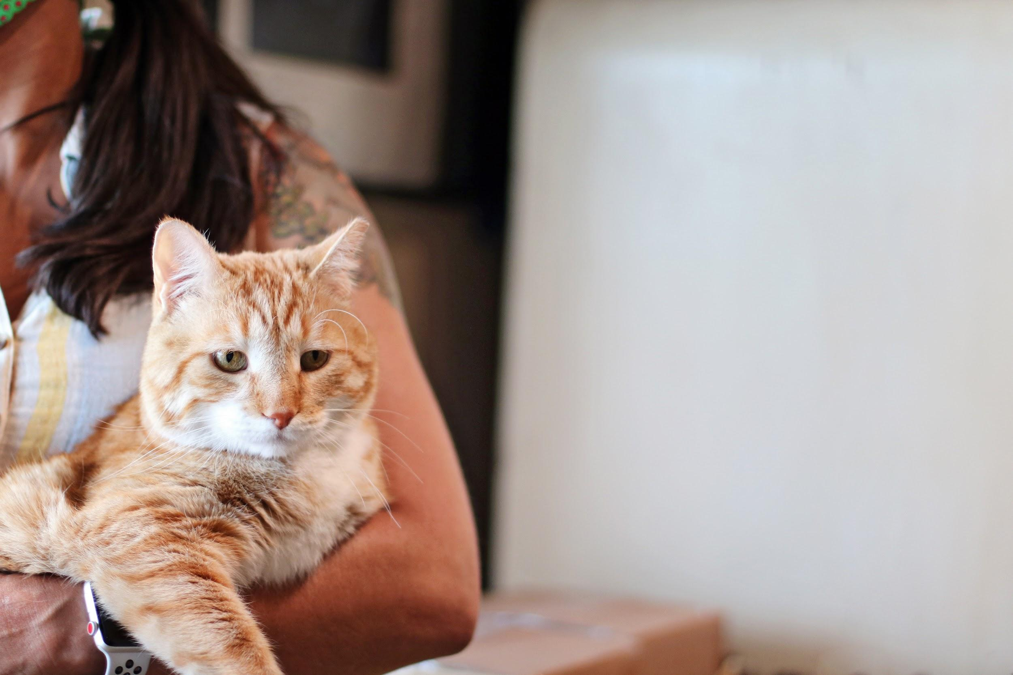

Foster Guide for Cats
1370 South 400 West  Salt Lake City, UT 84115  www.ruffhaven.org | FOSTER CONTACTS:  Caitlin Lisle: 801-808-7746  Emergencies: 801-251-6765 (text)
Table of Contents

Overview & Contact Information . . . . . . 3

Foster Expectations . . . . . . . . 4

What is an Emergency? . . . . . . . 5

Before the Foster Comes Home . . . . . . 6

Your Foster’s First Day . . . . . . . 6

Cat Fostering 101 . . . . . . . . 7-8

Many thanks to Lost Our Home Pet Rescue in Tempe, AZ for providing the basis for this foster guide.
Thank you for fostering with Ruff Haven Crisis Sheltering.

Ruff Haven could not exist without a network of dedicated, compassionate fosters. Our mission is to provide a temporary safe haven for companion animals in order to keep pets and their people together in times of crisis, increase pet retention, and decrease the number of animals entering the shelter system.

Ruff Haven volunteers and fosters treat the people and pets we serve with kindness and dignity. We strive to provide a non-judgmental environment where people feel safe entrusting their pets into our care.

We hope this foster guide prepares you for what to expect when you bring home a Ruff Haven foster cat. While it may not hold all the answers, Ruff Haven volunteers are always happy to help and we are only a phone call, text, or email away.

Contact Information

Your Foster Sitter Coordinator: Caitlin Lisle
Cell: 801-808-7746 (call or text)
Email: foster@ruffhaven.org

Your Fellow Foster Sitters:
Join the Ruff Haven Foster Sitter Facebook group!

In Case of Medical Emergency: 801-251-6765 (text is best)

Maddie’s Pet Assistant App

You aren’t in this alone. Nothing sets up a foster for success more than a powerful communication tool and immediate response. The Maddie’s Pet Assistant app gives caregivers the opportunity to submit questions, photos, and videos and take surveys. When you foster your first Ruff Haven pet, you will receive an email with instructions on setting up the Maddie’s app.
What to Expect as a Ruff Haven Foster

The Ruff Haven Crisis Sheltering program is for pet owners in Utah who are temporarily unable to care for their pets. There is no cost to the pet owner seeking RHCS services. All pets that enter the program are vaccinated and sterilized. The program allows for up to 60 days of sheltering, though extensions may be granted.

A foster home shall provide a warm, clean, and loving environment for the foster cat. Food shall be provided and medications given as directed. A foster home will bring the foster cat into the facility (Dogs All Day) or veterinarian as scheduled for medical care and vaccinations. A foster home will never allow the foster cat outside. A foster home will also monitor the health of the foster cat and immediately contact Ruff Haven leadership in the event of questions or concerns about the health or safety of the foster cat.

In the event that the foster cat is commingled with other animals in the foster home and illness or injury results, veterinary expenses shall be the sole responsibility of the foster home.

Foster cats are released into the possession of the foster parent and cannot at any time be given to another person without prior authorization from Ruff Haven Crisis Sheltering.

Foster Supplies

Ruff Haven will provide foster families with the following items for foster cats: food and carrier. Please anticipate providing bowls, beds, blankets, litter boxes, litter, brushes, etc. If we have these items available via donation, we will provide them as we are able.
Any items you acquire for the care of the foster cat are NOT the property of Ruff Haven nor the foster cat’s owner. Ruff Haven cannot reimburse fosters for the purchase of supplies. Thank you for understanding.

Check Ins/Photos

If you are fostering a cat, our foster coordinator will reach out at least biweekly to check on both you and the foster. You are welcome to reach out any time with questions, concerns, or updates.

♡ We LOVE photos and videos to share with pet owners! ♡ Please make sure any photos/videos you send are anonymous (no identifying information such as your face or address) so that we can send them to the pet owners.
Examples of Emergency Medical Symptoms

- Blood from any orifice/opening  - Blood in vomit or vomit that is dark in color  - Blood in the urine, or if the foster animal is unable to urinate at all  - Blood in the stool, especially with diarrhea  - Congestion, wheezing, or labored breathing  - Fever (often accompanied by lethargy)  - Diarrhea in neonates/underweight animals for more than 24 hours | - If an accident has occurred and the foster animal appears to be injured  - Lameness that appears severe and painful  - Pain -- irritability when handled or touched, particularly if it seems out of character for that animal.  - Seizures or convulsions  - Trouble eating, mouth pain, or drooling  - Lethargy or decline in activity level normal for your foster animal for more than 24 hours

Examples of Non-Emergency Medical Symptoms

- Any change in appearance of the eye: squinting, winking, tearing, swelling, redness, or yellow, green, or crusty discharge  - Coughing for less than 24 hours  - Diarrhea/loose stool (in adult animals and for less than 48 hours)  - Excessive drinking for more than 48 hours  - Increased appetite for more than 1 week, especially when accompanied with weight loss  - Weight loss is observed over a 48 hour period, especially with kittens, puppies, or nursing mothers -- when weight loss is accompanied by normal to more-than-normal food intake | - Increased scratching at any part of the body, including head shaking  - Increased urination or sudden accidents in the house, difficulty urinating, and straining for less than 24 hours  - Nasal discharge -- white, yellow, or green  - No apparent weight gain, especially with puppies and kittens during a 72-hour period  - Poor appetite for more than 48 hours  - Sneezing for more than 24 hours  - Unexplained lameness that does not improve with rest within 24 hours  - Hair loss  - Vomiting less than three times

Better safe than sorry!

If you have any concerns (emergency or not) about the health of your foster pet, please text or email an explanation and/or photos to Ruff haven program leadership at 801-251-6765 or info@ruffhaven.org.

Ruff Haven leadership (Kristina, Marisa) MUST authorize veterinary care before services are rendered.

Unauthorized veterinarian expenses are the responsibility of the foster home.
Cat-Proofing Your House: Before the Foster Comes Home

When cats are in a new situation (like your home!), they may act in ways that the owner could never imagine or forewarn Ruff Haven volunteers or fosters about. This includes chewing, scratching, and soiling when they don’t have a history of doing so.

Cat-proofing your home ensures that an anxious, stressed, or mischievous foster cat does as little damage as possible to your home and themselves.

Consider the following:
- Tie up blind cords in your windows.
- Make sure that kitchen counters are clear of snacks or treats.
- Ensure that trash cans (in your kitchen and bathrooms) have lids or are put away where a cat can’t get into it.
- Put away valuables that could be knocked off fireplace mantles or shelves.
- If you enjoy opening your windows, check that your screens are secure.
- Make sure houseplants that are toxic to cats are out of reach.
- Check that wires are tucked away behind and under furniture.
- And more -- walk around your house and consider what a cat could get into and make changes accordingly.

Your Foster Cat’s First Day Home

Cats are usually more shy than dogs. Prepare a quiet room for your foster with a litter box, food, water, and bed/blanket. Put the foster cat into the room and prepare for them to hide for the first few hours or days. Close the door of the room so they can feel safe to sneak around and explore. Don’t force attention on your foster cat and don’t let your existing animals meet them right away.

Your foster cat may eat their first meal at your home without a problem. They may also turn up their nose at food and that is OK. If your foster still hasn’t eaten anything (not even treats or tuna) after 24 hours in your home, please notify your foster coordinator.

Most cats will use a litter box without a problem. Be sure to check and clean the litter box daily. Your foster cat may have diarrhea or loose stool for the first few days, which is common when adjusting to a new environment or diet.

You may not get to play with or cuddle with your foster cat immediately. Once they are comfortable in their private room, allow them to explore your home and go slow. When they are comfortable, you can move their food, water, and litter box to the correct location. Before you know it, your foster cat will be begging for attention!
Cat Fostering 101

Socialization and Playtime
- Socialize your cat a minimum of 3 to 4 20-minute visits daily if they are staying in their own room.
- Always encourage affectionate behavior and reward your foster cat with pets and treats when they want to spend time with you.
- Even adult cats like to play. Toys on strings and balls with bells can encourage even older cats to play like they are kittens again.
- Discourage your foster cat from playing with your hands. Never use your hands as toys!
- Change up your foster cat’s environment in small ways to encourage exploration and play (add cardboard boxes or move around their scratching posts).
- Treats are a great way to befriend your foster cat.
- Never yell at or punish your foster cat for normal cat behaviors such as scratching. Instead, provide the proper outlets for those behaviors (for example, a scratching post) and redirect their behavior.

Cleaning Schedule
- The rule of thumb is to have at least one litter box for every cat, plus one extra. If you have two cats then you should have three litter boxes, etc.
- Litter boxes should be easily accessible to the cat and as far away from food and water bowls as possible.
- Monitor your foster cat’s stool for abnormalities.
- Litter boxes should be scooped at least once a day, potentially more if you have more than one cat sharing a box.

Feeding
- We do not recommend free feeding. Feeding your foster cat on a schedule ensures you can track their food intake and report any concerns right away.
- If your foster cat does not seem to be drinking water, supplement their water intake with wet food.

Grooming
- Once your foster cat has had time to explore and adjust to your home, they may need some grooming. This could include cleaning their ears, trimming their nails, giving them a sponge bath, or brushing their coat.
- When trimming their nails, be careful not to cut too close to the pink veins. To be safe, simply clip off the curved tip carefully.
- When cleaning their ears, be careful not to go too far into the ear canal as this could be painful and cause internal damage.
- All cats need to be brushed regularly. Brushing prevents hairballs, controls shedding, and helps you bond with your foster cat. Longhair cats do need more frequently brushing, but cats of all fur lengths can suffer from matting.
- If your foster cat is dirty or has gotten into a mess, use warm water and a washcloth to clean them if possible. If the washcloth is too hot to be comfortable on your forearm, it is too hot for your foster cat.
- If your foster cat has a more severe grooming need, please notify us.
Introductions
- Do not immediately introduce your foster cat to the other pets in your home. Allow your foster cat to decompress in a private room. This could take several days. Your pets can sniff at the cat under the door, but do not let them rush in and scare the cat.
- Make sure that the foster cat has some places to hide if necessary.
- If you have children, make sure they understand that while a new foster cat is fun, they need time and space to feel safe. Too much noise or “crowding” the cat can make them nervous and scared.

Additional Resources
The Jackson Galaxy Project: Cat Behavior Resources

(VIDEO) 5 Tips for your New Foster Cat

(VIDEO) How to Introduce Cats

