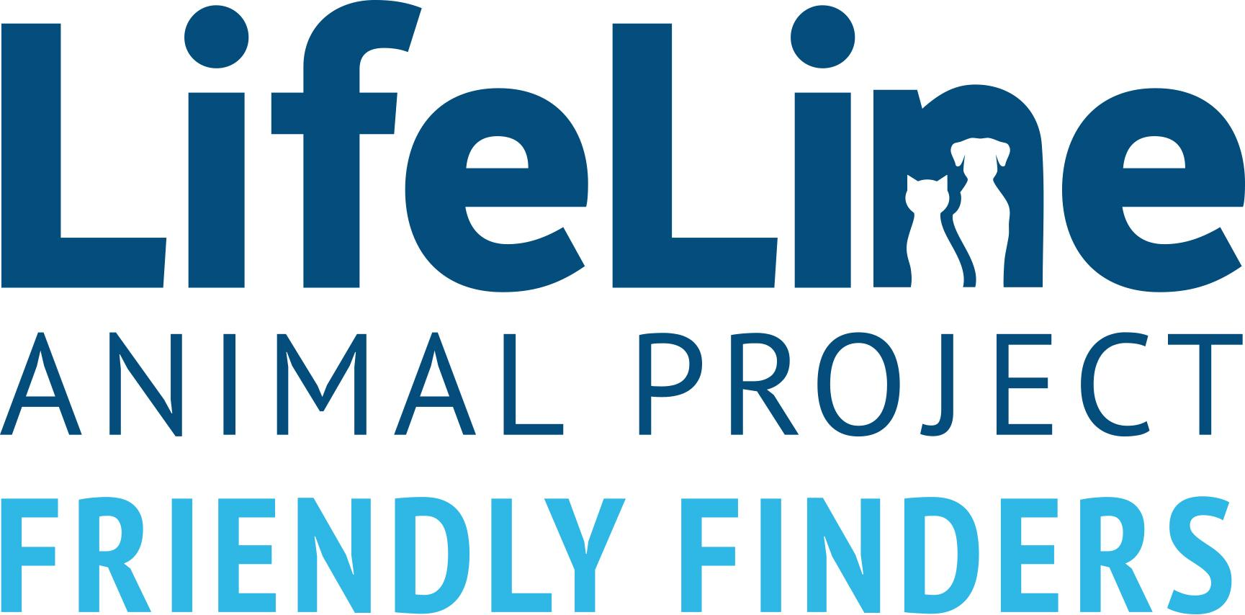
FRIENDLY FINDERS AGREEMENT

Thank you for helping the pet you brought in today. By taking this pet home today, you have helped save his/her life. We have provided the pet with all of the initial vaccinations and tests required to get his/her on the track to a new home. Our Foster Coordinator will reach out on day four to discuss continuing to foster or returning the pet to the shelter.

Contact Us: 404.294.2949 or intake@dekalbanimalservices.com
Hours: Mon. – Fri. 11:00am -7:00pm/ Sat. – Sun. 11:00am – 6:00pm
If the pet is in immediate distress outside regular business hours, please call 404.782.2693 (dogs) & 404.782.0942 (cats)
Animal Name:________________________________________ Animal ID#________________________
**Please initial beside each regulation below**
_____ Foster understands that the foster pet is only temporarily in his/her care and remains the property of DCAS. Any and all adoptions of the foster pet will be handled through DCAS. DCAS or designee can remove the foster pet from the Foster at any time and without any prior notice.
_____ Foster agrees to bring the pet back within 24 hours if the owner is located.
_____ Foster will make no decisions or actions regarding the foster pet's medical care (including euthanasia) without prior approval from DCAS. All well and sick visits will be scheduled at DCAS. In the case of an emergency, Foster will make every effort to contact the Foster Coordinator or the Shelter before considering an emergency visit. DCAS will not reimburse for unapproved emergency vet visits.
_____ Foster shall provide the foster pet with humane care and maintain him in accordance with all current state, county, and municipal laws and ordinances while the animal resides with the Foster. The Foster agrees to provide the foster pet entrusted to his/her care with adequate food, water, shelter, affection, socialization and exercise as (s)he would his/her own pets.
_____ Foster pet shall not be kept constantly tethered or outdoors. Foster dogs shall be leashed at all times when outside an unfenced area. Foster cats shall be housed exclusively indoors.
_____ Foster understands that DCAS will not reimburse for any property damage incurred due to foster pet’s presence in the home.
_____ Foster understands the foster pet may be incubating infectious diseases unbeknownst to the DCAS Veterinarian. He/She also understands that DCAS will not provide medical care or treatment to Foster’s personal pets should they contract any disease from the DCAS foster pet.
_____ Foster agrees to attend at least two adoption events each month with any foster who is ready for a new home.
_____ Foster understands that DCAS and its representatives have limited information regarding the temperament and habits of the foster pet. The Foster will take all reasonable precautions (through the use of crates, leashes, supervision and common sense) to ensure that the foster pet does not run loose, become a nuisance, destroy property, injure or be injured by another animal, or injure or be injured by any person or persons.
_____ Foster does hereby release, discharge, and hold harmless DCAS and any person, firm or corporation charged or chargeable with liability, their heirs, administrators, executors, successors, and assigns, from any and all claims, damages, costs, expenses, loss of services, actions, and causes of actions, whether known or unknown, belonging to the said Foster due to any action or occurrence from the date of this agreement arising out of or in connection with the care of the foster pet.

By signing below, Foster acknowledges that she has read the terms of this agreement and understands its contents and provisions fully.

Friendly Finder Name:
Address: ___________________________________________ City/State/Zip:
Home Phone: _____________________ Cell Phone: _____________________________ Email:
Friendly Finder Signature: ____________________________________________________________________ Date:
DCAS Representative:
DCAS Signature: ________________________________________________________________________ Date:

