Past Recordings on Maddie’s Pet Forum
- https://forum.maddiesfund.org/communityconversations

This Meeting’s Recording
- This Meeting’s Recording on Maddie’s Pet Forum:
https://maddies.fund/awleadershiproundup42922
- Maddie’s Fund Box Link to Recording File:
https://maddiesfund.box.com/s/3utk4sw7gtop4ov2gw6kutkxw4rz3kzk

Friday meeting registration page
- https://maddies.fund/Register_AWLeadershipRoundup
- https://us02web.zoom.us/meeting/register/tZEud-2orzMrHtLTuNo0GbrSNeCQlQkdWKAp

Monday meeting registration link (for shelter staff and committed volunteers)
- https://maddies.fund/Register_ShelterRescueSupport
- https://us02web.zoom.us/meeting/register/tZUqc-6spj0jHtES3GWxrpaG6L3HcbMh_dCu

199 Attendees

Agenda
- Welcome:
Guest Host: Julie Levy, Maddie’s Shelter Medicine Program, University of Florida and Maddie’s Million Pet Challenge

- National Updates:
  - Anna Cabrera’s talk at Expo (global issues track) on the Fetch and Fix Program: https://paws.org.ph/fetchandfix/

  - Dr. Kevin Morris' live presentation on the science behind the human-animal bond next Wednesday, May 4 at 9am (CST): https://e.givesmart.com/events/qpc/

  - Humane Canada’s Summit for Animals runs through the month of May. Register here: https://humanecanada.swoogo.com/summit/

  - Maddie’s Fund Monthly Giveaways! Enter here for a chance to win CA$H in a random drawing. Open to all who are watching live or on-demand! Be sure to enter each week you attend! https://www.maddiesfund.org/monday-community-conversations-apr22-giveaway.htm

  - This is a regional update - California for All Animals new grant period will start on May 1st. Please share with California organizations - https://www.californiaforallanimals.com/grants/open-grants/

  - Link to HASS blog about Open Door access to care clinic model: https://www.humananimalsupportservices.org/blog/innovators-working-to-make-veterinary-care-more-accessible/

  - A Great Place to Work Series starts 5/04 https://learning.theaawa.org/products/a-great-place-to-work-series

  - Survey link for Let Pet Reunification: https://www.surveymonkey.com/r/2MFSBYL

  - The Spring Conference For Animal Welfare Advancement June 15-17 in Chicago! https://theaawa.org/event/spring22

  - ASPCA & UMN CVM will be co-hosting an Access to Veterinary Care Conference from October 17-19 in Minneapolis, MN. Call for Proposals: aspcapro.org/avcspeakers, https://airtable.com/shrAarx5VpVFvYN9Y. Save the Date: https://email.aspcapro.org/save-the-date-for-the-access-to-veterinary-care-conference.

  - Times are tough for shelter dogs. We can help. Did you miss the Big Dog Master Class? You can now watch the entire conference on-demand at https://maddiesmillionpetchallenge.org/big-dog-master-class/.

  - Thank you for joining this leadership call hosted by Maddie's Million Pet Challenge. Learn more about our consultations, mentorships, and continuing education at https://maddiesmillionpetchallenge.org/. To learn or apply for Bootcamp visit maddiesmillionpetchallenge.org.

---------------------------------
TOPIC 1:
UPDATED GUIDELINES FOR COVID-EXPOSED PETS

Dr. Chumkee Aziz from the UC Davis Koret Shelter Medicine program will explain the updated COVID exposure and quarantine guidelines developed by the Shelter Medicine Academic Consortium for shelters intaking and handling dogs and cats potentially exposed to SARS-CoV-2.

Chumkee Aziz, UC Davis Koret Shelter Medicine program, https://www.sheltermedicine.com/about/our-personnel/mehnaz-chumkee-aziz-dvm/

https://sheltermedicine.vetmed.ufl.edu/2022/04/15/new-guidelines-for-dogs-and-cats-exposed-to-covid-19/

Crisis in Veterinary Care article: https://humanepro.org/magazine/articles/crisis-veterinary-care

Dr Scott Weese wrote an excellent recent blog about animal shelters and how staff should manage risk for human-human transmission: https://www.wormsandgermsblog.com/

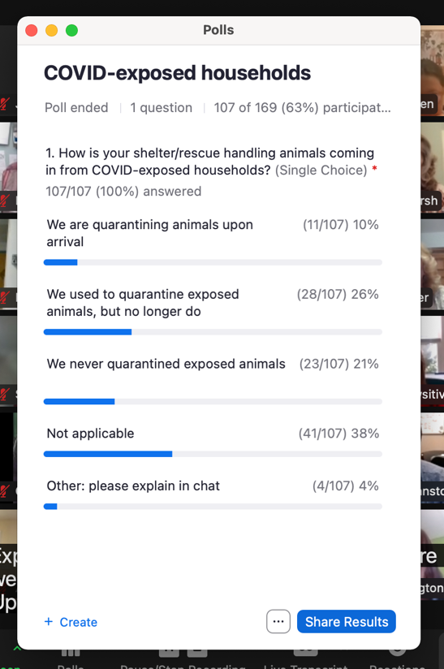

TOPIC 2:
​​BECOMING THE CHANGE
For an 85-year-old enforcement agency, change has always been a difficult and complicated process for the County of Los Angeles Department of Animal Care and Control. 2020 was a pivotal year for the agency to bravely embrace Managed Admissions and become a community resource and provide alternatives to impoundment through its outreach programs. Deputy Director Dr. Maria Sabio-Solacito will share how two years into it, DACC is still on its path to be the change it needs.

Dr. Maria Sabio-Solacito, Deputy Director, County of Los Angeles Department of Animal Care and Control

https://animalcare.lacounty.gov/
https://animalcare.lacounty.gov/got-kittens/

Dr. Hurley published this great article about managed intake by appointments and mentions the County of Los Angeles Department of Animal Care and Control's award-winning program. Way to go, Dr. Solacito and Team! https://www.frontiersin.org/articles/10.3389/fvets.2022.809340/full

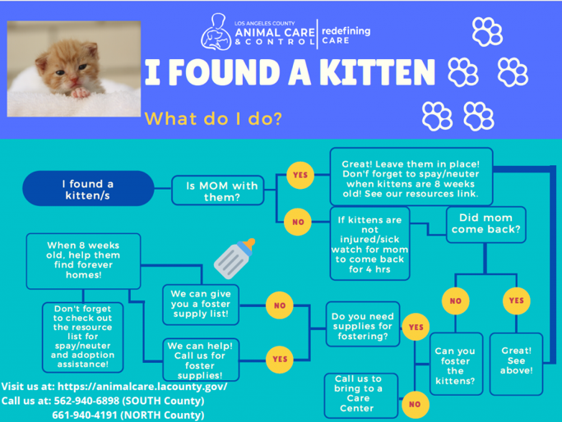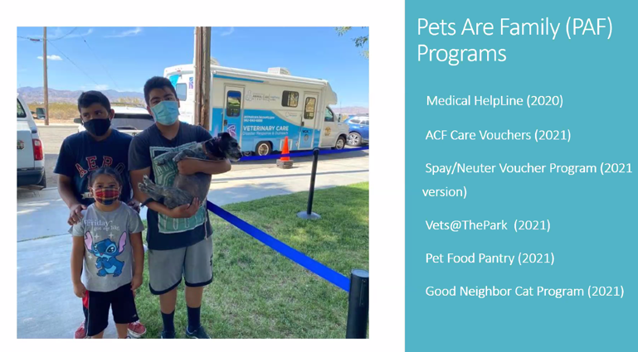

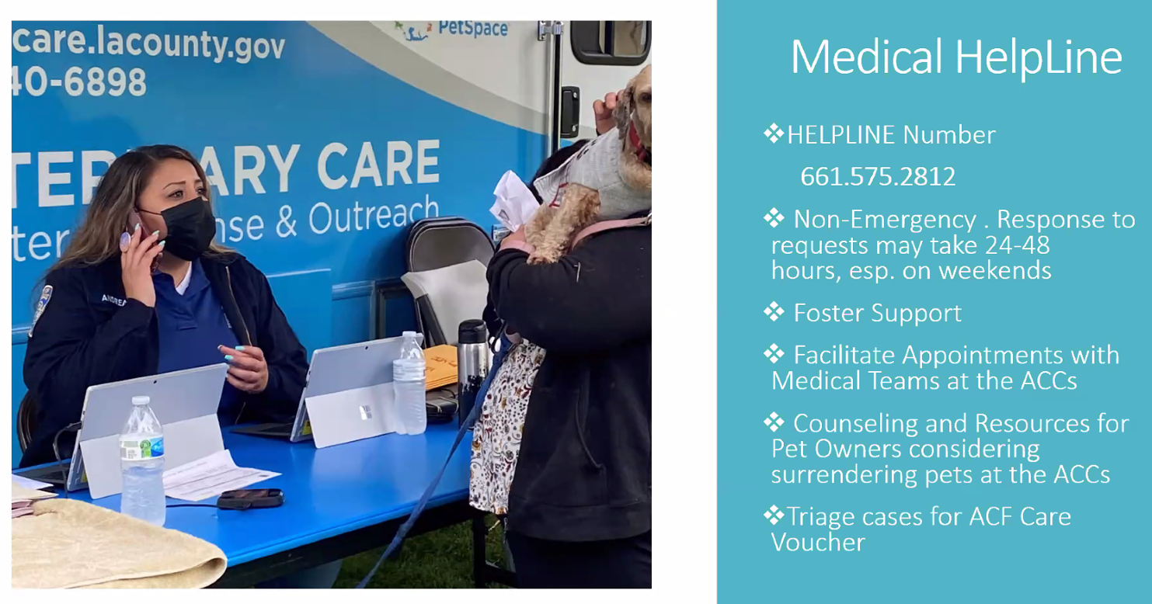

TOPIC 3:
HOW WE THICKENED OUR SKIN TO SAVE SOME FUR
Until recently, the Danville-Boyle County Humane Society in Kentucky took in over 1,000 cats a year and euthanized most of them. In 2021, intake for cats plummeted to 19, and more than 1,000 community and owned cats were sterilized instead of entering the shelter. Team Shelter USA’s Dr. Sara Pizano will lead a discussion with Fizzy Ramsey and Kari Kuh to hear how the board and shelter team overcame each challenge during this remarkable transition.

Dr. Sara Pizano, Team Shelter USA;
Fizzy Ramsey and Kari Kuh, Danville-Boyle County Humane Society in Kentucky

https://www.teamshelterusa.com/
https://www.dbchs.org/
fizzyramsey@dbchs.org

Video: https://www.canva.com/design/DAE6_YXDoMY/E0ua8JH8r0x9wMcCYCBHzg/watch?utm_content=DAE6_YXDoMY&utm_campaign=designshare&utm_medium=link&utm_source=publishsharelink

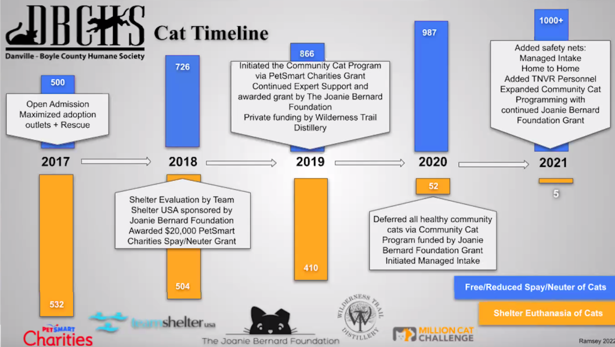

---------------------------------
CHAT:
10:52:00 From Anne George to Everyone:
Good morning!
10:52:22 From Kathy Duncan to Everyone:
Morning everyone!! Happy Friday!
10:52:43 From Gracie Redden to Everyone:
Good morning! I'm new here!
10:53:13 From Kathy Duncan to Everyone:
Welcome @Gracie!!
10:54:49 From Kyra Lynch to Everyone:
We were at Expo :-)
10:56:03 From Allison Cardona to Everyone:
Dr. Lila Miller was incredible - her keynote was fire!
10:56:15 From Lindsay Damron to Everyone:
Does anyone use Trello for communication with fosters? I would love to see an example of how you set up your boards etc.
10:56:21 From Anne George to Everyone:
I have been working toward reform of our municipal animal shelter in Baltimore County (not city) for eight years. Our progressive County Executive would like to set up a meeting with his senior advisor to share ideas about the future of animal sheltering in Baltimore County. Who should I contact? Any help is appreciated.
10:56:25 From Kathy Duncan to Everyone:
I was so sorry I did not go. Especially missing Dr. Miller!!
10:56:39 From Maria Solacito to Everyone:
Jyothi... when are you visiting the Philippines?! Let me know... I'll join you!
10:57:00 From Maria Saucedo, PFL to Everyone:
Dr. Miller's presentation is online if anybody wants to watch! That's how I saw it
10:57:02 From Sarah Javier to Everyone:
Good morning!
10:57:06 From Jyothi Robertson to Everyone:
I plan to go in the winter! I’ll keep you posted, Maria!
10:57:25 From Kathy Duncan to Everyone:
@Maria, do you have a link for Dr. Miller’s presentation?
10:58:00 From Sara Pizano to Everyone:
Hi Anne, I did an assessment for Baltimore County several years ago. I’d be happy to speak to you. Reach out at drpizano@teamshelterusa.com.
10:58:08 From Kathy Duncan to Everyone:
@Amber, will we be doing national updates first? I have to hop off at quarter past the hour for another meeting.
10:58:33 From Maria Saucedo, PFL to Everyone:
It's in the Expo online presentation site: https://humanepro.mycrowdwisdom.com/diweb/dashboard
10:58:45 From Kathy Duncan to Everyone:
Thanks Dr. Levy!!
10:58:55 From Kathy Duncan to Everyone:
Thank you, Maria!
10:59:35 From Amber Freiwald, Maddie's to Everyone:
This meeting is being recorded. Find past recordings and links from the chat within 24 hours on Maddie’s Pet Forum: https://forum.maddiesfund.org/communityconversations.
10:59:51 From Jyothi Robertson to Everyone:
This is a link to the program Anna Cabrera talked about in her talk at Expo (global issues track) on the Fetch and Fix Program: https://paws.org.ph/fetchandfix/
10:59:57 From Sarah Javier to Everyone:
As a reminder, if anyone is interested in joining our livestream of Dr. Kevin Morris' presentation on the science behind the human-animal bond next Wednesday, May 4 at 9am (CST), we'd love to have you! Information can be found here: https://e.givesmart.com/events/qpc/
11:00:12 From Tammy Bristol to Everyone:
She is adorable!
11:01:41 From Kathy Duncan to Everyone:
Humane Canada’s Summit for Animals runs through the month of May. Register here: https://humanecanada.swoogo.com/summit/
11:01:52 From Tracy Brad to Everyone:
hi Yolanda!
11:01:59 From Allison Cardona to Everyone:
This is a regional update - California for All Animals new grant period will start on May 1st. Please share with California organizations - https://www.californiaforallanimals.com/grants/open-grants/
11:02:14 From Amber Freiwald, Maddie's to Everyone:
This meeting is being recorded. Find past recordings and links from the chat within 24 hours on Maddie’s Pet Forum: https://forum.maddiesfund.org/communityconversations.
11:02:14 From Irene Chansawang to Everyone:
Maddie’s Fund Monthly Giveaways! Enter here for a chance to win CA$H in a random drawing: https://www.maddiesfund.org/monday-community-conversations-apr22-giveaway.htm Open to all who are watching live or on-demand! Be sure to enter each week you attend!
11:02:31 From Stacey Zeitlin to Everyone:
Happy day ago birthday, Jerrica!
11:03:02 From Sara Pizano to Everyone:
Link to HASS blog about Open Door access to care clinic model: https://www.humananimalsupportservices.org/blog/innovators-working-to-make-veterinary-care-more-accessible/
11:03:02 From Amber Freiwald, Maddie's to Everyone:
Happy Birthday Jerrica!!!
11:03:11 From Shelly (she/her), Maddie's Fund to Everyone:
Happy Birthday, Jerrica!
11:03:11 From Sara M. - Pasadena Humane to Everyone:
Happy birthday, Jerrica!!
11:03:12 From Amber Freiwald, Maddie's to Everyone:
thx @stacey! for the intel ;)
11:03:37 From Valerie Sheppard to Everyone:
A Great Place to Work Series starts 5/04 https://learning.theaawa.org/products/a-great-place-to-work-series
11:03:46 From Jerrica Owen to Everyone:
Survey link for Let Pet Reunification: https://www.surveymonkey.com/r/2MFSBYL
11:03:48 From Sarah Javier to Everyone:
Very excited about this series!
11:03:56 From Jyothi Robertson to Everyone:
Happy Birthday, Jerrica!
11:05:12 From Valerie Sheppard to Everyone:
The Spring Conference For Animal Welfare Advancement June 15-17 in Chicago! https://theaawa.org/event/spring22
11:05:23 From Emily Gelb to Everyone:
ASPCA & UMN CVM will be co-hosting an Access to Veterinary Care Conference from October 17-19 in Minneapolis, MN
Call for Proposals: aspcapro.org/avcspeakers
Save the Date: https://email.aspcapro.org/save-the-date-for-the-access-to-veterinary-care-conference
11:06:10 From Amber Freiwald, Maddie's to Everyone:
Dr. Chumkee Aziz from the UC Davis Koret Shelter Medicine
11:06:33 From Amber Freiwald, Maddie's to Everyone:
https://www.sheltermedicine.com/about/our-personnel/mehnaz-chumkee-aziz-dvm/
11:07:31 From Sandi Mercado to Everyone:
I don't think we had anyone tell us there was any exposure when they surrendered an animal, oddly enough.
11:07:37 From Sarah Swanty to Everyone:
Same, Sandi.
11:07:40 From Susan Austin to Everyone:
HSforBC - we had no idea if a pet came from a covid household, so we bathe them all.
11:07:41 From Vicki Davis to Everyone:
we haven't had any come in
11:07:45 From Nancy McKenney, Marin Humane to Everyone:
We’re not seeing cases tho
11:09:17 From Tracy Brad to Everyone:
One client tested positive two days after I took in their dog, but we didn't have direct contact.
11:11:36 From Amber Freiwald, Maddie's to Everyone:
Hi everyone, reminder that you can change your view to “Speaker” by clicking the View icon in the upper right corner. Thanks for joining!
11:11:48 From Julie Levy to Everyone: Crisis in Veterinary Care article https://humanepro.org/magazine/articles/crisis-veterinary-care
11:12:58 From Christopher Fitzgerald to Everyone:
where is the guidance posted?
11:13:09 From chumkee aziz to Everyone:
https://sheltermedicine.vetmed.ufl.edu/2022/04/15/new-guidelines-for-dogs-and-cats-exposed-to-covid-19/
11:13:17 From Melissa Engerman to Everyone:
Does anyone ask clients when they surrender if anyone in their home is sick?
11:13:18 From Carley Faughn, BFAS to Everyone:
Yes, anxiety about Covid from person to person
11:13:37 From Sandi Mercado to Everyone:
No, our staff doesn't even want to wear masks at all anymore. I think they are all so young that they think they are invincible. :)
11:13:46 From Emily Dolan to Everyone:
Should people with Covid who want to keep their pets isolate from their pets while they are positive?
11:14:33 From Cynda Crawford to Everyone:
Dr Scott Weese wrote an excellent recent blog about animal shelters and how staff should manage risk for human-human transmission. This is in Worms and Germs
11:14:59 From Carley Faughn, BFAS to Everyone:
Thanks Cynda!
11:15:20 From Cynda Crawford to Everyone:
The CDC still recommends that people with COVID turn over pet care to other family and friends
11:15:24 From Amber Freiwald, Maddie's to Everyone:
https://www.wormsandgermsblog.com/
11:15:37 From Irene Chansawang to Everyone:
If you just joined, don’t forget to enter for a chance to win money from Maddie’s Fund! Fill in the contest entry form here: https://www.maddiesfund.org/monday-community-conversations-apr22-giveaway.htm. Open to all who are watching live or on-demand! Be sure to enter each week you attend!
11:17:53 From Amber Freiwald, Maddie's to Everyone:
Dr. Maria Sabio-Solacito, Deputy Director, County of Los Angeles Department of Animal Care and Control https://animalcare.lacounty.gov/
11:18:15 From Sara Pizano to Everyone:
Bravo!!!!!
11:21:14 From Sara Pizano to Everyone:
To learn or apply for Bootcamp visit maddiesmillionpetchallenge.org
11:26:26 From Sara Pizano to Everyone:
Love it!!! Will tell people to use it!!
11:26:53 From Janeene Johnston to Everyone:
Love it!
11:27:04 From Amber Freiwald, Maddie's to Everyone:
infographic can be found here: https://animalcare.lacounty.gov/got-kittens/
11:27:10 From Allison Cardona to Everyone:
So crucial to explain the Why to staff and volunteers
11:27:45 From Sara Price to Everyone:
That's a huge culture change for both your staff and community, well done!
https://www.frontiersin.org/articles/10.3389/fvets.2022.809340/full
11:32:37 From Jesse Oldham to Everyone: The Help Line option is such a cool resource for the community with the Managed Intake shift!
11:32:50 From Gina Burrows to Everyone:
Wow!
11:33:32 From Christopher Fitzgerald to Everyone:
what hours do you staff the medical helpline?
11:33:34 From Cody Dressler to Everyone:
How do you make sure the help line info being given is consistent? Is there a list of resources staff can see or a flow chart type of thing?
11:34:11 From Allison Cardona to Everyone:
Christopher - generally 8AM-5PM and after hours it rolls over to the Call Center.
11:34:25 From Kriss Harrigian to Everyone:
When public finds animal, law is that need to do due diligence for 30 days before ownership can occur. If you are promoting public to keep animal out of shelter, can ownership occur after the shelter stray hold instead of the 30 days? Does animal come into shelter at all to be vetted?
11:34:30 From Nancy McKenney, Marin Humane to Everyone:
What a good idea. The medical helpline isn’t considered telehealth?
11:35:07 From Nancy McKenney, Marin Humane to Everyone:
Kris, what law says you have 30 days?
11:35:10 From Janeene Johnston to Everyone:
would like more info on compassionate euthanasia as we've had calls about this recently due to owners unable to afford
11:35:22 From Kriss Harrigian to Everyone:
California
11:35:47 From Sara Pizano to Everyone:
Amazing!!
11:36:16 From Allison Cardona to Everyone:
Cody - the staff members have received training and have accumulated best practices. It ends up being more of a general resource - if there is a medical concern, they will be scheduled for an appt or voucher. The helpline is not for emergencies, it's more of preventative care and minor medical. The helpline also makes referrals to social services
11:36:35 From Maria Saucedo, PFL to Everyone:
Janeene, where are you? That is something Pets for Life programs often offer
11:36:45 From Janeene Johnston to Everyone:
Columbia, MO
11:37:08 From Holly Carey to Everyone:
This helpline is a wonderful idea. I am going to pass this on to our open intake shelter. We answer many calls every day and try and help the public as much as possible, but it certainly needs to be available through our open intake local shelter.
11:37:22 From Allison Cardona to Everyone:
At LA County, we worked with local veterinary clinics to set up the compassionate euthanasia program. We set a price and said we would refer clients to them.
11:37:28 From Sarah Hicks to Everyone:
Bravo!
11:37:30 From Annette Bedsworth-Sacramento County to Everyone:
Excellent work performed by LA County! Can you share your PowerPoint with everyone? It lists all the new programs that can be implemented by other animal shelters.
11:37:44 From Nancy McKenney, Marin Humane to Everyone:
Kris—I’m not sure there is a 30 day period before one is a pet guardian in CA
11:38:25 From Christopher Fitzgerald to Everyone:
In NY, the 30-days applies to pets left at vet clinics and not reclaimed by owners.
11:38:35 From Allison Cardona to Everyone:
The helpline was a game changer! Time for staff to help folks work through challenges they are going through and problem solving. Do they need a crate, pet food, temporary boarding? They are not diagnosing problems, just making referrals.
11:38:54 From Phillip Zimmerman to Everyone:
This is the direction we received from our City Attorney re founds animals being held by a community member. "Pets are considered to be the legal property of their owners. Finding a pet does not entitle the finder to keep, sell, or give away the pet, nor does it convey ownership to the finder. If you find a pet, you must actively look for the owner for at least 90 days. Even after that period of time has elapsed, the owner may still have the right to reclaim his/her pet under certain circumstances. According to California Penal Code 485, a person who finds lost property without first making reasonable and just efforts to find the owner and to restore property to the owner may be guilty of theft. It is important to report the found pet to the animal control agency servicing the area where the pet was found and to follow your jurisdiction's policies and procedures regarding stray animals."
11:39:00 From Allison Cardona to Everyone: Kris, check your local ordinance and I would also suggest reaching out to Shelter PALS for help
11:41:30 From Allison Cardona to Everyone:
Annette, this session is being recorded and we can share the PPT.
11:42:04 From Carolina Trivino to Everyone:
what does a private veterinary clinic need to do to be part of the spay\neuter voucher program? how does it work operatively?
11:42:12 From Shelly (she/her), Maddie's Fund to Everyone:
Phillip - if the finder engages with their local shelter, does that count as an intake, even though the animal remains in the finder’s home? (So, the animal then goes through the shelter’s policy vs Code 485)?
11:42:43 From Kriss Harrigian to Everyone:
Thanks. Shelter does not have the 90 day hold which is why there is confusion. We have always told stray finders to take to shelter first so it would not need the 90 day hold.
11:43:09 From Julie Levy to Everyone:
Love the name "Good Neighbor Cat Program."
11:44:10 From Allison Cardona to Everyone:
Carolina - they sign up as a vendor with LA County and agree to the pricing. The County works with the clinic to help them understand the community impact
11:44:33 From Irene Chansawang to Everyone:
Dr. Hurley published this great article about managed intake by appointments and mentions the County of Los Angeles Department of Animal Care and Control's award-winning program. Way to go, Dr. Solacito and Team! https://www.frontiersin.org/articles/10.3389/fvets.2022.809340/full
11:44:36 From Sara Pizano to Everyone:
Great work LA County!!!
11:44:54 From Lauren Rogers to Everyone:
Amazing. So inspiring!
11:45:03 From Adrienne McHargue to Everyone:
Congrats on all you've done!
11:45:12 From Carolina Trivino to Everyone:
thank you Allison
11:45:12 From Annette Bedsworth-Sacramento County to Everyone:
Thanks Allison!
11:45:16 From Allison Cardona to Everyone:
The focus on asking community members to help with stray and lost dogs is to help get the pet home as soon as possible.
11:45:23 From Phillip Zimmerman to Everyone:
Shelly, we just finished working with Chameleon and now when a finder finds a pet and contacts us, we enter the animal as a found pet. We then send out a follow-up email (not sure of the time, I believe it’s a week), to confirm if they found the owner, and if not, we enter them as an impound and the finder can either bring in the owner or become a foster parent/adopter.
11:45:40 From Allison Cardona to Everyone:
Love that Phil!
11:45:43 From Phillip Zimmerman to Everyone:
I meant bring in the pet, not the owner...;)
11:45:46 From Stacey Zeitlin to Everyone:
Really exciting programs to support the communities even more!
11:45:57 From Shelly (she/her), Maddie's Fund to Everyone:
Thanks, Phil!!
11:46:37 From Amber Freiwald, Maddie's to Everyone:
Hi everyone, please share your questions in this chat, and we can work to get you responses!
11:47:15 From Amber Freiwald, Maddie's to Everyone:
Dr. Sara Pizano, Team Shelter USA; Fizzy Ramsey and Kari Kuh, Danville-Boyle County Humane Society in Kentucky
11:47:26 From Amber Freiwald, Maddie's to Everyone:
https://www.teamshelterusa.com/, https://www.dbchs.org/
11:53:15 From Cynda Crawford to Everyone:
I am continually surprised by the commonality of this shared private-public shelter arrangement
11:53:37 From Lindsay Damron to Everyone:
make sure to click share audio too
11:54:01 From Julie Levy to Everyone:
Times are tough for shelter dogs. We can help. Did you miss the Big Dog Master Class? You can now watch the entire conference on-demand at https://maddiesmillionpetchallenge.org/big-dog-master-class/
11:56:37 From Julie Levy to Everyone:
Thank you for joining this leadership call hosted by Maddie's Million Pet Challenge. Learn more about our consultations, mentorships, and continuing education at https://maddiesmillionpetchallenge.org/
11:57:07 From Christopher Fitzgerald to Everyone:
can we get a link to the video?
11:57:10 From Carley Faughn, BFAS to Everyone:
Great work!
11:57:15 From Susan Austin to Everyone:
Love the video!
11:57:21 From Fizzy Ramsey to Everyone:
fizzyramsey@dbchs.org
11:57:26 From Tracy McQuarrie to Everyone:
awesome
11:57:27 From Samantha Polen to Everyone:
Wow wow wow! Our community can use some media like this!
11:57:27 From Gina Burrows to Everyone:
Great video! Is it okay to share that with other shelters for reference?
11:57:42 From Steve Marrero to Everyone:
steve.marrero@libertycountyga.com
11:57:45 From Sara Pizano to Everyone:
https://www.canva.com/design/DAE6_YXDoMY/E0ua8JH8r0x9wMcCYCBHzg/watch?utm_content=DAE6_YXDoMY&utm_campaign=designshare&utm_medium=link&utm_source=publishsharelink
11:57:58 From Amber Freiwald, Maddie's to Everyone:
Share your questions in this chat and we’ll work to get you answers!
11:58:35 From Irene Chansawang to Everyone:
Remember to enter for a chance to win money from Maddie’s Fund! Complete the entry form Remember to enter for a chance to win money from Maddie’s Fund! Complete the entry form here: https://www.maddiesfund.org/friday-community-conversations-apr22-giveaway.htm
Open to all who are watching live or on-demand! Be sure to enter each week you attend!
11:58:53 From Sara Pizano to Everyone:
maddiesmillionpetchallenge.org
11:59:00 From Amber Freiwald, Maddie's to Everyone:
https://forum.maddiesfund.org/home
11:59:20 From Carolina Trivino to Everyone:
a common question is how to balance TNR and the impact of cats for wildlife
12:00:28 From Cynthia Karsten to Everyone:
Will do!
12:01:24 From Carolina Trivino to Everyone:
thank you. my email is carolina.trivino22@gmail.com
12:02:00 From Amber Freiwald, Maddie's to Everyone:
https://www.teamshelterusa.com/

----------------END---------------

