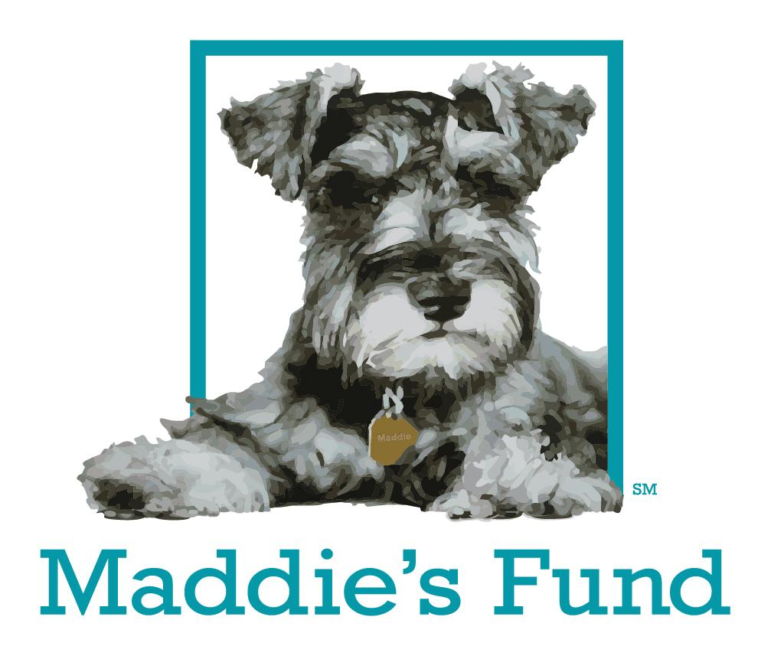

The Foster Caregiver Marketing Guide:
Getting Pets Adopted Directly from Foster Homes

Table of Contents

Marketing Your Foster Pet 4
Lifesaving Marketing 4
Your Tasks 5
How it Works 6
4 Guidelines 7
The Building Blocks 8
Your Foster Email Account 8
A Gripping First Sentence 8
A Great Title 8
A Good Biography 9
Bio Example: Painting a Picture 10
Bio Example: Telling a Story 10
Bio Example: The Gut-Puncher 11
Stories 12
Photographs 13
Always Have Your Camera Handy 13
Take Multiple Photos 13
Take Photos With People and/or Other Animals 14
Take Photos of Dogs Outdoors 14
Make Sure the Pet Is Looking Into the Camera 15
Use Photos to Showcase Personality 15
Videos 16
Make Your Video 60 Seconds or Less 16
Create a Flyer 16
Memes 16
I Can Haz Adopter? Creating Memes for Shelter and Rescue Animals 17
The Animal’s Personality 18
Meme Photographs 19
Other Types of Graphics 20
Volunteer- and Foster-Created Social Media Pages 20
Steps to Marketing Your Foster Pet 21
Step 1: Gather Your Team 21
Step 2: Market, Market, Market! 21
Step 3: Diversify Your Platforms 21
Social Media Sites to Try: 22
Step 4: Connect With the Community 25
Field Trips 25
Attend Adoption Events 26
Word of Mouth 26
Step 5: Try ALL the things! 26
Marketing vs. Adoption Counseling 28
Marketing is Not Adoption Counseling: Keep ‘em Separate, Save More Lives 28
Removing Stop Signs: Fine-Tuning Your Marketing 34
Removing Stop Signs: Adoption Counseling 35
Teamwork for the Win! 37
Appendix A: Resources 42
Marketing Shelter Pets 42
Photography, Videography and Writing 42
Volunteer-Driven Marketing 43
Boosting Your Marketing Efforts 43
Appendix B: Shelter Pet Marketing Checklist 44

Marketing Your Foster Pet
Shelters have traditionally looked at pets residing in foster homes differently than those inside their kennels. Because pets in foster care are usually not at risk of euthanasia for space, time or behaviors related to kennel stress, once a shelter pet is placed into foster care, they’re generally considered “safe." In the past, shelters have reserved their heavy adoption marketing for the pets in their kennels, while the pets in foster care were placed on the back burner or not marketed at all.

As a result, foster pets sometimes lived in homes for months or even years, with no real plan for their adoption. For foster caregivers, this could be frustrating and difficult. For shelters, this meant their foster capacity was used up by these long-stay pets, leaving nowhere to place new pets in need of foster care.

While there’s been a revolution in pet foster care in recent years, this unfortunate situation does still occur. Regardless of how much effort a shelter puts into marketing its foster pets, however, there’s someone who can make sure that pet is seen, heard and interacted with my a whole community full of potential adopters: You, the foster caregiver!

In this guide, we’ll show you how you can be your foster pets’ best advocate, marketing them to a wider range of potential adopters so they can find a great match as quickly as possible – and you can open your home to another pet in need of your care!

Lifesaving Marketing

Our approach is known as “lifesaving marketing.” Compared to traditional marketing, lifesaving marketing is more inclusive, more dynamic and easier on shelter staff! Take a look at some of the differences between the two:

Traditional Marketing | Lifesaving Marketing
- Following the “rules”  - Pet marketing via biography  - Stop signs in text:  - “NO CATS”  - “Must be the only dog”  - “Needs a home with no children  under 12”  - General animal care social media posts, funny pet videos, foods to avoid at Thanksgiving, etc., with no specific tie-in to the organization’s mission of adoption  - All social media and other communications created by shelter staff | - Thoughtful rule-breaking  - Highlighting a specific pet’s adorable quirk, or a story about an interaction with other dogs or people  - Biographies are also used, but not exclusively  - Leave the adoption counseling to the pet’s foster and adoption counselors  - Community-creating language: you, us, we  - Use only messages that are fun and engaging and at the same time relevant to your mission  - Volunteer- and foster-driven messaging for innovative content

When you’re marketing a pet for adoption, your ultimate goal is to find an adopter. You do this by making the pet a local celebrity. There are several reasons for this approach. When a pet becomes a household name, it’s more likely that their family will find them via word of mouth. The more people who get to know your foster pet, whether it be through photographs, video or stories, the better the chances they will become engaged in helping that pet find a home. When shelter pets become local celebrities, it also gets people talking about your shelter and the plight of long-stay pets in general.

With any adoptable pet marketing, your most basic goal is to create an emotional connection between your supporters and the featured pet. Emotional connections are what drive us to act (sharing a post, advocating for a pet, adopting, etc.).
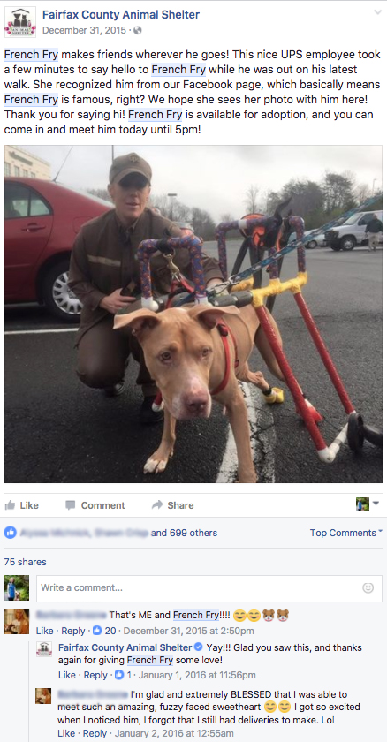

Your Tasks

1. Find an adopter for the pet
2. Make the pet a local celebrity
3. Create an emotional connection
between the pet and your
supporters

How it Works

Ghost, a young, energetic dog that the Fairfax County Animal Shelter who had been transferred in from another county, had a very hard time in the shelter. She was deaf, and her high energy level combined with that communication challenge made it hard for volunteers to work with her.
At many shelters, a dog like Ghost could have waited for years for an adopter, or been euthanized when kennel stress made it nearly impossible to work with her in the shelter. Instead, the shelter put her into foster care to lower her stress. Then they marketed her heavily, utilizing content created by volunteers and fosters. Her adoptive mom followed her from Day 1, developing an emotional connection with her along the way, leading to her adoption!

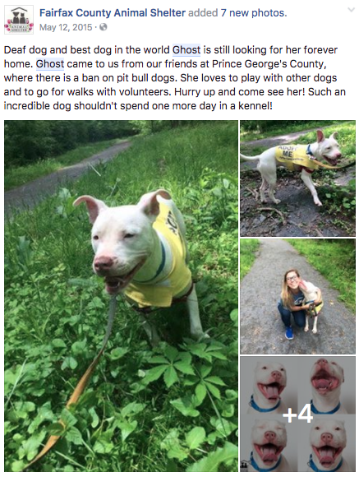
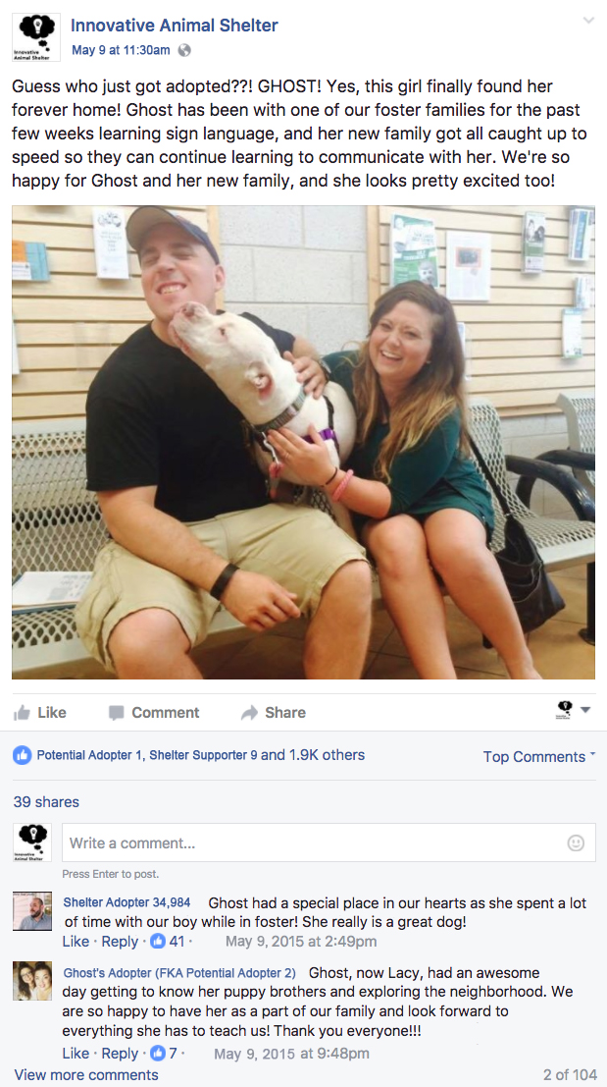
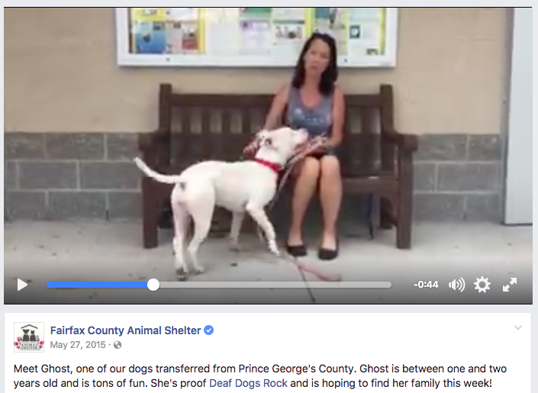
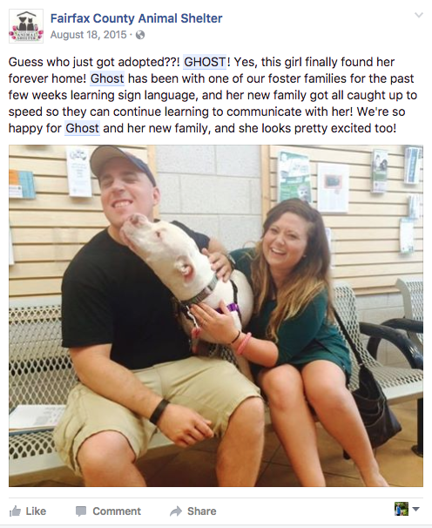
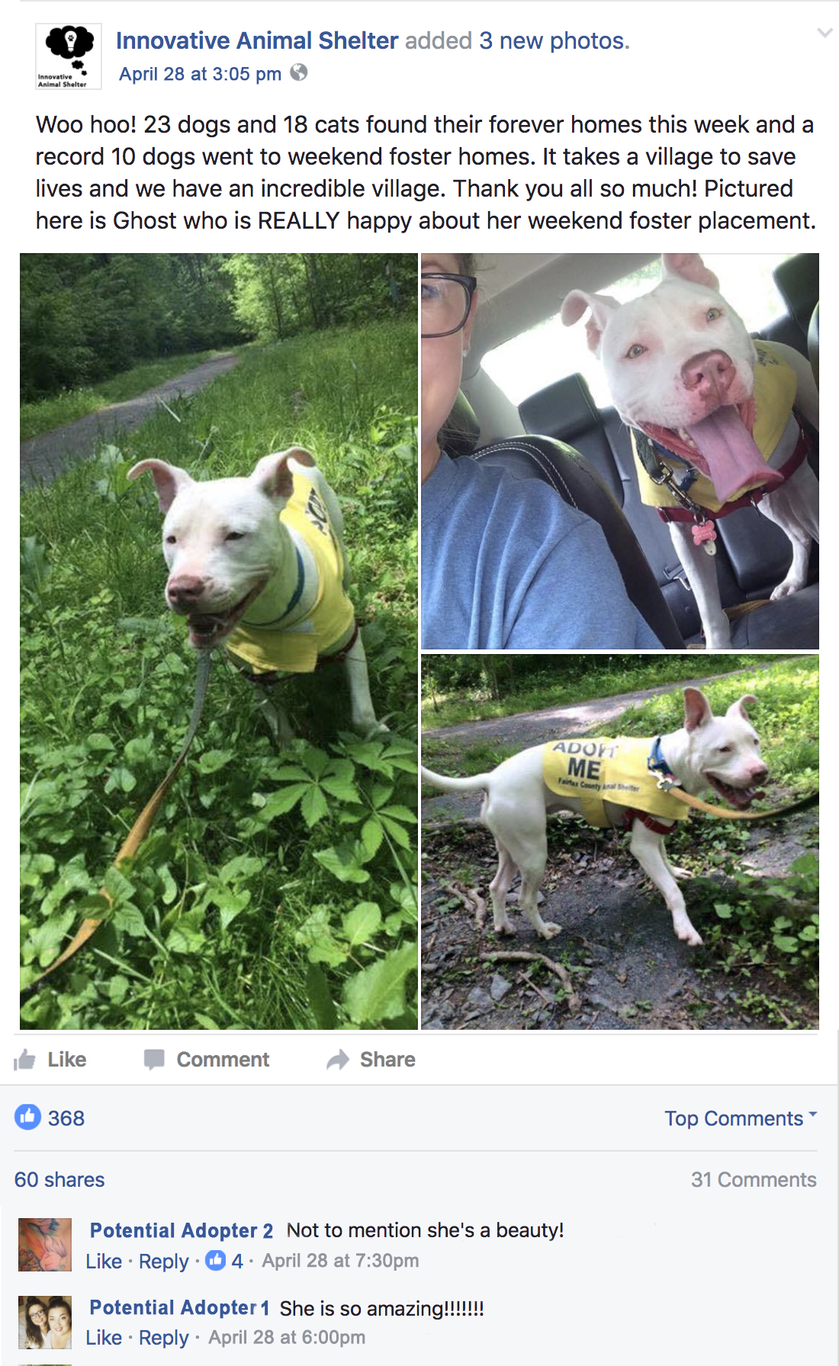

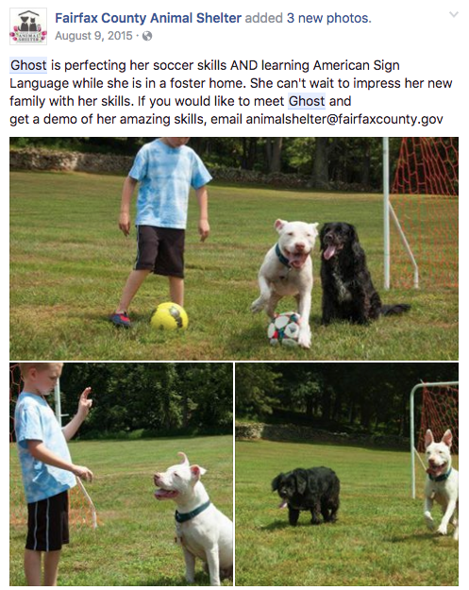

4 Guidelines

- Don’t use “STOP language.” “Stop language” is essentially a disclaimer (e.g., “not potty trained”, “chews furniture”, etc.). This type of information is for adoption counseling, not marketing. Even – and especially! – if your dog has behavioral challenges, you’ll need to cast the widest net possible then whittle away at inquiries until you find the right match! Full disclosure should be provided in the adoption counseling process. See the section “Marketing is Not Adoption Counseling” for more information on this.
- Be accessible. The more accessible you are, the more likely a potential adopter is to remain engaged. Ease when scheduling meetings and quick responses keep people engaged with your dog

As a general rule, the faster you plop a foster down in front of a potential adopter, the better. People are often not willing to work much for an animal they haven’t met, so it may fall to you to bridge the gap when you get a lead. Once a potential adopter meets your foster in person, an emotional connection is usually made, enabling the relationship to grow on its own.

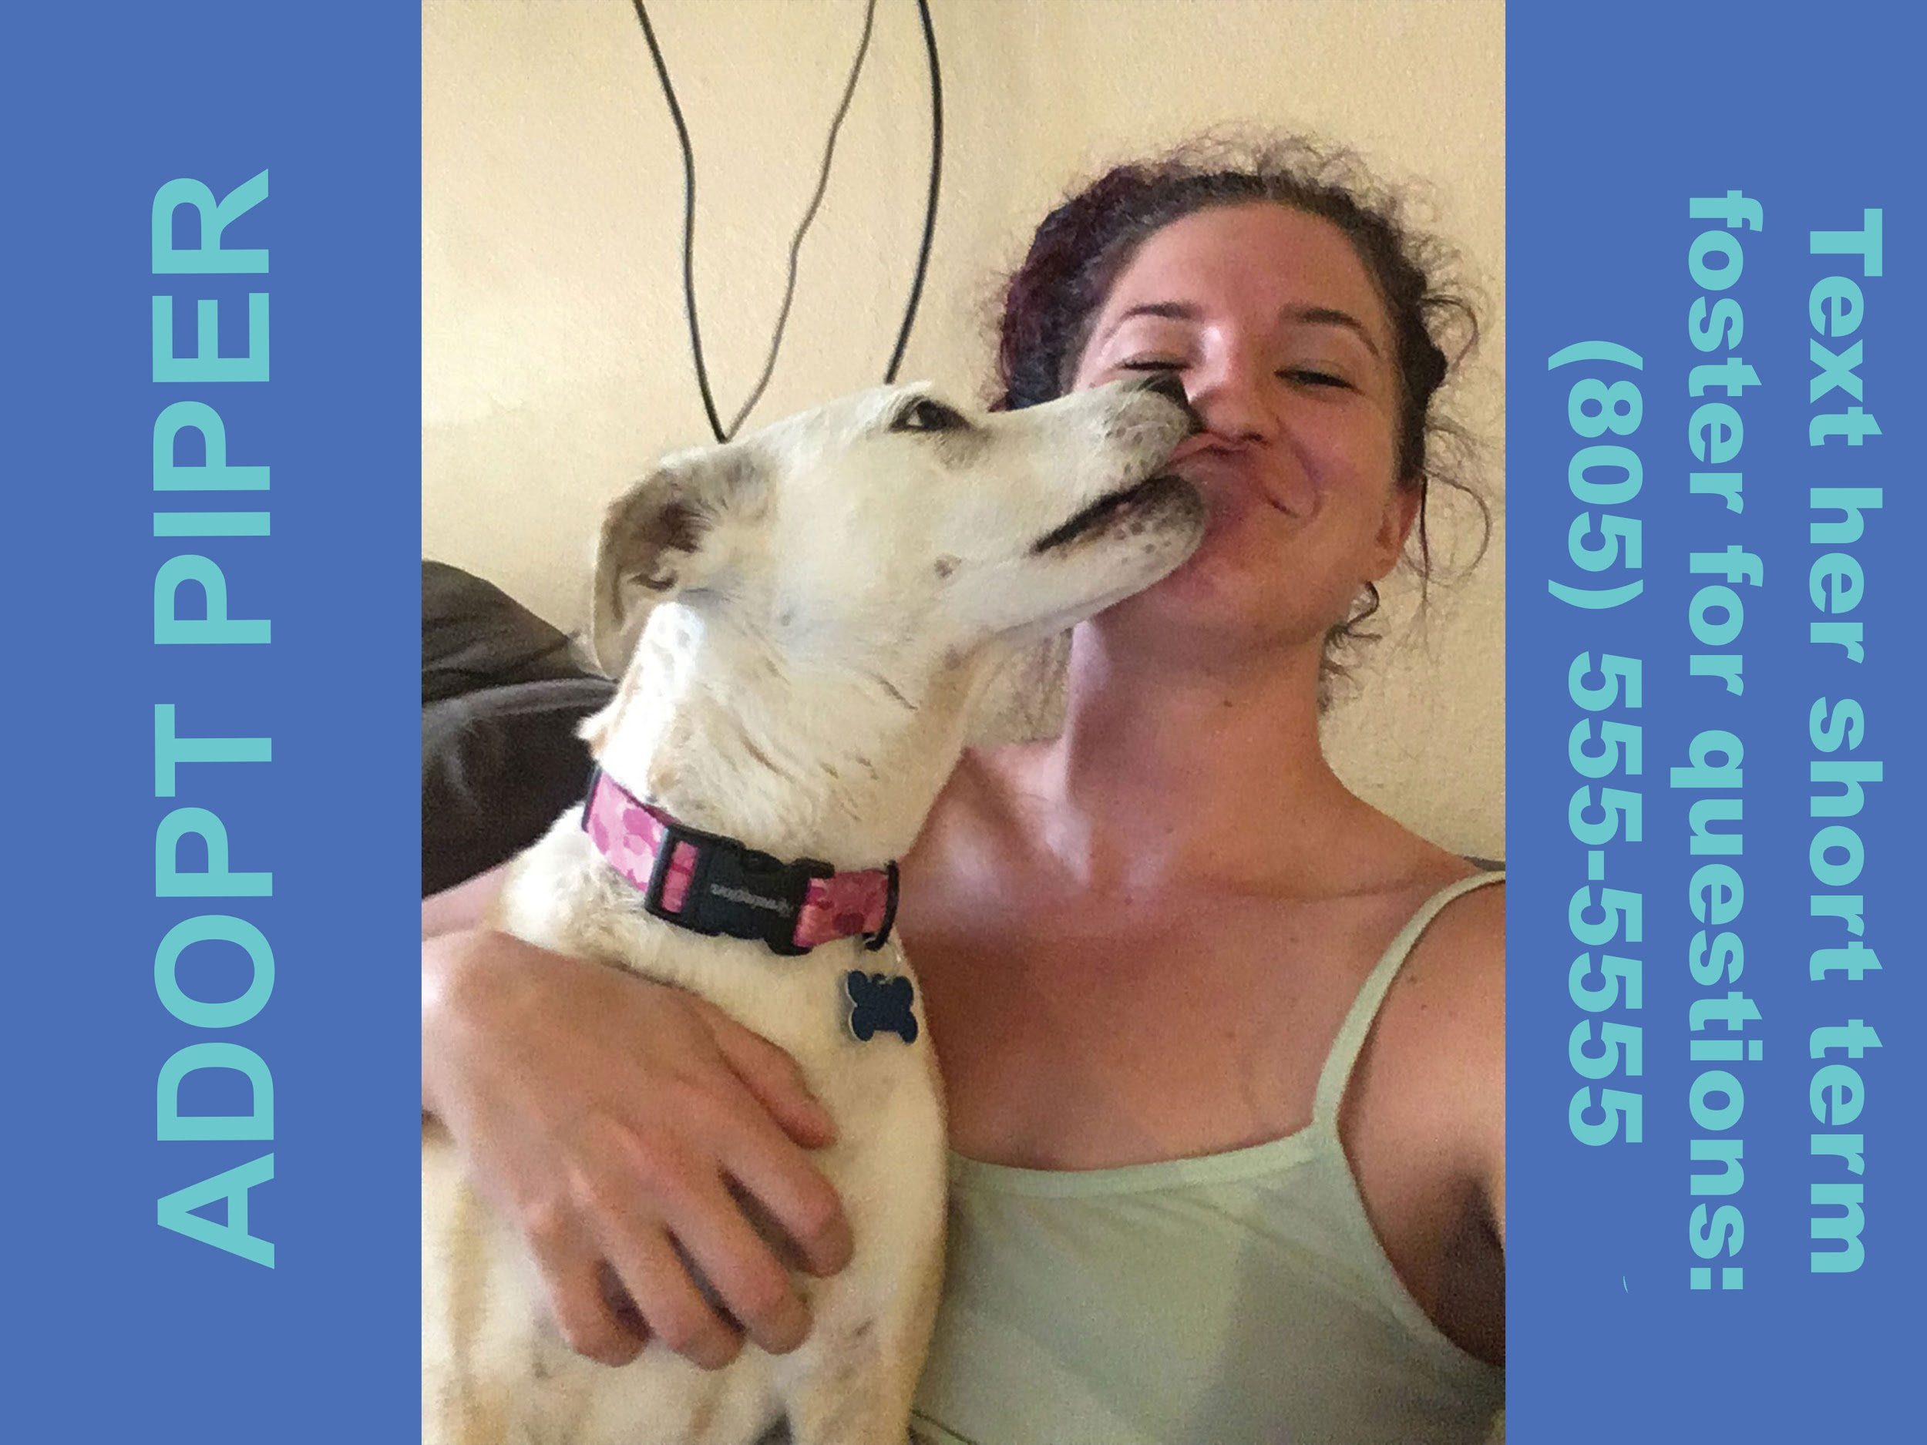
Piper’s kennel card and shelter profile pic
- Be creative. Don’t be afraid to try new things! You may strike gold. On a whim, one foster emailed a rescue pup’s story to a local news station and he got his own feature!
- Be everywhere. Post every place that will let you. The more sites, digital and physical, that display your foster’s face, the closer you are to the right match. The content does need to be engaging, but the phrase “out of sight, out of mind” applies here.

The Building Blocks
There are an infinite number of ways to market your foster pet. Biographies are important, but think outside the box when you create your other marketing tools. Other things you might consider featuring are the cute quirks the pet has, stories about things they did, the pet’s behavior in the home or skills they have learned. Think about the ways your foster pet reveals who they really are. And those things they do that you find absolutely adorable? Chances are, potential adopters will, too!

In this section, we’ll list and explain how you can create the many things that go into marketing a shelter pet.
These are:

- Your foster email account
- A gripping first sentence
- A great title
- A good biography
- Photographs
- Video
- The flyer
- Memes
- Other types of graphics

Your Foster Email Account
Since you’ll be doing a lot of marketing yourself, a smart way to be available to potential adopters without giving away personal information is to create a dedicated foster email account. Instead of using your name in the address, you could name the account something foster-related. You can use this account for all adoption inquiries, put it on flyers and in social media posts, etc. If you create the email on Gmail, you can also use its Google drive to save all of your marketing creations!

A Gripping First Sentence
Similar to a title, the first sentence of your text is crucial. This is what the reader will use to determine whether to keep reading. What you’re looking for is text that will make an emotional connection with the supporters and make them want to find out more about your foster pet.

DON’T | DO
- Meet Fido!​  - My name is Kitty!​  - Rover is our Pet of the Day.​  - We don’t know why Coco hasn’t been adopted yet! | - Who’s the squishiest, cutest dog on the block? Roscoe!​  - Balloon-bouncing, swing-pushing, life-loving Coco is our longest-term doggie resident.​  - In a foster home full of brothers, what’s a girl to do? Take the lead, of course!

A Great Title
Posts on certain sites (Craigslist, Imgur, etc.) may necessitate a title. A title that is exciting and different will set your post apart and increase your chances of further investigation by potential adopters.

DO - Use a title as an opportunity to snapshot your dog’s personality or dabble in the dramatic:
- Couch Dogtato Seeking Netflix Buddy
- Meet Sir Harley the Gentleman
- Save Cowboy the Forgotten Senior Dog

DON’T – Go the generic route. Most titles will look like this and most will get passed by:
- My Foster Needs A Home
- Adopt Cowboy
- Pit Bull Available for Adoption

A Good Biography
Most shelters list their adoptable pets online, and for this every pet needs a biography (bio). As the foster, you are the person who most likely knows the pet the best, and are uniquely suited to writing or updating their biography. If your shelter or rescue doesn’t have a system in place for you to update your foster’s profile, ask your foster coordinator if they’d be willing to do the updating if you send in a bio. Photos in a home and an updated biography paired with contact information are a recipe for success.

Write a short and sweet summary that includes some information on your foster pet’s behavior, likes and dislikes, and the best things about them – kind of like an author’s biography at the end of a book. Leave out negative details (Stop Signs) such as “no other pets,” “needs training,” etc., as these can deter even the perfect potential adopters and are best discussed one-on-one during adoption counseling (see heading, Marketing vs. Adoption Counseling). As in all adoption marketing, our most basic aim is to create a positive emotional connection with the reader.

There are several different ways bios can be written. The traditional method is to paint a picture of your foster pet that gives potential adopters a rounded view. Another method is to tell a story about them in order for potential adopters to get deep insight into one aspect of their personality. In general, try to stay positive in your writing, but the gut-puncher may be a method to try in certain cases such as your longest-term resident or hardest-to-adopt pet.

Bio Example: Painting a Picture
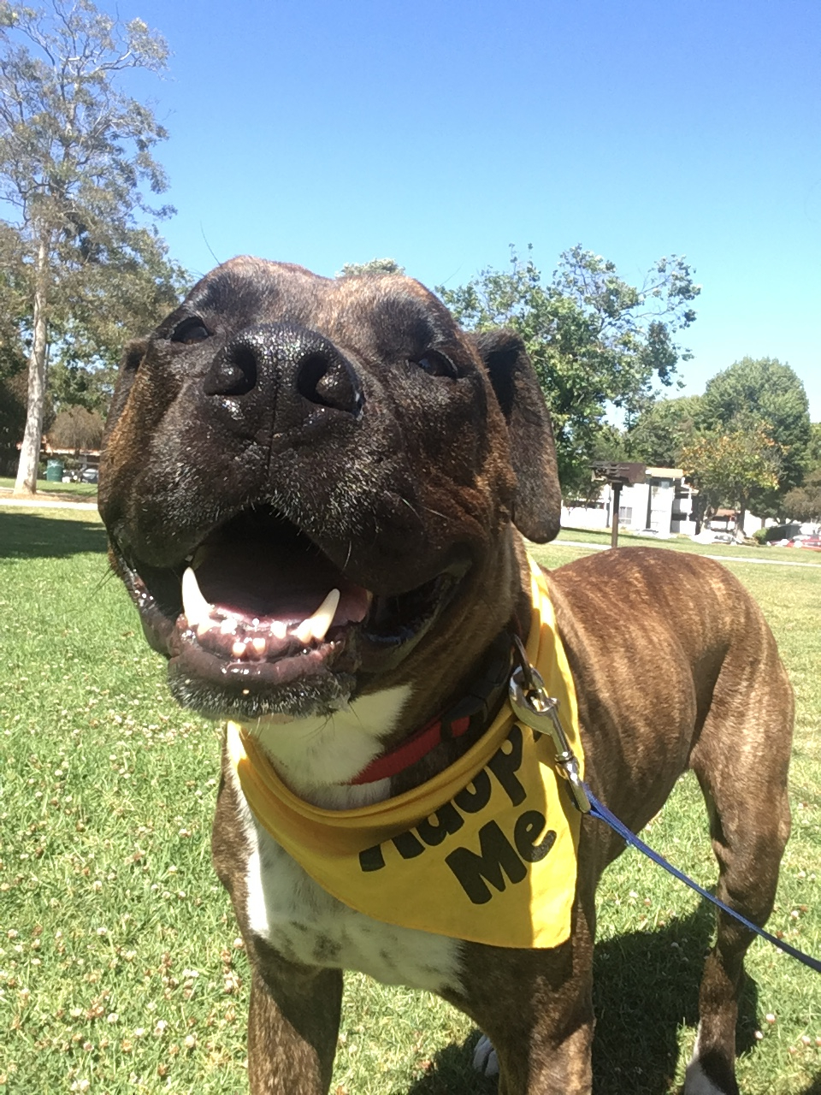
After some time with Harley in foster he has made it abundantly clear that he is a gentleman, and as such, will henceforth be known as Sir Harley.
HOW WE KNOW SIR HARLEY IS A GENTLEMAN:
Sir Harley has manners. We were worried he had an infection when he didn’t pee his first 24 hours with us. As it turns out, he simply prefers not to urinate in the presence of a lady. We also learned he has a bladder of steel.
Sir Harley is grateful. He is so expressive in his gratitude; in fact, he has an injury called “happy tail.” Breakfast? GRATEFUL. Pets? GRATEFUL. Walkies? GRATEFUL. Nap time? GRATEFUL. Eye contact? GRATEFUL. (In Harley’s everlasting gratitude, his happy tail was unable to heal so Shadow’s Fund addressed it. Harley now displays his gratitude with a happy wiggle butt.)
Sir Harley makes everyone feel welcome. As a one-dog welcoming committee, there is no door greeter as wiggly as Sir Harley. If retail stores had Sir Harley mascots, the American economy would be repaired in a matter of days.
Sir Harley does not beg. He understands that "no means no" and he will not push the issue on that pint of Ben ‘N Jerry's. Bonus: He won't shame you for eating it all in one sitting either. He knows you are beautiful at any size.
Sir Harley rolls with the flow. You wanna sleep all day? So does he. You wanna party outside? So does he. You wanna have an existential crisis because life is an illusion? Sir Harley knows you will calm down if you rub his belly, and he will offer it to you gladly.
Sir Harley will make some man or woman very lucky when they welcome this class act gentle giant into their home. #adoptsirharley

Bio Example: Telling a Story
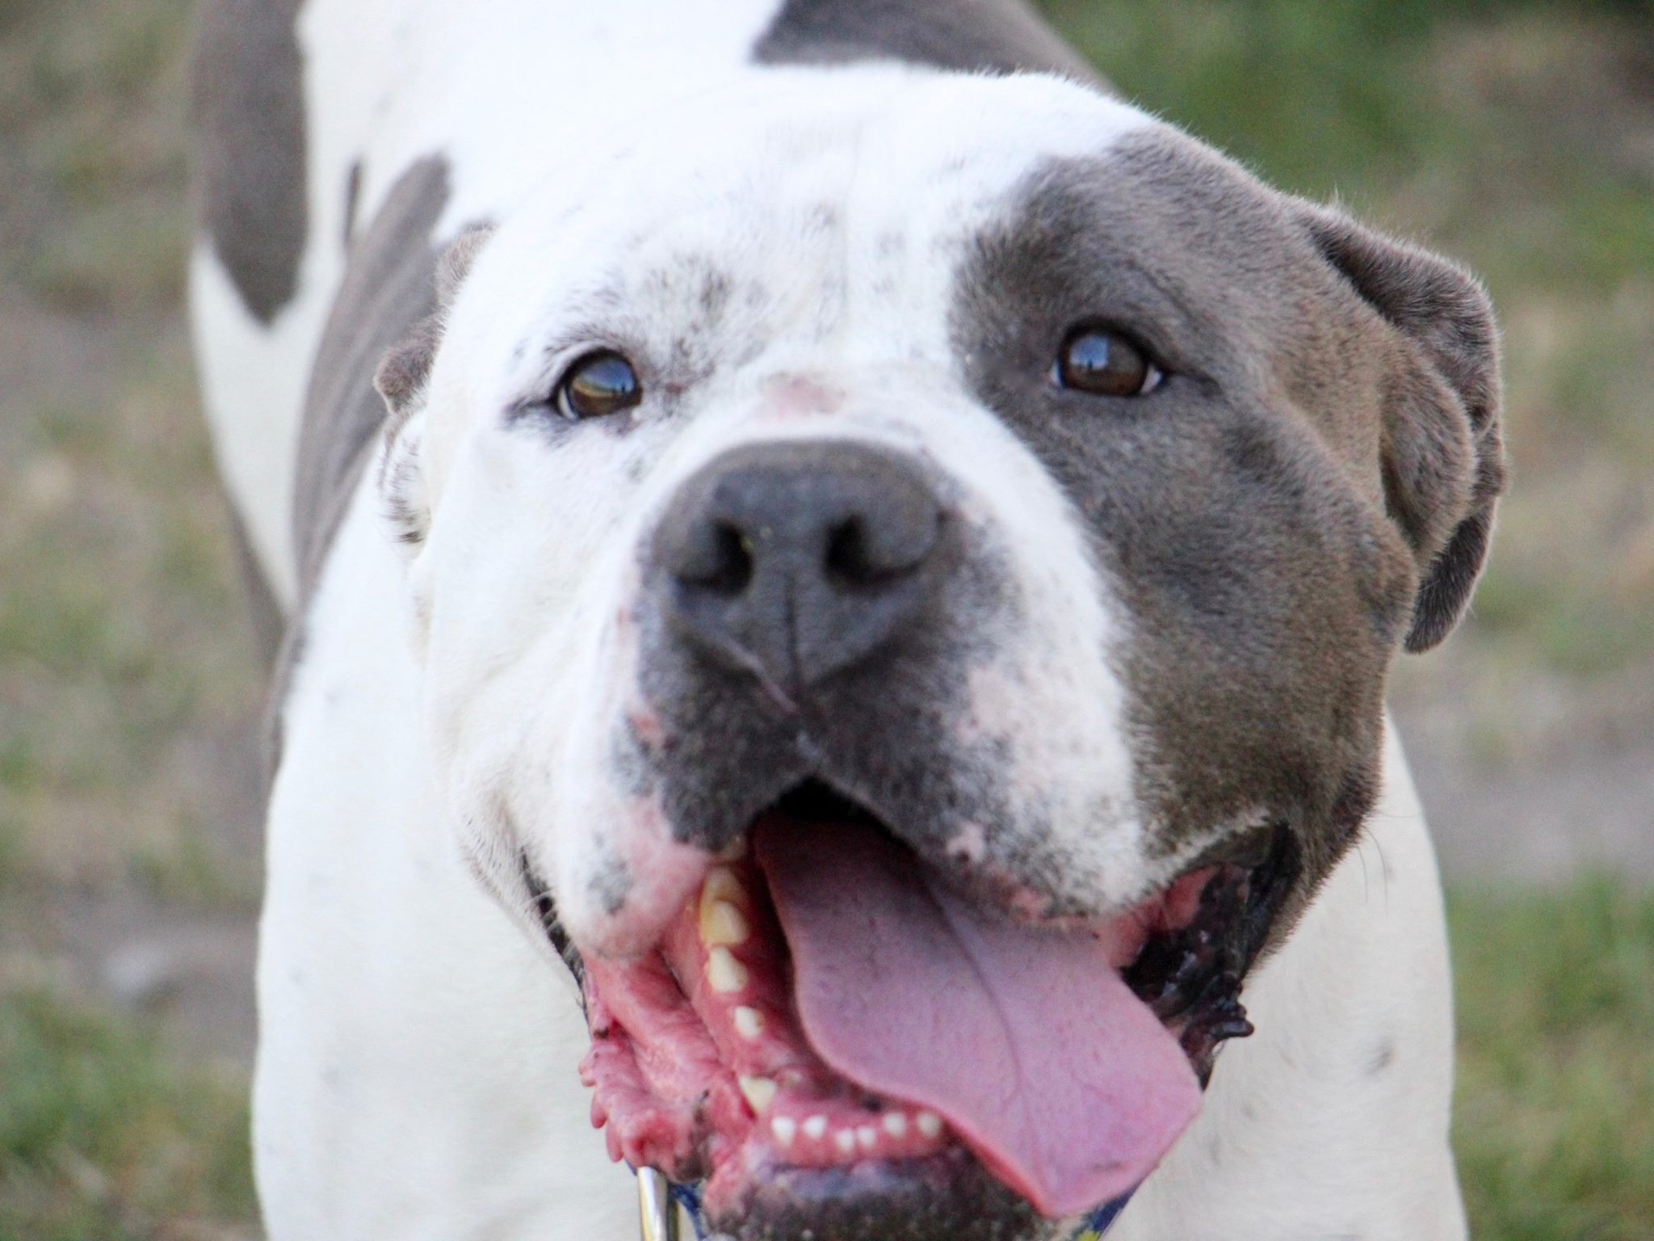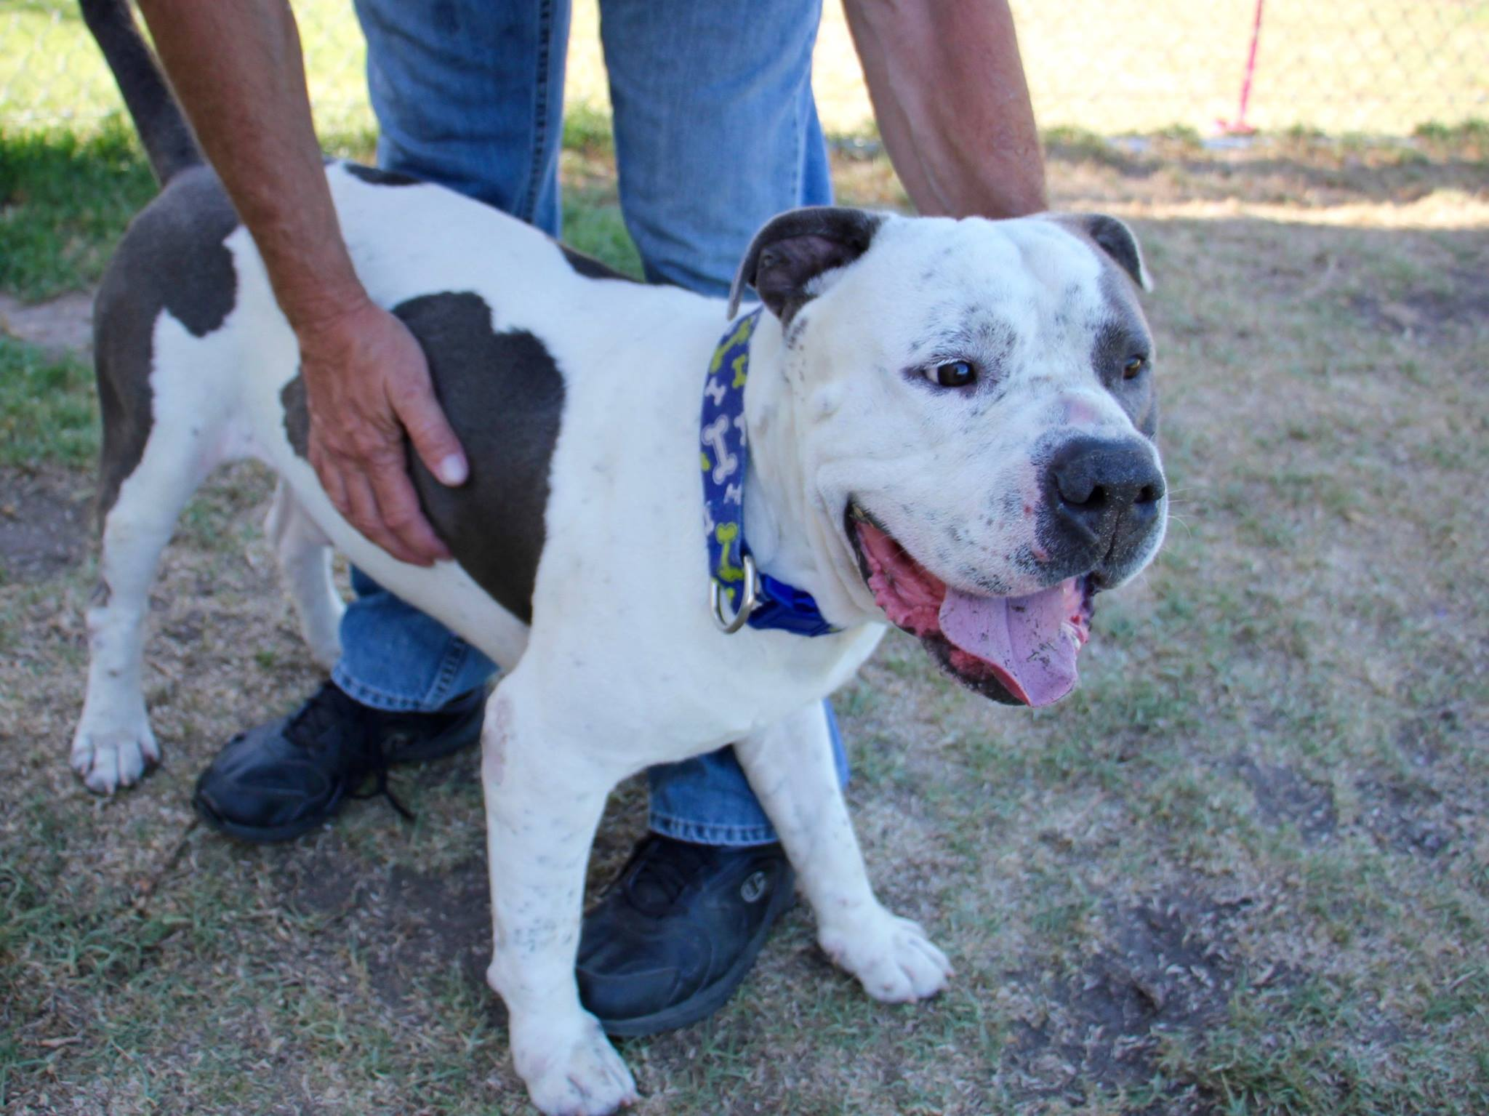

This is Snoopy but you can call him Velcro Lite, Splooter (his sploots are unparalleled. Truly.) or Snoop Dogg (but that’s kind of a given).

I brought Snoopy home for an overnight foster and he instantly took to my boyfriend and me like a baby takes to his parents. His primary objective all day and night was to please, and he did. You could call him from any room in the house and he’d come running with that giant smile on that mammoth head of his to sit at your feet and look up at you so adoringly you couldn’t help but feel guilty for being loved this much.

Snoopy is the rare dog who wants to be by your side always, but also has a natural understanding of personal space. If you’re on the couch, he is gonna climb right up on there and sploot (lay with his legs back, like a frog) next to you - close enough for the scritches, but not so close that you’re strapped in for a 12-hour Netflix marathon.
His two states of being are "overjoyed" and “asleep,” and that goofy smile will follow him into both. He is a natural couch potato but is versatile in his ability to go from “sploot” to 60 and back again depending on what it is you wanna do.

Though people keep letting him down, Snoopy holds onto his spirit with a big, heart-melting grin. This boy loves with his whole body and the person who welcomes him into their family will have a lifelong best friend.

Bio Example: The Gut-Puncher
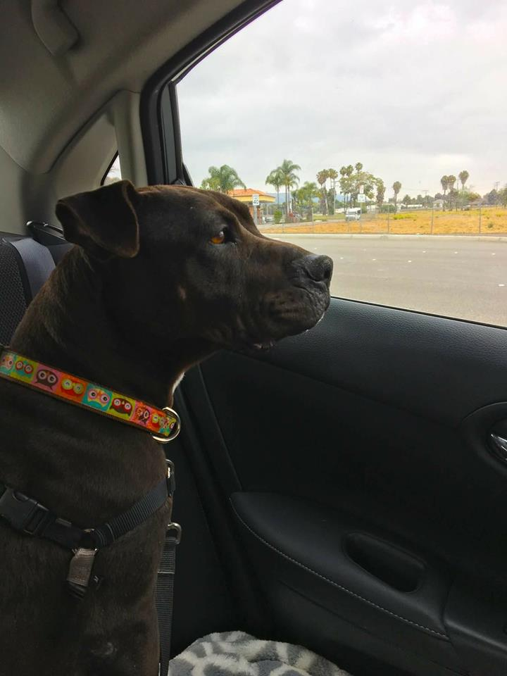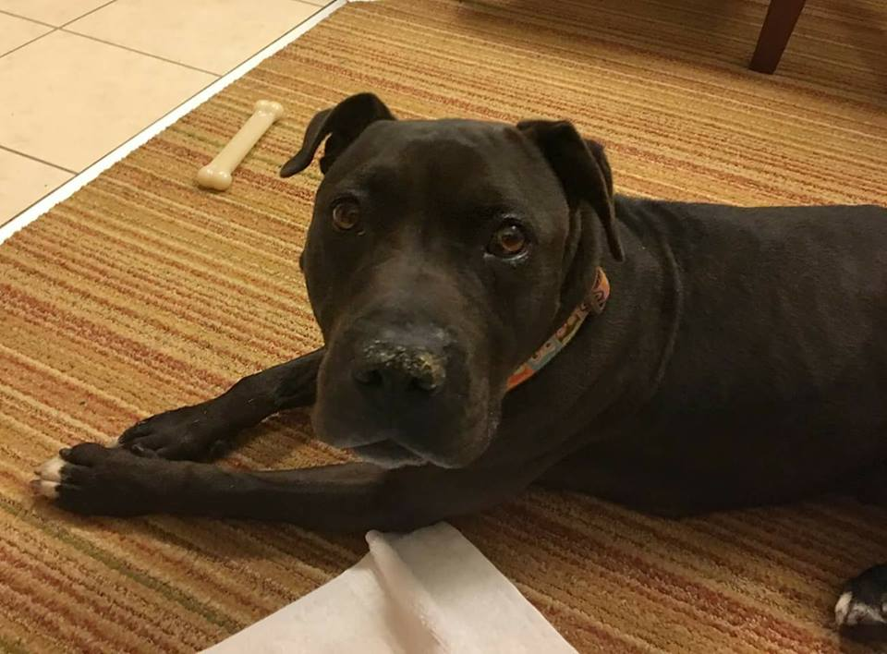
In the shelter, Ruby can appear stoic due to her shyness and fear; this may be a reason she’s been overlooked for so long. I hope someone takes a chance on her, because they will be greatly rewarded. My prediction: once someone earns her trust, Ruby will love them so completely that it will surprise them both.
On our overnight, I saw sure signs of her emerging trust in so many ways: the way she looked back at me while walking to make sure I was with her; in how, by morning, she was so in tune with me that she needed only for me to quietly say, “this way” when walking to ensure she was turning or stopping right next to me; how, when something frightened her, she would walk closely behind me because she knew I would protect her. Initially, she was afraid to walk down the stairs at the hotel- she stopped, wide-eyed, and after some coaxing she walked down so close to me that she was touching my heels. By the end of the trip she was going up and down the stairs with confidence.
The hardest part of my overnight with Ruby was seeing the stress return when I brought her back to the shelter. The second she heard the dogs barking in their kennels and realized where she was, I could literally see her steeling herself. Like a boxer trying to pump themselves up, she let out a series of huffs, and she began to scan her surroundings for threats. Putting her back in the kennel broke my heart.
Ruby was the perfect overnight guest. She followed directions immediately, was quiet in the room and had no accidents. She ate well, slept right next to me in the bed, and I’m pretty sure she would have slept in if I hadn’t gotten her up early to take a walk and get breakfast. I took her into the breakfast room and though I could tell the smells were tempting her, she didn’t jump up on the counter or pull on the leash. She rode in the car like a dream. Someone is going to think they've won the lottery when they adopt her!

Stories
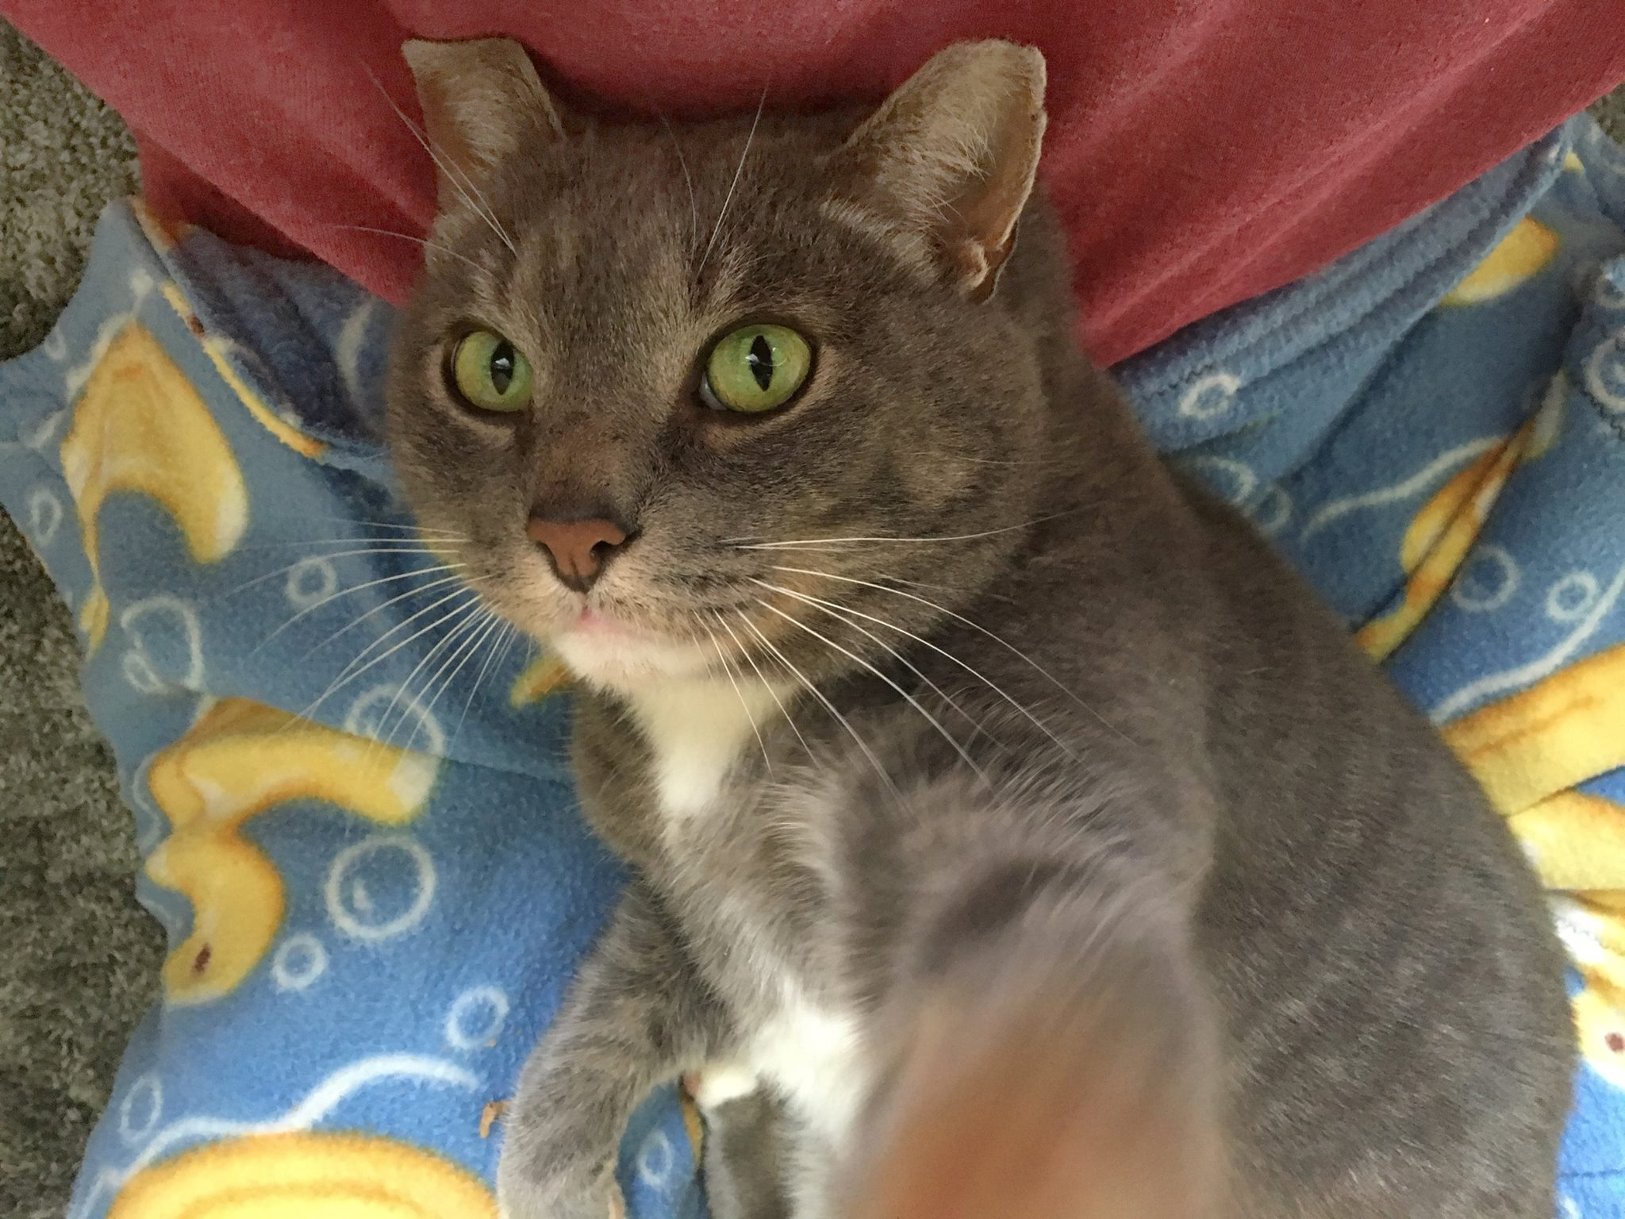
Guy spent the last few months demonstrating for the shelter’s staff what a complete emotional breakdown looks like in a cat who has lived much of his life outside. By all accounts, he was feral. Shelter life was terrifying for him.
When we took him into foster care, both my husband and I expected him to be a challenge. Looking at him the first night, unhappily crouched behind a laundry basket, my husband asked, "Did you ask for the hardest cat in the shelter or something?" We had no idea that less than 30 minutes later, he'd be in my lap, kneading and purring.
He’s gotten comfortable with Lee and I quickly, but I wasn’t sure how he’d do meeting others until last night. We had about 15 people over, so I put our own pets away and left the door to Guy’s room open. I expected him to stay in his room for most of the night, and he surprised me yet again. Guy spent the majority of the evening- at least 2 hours- making the rounds from guest to guest, soliciting attention. He was truly the life of the party, and it was great to see him so confident.
A good story can be an invaluable tool for emotional connection. Stories can bring aspects of a pet’s personality or their history into vivid detail. Qualities that potential adopters might be looking for, such as great social skills with other dogs, intelligence or having an easygoing personality, are often illustrated in any number of small actions that a pet performs every day. When your foster pet does something positive that affects you emotionally, think about how you can write about what happened to illustrate that aspect of their personality. Consider this story from a foster caregiver:

“Violet, a young dog that we fostered, loved to be around my two older dogs. Much like the stereotypical little sister who idolizes her older siblings, she seemed happiest when she had their attention, while being polite when they needed their space. Nothing gave me a better picture of her dog-friendliness than this morning, when I gave them all a treat that they all normally love. Roxy swallowed hers immediately, but for some reason, Violet didn’t want to swallow hers. I realized that Roxy was looking at Violet’s treat with longing- basically begging- and that Violet had picked up on it. I put the treat in Violet’s mouth and thought she had swallowed it. Then Violet slowly leaned over and deposited the treat in between Roxy’s front feet.”

Photographs
A good photo is...
Bright. Clear. Happy.
Photographs can be the key to your foster dog’s adoption. Getting photos that are well-lit, in focus and that give the viewer a window into a pet’s personality can be tricky, but we have some ideas that can make this much easier for you.

Always Have Your Camera Handy
Without a camera handy, you may not be able to capture those intimate moments that will help your pet make an emotional connection, like when your foster cat is finally comfortable enough to rest their head in your lap, or when your own dog and your foster dog curl up together on the couch. Here are some examples:
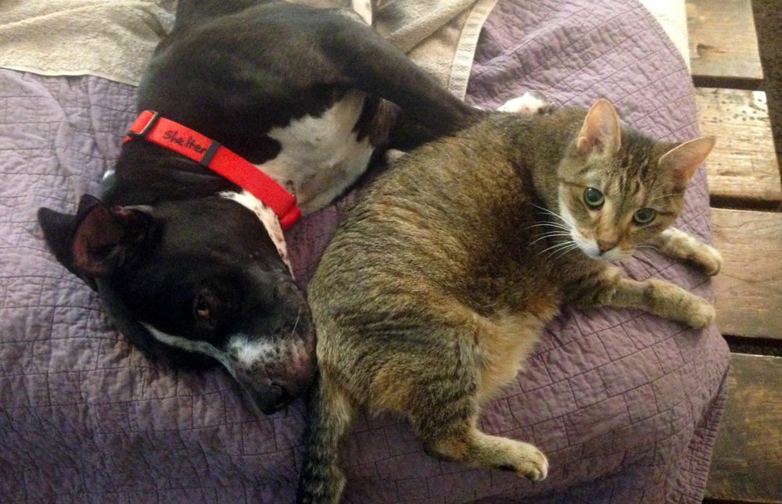

Take Multiple Photos
One foster explains, “I am an awful photographer. This is easily combated by taking one million rapid fire photos at once. Odds are you’ll snap something to work with.” Whether you’re an ace photographer or not, taking multiple photos increases the chances of coming up with something good!

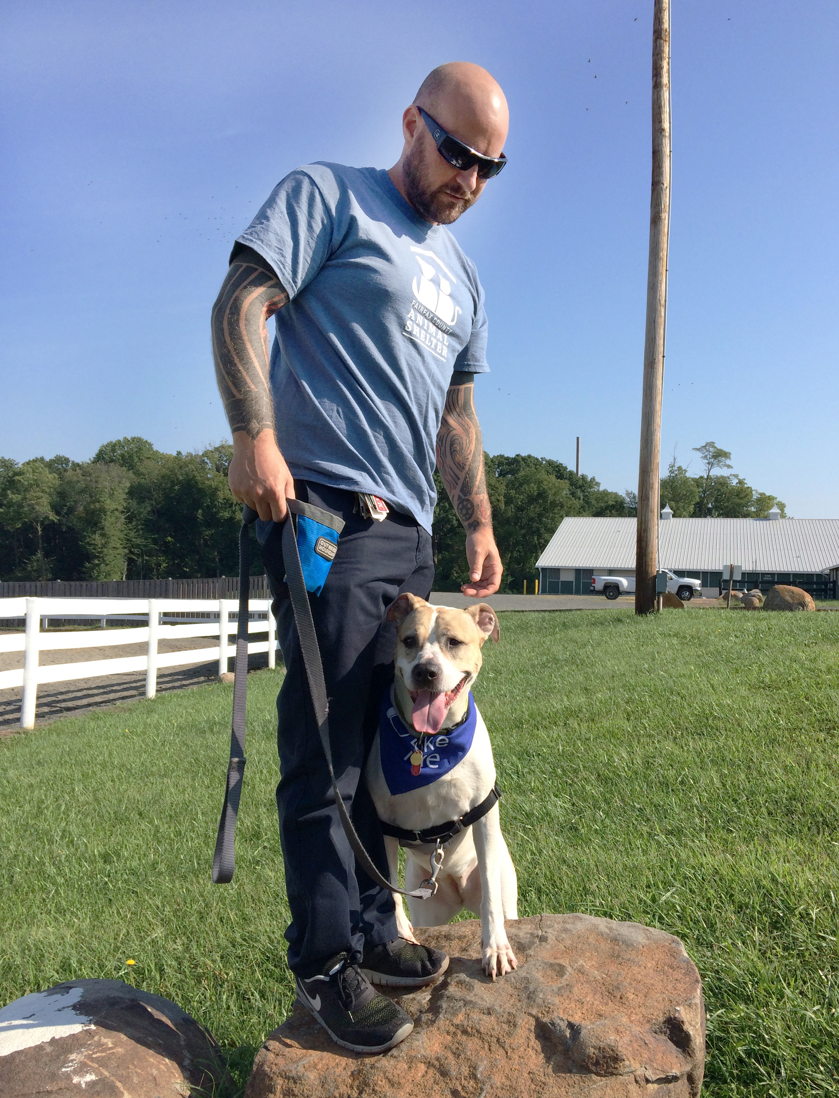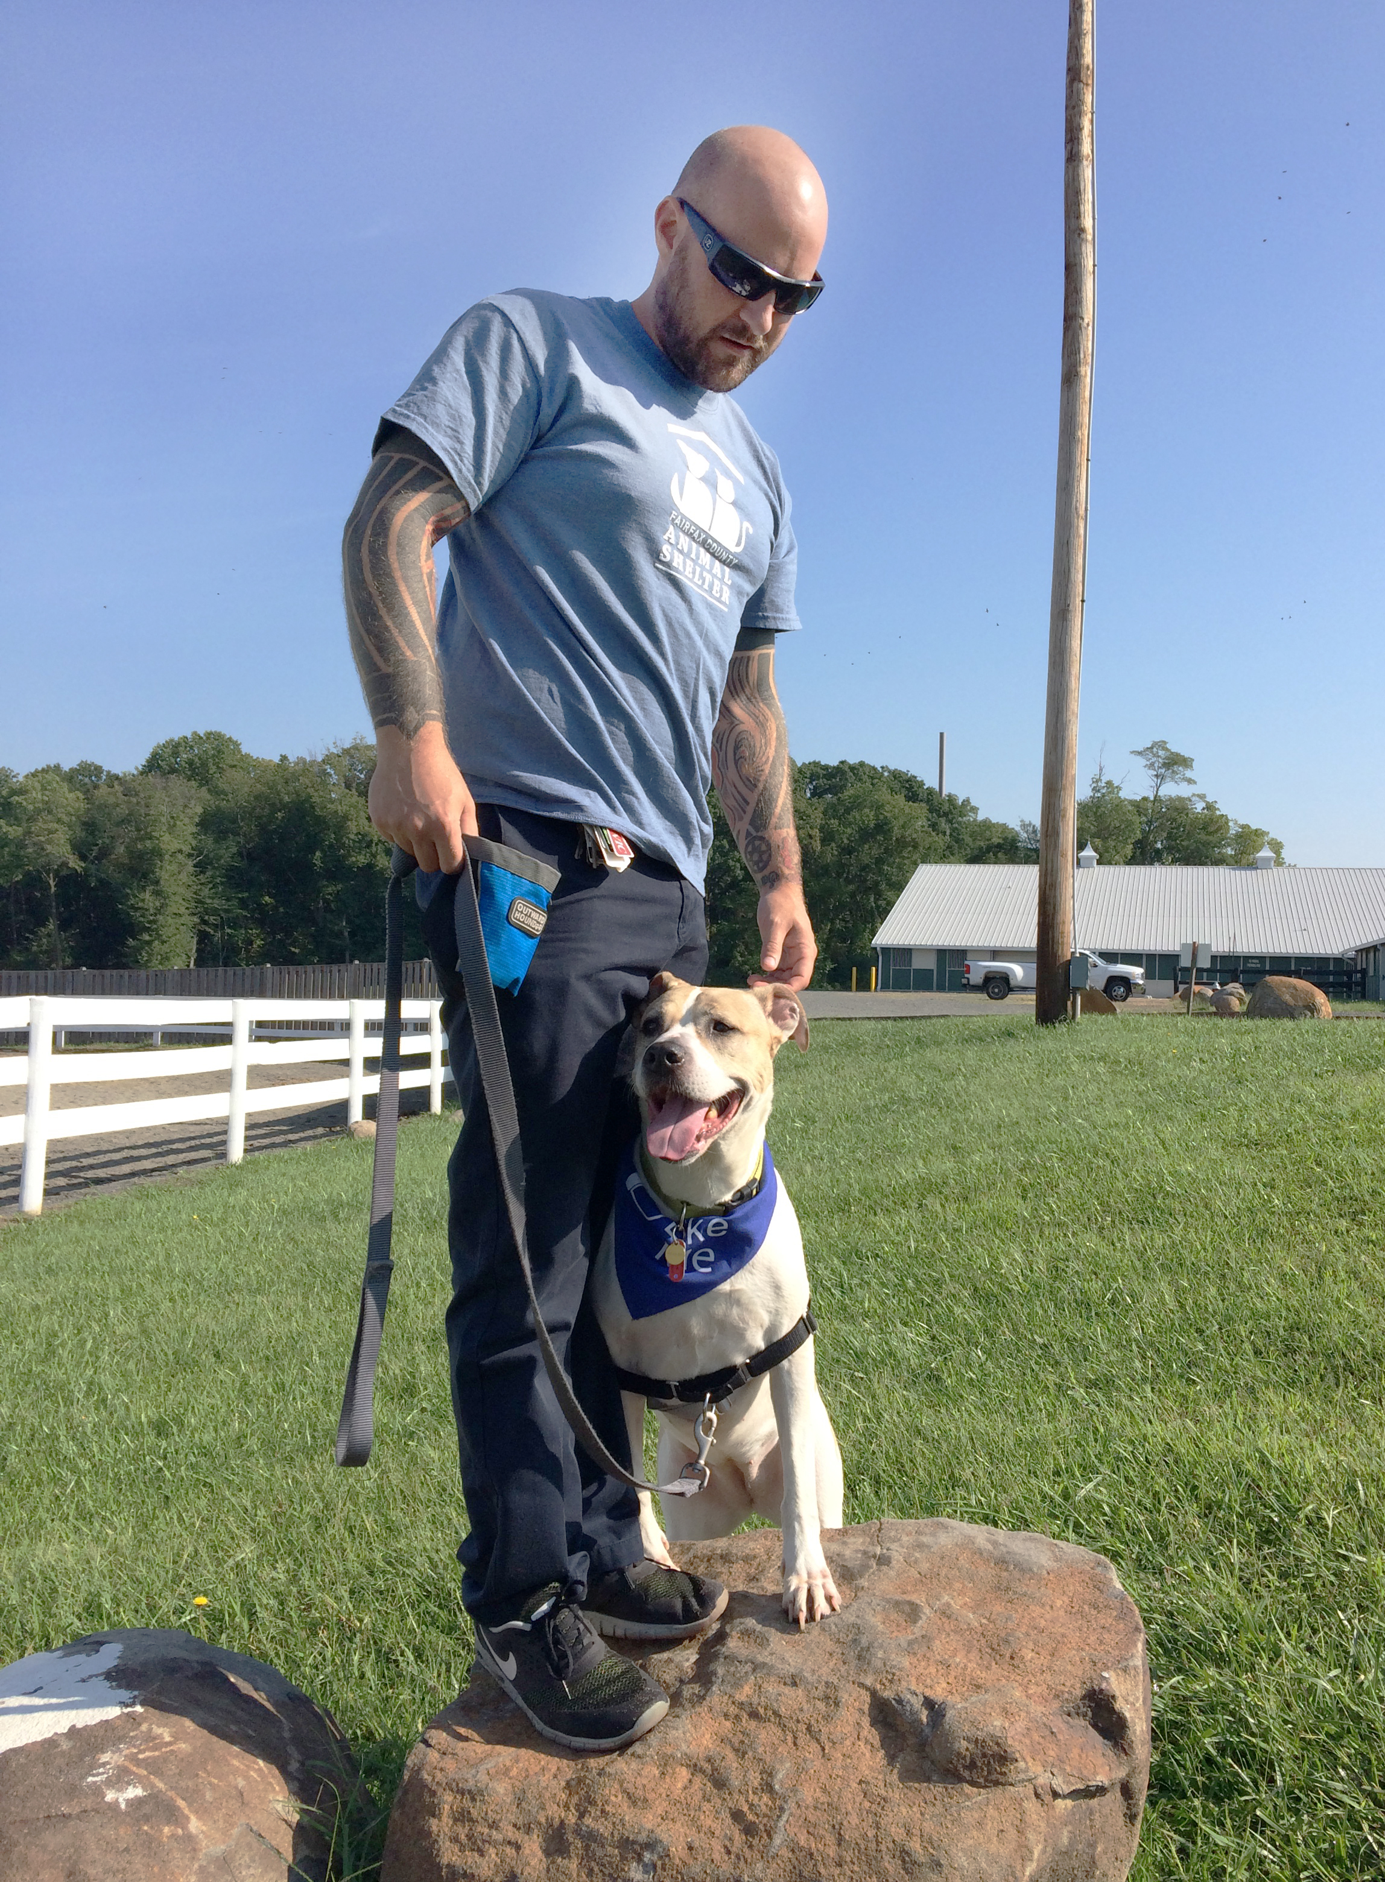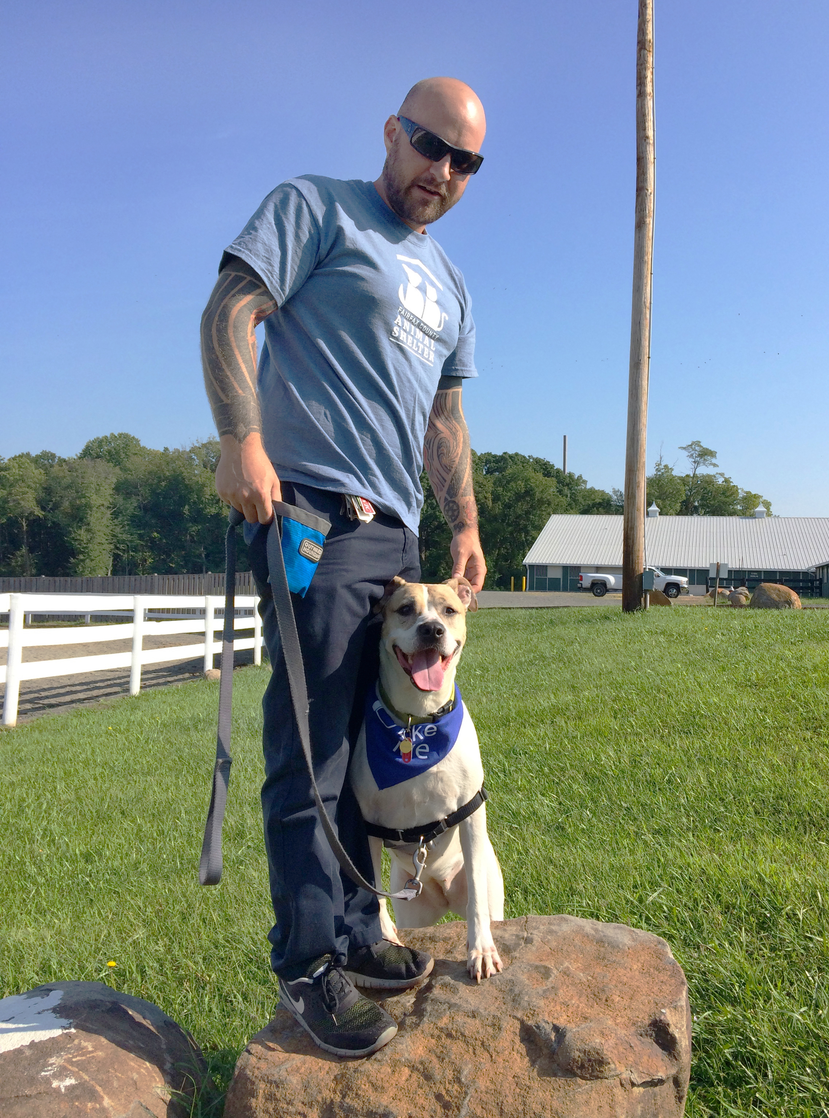
 ☒     ☒        ☑

Take Photos With People and/or Other Animals
Photographs taken with people and/or other animals are great because they not only feature the pet, they give information as well. A photo of two dogs together looking happy tells potential adopters, “This dog is good with (at least some) other dogs.” A photo of a cat and a small child implies that the cat is safe with children. Keep this in mind when creating marketing material for your foster pet.

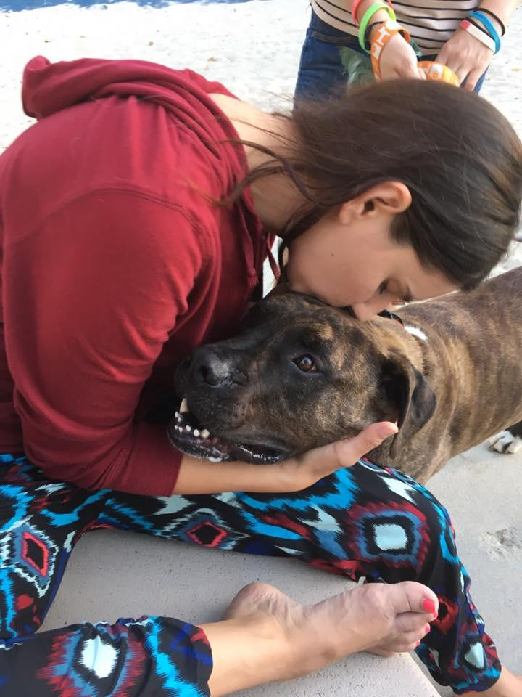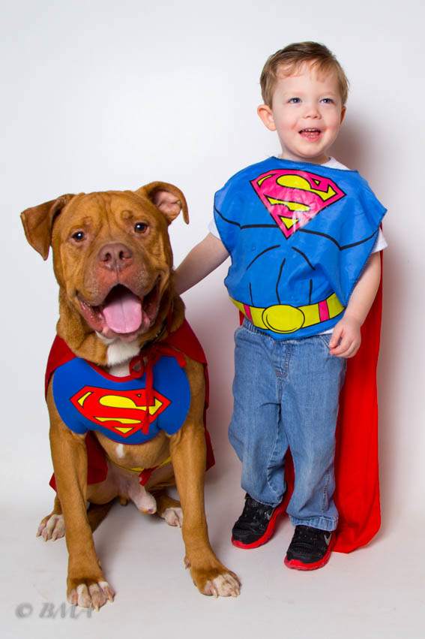

Take Photos of Dogs Outdoors
Studies have shown that photographs of dogs taken outside can help dogs get adopted more quickly. Outside, the options for nice-looking backgrounds are unlimited, and dogs’ stress levels may be lower, enabling you to get better photos.

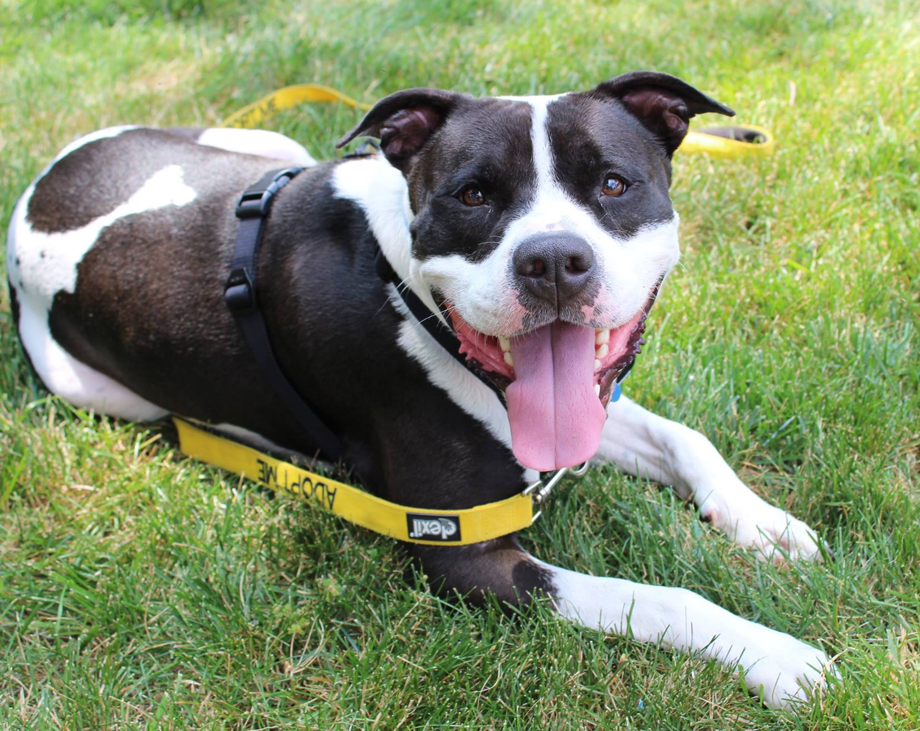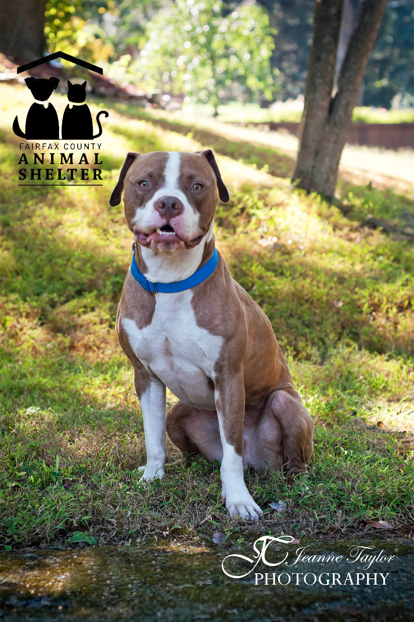

Make Sure the Pet Is Looking Into the Camera
The eyes are the window to the soul, so it follows that eye contact is helpful in establishing an emotional connection, even if it’s just from a photograph.

Use Photos to Showcase Personality
We want potential adopters to get a feel for our foster pets’ personalities, so use photos in a way that does just that. Take photos that capture an aspect of a pet’s personality. When viewed together, one gets a more accurate picture of who they are. For example, from the photos below we might surmise that Louie enjoys care rides and probably outings, isn’t a huge fan of the bathtub but allows himself to be bathed by his human, and is affectionate and friendly.
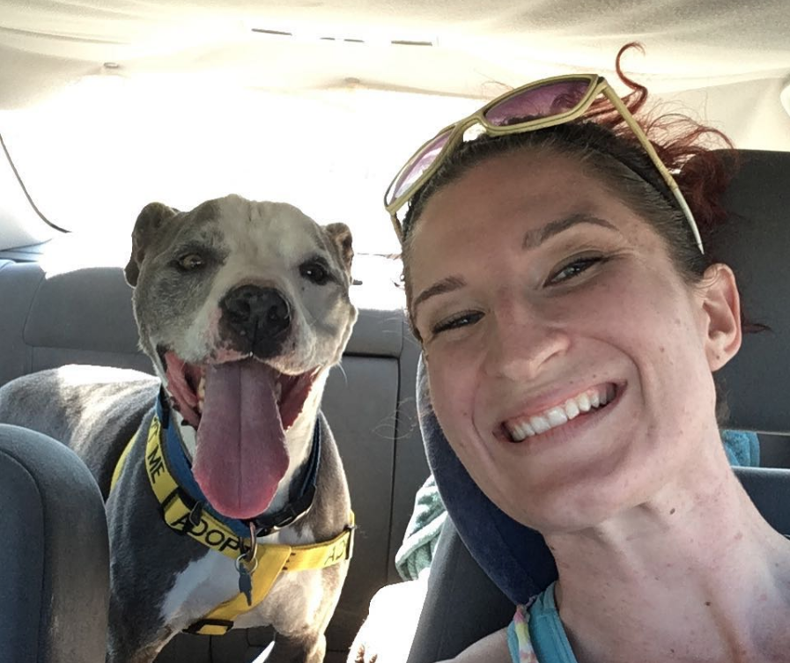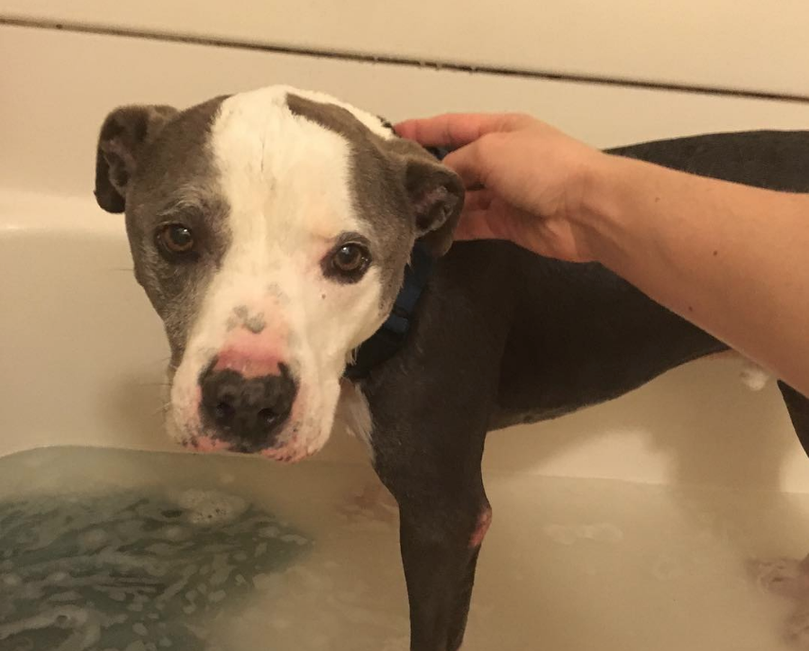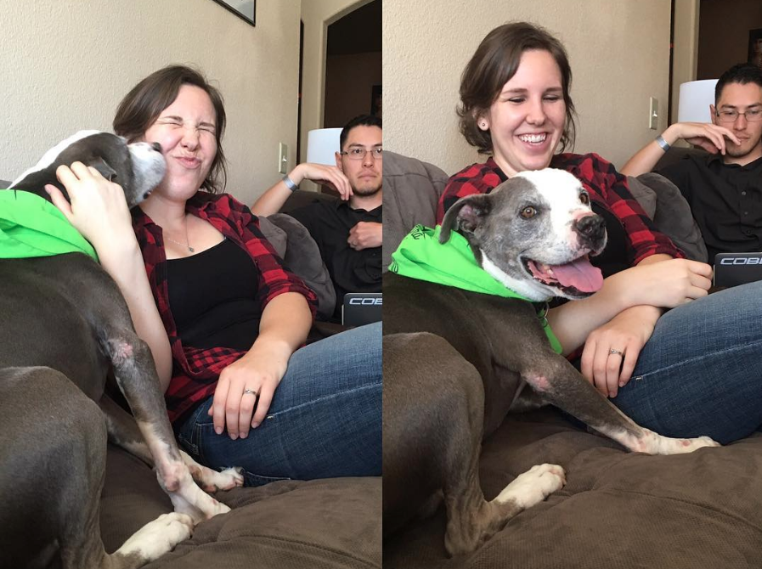

Videos

Great videos can give the best picture of who your foster is. They can offer legitimate proof that you have a very good boy on your hands and cast a spell on potential adopters. Videos have the power to clinch the connection before an official meet-and-greet happens. The following are a few tips for making great videos.

Hold the Camera Horizontally (unless you’re doing Facebook live)
As you can see in the first photo, holding the camera vertically creates wide black lines on either side of the video.
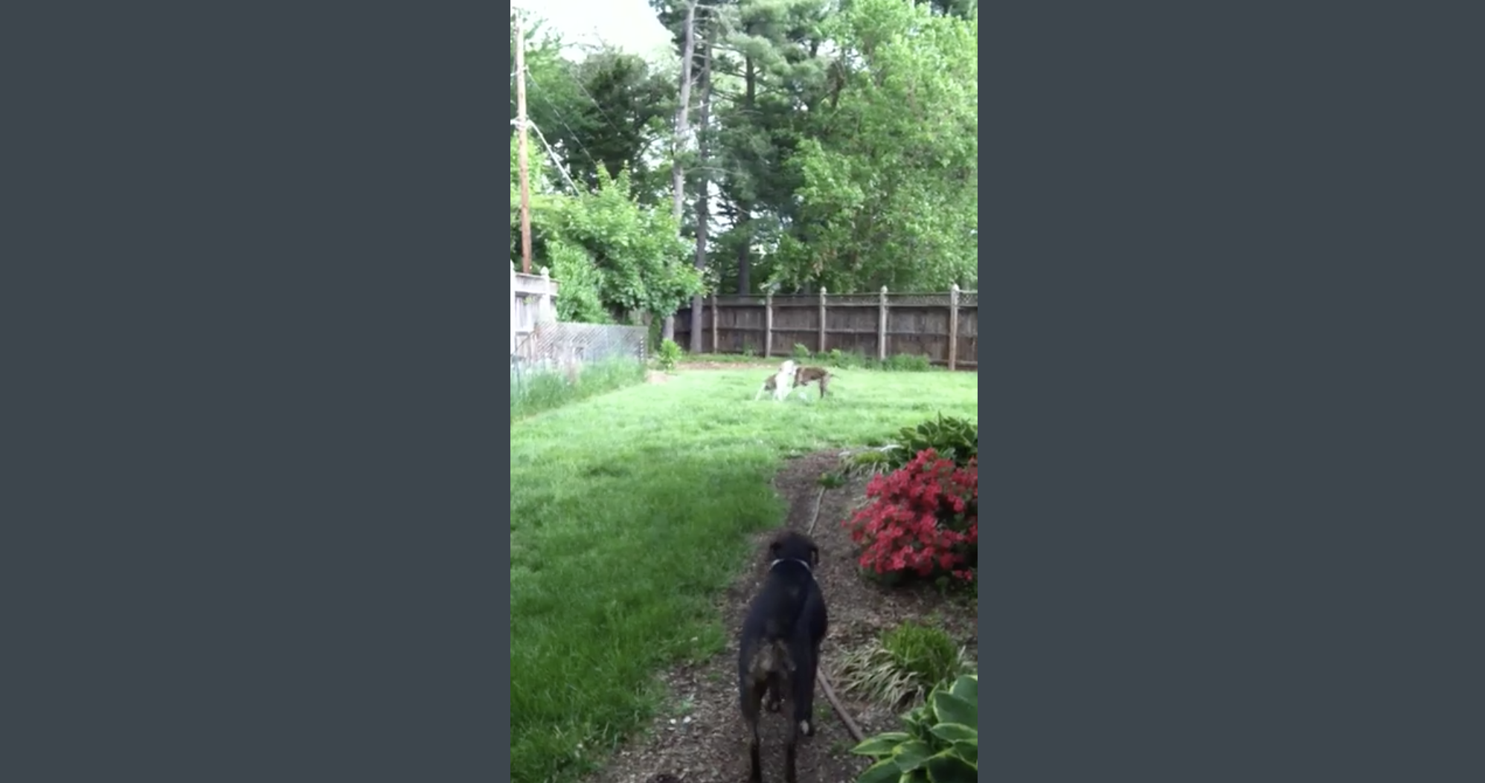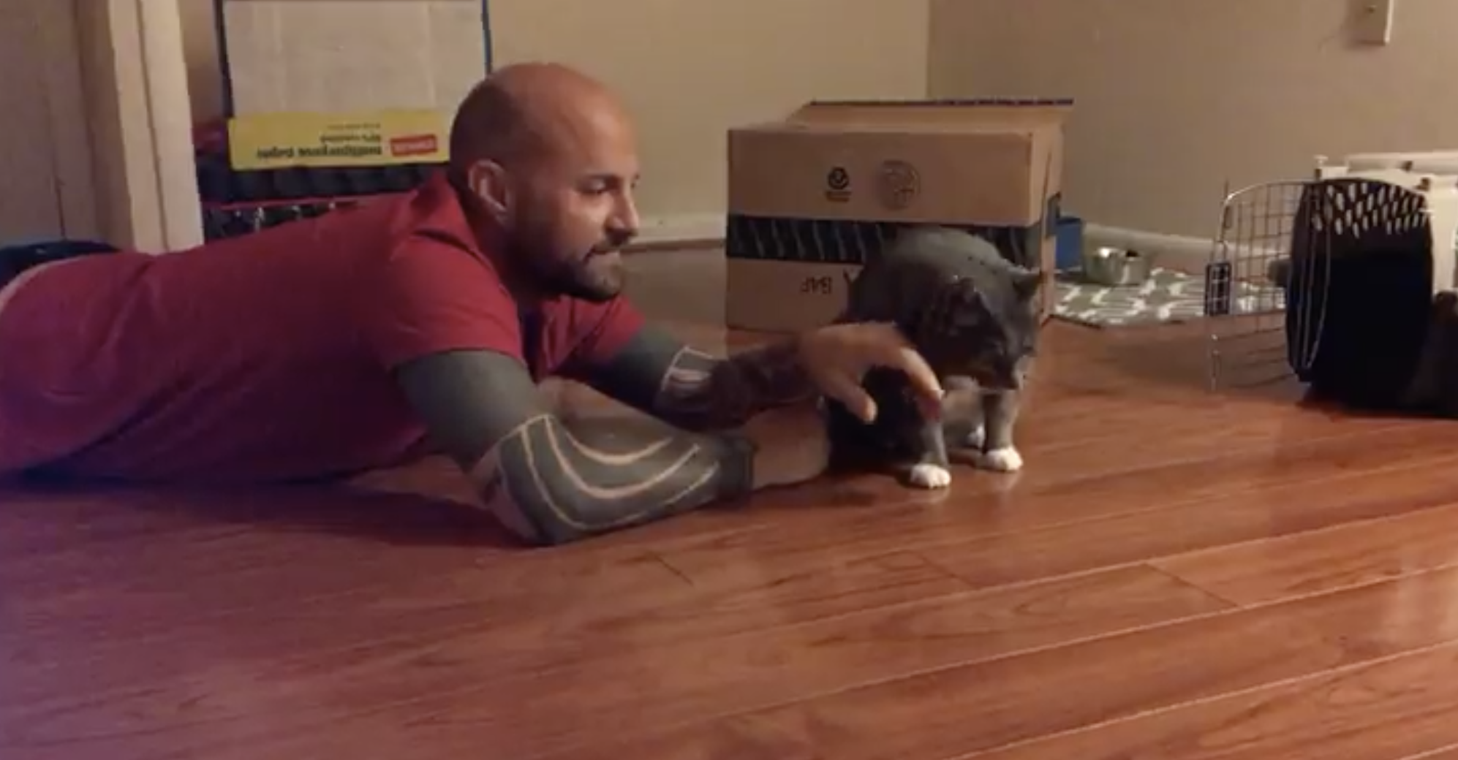

Make Your Video 60 Seconds or Less
Attention spans are short, so make sure your video is fast-paced and succinct.

Create a Flyer

You can use Word or any program you’d like to create the flyer. The design does not need be intricate – simple is often best. Use one or two awesome photos, plus your short and sweet bio or story. Include contact information. These flyers can be hung at your office, your school, the local coffee shop or anywhere that will let you hang a flyer! Print it yourself, or try making it into a poster at http://bit.ly/2uliyS4

Memes

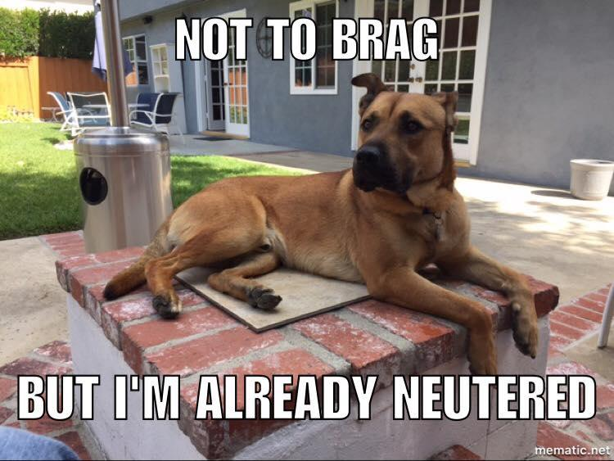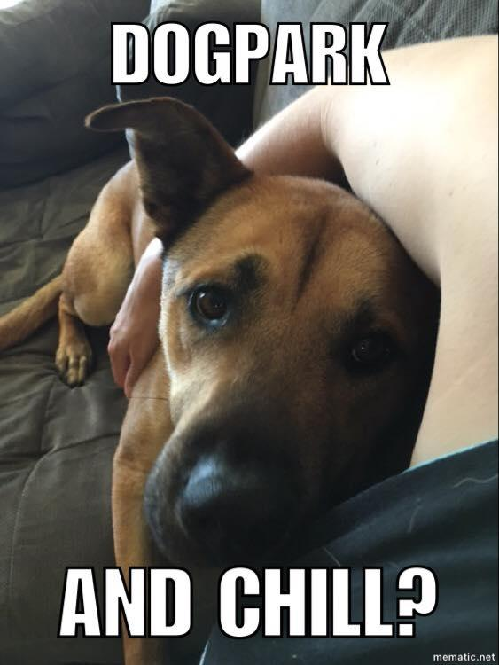

I Can Haz Adopter? Creating Memes for Shelter and Rescue Animals

When you’re creating a meme to advocate for an animal’s adoption, there are several different areas you can focus on. An animal’s appearance and personality are the two most basic areas of focus. There are also some successful strategies for promoting the adoption of animals that are victims of breed discrimination and those who have special needs. As you’ll see in the following examples, these four strategies can be combined in various ways as well.
The Animal’s Appearance
One of the simplest ways to create a meme is by focusing on an animal’s appearance. Your meme can highlight one or more of the animal’s features, her facial expression, the position of her body, or a combination of these.

Things to think about:

Does the animal have any prominent features? How can this be spun in a positive way? Does the animal’s appearance remind you of anything, and if so, what can you do with that?

Does the animal’s facial expression look particularly “human?” If the animal could speak, what might he be saying? More importantly, what could the animal be saying that would help him connect with a potential adopter?

Roxy’s pout in this photo was priceless. Input from several people was solicited in order to come up with a meme that might help her connect with a potential adopter.

The Animal’s Personality

Getting to know an animal will give you more opportunity to come up with a good meme. You can use aspects of the animal's personality and behavior to create a positive meme that will help potential adopters “get to know” and connect with the animal.

Things to think about:

What kind of energy does the animal give off? What are their personality quirks? Does he or she have any behaviors that are sweet, amusing, funny, etc.? What is the animal’s energy level? What funny things might they do that are similar to other animals of the same type and age?

You might also consider these questions, especially for animals who have been in the shelter for a while: What are the factors that might be preventing this animal from being adopted? Is he or she barrier-reactive? Is he or she more comfortable with people of one particular sex? What positive behaviors does this animal have trouble displaying in the shelter environment? What positive behaviors does this animal display when they’re not feeling stressed, or after they’ve become comfortable with someone?

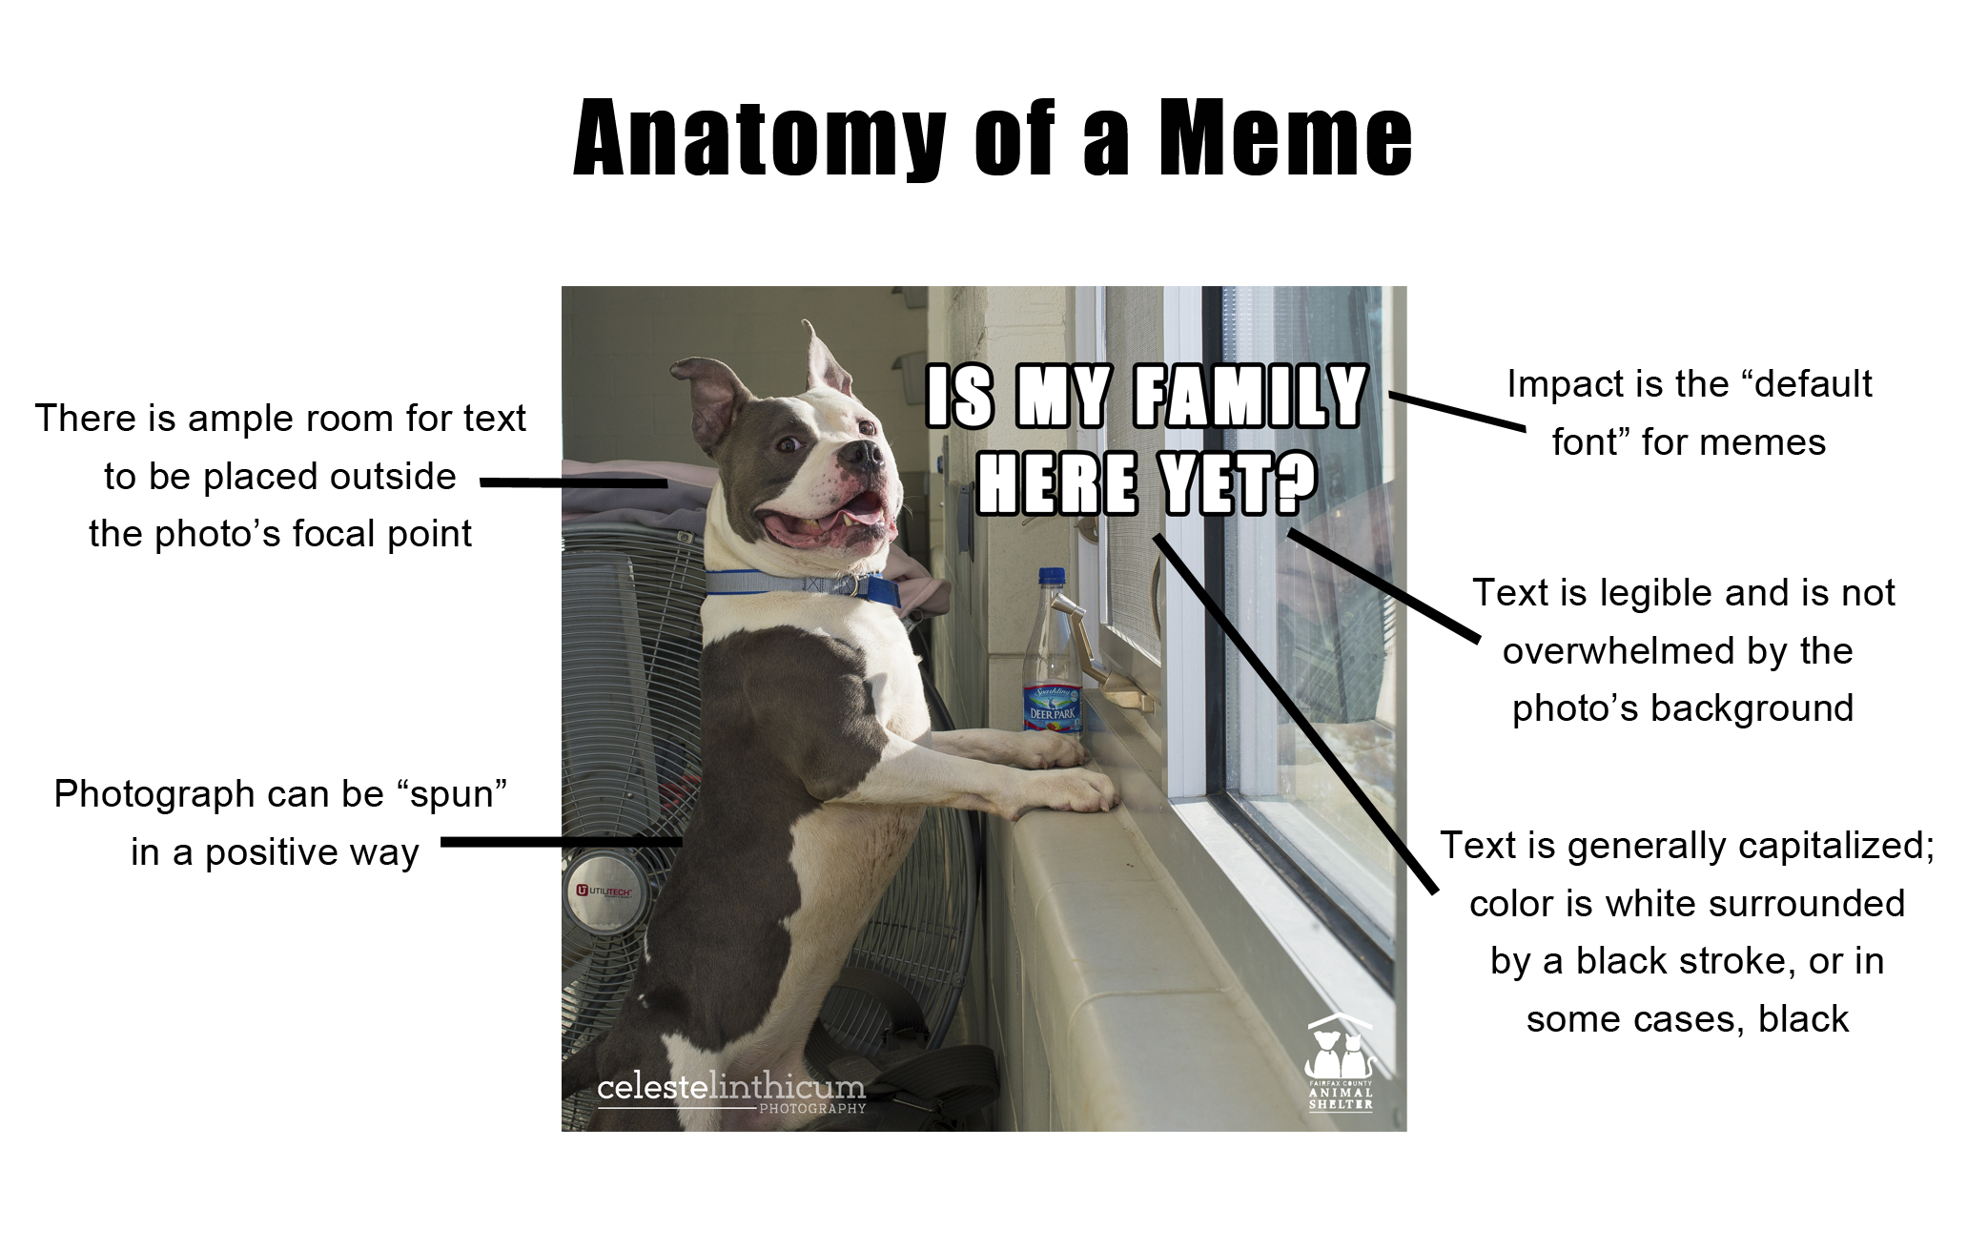
Written for Animal Sheltering Magazine and The HSUS by Kelly Duer. Used with permission.
####

Meme Photographs
Many of the things that make a successful animal photograph also make for a successful meme: the image is in focus, the lighting is good and the subject is looking into the lens. In a good animal photograph, the animal is generally happy and relaxed. Some things that work in memes are counterintuitive: For memes, almost any facial expression or body position can work if you have the right text and design to go with it. Above all, make sure that the photo quality is good and the expression on the animal in your photo relates to the meme’s text.
Background
It is important to stay up-to-date with the image sizes required by the social media you are using. The specifications for your memes is a question best answered by the shelter or rescue that you are working with. That said, square memes are usually scaled correctly on Facebook pages and will also fit Instagram.

Careful consideration must be given to the background of an image due to design issues and the requirements for different types of social media. It is fastest and easiest to create memes with photographs that show the entire animal and have a backdrop that is a single color. If the background is not a single color, keep in mind the text you’ll be adding, as it is easy for the background to overwhelm the text.
Subject
Photos that would otherwise be considered “outtakes” in traditional animal photography often work perfectly in a meme: strange facial expressions, dogs with their eyes closed, animals in mid-step, you name it! When you can “spin” your text in a positive way and the animal’s expression corresponds to it, just about any quality photo can be used.

While not an example of great photography,
Kitty’s facial expressions are hilarious.
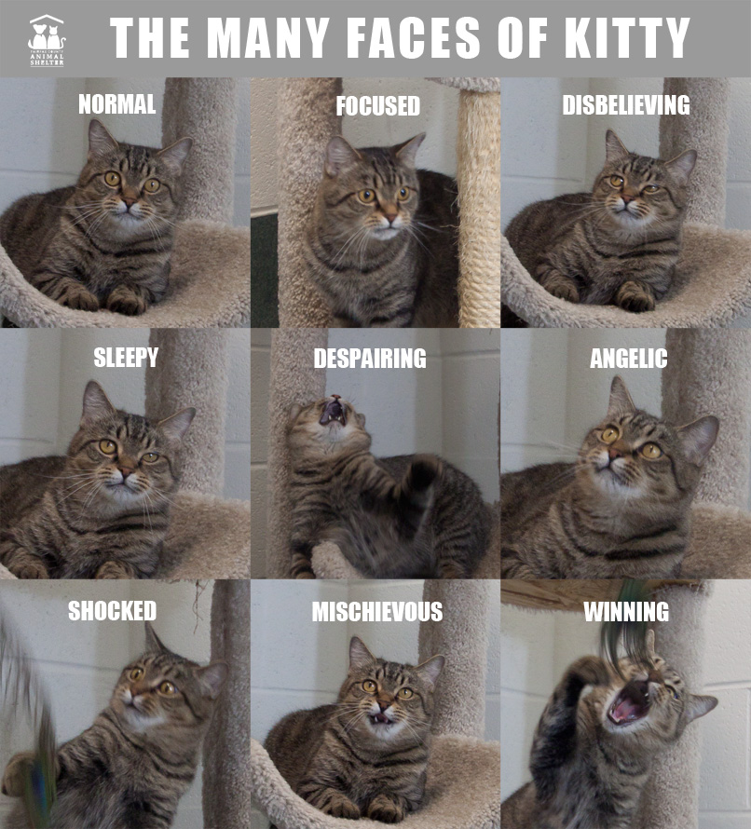

Other Types of Graphics
Photo collages, “dressing up” pets using graphic design, and other graphics tools can help set your foster or favorite shelter pet apart when marketing them for adoption. Try the apps Canva, Over, Skitch, PicCollage, etc. for a wide range of capabilities. You can even make your work into a poster at http://bit.ly/2uliyS4.

Volunteer- and Foster-Created Social Media Pages
Social media pages can be created and maintained by volunteers and fosters in order to showcase a particular niche within a shelter, the local area or even their own foster pets. They can be immensely helpful in getting more pets showcased before a wider audience. The VCAS 3 and Desperate Housecats are two examples of these types of pages.

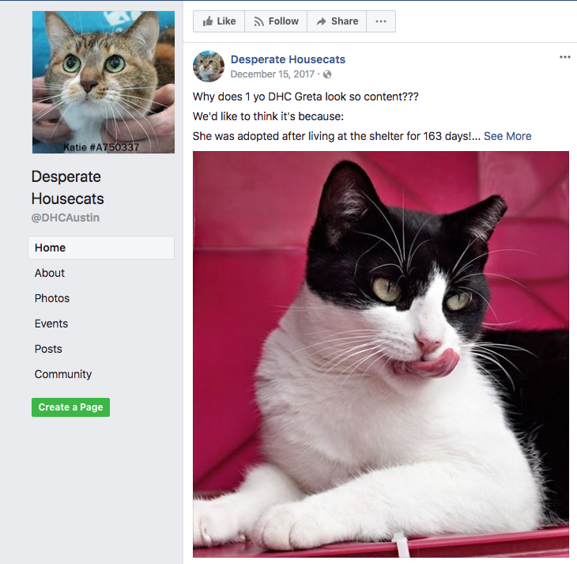

Steps to Marketing Your Foster Pet
Now that you have all of the building blocks, it’s time to get marketing. Here are some steps you should take in order to get maximum exposure for your foster pet.

Step 1: Gather Your Team

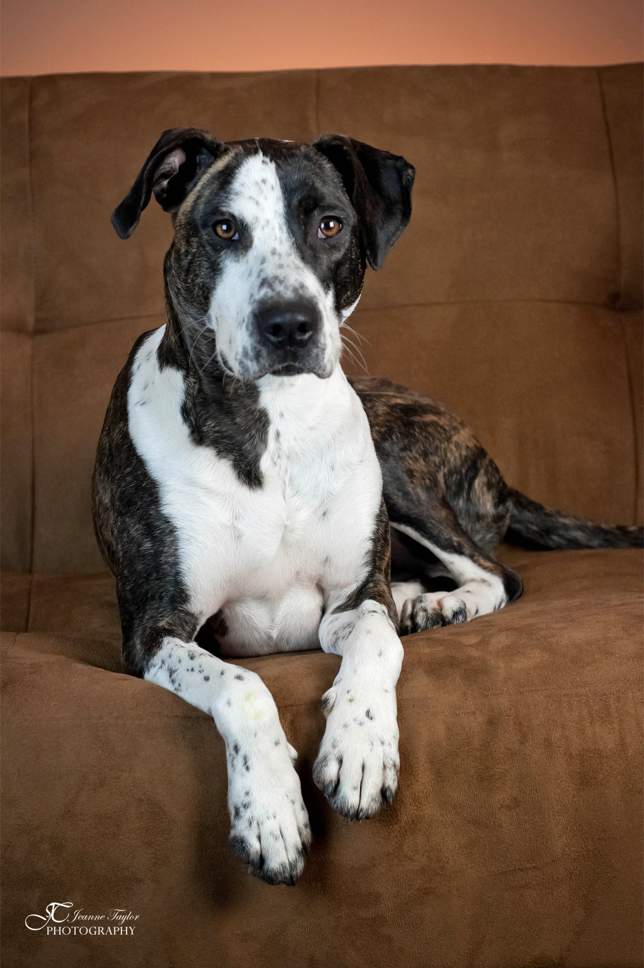
You can surely do this alone, but why not tap some of your friends and acquaintances to market with you? That new shelter volunteer who likes taking photos might be more than willing to meet up in a park and get some great outdoor shots of your foster pet. The friend who’s always making you laugh could write a hilarious and touching biography.

Consider this story from an adult dog foster:

“My friend Jeanne was a professional photographer who volunteered with the Fairfax County Animal Shelter, the same shelter my family fostered dogs for. When we had a foster dog, she would invite us to her home studio for photos. It was a win-win proposition: When the shelter posted her photos, our foster dog would immediately get at least four or five inquiries from potential adopters, and when we came to her house for photos it would save her a trek up to the shelter so she could make her monthly quota for volunteer hours. One particular dog, Coco, found a home even more quickly because of this relationship.”

“I brought Coco over to Jeanne’s, where she made quite an impression. While she was taking photos, Jeanne asked me what I thought would be the perfect home for Coco. She was quite energetic, so I told her I’d love for her to be adopted by someone athletic – maybe a runner or a hiker. Since we were talking about a dream family, even though I’d certainly consider families without all of these qualities, I threw in a high fence and no young children.”

“No sooner had we arrived home than I got a message from Jeanne. She said that her neighbor, Jean, would like to meet Coco. Jean’s senior Beagle had passed away several months before, and since then she’d continued on their 3-mile daily walks while carrying his collar. Jean’s kids were grown; she and her husband lived together in house with a 6-foot fence surrounding the backyard. She did a marathon every month. As they say, the rest is history!”

Step 2: Market, Market, Market!

In order to create content that connects your foster with potential adopters, you need to make marketing as much as part of your experience as feeding your foster pet. Aim to create new marketing material (a photo, video, story, etc.) a minimum of every 7-10 days. Make sure your camera is always on hand for those great photo-op moments. When your foster does something memorable or touching, write it down so you can craft a post.

Step 3: Diversify Your Platforms

The shelter’s social pages may be where you get the biggest return on investment for your marketing material, but don’t stop there. Market to potential adopters using different avenues, such as your own personal social media pages or ones you and others create specifically for the purpose of marketing pets, as well. Post on Craigslist. Post on Instagram. Ask the guy who runs that page that markets local shelter pets, too – or create one yourself!

“NoVa Cats uses social media to promote adult and senior cats in the Northern Virginia area,” says Stefanie Sacripante Hives. “It’s very easy. I get some good pictures, write some text, add some rudimentary graphics, and voila!”

The results have been extraordinary: through NoVa Cats, Hives has found permanent homes for dozens of senior and special needs cats in just the last few years.

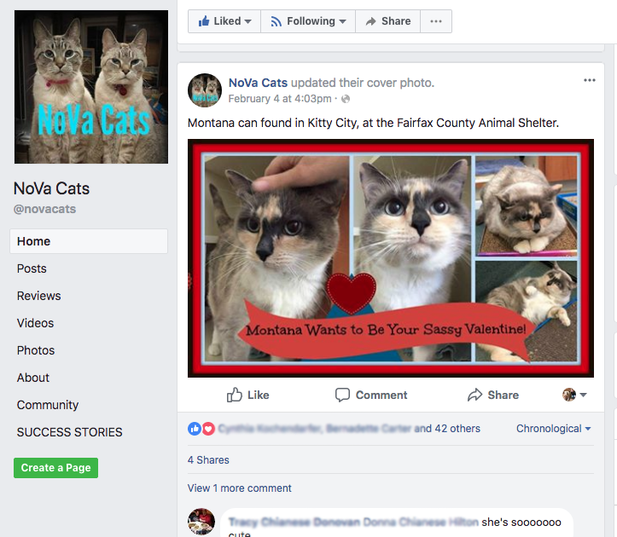

Social Media Sites to Try:

Craigslist.com
Don’t be afraid of Craigslist. Many shelters have found several wonderful adopters via this website. This doesn’t mean don’t take precautions, but definitely do not write off posting here. The section that will allow you to post an ad for your foster is Pets & For Sale – By Owner. You can also post shelter events in their Events section. Don’t forget to “renew” your post every 48 hours to cycle it to the top of its listing page.

Instagram
Instagram is an excellent place to showcase for your foster pics and video. This is not only a great way to find potential adopters, but it’s also useful as a place to direct interested parties to proof that the foster they are asking about is the best animal in the whole world. You can use your own Instagram account or create one specifically for marketing your fosters, favorite shelter pets or local adoptables.

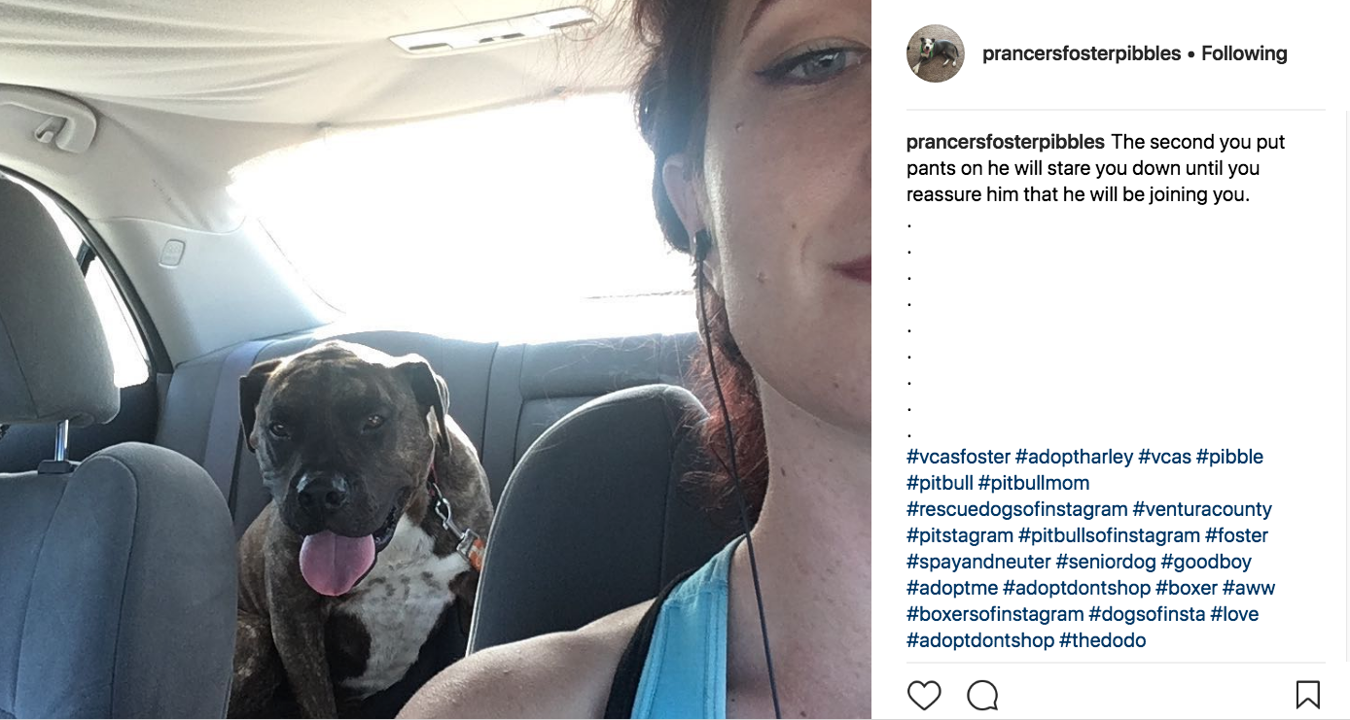

Twitter
Post photos of your foster pet and introduce them to your followers. Twitter’s limit of 280 characters or less may make it tough to tell stories, but you can post links to them from your account.

Nextdoor.com
Nextdoor is like social media for your neighborhood. You’ll need to verify your address in order to register. We know several fosters who have found wonderful adopters via Nextdoor.
Imgur
A big dog foster shared the following tips with us: “Imgur, in particular, is a social media site to check out. While on Facebook, the majority of users are women, 70% of Imgur’s users are men, opening your marketing up to a whole new demographic. Additionally, posts are seen by more people based 100% on the popularity of the post, not on “likes” or “follows” that your account has gained over time. This makes it easier for newbies to see their marketing material go viral. Posts are written much like articles, with a title, as many photos as you’d like, and text in between. Your title and first photo are crucial for making an impression.

My first experience on Imgur was awesome. I decided to try it out by posting four dogs I had fostered. Overnight, two of the posts went viral, racking up over 100,000 views each! Incredibly, there was a message in my inbox from a writer for iheartdogs.com, who asked if she could do a story on one of them. She interviewed me about him, and the article came out shortly afterward. Some amazing women from a rescue in Washington State read the article, hopped in their van and drove to California to adopt him!”

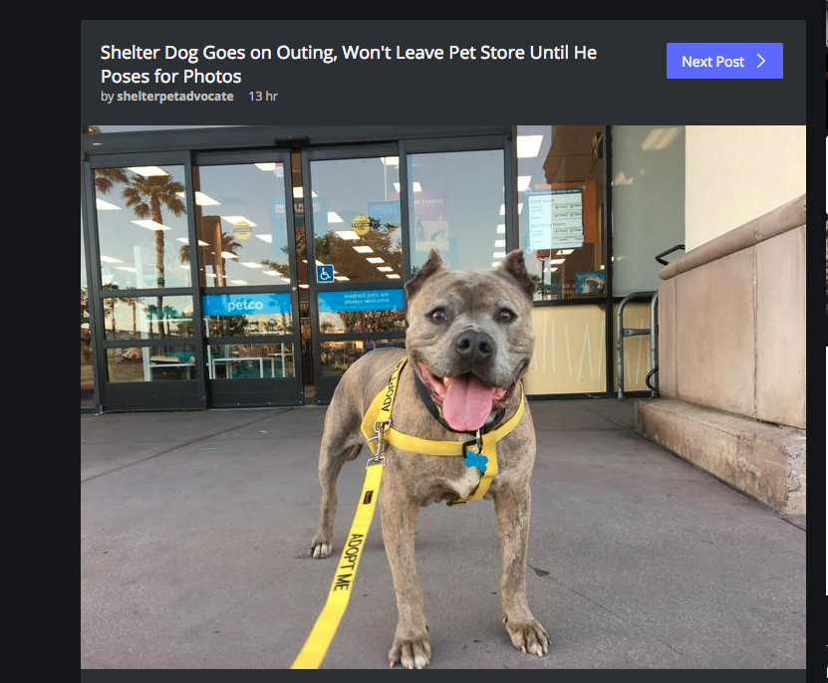

Reddit.com
Reddit is a worldwide community made up of a bazillion “subreddits.” There is pretty much a “subreddit” for everything. Try posting to relevant ones like reddit.com/r/fosterdogs, reddit.com/r/dogs, reddit.com/r/*yourcity*, etc.

Rescueme.org
Rescueme.org is a nonprofit organization that aims to help all breeds of dogs, cats and other animals find good homes, anywhere in the world. You can post pets on the site, and they will send the pet’s information out to hundreds of potential adopters in your area within two hours.

Adoptapet.com
Adoptapet now has a “rehome your pet” option that you can use to list your fosters.

Pinterest
Post your foster’s photo or flier and add details and contact information below.

The Shelter Pet Project
The Shelter Pet Project is a free resource that can put a long-stay pet in front of a much wider, national audience. Anyone can submit a pet to be featured. Here’s how it works:
- Find:
- A URL to the pet’s adoption listing on the shelter website, AdoptAPet.com, Petfinder.com, etc.
- If the pet is not listed on a site, or you have a better description than the one listed there, include that with the submission.
- The email address or phone number interested parties can use to contact the adoption organization or foster caregiver about the pet
- A great photo of the pet, preferably a close-up of his or her face, looking directly into the camera
- Email this information to contact@theshelterpetproject.org
3. When you receive a reply, make sure the shelter knows. Post a message in your Volunteers & Fosters Facebook group with the date and time the pet will be posted. This way, other volunteers will know ahead of time and will be able to help promote the post and answer additional questions about the pet.

Step 4: Connect With the Community

Introduce your foster to friends and family. Put an “adopt me” vest or leash on your foster dog and venture out into the community. Make sure you have something you can write on, or even a card with information on how to adopt your foster in case you’re asked.

Even if those who meet your foster dog aren’t in the market for a new pet, they will often become his or her advocate. When the shelter does a post on your foster pet, the more people who like, share and leave positive comments, the farther the post will go. You can even ask them to post the pet to their social media to give them more exposure.

Field Trips
If your foster is comfortable in public, take them out! Not only are these A+ photo opportunities, but it gives your foster a chance to meet people organically and ham it up in their “Adopt Me” apparel. Try to think outside the obvious animal enthusiast locations. You know who loves pets? Athletes. Construction workers. Single adults. The possibilities are endless!

With dogs who like riding in cars and meeting people, taking them out when you’re running errands, picking up the kids or getting coffee is a great way to give them exposure. If they’re comfortable being around crowds and other dogs, head to an outdoor mall or visit dog-friendly stores. Make some business cards with the dog’s name and your contact information written on them and hand them out to anyone who stops to say hi.

One amazing foster told us, “King Louie became my roller derby league’s team mascot. One teammate almost adopted him and another went on to become a foster mom and active shelter volunteer. I swear there is no demographic more animal-obsessed than female athletes. Imagine how many other untapped demographics there are!”
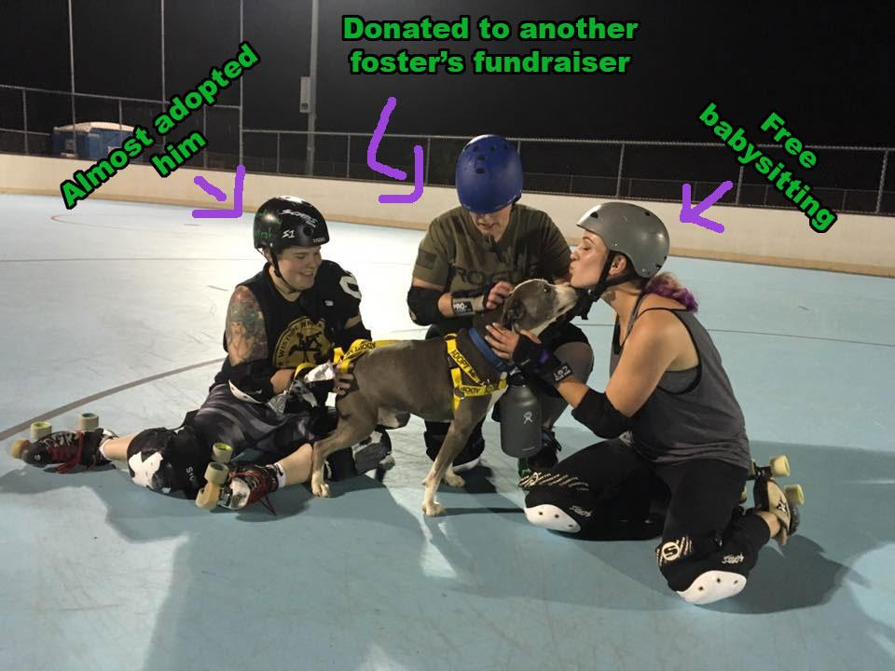

Attend Adoption Events
Anytime the shelter has organized an adoption event, bring your foster dog and join the fun! Some events are offsite, and shelter dogs are transported and get adopted from there. Those events have lots of promotion and draw in people looking to adopt, so show up and show your pet off and meet potential adopters. If your dog is extremely fearful or dog reactive, events like these might not be a great place for exposure, since they won’t be on their best behavior.

Cats aren’t generally candidates for field trips, but you can get extra exposure for cats (and dogs!) in foster by creating “meet and greets” for them. See if you can schedule a quiet room to hang out in for two hours or so during a big adoption event or even on a busy Saturday. Publicize the event the same as you would for any celebrity meet-and-greet (social media posts, Facebook Events, etc.) to invite potential adopters to visit with the pet during the time you’ll be in attendance.

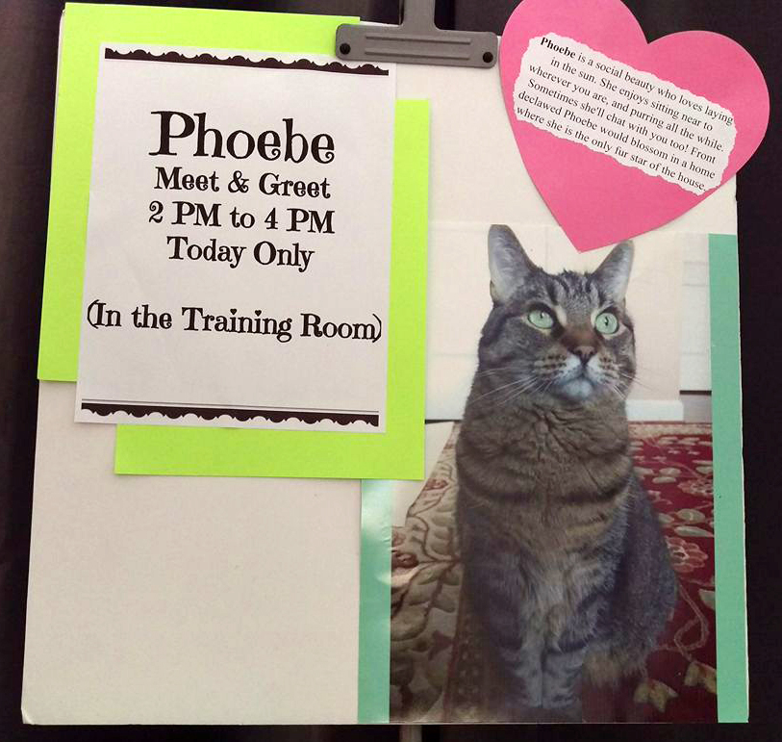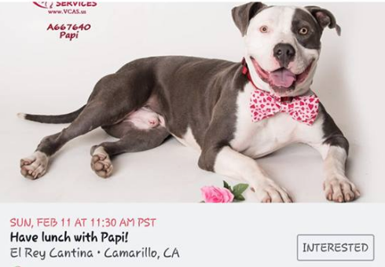

Word of Mouth
Simply telling your friends, neighbors, hairdresser, mailman, waiter, etc. about your amazing foster pet can create potential adopters. Make sure people know how to get a hold of you (your friends have your phone number or can contact you on Facebook, but strangers might want to get in touch later, so those business cards and your foster email will come in handy). You can create a team of adoption advocates this way!

Step 5: Try ALL the things!
There are infinite ways to market your foster pet; more great ways are being discovered every day. Got a great new idea you want to try out? As long as it’s safe for you and your pet, and could lead them to their forever home, try it! Take a look at some of the innovative ways fosters and volunteers have found to market pets for ideas:

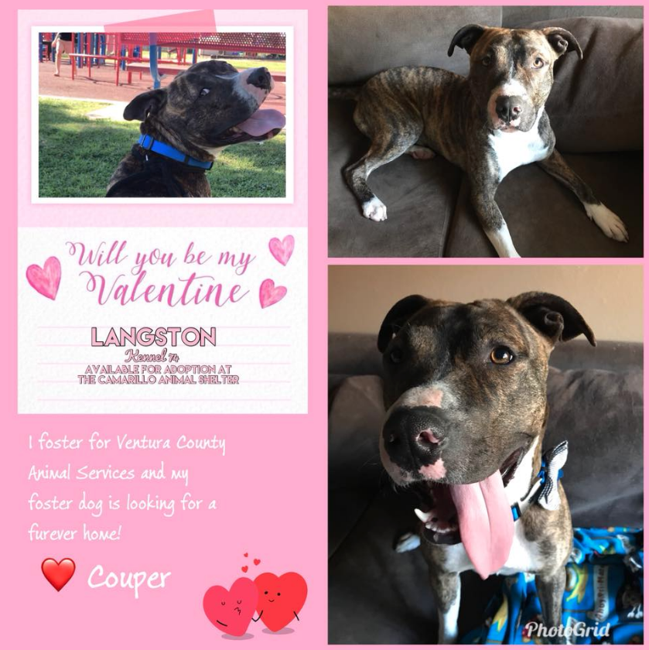

One family thought of an adorable way to promote their foster, Langston: Put him on Valentines that can be given out at school and in the community!

Marketing vs. Adoption Counseling

Marketing is Not Adoption Counseling: Keep ‘em Separate, Save More Lives

Shy dog Derek had been at Austin Animal Center, waiting for a family for several months, but was timid and scared in his kennel and didn’t seek out attention. There were no sparks with potential adopters.

As I sometimes do with dogs who need some extra attention, I brought him into my office and got to know him over the course of a few days. I saw him around other dogs, kids, and cats. I learned that he was very well behaved, but seemed unsure of the world, and sometimes became nervous. I observed his back legs seemed to bow out and he walked a little funny.
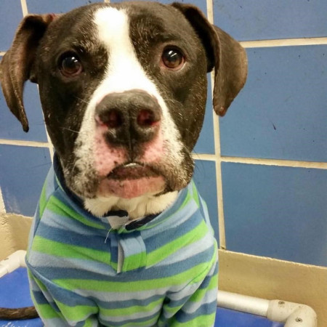
Derek was super shy in his kennel and was one of those dogs we sometimes call “shut down.”
With this new information, it was time to do some marketing. I wrote a silly little description of my experience with Derek and stuck it on his kennel.
I brought him in my office and got to know him over a couple of days. I made a silly flyer and put it on his kennel.

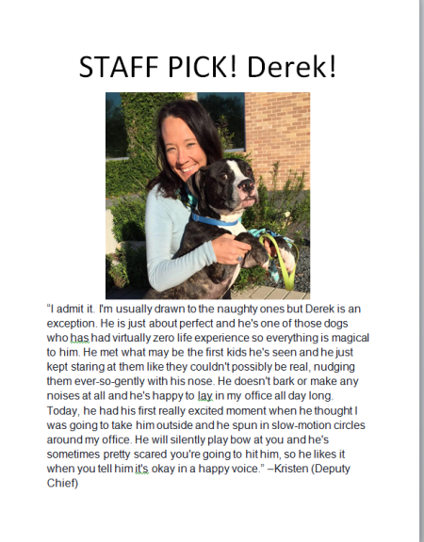

After just two days with the new sign, a woman wanted to meet him in the play yard. Once they got to meet, she saw there was a spark between them and said, “I want to take him home.”
At that point, after that initial magic connection had been made, we began the adoption counseling.
I described everything I had observed, including that he seemed to like the children he met, but also seemed unsure of them. I also told her that he needed his back legs checked out and that he might have some issues because of his conformation. I was honest and disclosed everything we had assessed and observed about Derek.
The adopter asked a lot of good questions. She considered if he was the right fit for her.
At the end of the counseling process, she was still convinced Derek was for her. She adopted him that day and when we followed up, she told us she is ‘completely in love’ and he’s the perfect dog for her.
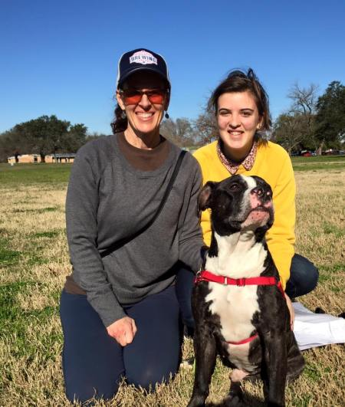
This family saw the flyer, met Derek, bonded with him, went through the counseling process and adopted him.
Derek was so proud!
Dogs like Derek are typically marketed to the public with information like:
“Shy, needs home with adults only” or “Probably a backyard dog and not well-socialized.”
These statements, used during the marketing phase, act as STOP signs which prevent potential adopters from asking to meet dogs (even ones that would be a great fit for them!). To help send more pets home, shelters need to separate the marketing from the adoption counseling.
Too often we mistake social media marketing as the place for adoption counseling.
Can you spot the ‘stop signs’ in these posts?
“Elsa is a gorgeous, two-year-old pit bull who loves people and loves to snuggle and go on walks. She must be the only dog in the house. She’d do best in house with no kids. Elsa has been waiting more than two years to find a new family to love her. Could she be the one for you?”
“Sam is fun-loving dog with tons of energy who is looking for an active home. He is really good with most people, but he prefers women over men. He is reactive and has mild separation anxiety, but with the right person, he’s going to make an awesome pet!”

I know what you’re thinking: “We have a responsibility to our adopters/fosters/rescuers/public to tell them everything we know about that animal! Are you saying we should intentionally hide the truth?”
No. As animal welfare professionals and volunteers, we owe it to our community and our adopters to disclose everything we know about one of our animals.
However, we share all of that information during the adoption counseling portion of the process…not in the marketing.
Marketing is meant to grab attention and open a door. Adoption counseling is for full disclosure.
Marketing is what GETS people to the adoption counseling process by piquing their interest in meeting the animals. But you can’t do the complicated business of adoption counseling if NO ONE is there for you to talk to. Marketing: it’s what makes the full conversation happen!
Here are some simple tips for keeping your marketing separate from your adopting counseling process. If you do this, you’ll increase your adoptions, make better matches, and get more pets out of your shelter or rescue and into permanent homes.
DON’T include every single detail about an animal’s entire life or try to explain every possible flaw or challenge this pet may have in one post.
Imagine writing a job resume where you list every mistake you’ve ever made, all the projects that didn’t go well, and all the things your coworkers find most annoying about you. You’re probably never going to get the call to come in for that job interview, even if you are a great prospect!
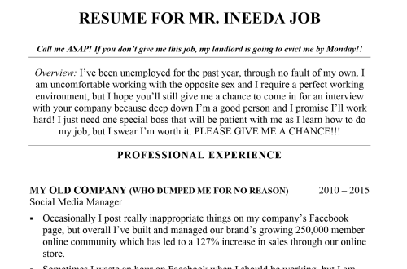
While this is an extreme example, it makes an important point. Every person (and dog) has a variety of personality traits and behaviors. We all have a history of highs and lows that makes us who we are. If we put it ALL on the table, before a prospective employer gets to meet us and form a connection with us, we’re not going to get the call to even come in for the interview.
For dogs, they’re probably not going to get the opportunity to meet the person who could change the course of their lives!
Think about it like this: Your resume is a way to land the interview where you have a chance to discuss your strengths and weaknesses. The social media post or bio is the way to get adopters to meet your dogs and have a discussion with you about all of their needs.
DO tell a story! Dalton, pictured here, was a wild child in the shelter. He barked and whined while kenneled and had tons of energy. His behavior in the shelter sent adopters running. Dalton was passed over many times.

In the past, we might have posted that Dalton was a ‘high energy’ dog looking for an ‘active’ family who would take him running and hiking. But we’ve learned potential adopters read through the lines, even when we try to be subtle about potentially negative traits.

Instead we sent Dalton to a foster home for a few days, so we could learn more about him. His foster mom shared a quick story about something he did while at their house.
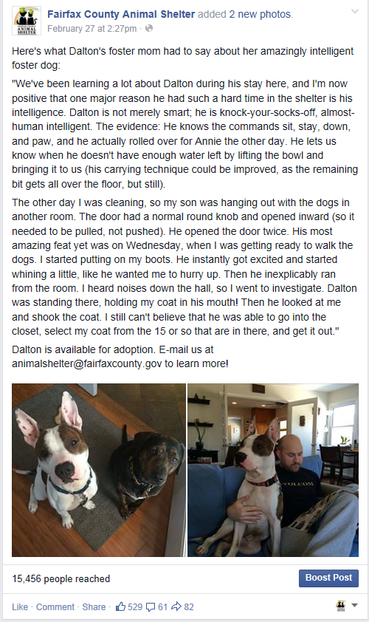
That story, posted on Facebook, brought in dozens of interested adopters. Marketing him this way allowed us to find a family from this group who was perfect for this young, exuberant pooch. Everyone else that was interested adopted other dogs. Win-win!
For more information on writing descriptions that create connection and draw in adopters, check out Animal Farm Foundation’s E-Book about marketing and advertising.

DON’T focus on restrictions. Restrictions are articulated either as a directive statement, as in “no kids” or as a passive statement such as, “would do best in a home with no kids.” A restriction like this means different things to different people. It leaves a lot of room for people to imagine why you’ve included it in your marketing.

For most adopters, a statement like this will act as a stop sign because they don’t know why you’re using it and it may sound scary. Even for potential adopters who don’t have kids, they may think, “Well, my neighborhood has kids and so I guess this dog won’t work for me,” or alternately, “I don’t have kids, but who wants a dog that doesn’t like kids?” or even, “I wonder if this dog has hurt kids?” By placing restrictions in your marketing, you may have turned off some really great adopters who are the right match.
Even if you are firm about the restriction and will not adopt the dog to a home with kids or cats, you can save that conversation for the in-person adoption counseling process. This is when you will explain the dog’s full history and why you are going to use the restriction. Your adopters will appreciate your transparency and information and trust in your adoption process.
To read more about restrictions, check out Animal Farm Foundation’s E-book about adoption best practices.
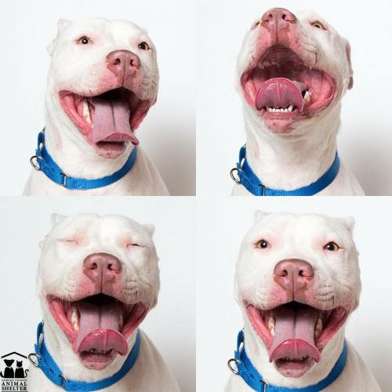
Ghost, pictured here, is a deaf dog. We marketed her by talking about how despite her inability to hear, how happy and joyful she always is. Without any special criteria or restrictions, we found her the perfect family.

DO stick to positive marketing that inspire adoptions and will create the opportunity for adopters to meet the dog, before beginning the counseling process.

DON’T feel bad if the marketing doesn’t lead to the right match. If someone comes to meet a pet because of your positive marketing and they can’t adopt that particular pet, because of a medical or behavioral issue that you discuss with them, that’s ok…

DO see this as opportunity to make the right match. All of our staff makes an effort to always know some information about six or seven different animals in our shelter. That way, if the pet the adopter saw on social media wasn’t the perfect fit, we have several other potential matches already in mind!

DON’T use industry language, or ‘shelter-speak’ in your marketing efforts. Terms like ‘barrier reactive’ and ‘resource guarding’ might be everyday lingo for you, but to adopters that are both frightening and confusing. Even terms like, ‘jumpy/mouthy’ mean something different to you than what they might mean to a person who is unfamiliar with animal welfare jargon. They may scare off adopters.

DO use everyday language in your marketing, as well as your adoption counseling, that regular people understand. And if you do use a term like ‘zoomies,’ make sure you explain what you mean!

Want to keep it simple? Remember that marketing gets people in the door who are excited to adopt and creates the opportunity for honest, open adoption counseling to happen at the shelter, where the best possible matches can be made.
Commit to a positive-only marketing approach combined with a conversation-based adoption counseling process and you’ll start to send more pets home, right where they belong.

Written for Animal Farm Foundation by Kristen Auerbach. Used with permission.

####

Removing Stop Signs: Fine-Tuning Your Marketing
When we talk about removing stop signs from marketing, the first question we’re usually asked is, “Doesn’t that mean you’ll bring in a whole bunch of interested people who aren’t the right match for the dog?”
The short answer is yes. However, having more people contact your organization, even if it’s initially about a dog that may not be ideal for them, is a great way to open the door to introducing other pets that are a good fit. We’ve also found that there’s a lot you can do to fine-tune your adoption marketing in order to find the right adoption candidate.

Consider the story of Sweet Jane. Her fosters worked hard at marketing her; while they believed her ideal placement was with older or no children, this stop sign was not included in the marketing. Several months later, they began to get frustrated because it seemed as though the only families inquiring about her were ones with small children. They looked back at their marketing to see if they could identify a problem:

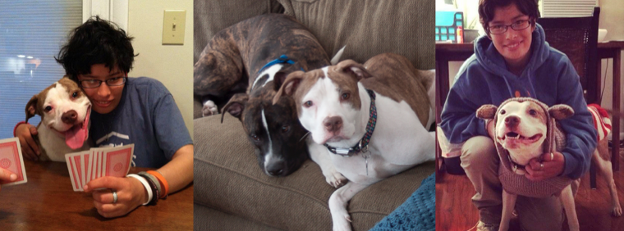

The problem is pretty obvious, no? Sweet Jane was very attached to their 20-year-old daughter, Annie. They’d used many adorable pictures of the two together in their marketing. The thing was, Annie looked much younger than 20, which meant that they were accidentally marketing her to families with children.

While they were certainly not going to scrap any photographs that would be good marketing material, they began to make a concerted effort to market Sweet Jane to adults. This time, the results paid off!
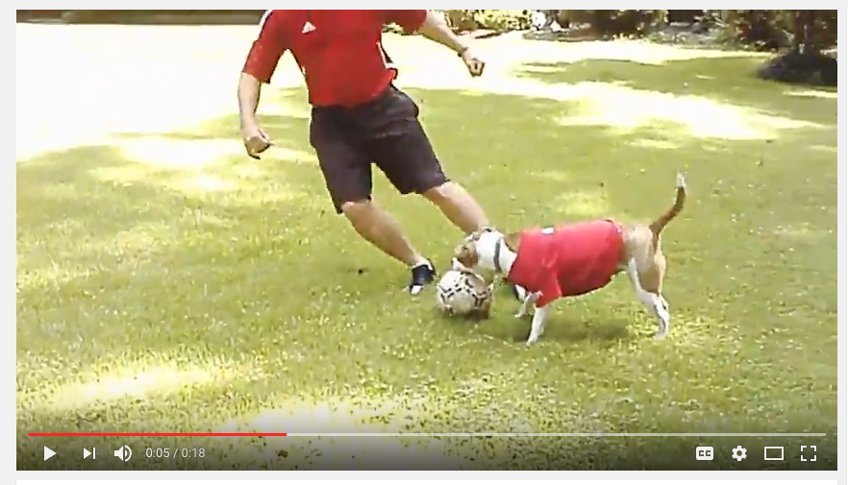

And what of the families with children who inquired about Sweet Jane? This was the perfect opportunity to show them the shelter’s great customer service and get some exposure for other dogs in the shelter’s care who might be a better fit for them. This need not be time-consuming for fosters. In Sweet Jane’s case, her fosters identified several dogs in the shelter who were known to be good with children and then crafted an email template that they sent to potential adopters who had kids:

Hi John,

It’s very nice to meet you! My husband and I are fostering Sweet Jane, and we heard that you had inquired about her. While she is an awesome dog, we’d love to see her placed in a home with older or no children. However, the shelter does have several amazing dogs that are good with kids! Rick has lived with kids before and is a really nice dog. I took him to an event a few weekends ago and he loved meeting all of the people and other dogs. Here’s a link to his online profile: http://www.petango.com/Adopt/Dog-Terrier-American-Staffordshire-23694671. Also, Maia has been with kids while she was in foster care with her puppies; she did very well with them.

Keep your eye on the shelter's Facebook page – fosters take some of the dogs on weekends, and the shelter is able to learn much more about them during this time. They usually post photos and information about weekend foster dogs on Sundays and Mondays.

Thanks!
Lee

Removing Stop Signs: Adoption Counseling

Another thing we’re often asked is, if we don’t do adoption counseling in our marketing, when will it be done? Are we lying to people?
Absolutely not. This strategy is just for marketing; complete transparency about pets’ history and behavior with fosters and adopters is critical.

The great thing about marketing shelter pets from foster care is that there are now two possible levels of adoption counseling: the foster and the shelter’s actual adoption counselor. If fosters have access to a dog’s history and in-shelter notes, they can do the counseling themselves without sending the dog back to the shelter. If not, the foster can show and tell the adopter everything they know about the dog, and the adoption counselor will go over the dog’s complete history and notes at the shelter.

Teamwork for the Win!
How Starting from Scratch and Thinking Outside the Shelter Can Get Long-Stay Dogs Adopted
In this guest post, Kelly Duer, Maddie’s® Foster Expansion Coordinator at Austin Animal Center, shares how the Ventura County Animal Shelter is getting all of their long-stay dogs adopted. Read the post, and then try some of the creative ideas for yourself!

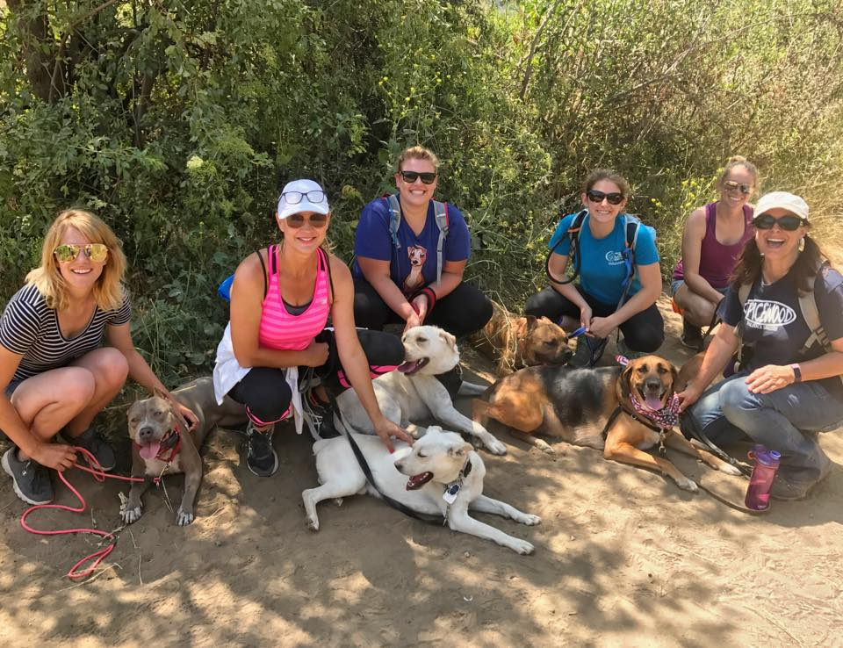
The Ventura County Animal Shelter was in a tight spot: The busiest time of year had barely begun, and they were already dangerously close to hitting capacity in their dog kennels. Worse, the shelter had a slew of long-stay dogs that desperately needed to get out of the shelter and into homes. What could they do?
They got creative. In addition to asking the community for help and placing as many of their pets as possible into foster care, the shelter piloted a new – and very successful – marketing program that they called the Long Stay Challenge. They started with a group of 20 dogs who had been at the shelter for the longest amount of time – a collective 6,181 days. Many had been living there for over a year.
Two months later, half of these dogs were settling into their new forever homes, efforts to market those who remained were well underway, and many other stressed-out dogs who were marketed had also been adopted or rescued. Here’s how they did it:
They focused on their neediest dogs. The shelter looked at their data to find the 20 dogs who had been there the longest. They created a list and asked their volunteers for help. They resolved to market these dogs heavily for a minimum of 60 days. Many other dogs who were suffering from shelter stress, no matter how long their stays, were also targeted.
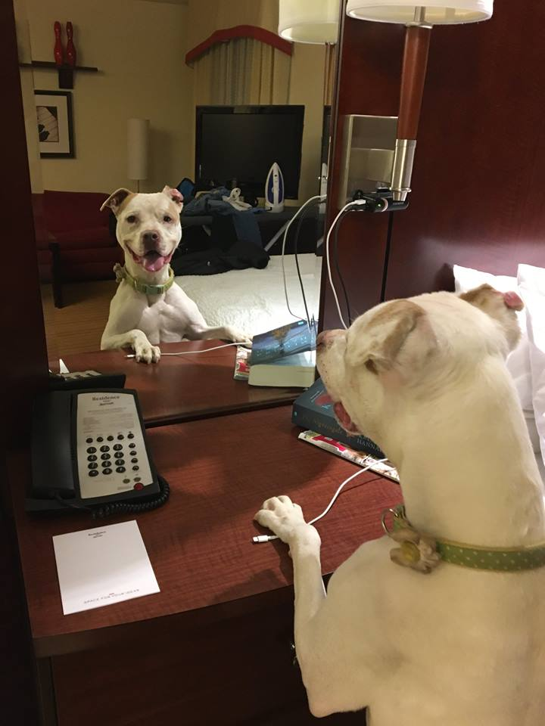
“It made us as volunteers continually check for dogs falling through the cracks,” said shelter volunteer Darrell Berdine.
Everyone participated in marketing the dogs for adoption. At many shelters, the organization’s Facebook page is the only way pets are marketed. This puts stress on the shelter’s staff and leaves out a huge group of people who are often more than happy to contribute: the shelter’s volunteers. Using volunteer- and foster-driven marketing, the shelter was able to feature a much wider variety of photos, videos and stories about the dogs in their care.
In addition to taking the dogs on outings, volunteers worked together to create new and innovative ways to showcase the dogs. They not only shared this material with the shelter, they shared it with the community by posting on their own social media pages and creating new pages to market these pets.
They got their dogs out of the shelter. A few went to foster for a week or more, but the majority? They only went off-campus for half a day at a time: on group walks, lunch dates, visits to the beach and outings to the park. It may not seem like a lot of time, but even a few hours in foster care was enough to capture these dogs looking relaxed and happy in different settings.
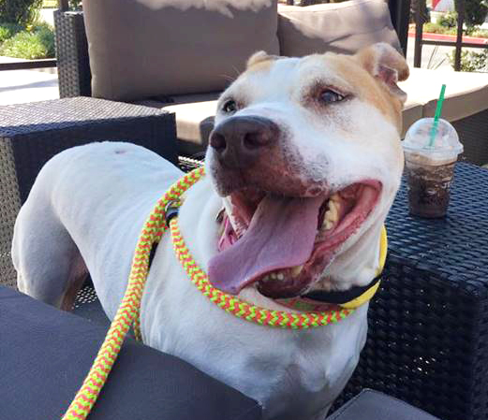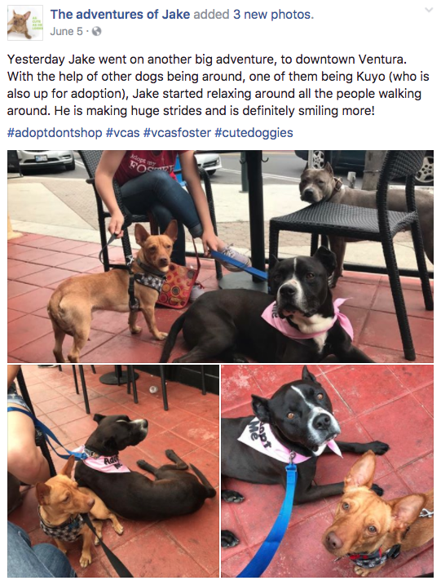
In the shelter, marketing opportunities can be limited. For example, it can be difficult to get photos of pets looking relaxed when they’re stressed out in a shelter setting. Adopters want to know what a pet would look like in a home, and this is not often possible to show in the shelter.
“Not only is this different marketing material than photos and assessments done in shelter, it reaches an audience that may not be following us on Facebook,” said Kim Flavin, the shelter’s behaviorist. “The dogs meet the people where they are. It is also a vital stress reliever for the dogs and helps gather important information about the dog’s behavior in the ‘real world.’”
They got creative. Volunteers and staff worked together to come up with innovative new ways to market the dogs. Photographers, fosters and other creative volunteers teamed up to generate ideas, make videos, take pictures and create themed photo shoots.
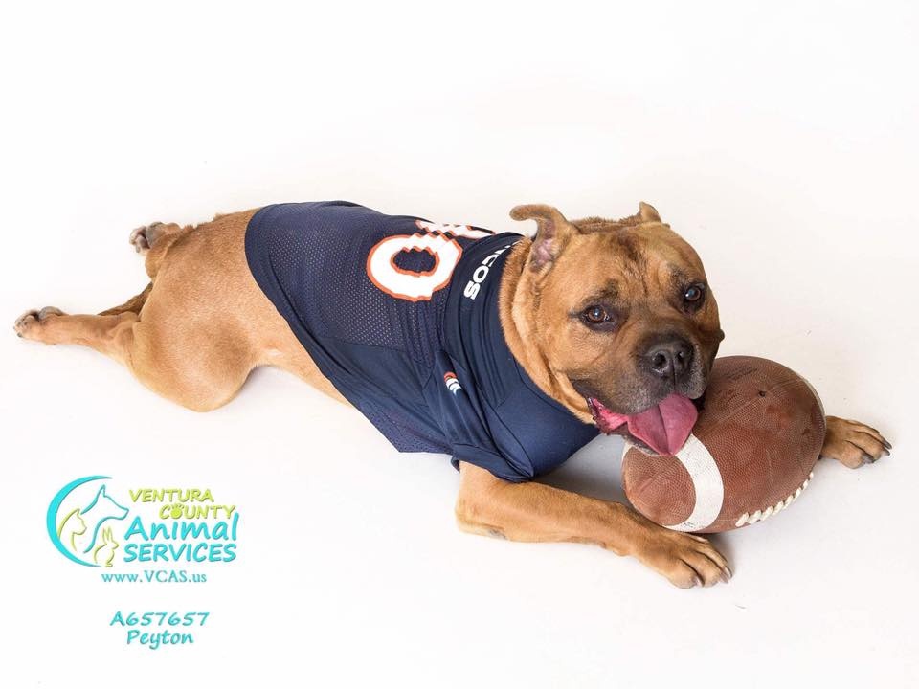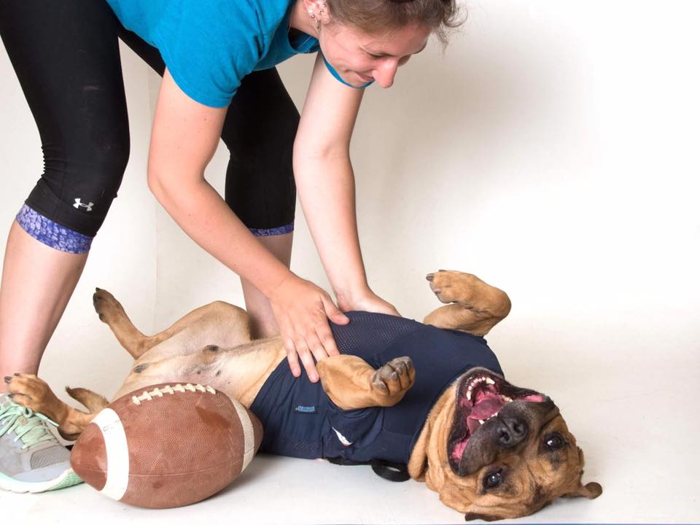

They made it into a fun game. Several gift cards were donated as prizes for participants. Prizes were raffled off to day trip fosters and the first two people whose marketing led to a dog’s adoption. A list of those who took dogs on outings was posted next to the long-stay list in order to keep track, and updates on winners were given in the shelter’s internal social media groups.
Berdine, whose advocacy on behalf of long-stay dog Snoopy led to his adoption, was the contest’s first winner. Snoopy had lived in the shelter for nearly a year, and his behavior was beginning to deteriorate. Berdine not only helped to market him, but also worked with Flavin to create and implement a plan and a training protocol.
“He blossomed very quickly with the consistent training. We took pictures and videos and marketed the heck out of him,” said Berdine. “The more I took him offsite the better he got with his manners. I think a lot of his issues were kennel stress. He turned out to be one of my all-time favorites.”
That gift card he won? Berdine spent it on enrichment items for his new favorite long-stay dog, Bayou!
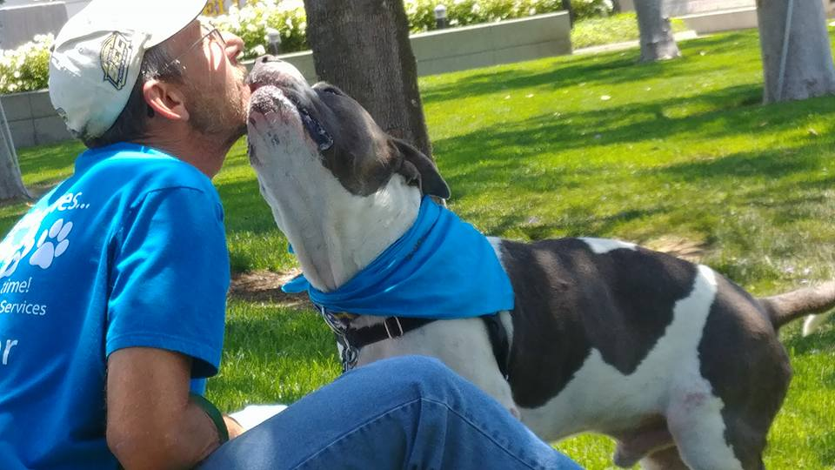
“I think the most important part of this project was bringing attention about these dogs to everyone,” said Sarah Aguilar, the shelter’s foster coordinator. “Getting them known, increasing awareness, having them ready to go — all of these things contributed to the number of these dogs that have gotten adopted.”
When the two-month trial period was over, the shelter reassessed. In just two months, the average length of stay for their 20 longest-stay dogs decreased from over 300 days to 235. Not only had half the shelter’s longest-stay dogs been adopted or rescued, but working together to achieve this goal brought renewed vigor to the whole organization.
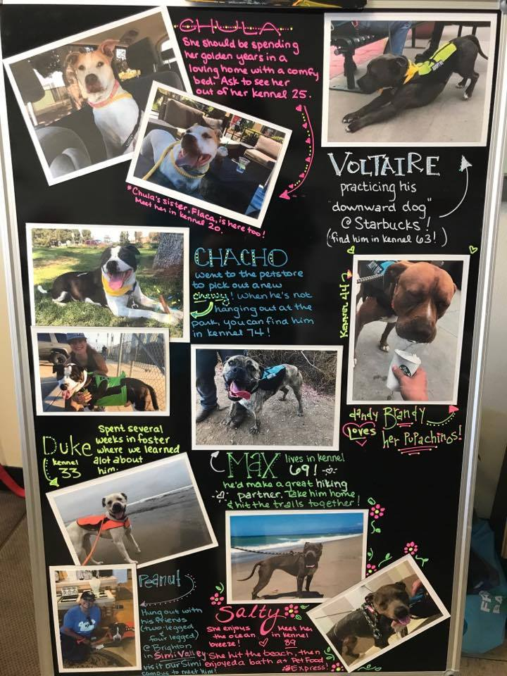
Building on their success, the shelter’s staff developed some additional marketing tools such as the new bulletin board of long-stay dogs that is now displayed prominently in their lobby. Then they printed out a new list of long-stay dogs and started over!
####

Appendix A: Resources

Marketing Shelter Pets

Marketing rules to increase adoptions
https://www.animalsheltering.org/magazine/articles/awesome

Using social media to maximize your lifesaving potential
http://www.maddiesfund.org/using-social-media-to-maximize-your-lifesaving-potential.htm

Marketing best practices from Animal Farm Foundation
https://animalfarmfoundation.org/wp-content/uploads/2017/08/Marketing-eBook-WEB.pdf
What animal organizations can do as Facebook makes changes
http://chewonthis.maddiesfund.org/2018/02/fb-zero-2/

Marketing, PR and Social Media
http://www.maddiesfund.org/topic-marketing-pr-and-social-media-social-media.htm

Don’t Be Boring and Other Secrets to Finding Dogs Homes
https://animalfarmfoundation.blog/2017/05/04/dont-be-boring-and-other-secrets-to-finding-dogs-homes/

Social Media: Six New Things
http://www.maddiesfund.org/social-media-six-new-things.htm?p=0EECED7D-7E3F-4ECB-A2D8-CD9099F21539

2 Weeks to Adoption Tips
http://aspcapro.org/sites/default/files/aspca-2WeekstoAdoption.pdf

Photography, Videography and Writing

Better Photos and Profiles for Long-Stay Shelter Dogs
http://chewonthis.maddiesfund.org/2016/04/long-stay/

How to Take Great Pet Adoption Photos with a Smartphone
http://chewonthis.maddiesfund.org/2015/03/how-to-take-great-pet-adoption-photos-with-a-smartphone/

Writing and Photography for Great Cat Adoption Profiles
http://chewonthis.maddiesfund.org/2016/05/cat-marketing-apa/

Using memes to market shelter pets
https://www.animalsheltering.org/magazine/articles/i-can-haz-adopter

Photography 101: Tips and Tricks from HeARTs Speak, Inc.
https://animalfarmfoundation.org/wp-content/uploads/2017/08/Marketing-eBook-WEB.pdf - page=14

Volunteer-Driven Marketing

http://www.huffingtonpost.com/2014/01/06/pit-bulls-fairfax-county-animal-shelter_n_4548926.html

http://www.connectionnewspapers.com/news/2014/dec/17/oakton-resident-helps-older-cats-find-forever-home/

Boosting Your Marketing Efforts

The Shelter Pet Project: submit adoptable animals, free of charge
https://www.facebook.com/ShelterPetProject/?fref=ts

Appendix B: Shelter Pet Marketing Checklist
Shelter Pet Marketing Checklist
a.k.a Steps to Find that Forever Home!

Here is the simple checklist. Cross off each step to help your pet get closer to finding their adopter. For explanations and examples, read below!

- Good quality, recent photo
- Good quality video
- Write-up a summary
- Make a flyer
- Post on Facebook
- Post on Craigslist and Nextdoor.com
- Main AAC FB page
- Out of the box social media
- Go out into the world/Field Trips
- Attend adoption events
- Word of Mouth
- Be Creative

THE BASICS
- Good quality, recent photo
This photo will be uploaded to our database and will show on the animal’s kennel card and online profile. Headshots are usually best, but full body can work too. Photos should be taken in landscape and be cropped to 3x4 ratio for best website display. If you need help getting your photos to come out, ask for help on our Facebook page… we have a lot of volunteers who are also talented photographers! Check out this short article, which offers some more photography tips.

- Good quality videos
Videos should always be shot in landscape (wide) so hold your phone sideways when taking video. Any number of videos can be uploaded and embedded into an animal’s website profile, but video links are also great for other methods of sharing. Try to make your video 1 minute or less, unless the content is really engaging.

- Write-up a summary
Write a short and sweet summary that includes your animal’s behavior, likes and dislikes, and the best things about them, like an author’s biography at the end of a book. This summary can be the text for a social media post but it can also be added to the website profile. Leave out negative details (Stop Signs) such as “no other pets,” “needs training,” etc., as these can deter even the perfect potential adopters and are best discussed 1-on-1 during adoption counseling. Aim to create a positive emotional connection with the reader.

- Make a flyer
You can use Word or any editor you want to create a flyer for your animal. Simple is best! One or two awesome photos plus your short and sweet summary from above. If the animal is in foster with you, include your contact info. If the animal is at the shelter, you don’t have to include their kennel number because those can often change. These flyers can be hung at your office, your school, the local café, Starbucks, Half Price Books, anywhere that will let you hang a flyer! At the shelter, there is a board that shows foster dogs who are looking for adopters so share your flyer with the foster coordinator. If your flyer was made for an animal still at the shelter, you can send it to the volunteer coordinators who print and laminate it (or you can learn how to print and laminate in the volunteer office!).

SOCIAL MEDIA

Just a few notes on social media:
- When describing an animal on social media, make sure to leave out Stop Signs like, “working on leash skills” or “can’t live with children”. While these may be facts or real safety concerns, they’re not the thing you want to market with and they can be a turn-off for potential adopters, despite glowing notes in the rest of the post. Read this article and then write your posts as positive marketing material, so you can do the adoption counseling later during a 1-on-1 conversation.
- The best way to get shelter pets, especially long-stays, into forever homes is to market them vigorously (at least every 7-10 days).
  - Post on each animal regularly - Think outside the ‘pet bio box’, and highlight a specific pet’s adorable quirk, a scene or story from their day, an interaction with other dogs or people, etc.
  - Regular posting creates an emotional connection between pet and your supporters. Together, the posts tell a story, and the happy ending is the adoption!

- Post on Facebook
You can create posts from your own FB page, regularly share your animal on internal shelter groups (so they stay at the forefront of everyone’s mind), or you can create a public celebrity page for your animal. Post regularly with new photos, videos, and stories. You can boost FB posts with money so they are seen by a wider audience than just your friends. If you want to do a BIG post, ask for donations to help create a big boost. Include how to find the animal or how to ask more questions.

- Post on Craigslist and Nextdoor
These sites are a GREAT tool to reach your neighbors. You might think Craigslist is only for scammers, but in fact many people are looking at CL to add new pets to their family! You can post lots of photos, links to videos, and more thorough write-ups. Follow the positive marketing guidelines and change your posts so that they’re not the same from week to week.

- Main AAC FB page
The shelter’s Facebook page has a ton of followers, so send a great story /write-up plus photos and/or videos to the foster coordinators who can help get your pet featured on the main page.

- Out of the box social media: Instagram, Imgur, Snapchat, Pinterest, Twitter, Reddit, etc.
COMMUNITY MARKETING

- Go out into the world/Field Trips
With dogs who like riding in cars and meeting people, taking them out when you’re running errands, picking up the kids, or getting coffee is a great way to give them exposure. Make sure they’re wearing an Adopt-Me vest or leash. Make some business cards with the dog’s name and your info written on them and hand them out to anyone who stops to say hi. If they can handle being around crowds and other dogs, head to a farmer’s market or a mall. Or visit dog-friendly stores (check out this list).

- Attend adoption events
Anytime the shelter has organized an adoption event, bring your foster dog and join the fun! Some events are offsite, and shelter dogs are transported and get adopted from there. Those events have lots of promotion and draw in people looking to adopt, so show up and show your pet off and meet potential adopters. If your dog is extremely fearful or dog reactive, events like these might not be a great place for exposure, since they won’t be on their best behavior.

- Word of Mouth
Simply telling your friends, neighbors, hairdresser, mailman, waiter, etc. about your amazing foster pet can create potential adopters. Make sure people know how to get a hold of you (your friends have your phone number or can contact you on Facebook, but strangers might want to get in touch later, so those business cards will come in handy). You can create a team of adoption advocates this way!

- Be Creative!
There are probably plenty other ways of marketing and getting exposure that we haven’t listed here. As long as it’s safe for you, your pet, and could lead them to their forever home, try out other ideas! And if your ideas are successful, share them with us so we can add them to this list!

