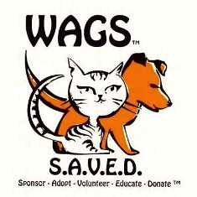

Hello WAGS Supporter and Friends,

We need your help more than ever! Become a sponsor for our WAGS to Riche$ 2018 fundraiser event. http://wagstoriches2018.eventbrite.com/ .

Help us continue our mission to increase adoptions of the stray and homeless pets.
In the past 7 years, WAGS has placed over 6000 animals in fur-ever homes! We have a robust TNR program- trap neuter (spay) and release which has proven method of reducing the cat population in a community over a period of time. We actively promote events which include children, families, and volunteerism. These include
- Dog/Cat/Kitten Yoga
  - Dog Cookie Making Class for kids
  - Reading to Cats for kids
  - B.A.R.K. program-socializing nervous/hard to adopt dogs
  - H.I.S.S. program-socializing “scaredy” cats
  - H.A.R.E. program-socializing adoptable rabbits

WAGS has even more fun activities coming in 2018 – 2019! WAGS does these events not only have socialization increase for the animals but to show our adoptable pets to guests in multiple settings and less shelter-like restricted housing. Additionally, these activities help promote WAGS as a community environment encouraging open door policies and visits.

We need your help as a sponsor to continue to care for over 600 animals on property. Please consider sponsoring WAGS at one of the individual levels or corporate sponsor levels. All the details are located on http://wagstoriches2018.eventbrite.com/

Sincerely,

Dr. Michelle Russillo, CEO

