Website Best Practices

for Organizations Interested in Expanding Foster Programs

Recommendations
- The foster section(s) of the website should be easy to find. This tells supporters your organization values foster caregivers.
  - Ideally, Foster should be viewable on the first/home page, whether it be a main menu item, a pop-up or some other type of mention. At a minimum, it should be no more than two clicks from the homepage.
  - Foster should be its own section, separate from Volunteer to avoid confusing it with volunteering at the shelter.
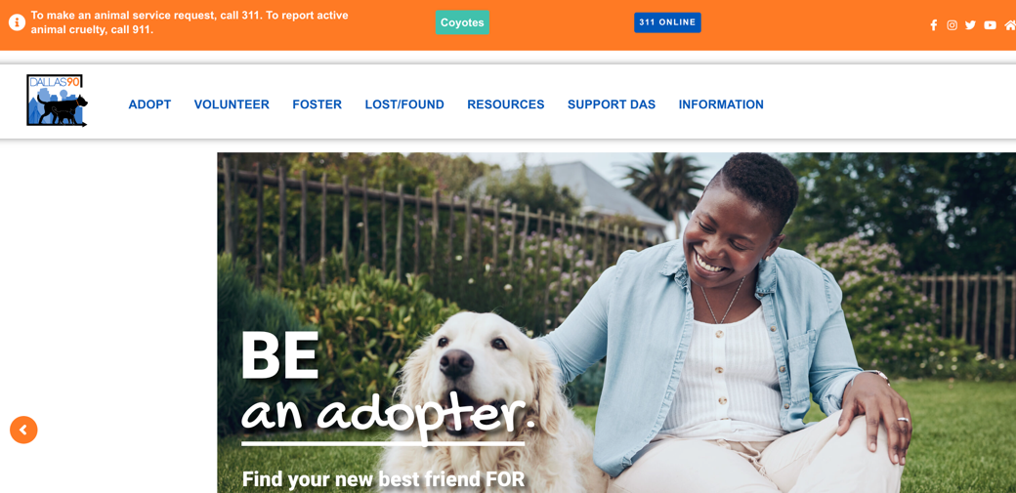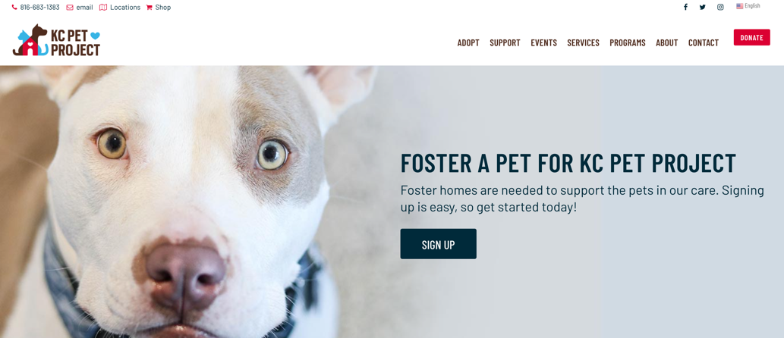
- Communication style
  - Friendly, helpful, inclusive language
  - Avoid discouragement, confusion and any sense that your organization may be “screening out” foster applicants.
  - Use pictures, bullet points and short text to keep people moving toward the call to action - avoid lengthy paragraphs.
- Separate information for those signing up to foster and resources for current fosters. Separating these will increase ease of use.
  - A section/page for those considering signing up to foster
  - A separate foster resource area with information for current fosters (foster manuals, information about medical issues, how to market pets from foster, etc.)
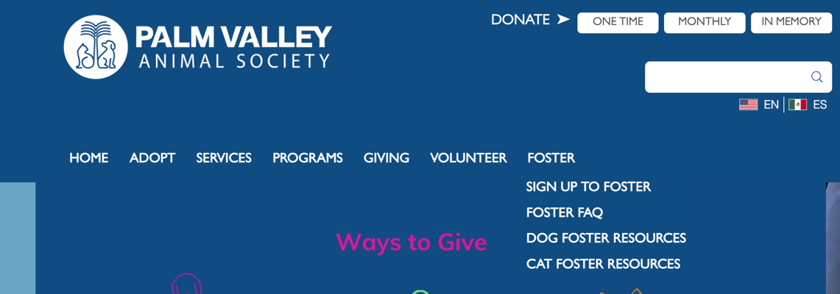
- Page(s) should be actionable
  - Allow people to help themselves as much as possible.
  - Make sure all the resources a foster would get from someone on the phone or through email, can be accessed online.
  - Allow the public to sign up to foster online as well as in person.
    - If you’re providing training, putting the training/orientation online is recommended (those who sign up in person can do this in person).
  - Set expectations for the next steps in the foster process—
    - How long will it take before they will have a foster animal?
    - What steps will they need to complete before they are ready to foster for you?
    - What do they need to provide to foster a pet, versus what will you provide?
- Make pets most in need of foster caregivers viewable on the website, if possible. For those who don't have the ability to link animals to their website, Trello or Facebook are other ways to showcase pets in need of placement.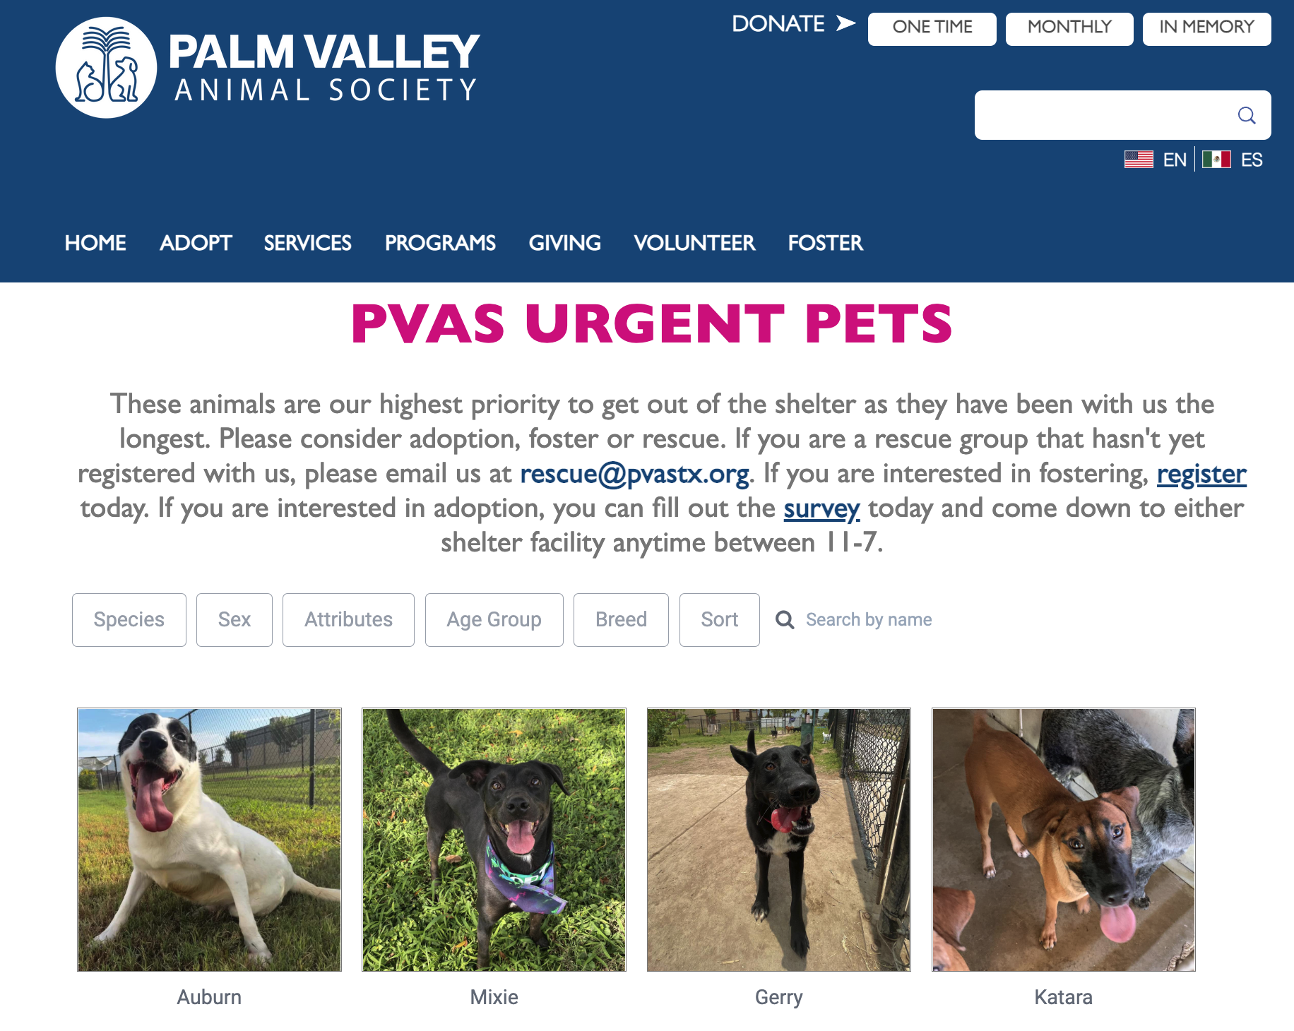
- Audit the page periodically to make sure information and links are still working and are up to date.

Contents: New Foster Sign-Up Page
- Explain why pets need foster caregivers (Shelter stress, 1-on-1 attention, practice living in a home and forming bonds with caregivers, reduced exposure to germs, etc.)
  - Brief information about the organization and its mission relative to the foster program
- Explain types of fostering that are available (e.g., sleepover, short term, long term) as well as types of animals (species, needs, age, etc.)
- Set expectations by clearly describing a foster caregiver’s responsibilities relative to the type of foster they’re considering. If possible, include information about how they will be supported as well.
  - Caring for the pet
  - Medical appointments and vaccines
  - Marketing a foster pet
  - Helping a foster pet get adopted
  - Estimated time commitment
- Clearly list the steps to becoming a foster parent
- Offer other ways to support foster if you can’t foster a pet (e.g. social media, events, photography, writing, etc.) and how to sign up for it
- Supplies and medical care that your organization will provide
- Testimonials and/or video from foster caregivers that highlight how easy and rewarding it is; ?contact info from foster caregivers who can answer questions about fostering?
- Program-related information
  - Contact information
  - Walk-in hours
  - Frequently asked questions

Contents: Foster Resource Page
- General program information
  - Program staff/volunteer information- “Meet the Team!”
  - Information & guidance about adoption policies/processes
  - Is this an emergency? (how to know if you need to urgently seek support)
  - Emergency support (contact info, general policies, after hours instructions)
  - Facebook or other source for connecting w/ other fosters
  - What to do if a pet is lost
  - How to make an appointment for vaccines, etc.
- Foster manual
- Relevant organizational information (links to social media, website, etc.)
- Information & guidance for common medical issues
- Information & guidance for common behavior issues
- Information & guidance for puppy/kitten socialization needs
- Marketing resources (guidance, links to submit photos/bios, etc.)
