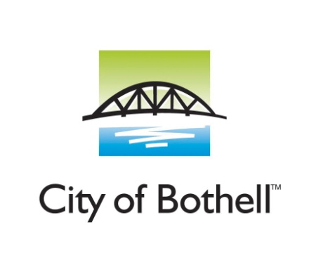
Animal Control
Date:__________ Time:__________ Case #__________
To: _____________________________________________
Address:___________________________________________________________________________________
Bothell Animal Control is investigating an incident involving an animal. We believe you may be of some assistance in the following matter(s).
- Animal Bite
- Animal Cruelty
- Animal Running at Large
- Noise Complaint
- Failure to obtain pet license
- Animal detained at PAWs Animal Shelter
- Other:______________________
- 24-hour notice to respond. Please call Animal Control at 425-487-5145 to contact the investigating officer. Failure to respond could result in legal action.

Thank you,

______________________
Animal Control Officer
Bothell Police Department
18410 101 st Ave NE
Bothell, WA 98011

How to license your pet in Bothell?

ONLINE

To license your dog or cat online, go to www.PetData.com and select Bothell from the customer service drop-down menu. Click on ‘Online Licensing’ on the upper left side of the screen. You can license multiple pets at the same time, and easily upload required documents. All major credit cards are accepted, and a small convenience fee will apply per transaction.

BY MAIL

To license by mail, simply mail a copy of applicable documentation, along with your check payable to “City of Bothell” to:
Bothell Animal Licensing
C/O PetData
PO Box 141929
Irving, TX 75014

IN PERSON

A pet may also be licensed in person at Bothell City Hall between 8 am and 5 pm Monday through Friday. Please be sure to bring proof of your pet’s spay or neuter with you. Bothell City Hall is located at 18305 101st Avenue NE, across from the Bothell Police Department. Payment in person is by check or cash only.

City of Bothell does not permit having more than three pets at one residence without a Kennel, Cattery, or Special Hobby Kennel License.

