MISSOURI ANIMAL CONTROL ASSOCIATION
ANNUAL TRAINING CONFERENCE
October 12th – 14th, 2022
Camden on the Lake Resort, Lake Ozark, Missouri

EXHIBITOR REGISTRATION

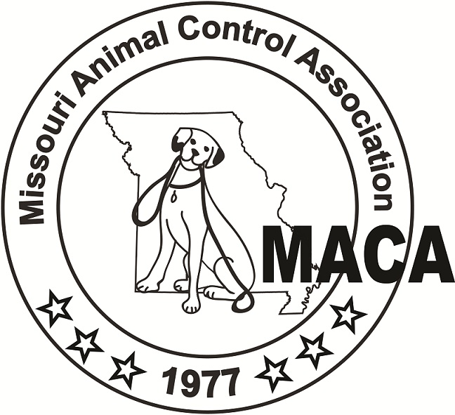
Organization Name: _________________________________________________________________

Representative’s Name: _______________________ Contact Number: ________________________

Number of 10x10 booth spaces needed? ___________

Number of days the booth will be manned. __________

Booth space will come with a table and two chairs provided and needs to be set up by 8:00 a.m. on Wednesday, October 12th, 2022, and may remain until 12:00 p.m. on Friday, October 14th, 2022. Exhibitors may set up Tuesday evening between 5:00 PM and 7:00 PM if they desire. Please list any additional accommodations needed. Registration deadline is 8/1/2022. Please list any additional accommodations needed. ________________________________________________________________________________________________________________________

Hotel Reservations: Exhibitors can enjoy MACA’s room rates for the conference. Exhibitors must make their own hotel reservations and state they are attending the MACA conference. This year’s conference will be held at: Camden on the Lake Resort 2359 Bittersweet Rd, Lake Ozark Missouri 65049. Phone: (573)365-5620; website: https://camdenonthelake.com/ . To guarantee the group rates and availability of a room, reservations must be made before September 30th, 2022. This year’s MACA room rate is: $140.35.

Meals and Events: This year all exhibitors will enjoy the meals and all conference social events and the awards banquet. The costs of meals and events will be included for each day your booth is open.

Registration Totals

Booth space: Only $300 x _____ spaces $____________

Total Registration Fee $____________

Please return this form, along with your registration fee as soon as possible. Make checks payable to Missouri Animal Control Association and mail registration to Stephen Norman, Exhibitor Chair, 701 Lower Lake Rd, St. Joseph MO 64504. You may also use PayPal to pay for a vendor booth at maca1.net by selecting the Exhibitor/Sponsor tab on the left of the home page, then add your sponsorship selection to the cart. NOTE: If you pay through the website, please mail this registration form to Stephen with a notation that payment has been made via the website. Thank you.

