I’ve adopted a Barn Cat, Now What?
Congratulations. You now have a free and all natural way to keep those pests out of your barn!
But now that you have the cat, what are your next steps? The most important thing to do is make sure that the cat “bonds” with the barn. This is called the Acclimation Stage.
The first thing you will need for the acclimation stage is a large wire dog crate. You will set it up in the barn. And the physical set-up of the barn is important because it determines where to place the cage.
The main considerations are these – The cats need to bond with the new environment; they should be able to see people and farm animals coming and going from the barn. The cat(s) need fresh air and light; their cage should be next to a window or in a center aisle, or a busy tack room. A great location is in the midst of barn traffic to get the cats acquainted to life in their new environment.
The cats will need to stay in this kennel set up for about 5 weeks. The barn cage pictured below gives you an idea of the set up.
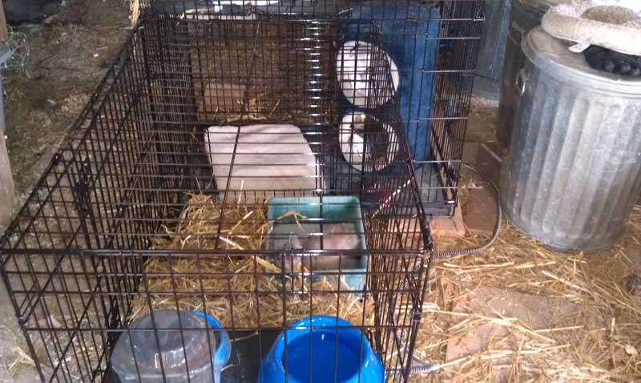
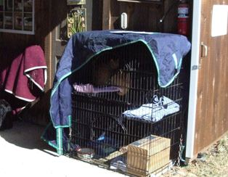
What do the barns need to provide in the way of supplies?
· Cat food – dry is essential; wet food is a bonus. · Special food like tuna fish or juice is great, but commercial cat food contains nutrients that cats need for their diets.
Some people feed their cats wet food—specifically in the evening during the acclimation process and continue that practice after the cage door is open—to help ensure that the cat will return to the barn for the evening feeding and then they close the cats into the barn at night to protect them from predators.
· Most of the rescue people we know recommend Purina One for dry food and Friskies for wet if you are budget conscious.
· Large water bowl.
· Food bowls – separate bowls for wet and dry are ideal.
· Litter – any kind and the smallest litter pan you can buy.
· Soft blanket or cat bed– cats like soft places.
· If the cat is feral, definitely a little house for them to hide in; a small cat carrier can fit in the cage. It is also helpful to cover the top of the cage with a blanket. You can also cover part of the cage with a blanket as seen above.

Other helpful tips about the acclimation process.
· The cats need to bond with their caretaker. You are automatically doing this when you feed them.
· Cats like toys and it is really nice for barn owners to buy the kind of rope or feather toys that allow them to interact with/play with the cats. This will also help in the bonding process. Remember, you are leaving them in the kennel when you play!
· The cats need a regular feeding schedule; morning and night. The litter box needs to be cleaned every day.
· The water needs to be changed every day.
The barn owners can usually tell how well the acclimation period is going by how the cats react when they open the door to feed them. If the cats are settling in comfortably, they will brush up against the feeder’s arm. But this may never happen with really feral cats, even though they may decide to stay in your barn forever so don’t get discourage if the cat continues to hide from you.
Even if cats are very skittish, it is often possible to pet them when they are eating – especially when they are eating something they really love – like wet food or tuna juice. If you have very, very skittish cats, try feeding them wet food on the end of a wooden spoon (as a friend-making gesture).

How do you recommend handling the “release” of the cats?
· After five weeks (some do less; we recommend five because we have seen it work many, many times), tie open the door of the cage in the morning after feeding the cats. Walk away! Go about your normal day. Give the cats a chance to come out on their own. They may even dart out and take off to hide in the barn. But they know where the food is! Leave the kennel door open and continue to feed the cats – in feed bowls in the cage – and continue to change the water and the litter regularly.
If you have a barn that you can close up at night – please do so – it will help protect your cats from predators.

What about the Winter Time?
Hay will not provide the insulation feral cats need to help them keep warm. Straw, being hollow, traps the heat from the cat’s body and helps them keep warm. Similar situation when you dress in layers – you create pockets of trapped air that are filled with your body heat. Providing a place for them to get out of the wind/rain/snow, that has some insulation, and preferable where they can snuggle together is ideal.
Some barn owners place dog igloos in barns and stuff them with straw. The straw works really effectively as an insulator per the recommendations above.
Heated water bowls are really great for winter. You can buy them for as little as $20 on amazon.com and they are very low voltage and have steel insulated cords, which appears to make them goat-proof.

