Tips and Trick for Incorporating Behavior into Day to Day Operations.

Many of us struggle with meeting our animals behavioral needs.

Where to start – evaluate yourself against the standards – how do you measure up?

Guidelines for Standards of Care in Animal Shelters page 26
https://www.sheltervet.org/assets/docs/shelter-standards-oct2011-wforward.pdf

Shelter Checklists Based on ASV Guidelines page27
https://www.aspcapro.org/resource/shelter-checklists-based-asv-guidelines

Large behavior team that we all desire (similar to a vet team)

Many have tried, many have failed, many have just given up and moved on. This has been my experience for over 30+ years.

For some reason we can’t get there… what else can we do?

- Teach/Train/Empower and rely solely on others to do daily implementation of programs/plans
  - Staff / Volunteers / Interns / Foster parents
- Becomes part of general operations
  - Treat buckets / Quiet kennel (pennies from above) / Animal communication / body language/safe handling / Hide, perch, scratch / Fear Free

Create/Build a culture
That includes general feed/clean/disease control along with – behavior best practices
- Firstly, it needs to be the organization's goal to have a holistic approach to animal well-being.
- Behavior is not a chore is a culture that needs to be embraced by all
- Embrace the Five Domains of Animal Welfare (https://kb.rspca.org.au/knowledge-base/what-are-the-five-domains-and-how-do-they-differ-from-the-five-freedoms/
- Review Intake policies on behavior
- Animal handling policy (Last page of this document)
- Build a team that makes you look good
  - (eg. Teacher/Marine Mammal trainer – can go well or not so well)
  - I hired a teacher who was doing animal care) You don't need another you.
- Why are you there? What's your goal? Chunk it down into smaller bites (sound familiar animal trainers)
- Euthanasia review monthly (Directors / Supervisors start at Department Level) judgment free it’s how to improve. Be Challenged in a professional manner
- Depending on your position, understand your budget (at least a little)
- What do higher ups need to justify expenditure (that cost could simple be time)
- Set your policies (Animal Handling, Treat Pouches, Clickers, Verbal Tone)
- People are can be resistant to change/feedback (You catch more flies with honey than vinegar)
- Get them adopted if they're safe “Fast Track” (Each organization will be different) Fully committed rehab takes a large amount of resources which you may not have. Use what resources you strategically and what's best for the animals. Resources could be used to help keep animals out of the shelter, think bigger picture.
- Have education materials / resources on hand (Get your organization to invest in educational materials https://forum.maddiesfund.org/discussion/community-conversations-1923-go-with-the-flow-increasing-efficiencies-using-animal-data
- Set expectations from the staff (Tell me what you see not what you think)
- Behavioral definitions, all speak the same language
- Use data, daily reports, animal status reports
- Training animals is not behavior mod, it's a part of it.
- We build “Trust Banks” in animals, why not your people?

It will take time, there are things I presented 8 years ago that are now just happening. Set priorities and have at it. You can make it happen.

Tips and Tricks (The People Part II)
- You have to be a people person
Don’t
- Force/Bulldoze People (you know how it could be better but how do you get there)
- Disregard people's views
- Think your always right
- Think that everyone is committed like you, for some it's just a job.
- Think you can save them all
- Don’t close your door
Do
- Be kind to yourself
- Invest you time on the floor with people (show them) Regularly: – relationships will create buy in!
- Get to know the people, use their life skills as analogies to help them understand animal behavior (you have hidden gems)
- Manage your resources, (you can't do everything so prioritize, learn to delegate, break it down, it takes as long as it takes: sound familiar?) Did you know that the average manager gets interrupted approximately once every eight minutes? That's about seven interruptions each hour. What's worse, after every interruption, it takes an average of 25 minutes to fully regain cognitive focus
- Build your team to work around the loss of any team member
- Post learning materials (Bilingual) e.g., educational posters such as fear free posters, body language, etc.
- Stay educated and follow best practices (continuing education/membership repayment agreement – invest in your team)
- Explain the why’s (EU let’s talk it through together)
- Tell software companies what you need to improve well-being and save lives
- Have a training session using post it notes on animal flow. (let line staff decide what note goes where, the big picture)
- Remember the line staff know the animal best, talk to them
- Click Tickets with prize draw once a month (work with CEO/HR so all are involved)

Explain Demonstrate Supervise (“See One, Do One, Teach One.”)
- Explain why they need to know this and how it can benefit them
- Demos (Thresholds, Doorways)
- 20% of people take up 80% of your time, don’t forget the good 80%.
- Learning styles (Find out how each person learns best)
- Train the Supervisors/senior staff if you can't train everybody – set your standard
  - With financial incentive?
- Buckets on kennels (Everyone gets a chance to reward good behavior)
- Do the best with what you have and go from there.
- You only remember 25% of what you were told 48 hours later

The Animal Part
- Open door policy, but tell me what you’ve seen, not what you think
- Don’t make their last day their worst day. Buy them a burger etc. Do EUs somewhere safe but comfortable. (New challenge). EU GARDEN, blankets etc.
- Fear Free is free (for shelters)
- Go to the kennels or the cage and show them threshold and changes in behavior
- Trips and tricks board.
- Language they can understand (KIS)
- Use analogies spiders
- 5 Second rule (time of rewarding desired behavior after an unwanted behavior
- No if, buts or maybes. No punishment (I don't even use the word no)
- Correction can train animals not to give behavior signals therefore losing important cues and them escalating to the next level “they just bit”
- You get what you pay
- Be proactive not reactive
- The Animal Tells the Story if you’re willing to listen
- Collaborate (Do not get stuck in your own bubble)

- What is your number 1 behavior to reinforce? (Calm, if you're not calm you can't think and if you can't think then you can't learn)

Characteristics of Adult Learning https://ncea.acl.gov/What-We-Do/Education/Adult-Learning-Principles.aspx
There are some common characteristics of adult learning that are important to be aware of when developing training.
- Adults have the need to know why they are learning something.
- Adults learn through doing.
- Adults are problem-solvers.
- Adults learn best when the subject is of immediate use.
- Repeat, repeat, repeat. Studies have shown that adults remember things better if they have heard them 3 times.
- Transfer of learning for adults is not automatic and must be facilitated. Follow-up support (for example, by supervisors on the job) helps adult learners incorporate what they have learned into their daily practice.

Learning Styles

We all have a preferred way of learning. It is how we learn best. There are three main styles—seeing, hearing, and doing. Because there is no way of knowing in advance the preferred learning styles of an audience, training should incorporate all three modes. A useful exercise with adult learners is to have them identify how they learn best. It allows the trainer to modify the presentation if necessary to best meet the audience's needs and allows the audience to maximize their educational experience by focusing on what benefits them the most.
- Visual
Visual learners have a preference for seeing (use visual aids such as powerpoint slides, videos, diagrams, handouts, etc.). They understand information better if they can read it.
- Auditory
Auditory learners learn best by hearing information (use lectures, discussions, tapes, etc.).
They can usually remember information more accurately when it has been explained to them verbally.
- Kinesthetic or Tactile
Tactile/kinesthetic learners prefer to learn via experience—moving, touching, and doing (use role play, exercises, hands on activities, writing, etc.). They can absorb information best if they are physically engaged in the learning process.
Mix it up. Not all groups have the same learning style. Incorporate activities for all learners. It adds diversity and interest to the presentation.

Training Is Best When the Information …
- Is Useful and Relevant
Adults will be more interested and invested in the training if they consider it realistic and relevant to them. Being able to apply it in the 'real world' is important to adult learners.
- Builds On and Utilizes the Learners' Own Skills and Experiences
Adults have a wealth of experience that they bring to training. Successful training stimulates learners to use their knowledge in new ways and in new situations. This builds on the learner's competence.
- Helps the Learner Achieve Their Objectives
Learners are interested in training which help them realize their goals. Creating learning objectives for the training informs the adult learners about what they can expect to learn.

Create a Conducive Learning Environment
- Supportive Environment
Adult learning has ego involved so it is important to create a supportive environment for the participants. Building a sense of community through warm-up or ice breaker exercises and structuring the training to encourage support from peers will reduce the fear of judgment during learning.
- Provide Feedback
Adults need to receive feedback on how they are doing and the results of their efforts. Having activities that allow the participant to use what they have learned and receive structured, helpful feedback will make the training more meaningful.
- Small-Group Activities
Adults benefit from small-group activities during the learning to allow them to move beyond understanding to application, analysis, synthesis, and evaluation. Small-group activities provide an opportunity to share, reflect, and generalize their learning experiences.
- Opportunities to Apply What is Learned
It is helpful to have opportunities to apply what they are learning to their own experiences. It allows them to 'test drive' what they are learning to see how it applies in their real work.

Animal Handling Policy
This policy is designed to assist staff, volunteers, contractors and interns (herein “members”) in understanding the expectations of the Animal Rescue League of Iowa, Inc. _______ with the regards to the handling of animals. It is essential that all representatives of the ________ display the same high standard of animal care and handling that’s expected from our clients and other animal care professionals.
All members who are involved with the handling of animals will receive training in Positive Reinforcement Techniques, Animal Handling and Body Postures and Animal Communication.
- Every person must afford each and every animal due care, consideration, respect and compassion.
- Prejudice or biases towards a particular breed on the grounds of personal preferences or beliefs is not acceptable.
- No animal should be caused unnecessary discomfort or undue stress as a consequence of act or omission by a member of the ________.
- Appropriate equipment, positive training and Fear Free techniques must be used when handling any animal to minimize the level of stress placed upon the animal. Care and time is needed when dealing with frightened and uncooperative animals. Unnecessary use of restraint, scruffing or dragging of animals in any way, including by the leash, is unacceptable.
- Any person who teases, tortures or terrifies, infuriates or provokes, abuses or otherwise inflicts pain or unreasonable stress upon an animal will be subject to disciplinary action or may have their employment or agreement with the ______ terminated at the discretion of Management. They may also be prosecuted under Iowa Code, City or County ordinance.
- All members must always be accurate in their reporting of all aspects of animal related information. For example: behavioral problems such as biting, resource guarding, inter dog aggression, etc. and health problems must be recorded. Our aim is to determine the most appropriate course of action for each animal in our care. Inaccurate, misleading or withholding information places both animals and people at risk.
- Concerns for personal safety gives all members the right to refuse to handle an animal. This includes but is not limited to entering the enclosure, handling, feeding, walking and home visits. In all circumstances that members of the _____ believe themselves at risk they must not proceed and should contact their supervisor as soon as possible for instructions.
I HAVE READ ALL OF THE ABOVE. I UNDERSTAND THE ABOVE CONTENT.
Signature Print Name

Front-line Business Management Program Overview:
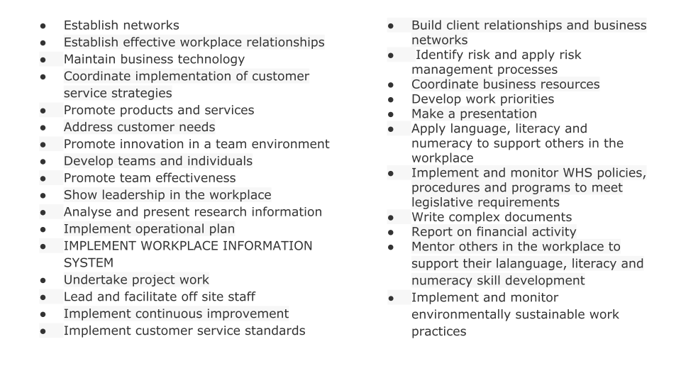Business Pyramid
