Open Arms Challenge Group:
https://maddies.fund/openarmschallengegroup

Huddle Registration Link:
https://maddiesfund-org.zoom.us/meeting/register/tZckduupqjsoGNGtPuk2fatmO_acogXGlPx7

Agenda
- Welcome – Wendy Frink, Marketing Specialist at Maddie’s Fund and Gina Knepp, National Shelter Engagement Director at Michelson Found Animals Foundation
- Speakers – Luis Quintanilla from Harlingen Humane Society and Shannon McKenzie from Underdog Rescue
- Q&A
80 live attendees

Previous Huddle Recordings & Discussion Threads

- Open Arms Challenge Group on Maddie’s Pet Forum: https://maddies.fund/openarmschallengegroup
- Open Arms Challenge Huddle #1 recording & discussion thread: https://maddies.fund/openarmschallengehuddle1
- Open Arms Challenge Huddle #2 recording & discussion thread: https://maddies.fund/openarmschallengehuddle2
- Open Arms Challenge Huddle #3 recording & discussion thread: https://maddies.fund/openarmschallengehuddle3
- Open Arms Challenge Huddle #4 recording & discussion thread: https://maddies.fund/openarmschallengehuddle4
- Open Arms Challenge Huddle #5 recording & discussion thread: https://maddies.fund/openarmschallengehuddle5
- Open Arms Challenge Huddle #6 recording & discussion thread: https://maddies.fund/openarmschallengehuddle6
- Open Arms Challenge Huddle #7 recording & discussion thread: https://maddies.fund/openarmschallengehuddle7

Resources Shared During Call
- Subaru Dealership Pet Causes: https://www.subaru.com/pets/pet-causes.html
- Front Street Sacramento: http://www.cityofsacramento.org/Community-Development/Animal-Care
- Halloween Candy Pet Adoption
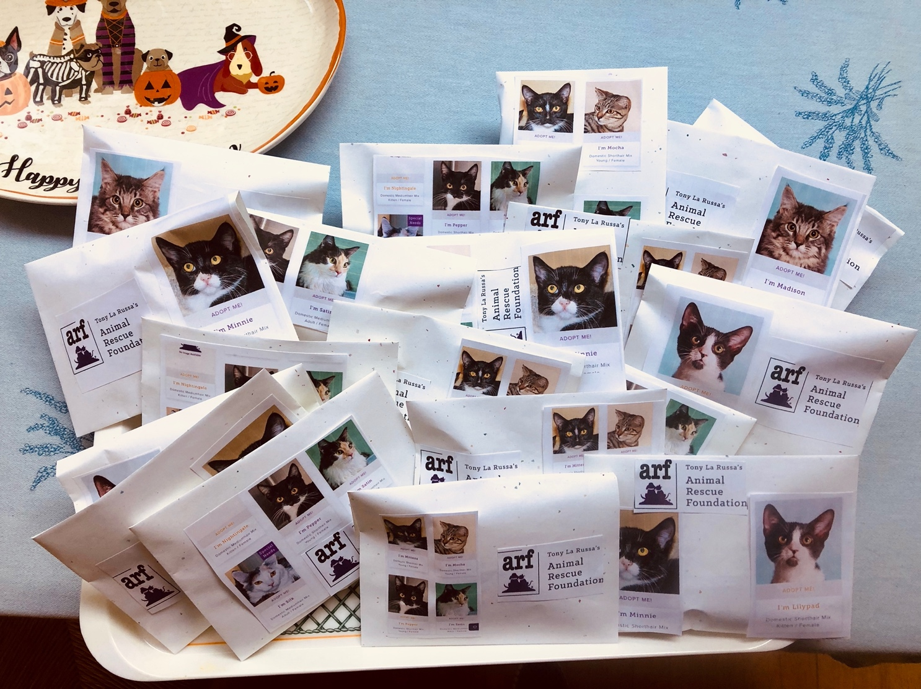

Chat Log

09:51:31 From Alison Gibson to Waiting Room Participants:
Welcome! We will be starting at 10am Pacific. Be sure to come by Maddie’s Pet Forum after the program. Our presenters will be available for questions, and we will also share resources there https://maddies.fund/openarmschallengegroup
09:51:43 From Alison Gibson to Waiting Room Participants:
Watch the recording of this and previous huddles here: https://www.maddiesfund.org/open-arms-challenge-huddles.htm
09:58:10 From Alison Gibson to Waiting Room Participants:
Welcome! We will be starting at 10am Pacific. Be sure to come by Maddie’s Pet Forum after the program. Our presenters will be available for questions, and we will also share resources there https://maddies.fund/openarmschallengegroup
09:58:59 From Alison Gibson to Waiting Room Participants:
If you join the Forum make sure to join the Animal Welfare Group and the Open Arms Challenge discussion thread.
10:00:47 From Peg Lucky to Everyone:
Peg Lucky, WFAHS from St Francisville, LA
10:00:49 From Anna Domings to Everyone:
Anna, Here Today Adopted Tomorrow Animal Sanctuary, Brimfield MA
10:00:49 From Julie Rickmond to Everyone:
Julie from the Roanoke Valley SPCA in Roanoke, VA
10:00:53 From Gina Knepp - Michelson Found Animals to Everyone:
Hello everyone!! Gina Knepp, Michelson Found Animals here with you from Hamilton, Montana
10:00:54 From Kim Cross to Everyone:
Kim Cross, Friends for Animals of Metro Detroit, Dearborn, MI
10:00:55 From Mary Lou Harju to Everyone:
Beaver County Humane Society - near Pittsburgh, PA
10:01:06 From Alison Gibson to Everyone:
Wendy SOOO cute!!!
10:01:06 From Kelly Clardy (she/her), Maddie's Fund to Everyone:
Kelly from Maddie’s Fund - coming in from Hayward, CA
10:01:07 From Amy Berke to Everyone:
Amy Berke, St. Francis Animal Rescue of Venice FL
10:01:11 From Stephanie Rambo to Everyone:
Stephanie Rambo from Friends For Life Animal Rescue in NJ
10:01:13 From jennifer leary to Everyone:
Jen from Friends for Life Animal Rescue in PA
10:01:15 From Cindy Flauger to Everyone:
Cindy Flauger, Neenah Animal Shelter, Neenah, WI
10:01:16 From Kimberly Qualls to Everyone:
Hello! Kimberly here from LifeLine Animal Project in Atlanta!
10:01:21 From Angel Stock to Everyone:
Angel Stock, Its Meow or Never of Tallahassee
10:01:24 From Ann Bollmeier to Everyone:
St Francis Animal Rescue - Annie Bollmeier
10:01:26 From Brooke Valet to Everyone:
Hi! Brooke Valet, SPCA of Brevard - Titusville, FL
10:01:26 From Lisa Saunders to Everyone:
Lisa, Adopt A Homeless Animal Rescue, Baltimore
10:01:28 From Charice Davis to Everyone:
Hi everybody, Charice Davis here from Hands and Feet Pet Advocates in Knoxville, TN
10:01:36 From Michele MatchDog to Everyone:
Michele from MatchDog Rescue - New Jersey
10:01:38 From Sarah AGUILAR to Everyone:
Sarah Aguilar - Austin Pets Alive!
10:01:45 From Becky Koop to Everyone:
Becky Koop from Friends of Madera Animal Shelter
10:01:49 From Daryl Yankee to Everyone:
Daryl from Duluth, MN Animal Allies
10:02:02 From Carolyn Almos to Everyone:
Carolyn Almos, LA Animal Services
10:02:07 From Phablo Dias to Everyone:
Hello! Phablo Dias from Rio de Janeiro - Brazil
10:02:12 From Amanda Porter to Everyone:
Amanda from Humane Society of Forsyth County - Forsyth County, GA
10:03:24 From Melina Ramos to Everyone:
Morning Everyone! Melina from Heaven Can Wait Animal Society and Pups On Parole Las Vegas NV
10:03:28 From Katie Shannon to Everyone:
Aloha - Katie from Maui Humane Society
10:04:08 From Steve Marrero to Everyone:
Steve Director of Liberty County Animal Services in Hinesville, Ga
10:04:23 From Wendy Frink to Everyone:
Previous huddles and conversation can be found on Maddie’s Pet Forum: https://maddies.fund/openarmschallengegroup
10:04:59 From Lindsay Molloy to Everyone:
Lindsay Molloy, Denver Animal Shelter. Hi all!
10:05:59 From Lisa Saunders to Everyone:
Woohoo! You rock! That’s amazing. We need to do that in Prince Georges County, Md that still has BSL.
10:06:07 From Frances Alford to Everyone:
Hi all Frances from Its Meow or Never Tallahassee
10:06:16 From Melina Ramos to Everyone:
👏👏👏
10:10:25 From Donna Casamento to Everyone:
Underdog Rescue is awesome!!!
10:10:47 From Elena Gowe to Everyone:
Hi! Elena from Baywater Animal Rescue, Cambridge MD!
10:14:53 From Kelly Clardy (she/her), Maddie's Fund to Everyone:
Wow Luis that’s awesome!!!!
10:15:42 From Sharon Fletcher to Everyone:
Brilliant suggestion
10:16:34 From Anna Domings to Everyone:
Lol. Saying yes and then thinking “now what?” is very relatable Luis!
10:18:18 From Frances @ Its Meow or Never Tally to Everyone:
Absolutely agree Luis.
10:20:38 From Anna Domings to Everyone:
Amazing!!!
10:21:08 From Sharon Fletcher to Everyone:
Car dealerships, realtors too
10:21:28 From Irene Chansawang (she/her) to Everyone:
Is Nebraska Humane Society on this Huddle? They partnered with Subaru this month!
10:22:21 From Anna Domings to Everyone:
Yes!! One Health model!
10:22:28 From Mary Lou Harju to Everyone:
We aren't having luck with car dealerships. Can any of you who are email me what you are doing with them? mharju@beavercountyhumanesociety.org
10:22:43 From Jan Williams to Everyone:
Hello from DLRR, Phoenix.
10:23:08 From Melina Ramos to Everyone:
In Las Vegas we have partnered with some very interesting businesses ;)
10:23:18 From Jan Williams to Everyone:
Love the idea of partnering with realtors.
10:23:26 From Sharon Fletcher to Everyone:
I remember Front Street partnered with the EXPO center in Sacramento for a crafting event for a coat-check type role. They brought cats and dogs for the attendees to socialize and play with during breaks. It was brilliant and I believe several cats and dogs were adopted that weekend.
10:23:31 From Anna Domings to Everyone:
@Melina 😂
10:23:43 From Kelly Clardy (she/her), Maddie's Fund to Everyone:
Adoption events at apartment lobbies are brilliant!!
10:23:48 From Cindy Flauger to Everyone:
We just partnered with the Kiwanis, 6 area animal shelters and 6 local Brewery's to run a top dog contest. It was amazing and 6 top dogs will have a local micro brew named after the winning dogs
10:23:49 From Dar Ania to Everyone:
In Phoenix, I’ve run into the road block with organizations already being partnered with other large animal welfare groups so not being open to partnering with our small rescue. I’ve been told that from many car dealerships I’ve asked.
10:24:07 From Frances @ Its Meow or Never Tally to Everyone:
Yes put it on the forum
10:24:11 From Sharon Fletcher to Everyone:
@Melina - tell us more
10:24:15 From Melina Ramos to Everyone:
Yes and YEs
10:24:26 From Melina Ramos to Everyone:
We just did an event last night with a chaple
10:24:28 From Daryl Yankee to Everyone:
We've done Love-A-Pet adoption event with Subaru for years. They are a very pet friendly business
10:24:50 From Jan Williams to Everyone:
4/20...love it!
10:24:54 From Melina Ramos to Everyone:
YEs we have partnered with cannabis vendors and strip clubs
10:25:31 From Anna Domings to Everyone:
Dar, that is something we hear from businesses too. It’s frustrating. We just cast a wide net and hope someone bites—and they do! Especially local businesses who either have adopted from us or trap for us or what have you.
10:26:02 From Patty Caffrey to Everyone:
Do you call all of these community organizations or do you start with written correspondence. How do you get in the door?
10:26:02 From Sharon Fletcher to Everyone:
Luis - your team connected with a pizza parlor who distributed flyers on every pizza box on your behalf, right?
10:26:04 From Daryl Yankee to Everyone:
https://www.subaru.com/pets/pet-causes.html
10:26:31 From Irene Chansawang (she/her) to Everyone:
Thanks for sharing the link, Daryl!
10:27:02 From Dar Ania to Everyone:
Would people please share their “pitch” communication on the forum. I’d love to see what others are sending. We are new so still learning what works
10:27:09 From Jan Williams to Everyone:
exactly..we need to become more free of judgment!
10:27:15 From Anna Domings to Everyone:
YES. If we’re going to have open doors, it needs to be open to people from all walks of life. And I imagine you meet different folks by diversifying the locations you partner with! Strippers love pets too I’m sure!
10:27:18 From Shannon McKenzie to Everyone:
Tattoo parlors!
10:28:50 From Sharon Fletcher to Everyone:
Shannon and Luis - how do you reach out to all areas of your community?
10:29:18 From Dar Ania to Everyone:
The main shelter is where we pull from most and I’ve asked but they aren’t open to that. But I’ve done that with other large rescues. Def helps.
10:29:41 From Sarah AGUILAR to Everyone:
HALLOWEEN CANDY this weekend! Photos of adoptables for everyone!
10:29:58 From Anna Domings to Everyone:
Sarah, what a great idea!
10:30:28 From Irene Chansawang (she/her) to Everyone:
Yes, Sarah! Kit Kats...what's a good dog one? LOL
10:30:33 From Kay Amland to Everyone:
Luis- good ideas, simple and effective.
10:30:55 From Sharon Fletcher to Everyone:
The Front Street volunteers are amazing…they did a great job when I asked where they were from.
10:31:21 From Kelly Clardy (she/her), Maddie's Fund to Everyone:
Sarah and Irene, expanding on that idea - what about setting up a Trunk or Treat event at a local business, maybe even a car dealership - have candy for the kids and animals for everyone!
10:31:33 From Sharon Fletcher to Everyone:
@sarah aguilar - you are brilliant!!
10:31:34 From Jan Williams to Everyone:
yes, maximize the Vols skills sets..we are a 100% Volunteer rescue and also would not be able to succeed without them.
10:31:48 From Anna Domings to Everyone:
Good question, Gina.
10:31:59 From Irene Chansawang (she/her) to Everyone:
FUN @Kelly!
10:32:07 From Sharon Fletcher to Everyone:
@Kelly Clardy - love that...
10:32:30 From Sarah AGUILAR to Everyone:
I wish I could take credit but it's not my idea - just one I share every Halloween and valentines!
10:33:03 From Sharon Fletcher to Everyone:
@sarah a - thanks for sharing
10:34:47 From Irene Chansawang (she/her) to Everyone:
@sarah - same - I think I saw a group use Kit Kats. :)
10:34:52 From Jan Williams to Everyone:
love bilingual"ish"...me too! Great descriptor.
10:36:04 From Anna Domings to Everyone:
Yes, Luis, thank you for bringing up language and bilingualism. It’s not just about speaking the language, it’s also about having the community know-how (and also the animal welfare vocabulary…. I speak Spanish but they didn’t cover how to say “foster” or “TNR” in class! 😂)
10:38:13 From Sharon Fletcher to Everyone:
My marketing brain is reeling with how you can message that in your community to grab attention…fun!
10:40:30 From Sarah AGUILAR to Everyone:
Pets with orange/black fur OR PSL colored pets
10:40:45 From Anna Domings to Everyone:
Yes. The only thing people love to talk more about animals is THEIR animals.
10:41:02 From Anna Domings to Everyone:
*the only thing people love to talk about more than animals is THEIR animals
10:41:09 From Melina Ramos to Everyone:
Perhaps Easter Egg hunt with candy and info in the egg about adoptables?
10:41:33 From Irene Chansawang (she/her) to Everyone:
Cute @Melina! I love that!
10:41:35 From Alison Gibson to Everyone:
Love it, @Melina!
10:42:46 From Sharon Fletcher to Everyone:
Not really stealing…sharing and lifting each other toward the same goal!!
10:42:50 From Dar Ania to Everyone:
Luis - does hshtx partner with rescues out of state, if so what does that look like? (Not necessarily asking about those rescues in areas with a lack of animals to transport)
10:42:52 From Anna Domings to Everyone:
^^^ Sharon
10:43:00 From Sarah AGUILAR to Everyone:
<3 Sharon
10:43:06 From Alison Gibson to Everyone:
Front Street Animal Shelter (Sacramento CA) http://www.cityofsacramento.org/Community-Development/Animal-Care
10:46:40 From Lisa Saunders to Everyone:
We are a small rescue and most of our pups don’t do well at an adoption event because we take the more challenging cases. Any ideas for events or businesses that might work for those guys?
10:47:09 From Alison Gibson to Everyone:
We will post the recording on Maddie’s Pet Forum. You can join the Open Arms Challenge group here: https://maddies.fund/openarmschallengegroup
10:47:12 From Patty Caffrey to Everyone:
Thank you so much!
10:47:13 From Melina Ramos to Everyone:
Thank you for a great huddle
10:47:18 From Anna Domings to Everyone:
Thank you!
10:47:19 From Charice Davis to Everyone:
Thanks so much!!
10:47:19 From Kay Amland to Everyone:
👏
10:47:24 From Kelly Clardy (she/her), Maddie's Fund to Everyone:
Thank you Luis and Shannon!!
10:47:27 From Sharon Fletcher to Everyone:
Thank you everyone!
10:47:33 From Becky Koop to Everyone:
Thanks!

------------------------end-----------------------

