Meeting Recording (no access code needed)
https://maddiesfund.box.com/s/hyoczwrxembv8ym9vlwj3pvtw41c2d9t

Agenda
- Welcome – Kristen Hassen, Director, American Pets Alive! Kristen.hassen@americanpetsalive.org
List your intake issues in the chat
- Mary's Motivation – upcoming conferences, Maddie’s Candid Conversation with Gabrielle Chapman and Justin Marceau, Quote about guilt from President Biden’s speech in Tulsa, OK
- National updates
- Dr. Paula Tarankow, Professor of History at Smith College - African American animal advocacy within the broader historical context of animal protection after the U.S. Civil War
- Close

List of resources referenced during today’s call

Mary Ippoliti-Smith’s recommendations:

Maddie’s® Candid Conversation Special Edition with Gabrielle Chapman and Justin Marceau – watch on Maddie’s® Pet Forum
http://bit.ly/candidconvochapmanmarceau

Upcoming virtual conferences
June 8-10, 2021: The Association for Animal Welfare Advancement Spring Conference
https://theaawa.org/event/2021Spring

June 17, 2021: Humane Canada’s Mini Event - The Future of Sheltering
https://humanecanada.swoogo.com/minievents/1177765

June 23-24, 2021: Best Friends National Conference
https://bestfriends.org/events/best-friends-national-conference

July 9-11, 2021: The ASPCA® Cornell Maddie’s® Shelter Medicine Conference
https://www.aspcapro.org/splash/aspca-cornell-maddies-fund-shelter-medicine-conference

President Biden’s speech in Tulsa, OK June 1: https://www.pbs.org/newshour/politics/watch-live-biden-honors-victims-of-tulsa-race-massacre

HASS https://www.humananimalsupportservices.org/
Community Cat Programs (CCP)
Communications Guidelines for Animal Welfare Organizations: https://docs.google.com/document/d/1p0MybXxJ5ZWkamRqwQWCVI6glCePqwBcSgx7ffHuV-w/edit?usp=sharing

Dr. Paula Tarankow, Professor of History, Smith College
https://www.smith.edu/academics/faculty/paula-tarankow
tarankowpaula@gmail.com
Dissertation: “Loyal Animals, Faithful Slaves: Animal Advocacy, Race, and the Memory of Slavery” (Indiana University, 2019) https://iucat.iu.edu/iub/17608978

Book by Mim E. Rivas: Beautiful Jim Key: The Lost History of the World's Smartest Horse
https://www.abebooks.com/Beautiful-Jim-Key-Lost-History-Worlds/30903890779/bd?cm_mmc=ggl-_-US_Shopp_Trade-_-product_id=COM9780060567040USED-_-keyword=&gclid=Cj0KCQjwnueFBhChARIsAPu3YkRWBfupvU1vLRirsDsXpUWx2pDP1VYbghvuBMDSTYOBtnaLDM6tMj0aAuD-EALw_wcB

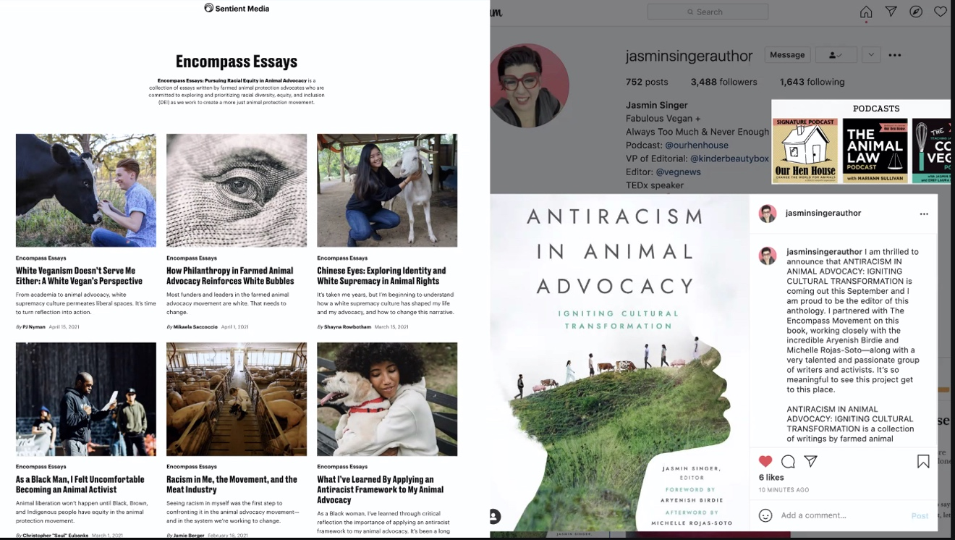

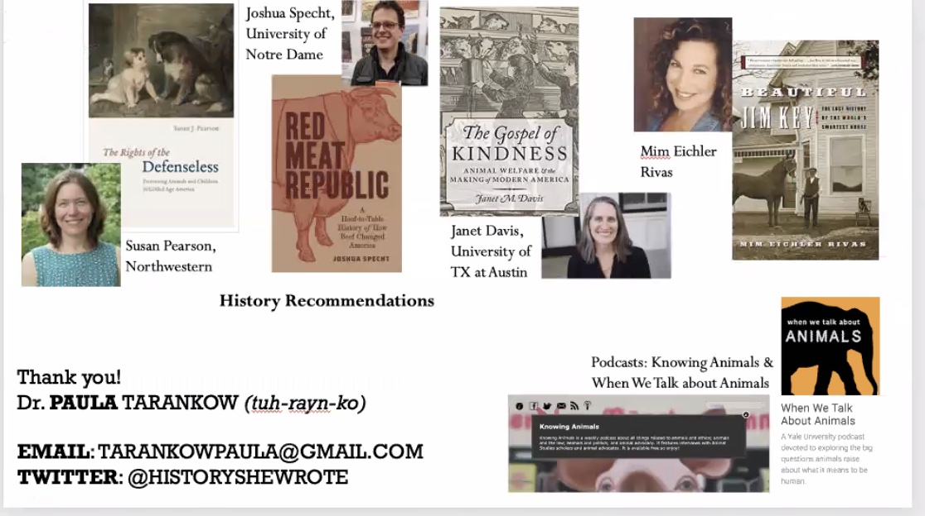

Katie Jarl recommends a children's book about Jim Key for a younger audience: https://www.amazon.com/Step-Right-Up-Taught-Kindness/dp/1620141485

Julie Levy If your organization can accept transports of dogs and/or cats from El Paso, please email me at levyjk@ufl.edu and I will connect you with our team that's on site now. :)

Gary Willoughby recommends “Pet Keeping and Pet Hiding in Black America”
https://ushistoryscene.com/article/pets-black-america/

Kathy Duncan : an Indigenous artist has designed a t-shirt which the Metis of British Columbia are selling and all of the profits will go to supporting indigenous children and youth: https://metis-nation-british-columbia.myshopify.com/collections/newreleases

Shannon Glenn recommends Rental Research Dashboard https://www.mypitbullisfamily.org/research/

Nancy McKenny - free legal aid & advise deducted exclusively to animal shelters, Shelter PALS out of SF SPCA. (PALS= Policy & Legal Services)

Jerrica Owen, NACA “Animal Care and Control Today” Magazine
https://www.nacanet.org/animal-care-control-today-magazine/

Valerie Sheppard: Webinar you want to attend: 6/16/21 Access to Veterinary Care: Community Care Models to Prevent Relinquishment https://learning.theaawa.org/p/sheltermed-6-16-21
Approved for RACE CE

Brent Toellner - People, Pets, and Policies: Towards Community Supported Animal Sheltering
https://network.bestfriends.org/tools-and-information/people-pets-and-policies

Webcast: The Top Ten: Questions and Controversy with Community Cat Programs
Friday June 25 at 12n PT -
Register here: https://maddiesfund-org.zoom.us/webinar/register/WN_NEcrYUdORHursmeF76ki_w

-----------------end----------------

