This Meeting Recording
https://forum.maddiesfund.org/communities/community-home/digestviewer/viewthread?MessageKey=06b64c8a-5326-4f76-8bd5-1ab06974cdf5&CommunityKey=afce7f7a-fd5a-431e-9f2a-aaedc46a03d6&tab=digestviewer

Find all of our recordings on Maddie’s Pet Forum
https://forum.maddiesfund.org/communityconversations
Box link: https://maddiesfund.box.com/s/q4204wfccnwt05iwhc7g4v6i8ljvc41t

Friday meeting registration page
https://us02web.zoom.us/meeting/register/tZEud-2orzMrHtLTuNo0GbrSNeCQlQkdWKAp

Monday meeting registration link (for shelter staff and committed volunteers)
https://us02web.zoom.us/meeting/register/tZUqc-6spj0jHtES3GWxrpaG6L3HcbMh_dCu

Agenda
- Welcome – Kristen Hassen, Director, American Pets Alive! - Things you can do now to keep shelter populations from spiking
Kristen.hassen@americanpetsalive.org

- Mary's Motivation – Remember, you do not have to do it all by yourselves! Maddie’s Fund Executive Leadership Team are Mary Ippoliti-Smith, Amy Zeifand and Dr. Laurie Peek. They support each other.
As CARE.org says, “The future we’ve been waiting for has been here all along.”
- Intake issues - Things you can do now to keep shelter populations from spiking
  - Mike Wheeler, Cabot (AR) Animal Support Services, mwheeler@cabotar.gov
  - Donna Casamento, Palm Valley Animal Care Services

- Polls about current intake and challenges
- Kelly Duer: Emergency Foster Resources and Templates https://chewonthis.maddiesfund.org/2021/05/6-tips-for-recruiting-fosters-for-pets-with-behavioral-needs/

- Teresa Johnson and Tori Fugate, KC Pet Project’s new Reclaim Fee Forgiveness Program
- Chris Fitzgerald, Director of Animal Services at City of Rochester

- Michelle Simmons, Greenville County (SC) Animal Care Services

- Monica Frenden, Maddie’s Director of Feline Lifesaving, AmPA and Deborah Cribbs, Board of Trustees Chair for the Joanie Bernard Foundation and Driving a Cat Culture Shift with the Ten Movement webinar on 6/17
- Close

155 attendees

List of resources referenced during today’s call

The Association for Animal Welfare Advancement Spring Conference recordings will be on demand soon!
https://theaawa.org/event/2021Spring

AAWA DEI Training Package https://learning.theaawa.org/products/diversity-equity-and-inclusion-resources-training-package

AmPA Shelter and Rescue Support Facebook page
https://www.facebook.com/groups/AmPAShelterRescueSupport/

C.A.R.E.
Jennifer Evans jen@careawo.org

Michael Bricker michael@careawo.org
Arin Greenwood, journalist
https://www.aringreenwood.com/

HASS Reduce your kennel census now
https://www.humananimalsupportservices.org/blog/reduce-your-kennel-census-now/

Kelly Duer shared Emergency Foster Resources and Templates
https://chewonthis.maddiesfund.org/2021/05/6-tips-for-recruiting-fosters-for-pets-with-behavioral-needs/
Create a comprehensive foster recruitment plan that uses multiple strategies for engaging potential fosters, year-round: https://docs.google.com/spreadsheets/d/1ip3lx-LARh1MNx6woMhq-iGafHV3gHF5/edit#gid=1813696577

KC Pet Project Reclaim Program
https://kcpetproject.org/news/kc-pet-project-announces-reclaim-fee-forgiveness-program-for-lost-and-found-pets/

KC Pet Project volunteer goes viral on TikTok after video with nervous Chihuahua
https://www.kmbc.com/article/kc-pet-project-volunteer-goes-viral-on-tiktok-after-video-with-nervous-chihuahua/36690743

Maddie’s Fund® Contest! Win a chance for a $50 gift card! Invite a friend to the National Calls contest – fill out this form
https://forms.gle/M8N2L87e1dsVLL469

Video response to the NACA Free-Roaming Cat Statement (Dr. Julie Levy, Danielle Bays, Peter Wolf) https://www.facebook.com/americanpetsalive/videos/186539003373547

Webinar: Driving a Cat Culture Shift with the Ten Movement
June 17 at 5pm CT https://us02web.zoom.us/webinar/register/8016228361371/WN_GBhGkdIRQOGrfQhzGNLYvg

Palm Valley Animal Society needs transport help! rescue@pvastx.org

WaitWhile appointment app

https://waitwhile.com/features/waitlist/?gclid=Cj0KCQjwk4yGBhDQARIsACGfAesmo70ZrxCvsfk10t42kPq6h7tsr7N93s2y2VdMpljE30oM-Fe-C_kaAvxVEALw_wcB

Walter Geoffrey the Frenchie

breaks his all-time melt-down record https://www.youtube.com/watch?v=GcuC7FEQhlM

CHAT SESSION

This meeting will be recorded. Find the recording within 24 hours on Maddie’s Pet Forum
https://forum.maddiesfund.org/communityconversations

07:50:43 From Alison Gibson to Everyone:
Walter the Frenchie breaks his all time melt-down record https://www.youtube.com/watch?v=GcuC7FEQhlM

07:51:59 From Alison Gibson to Everyone:
😍

07:52:29 From Kathy Duncan to Everyone:
Morning all!!

07:52:30 From Christopher Fitzgerald to Everyone:
Hello Friends

07:53:42 From Mary Smith to Everyone:
Hi Chris!

07:55:08 From Christopher Fitzgerald to Everyone:
My dogs have always messed with me when I do push-ups

07:56:11 From Kathy Duncan to Everyone:
I made the mistake, once, of trying to Yoga at home with 3 Bouviers…..

07:56:28 From Alison Gibson to Everyone:
LOL @Kathy

07:56:40 From Jen Evans to Everyone:
Sharon, your puppy picture!!!!

07:56:45 From Kathy Duncan to Everyone:
Right @Alison!!

07:56:50 From Sofia Tzoniki to Everyone:
Hello friends, I am Sofia Tzoniki from Greece representing Zero Stray Pawject (ZSP). I am so happy to join this zoom meeting with all of you !!

07:57:03 From Alison Gibson to Everyone:
Welcome Sofia!

07:57:06 From Bobby Mann to Everyone:
Welcome, Sofia!

07:57:09 From Ashley Rodriguez to Everyone:
Good Morning from Bryan, Texas :)

07:57:12 From Kathy Duncan to Everyone:
Wooo hooo!! Welcome Sofia!!

07:57:26 From Kathy Duncan to Everyone:
From Ontario, Canada

07:58:31 From Mary @ Maddie's Fund to Everyone:
Hi Michelle!

07:58:34 From Tammi Barrick to Everyone:
Good morning!

07:59:37 From Michelle Dosson to Everyone:
Hello hellooooooo

08:00:00 From Michelle Dosson to Everyone:
I've missed this group!

08:00:20 From Kathy Duncan to Everyone:
Hello Michelle and congrats Mike!!

08:00:36 From Sharon Fletcher to Everyone:
Congratulations Mike!!

08:01:58 From Sharon Fletcher to Everyone:
Hi Erin!! Good to see you

08:02:06 From Sharon Fletcher to Everyone:
Arin

08:02:36 From Alison Gibson to Everyone:
June 8-10, 2021: The Association for Animal Welfare Advancement Spring Conference
https://theaawa.org/event/2021Spring

08:03:00 From Sarah Javier to Everyone:

I agree, Mary, it was great!!!

08:03:33 From Alison Gibson to Everyone:
The AAWA DEI Training Package https://learning.theaawa.org/products/diversity-equity-and-inclusion-resources-training-package

08:03:52 From Kelly Cunningham to Everyone:
Thanks, Mary! Those DEI resources will be made available to ALL shortly. We're processing recordings now.

08:05:04 From Alison Gibson to Everyone: CARE
https://careawo.org/

08:06:08 From Alison Gibson to Everyone:
Maddie’s Fund® Contest! Win a chance for a $50 gift card! Invite a friend to the National Calls contest – fill out this form
https://forms.gle/M8N2L87e1dsVLL469

08:06:43 From Dana Brown to Everyone:
Hello! This is my first meeting. Representing LA Animal Services.

08:06:49 From Jen Evans to Everyone:
Wow. Thanks Mary! Lots of amazing things coming soon from CARE! Stay Tuned

08:06:55 From Alison Gibson to Everyone:
Welcome, Dana!

08:07:12 From Mary @ Maddie's Fund to Everyone:
Congratulations, Dana!

08:07:25 From Sharon Fletcher to Everyone:
Hello and congratulations Dana!

08:07:47 From Ashley Rodriguez to Everyone:
Congrats!

08:08:01 From Faith Wright to Everyone:
I feel you Dana! Congrats!

08:08:18 From Tammi Barrick to Everyone:
Congratulations Dana!

08:08:48 From Michelle Dosson to Everyone:
Eat that red tape for breakfast!

08:08:49 From Sharon Fletcher to Everyone:
Any other new folks? Say hello and let us know you are new

08:08:54 From Nancy McKenney, Marin Humane to Everyone:
Congratulations and I look forward to meeting you -- perhaps at a future CalAnimals gathering?

08:09:26 From Kelly Duer to Everyone:
Welcome Arin!! We missed you!

08:09:40 From Alison Gibson to Everyone: Arin Greenwood, journalist
https://www.aringreenwood.com/

08:09:47 From Katy Hansen to Everyone:
Hi Arin!!!!

08:09:56 From Teresa Johnson to Everyone:
So happy to have Arin in this group!!

08:10:02 From Tori Fugate to Everyone:
Everyone needs Arin's book!

08:10:21 From Arin Greenwood to Everyone:
HI EVERYONE!

08:10:23 From Arin Greenwood to Everyone:
E!
08:10:24 From Alexis Pagoulatos to Everyone:
Welcome and congrats Dana and Arin!

08:10:29 From Debra Fair to Everyone:
Welcome Arin and Dana!

08:10:46 From Alison Gibson to Everyone:
This meeting is being recorded. Find the recording within 24 hours on Maddie’s Pet Forum, along with the resources from this chat session.
https://forum.maddiesfund.org/communityconversations

08:11:07 From Jennifer Federico to Everyone:
Hi! I'm new today - Jennifer Federico, DVM - Animal Services Director for the Wake County Animal Center in Raleigh, NC. Heard about this group thru a HASS email! So glad to be here!

08:11:19 From Bobby Mann to Everyone: HASS Reduce your kennel census now
https://www.humananimalsupportservices.org/blog/reduce-your-kennel-census-now/

08:11:26 From Mary @ Maddie's Fund to Everyone:
Welcome, Jennifer!

08:11:39 From Sharon Fletcher to Everyone:
Hello and welcome Jennifer Federico!!

08:11:41 From Kathy Duncan to Everyone:
Welcome @Jennifer!! From the Canadian contingent!

08:11:46 From Alexis Pagoulatos to Everyone:
Welcome Dr. Federico!

08:12:04 From Alison Gibson to Everyone:
Palm Valley Animal Society https://www.pvastx.org/

08:13:30 From Brandy Buie to Everyone:
Where did Ms. Donna state that she was from?

08:13:52 From Kerri Burrows to Everyone:
We’re at Palm Valley in Edinburg TX

08:13:53 From Shelly (she/her), Maddie's Fund to Everyone:
Palm Valley Animal Society in the Rio Grande Valley, TC

08:13:55 From Ashley Rodriguez to Everyone:
Donna, the intake down in the RGV is absolutely insane. I actually worked at PVAC back in

2010. You have done a wonderful job in turning a new leaf in South Texas.

08:13:58 From Brandy Buie to Everyone:
Thank you.

08:14:03 From Sara Muriello to Everyone:
Donna, what is the main reason for dog intakes? Are the mostly stray or OS? What are the main reasons for OS?

08:15:50 From Jen Evans to Everyone:
Has anyone from Palm Valley reached out to Mike Bricker for his insight. Bc he was largely involved in the save rate there

08:16:03 From Jen Evans to Everyone: Michael Bricker C.A.R.E.
michael@careawo.org

08:16:10 From Sharon Fletcher to Everyone:
Donna - post this request in the Maddie’s Pet Forum too

08:16:13 From Donna Casamento to Everyone: Palm Valley Animal Society
http://www.pvastx.org/rescue

08:16:24 From Alison Gibson to Everyone:
Cabot AS https://cabotanimalsupportservices.com/

08:16:32 From Connie Howard to Everyone:
For any Colorado Shelter Palm Valley has their transfer license with the State. We have been transferring from them but we are full as well.

08:16:51 From Erika Leckington to Everyone:
Great job Cabot team!!

08:16:56 From Donna Casamento to Everyone:
Or you can take email rescue@pvastx.org

08:17:08 From kristen hassen to Everyone:
We have partners who can provide some funding for transportation costs or medical for pets pulled from PVAC

08:17:10 From Annie Guion to Everyone:
Can Wings of Rescue get dogs to New England?

08:17:37 From Sarah Wees to Everyone:
Donna - If you can arrange transport to Florida, we can take dogs at Southeast Volusia Humane Society.
INTAKE POLL RESULTS
Poll 1
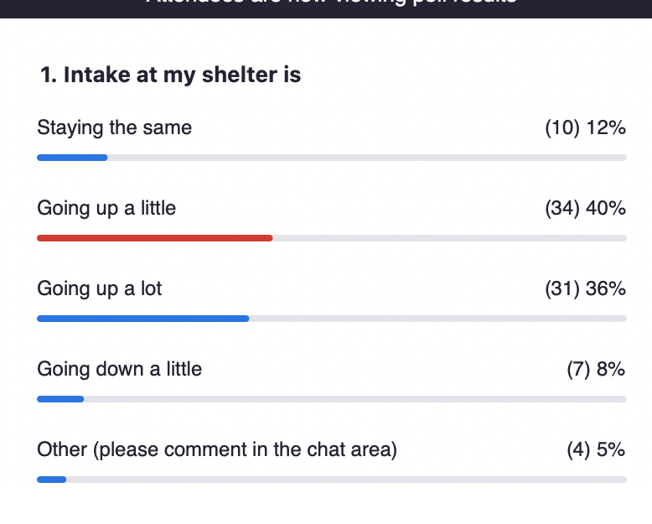
Poll 2
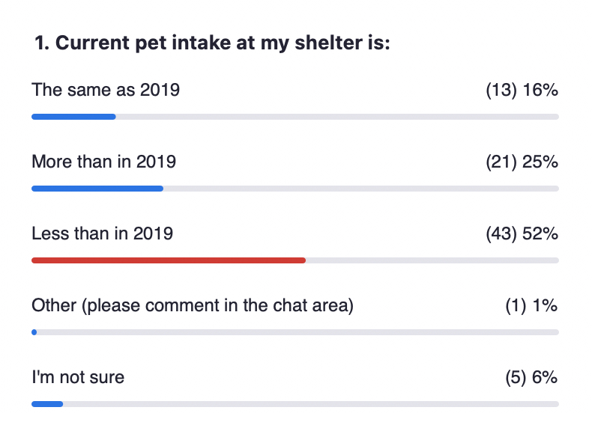
Poll 3
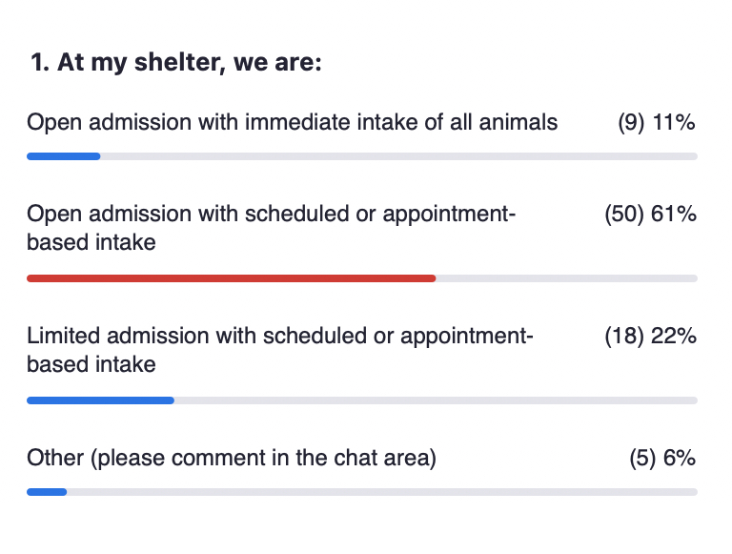

Poll 4
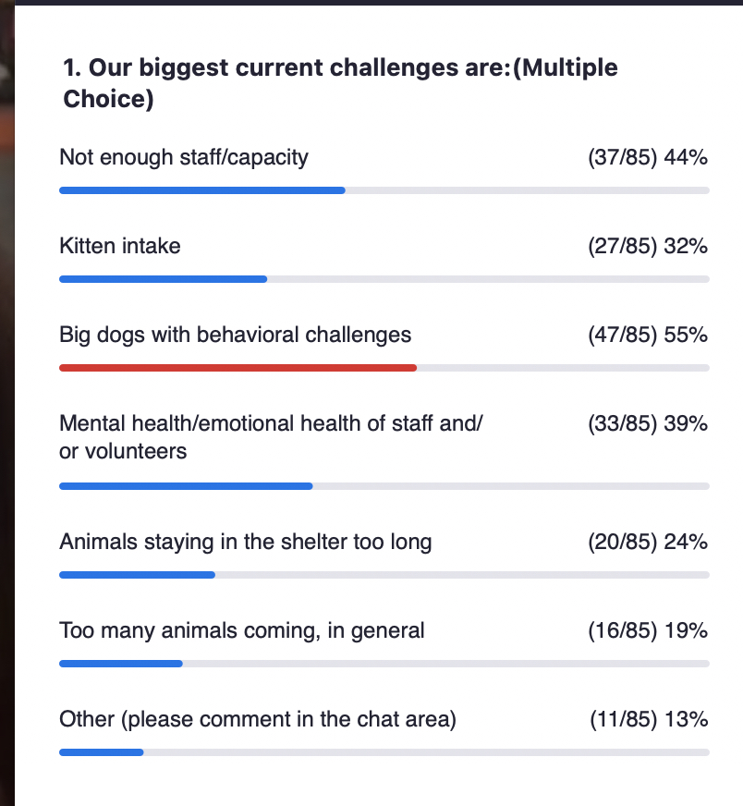

08:18:06 From Julie Bank to Everyone:
We have 561 in our inventory. Three weeks ago we had under 150. Mostly cat and large stray dogs.

08:20:07 From Donna Casamento to Everyone:
Sara Muriello, most dogs come in as strays, we are working with as many owners as we can to help support keeping them in their homes. There is a huge amount of stray and free roaming dogs in this community.

08:20:53 From Jennifer Federico to Everyone:
Our intake has gone down over COVID and still remains very low for us.

08:21:18 From Katie Trennepohl to Everyone:
Going up to compared to last year but still less than this time in 2019

08:21:20 From Ashley Rodriguez to Everyone:
Intake has spiked quite a bit in our community over the last two weeks, with mostly large breed puppies and large breed dogs.

08:21:24 From Jones Cheryl to Everyone:
Intake is up from last year and adoptions are still not back to pre covid numbers

08:21:25 From Connie Howard to Everyone:
The demand for transfers in is incredible. Our local intake is reasonable but we are full with incoming transfers and are turning probably 10 requests for every one we can accept.

08:21:59 From Emily Sprong to Everyone:
our intake is going up as we have more staff onsite and can take on more animals (private rescue w/o municipal contract)

08:22:16 From Shannon Glenn to Everyone:
Not a shelter - but seeing more new families at our North Minneapolis Pet Resource Center (community-based program - not associated with a shelter or rescue org)

08:22:21 From Donna Casamento to Everyone:
Puppies and kittens are increasing dramatically.

08:22:28 From Brad Shear to Everyone:
Our intake is up because we've increased transport, not quite back to 2019 levels yet

08:23:34 From emily wood (she/they) to Everyone:
Also, we are taking in more medical and behaviorally challenged animals than ever before, as intake rises again...

08:23:45 From Bobby Mann to Everyone:
kristen.hassen@americanpetsalive.org

08:24:05 From Erika Leckington to Everyone:
@ Emily - same - none of the animals we are receiving are "easy" as we are able to keep them out!

08:24:09 From Michael Bricker to Everyone:
Hey everyone! I haven’t had a chance to be on these calls in a while but now that I’m with CARE I’d love to offer my support to anyone in need with shelter operations to anyone in need. michael@careawo.org

08:24:20 From Elisabeth Manwiller to Everyone:
We are seeing numbers similar to 2018, which was our busiest year in the past 6 years.

08:24:21 From Elizabeth Berliner to Everyone:
I am also concerned about how in our org we have always relied on “chance encounters” with adopters not looking but running into our animals at outreach events. We need to find new ways this summer to encourage chance encounters

08:24:23 From Michelle Dosson to Everyone:
BRICKER!

08:24:32 From Michael Bricker to Everyone:
DOSSSONNNNN!

08:24:36 From Beau Archer to Everyone:
Open intake with contract so immediate strays, scheduled surrenders

08:24:54 From Spencer Conover to Everyone:
Dosson and Bricker together. The call is about to be cancelled

08:25:13 From Kathy Duncan to Everyone:
LOL @Spencer!!!

08:25:21 From Michael Bricker to Everyone:
Hahaha

08:25:29 From Tasha Haug to Everyone:
We are a private non-profit taking animals from the local pound. We've had to pay to board dog at the pound due to lack of space at the shelter and lack of enough foster families.

08:25:33 From Elisabeth Manwiller to Everyone:
I am also curious to know your definition of open admission

08:26:44 From Julie Bank to Everyone:
Dana, same with us in Riverside County.

08:26:51 From Sarah Javier to Everyone:
We have made the switch from immediate intake to scheduled. In some instances, we will still do immediate, but being able to schedule much of it has made a big difference.

08:27:06 From Elisabeth Manwiller to Everyone:
we are also open intake with contract so immediate strays, scheduled surrenders

08:27:42 From Annette Ramirez to Everyone:
Are any national orgs going to do a position statement in support of appointments/managed intake?

08:27:51 From Lisa Krummen to Everyone:
We take in strays immediately and schedule intake for surrenders.

08:27:59 From Julie Bank to Everyone:
Its our staff that is having a hard time too because of being yelled at by customers. There is also a fear that some animals are being missed because people "can’t see them".

08:28:17 From Amy Bartholomew to Everyone:
We are open intake for strays and appointments for surrenders

08:28:22 From Lisa Krummen to Everyone:
Although we encourage ACO's to try to RTO in the field.

08:28:48 From Sarah Javier to Everyone:
We are open admission private (no govt. contract, so no mandate). For strays we take in immediately but encourage finders to help find the owner. For owner surrenders, we now schedule.

08:29:14 From Elisabeth Manwiller to Everyone:
I would add not enough fosters.

08:29:14 From Chris Fitzgerald to Everyone:
My other is limited number of animals transferred to partners

08:29:15 From Jessica Reed to Everyone:
big challenge: veterinary professional staff - especially LVTs!

08:29:23 From emily wood (she/they) to Everyone:
Big dogs, not necessarily behavioral challenges.

08:29:23 From Brad Shear to Everyone:
We take in strays immediately and schedule surrenders,

08:29:24 From Rhea Moriarity to Everyone:
Lower adoption numbers

08:29:28 From Annie Guion to Everyone:
love the polls, don’t apologize!

08:29:29 From Becky Tegze to Everyone:
Our adoptions have tanked - no adopters

08:29:31 From Nancy McKenney, Marin Humane to Everyone:
Our biggest challenge is figuring out all the reopening details -- the workplace policies given our COVID restrictions are easing up on 6/15 yet CalOSHA may continue to require masks and facial coverings inside, etc etc.

08:29:47 From Connie Howard to Everyone:
Being able to hire, we keep having to increase wages and people can't afford to live here now. We are the new CA.

08:29:50 From Kate Meghji to Everyone:
Trying to find DVMs/techs

08:29:50 From Shelley Joaquin to Everyone:
reduced budget and high medical costs

08:29:51 From Rachael Max to Everyone:
Special needs cats - biggest challenge (medical/ behavior)

08:29:52 From Chris Fitzgerald to Everyone:
also shortage of foster caregivers

08:29:55 From Robin Vincent to Everyone:
Adoptions don't seem to be increasing as fast as intake is increasing

08:29:56 From Tom Colvin to Everyone:
Who else can't find people to hire?

08:29:57 From Jones Cheryl to Everyone:
Adoptions are lower and fosters are almost non-existent

08:30:00 From Lisa Krummen to Everyone:
Definitely large behavior challenged dogs and their LOS.

08:30:01 From Jessica Des Lauriers to Everyone:
Do we think that adoptions are lower due to the appointment system we have implemented?

08:30:02 From Phillip Zimmerman to Everyone:
@Nancy, same here in Sacramento.

08:30:16 From emily wood (she/they) to Everyone:
Advocates wanting operations to go back to the past...

08:30:21 From Ashley Rodriguez to Everyone:
My ACO's have been working in over drive over the last few weeks doing their best to knock on doors. We have also tried to get individuals who find animals out in the field to call Animal Control rather than brining the animals to the shelter so that ACO has the ability to get that animal home in the field.

08:30:28 From Kelly Duer to Everyone: Recruiting for fosters for pets with behavior needs
https://chewonthis.maddiesfund.org/2021/05/6-tips-for-recruiting-fosters-for-pets-with-behavioral-needs/

08:30:29 From Annie Guion to Everyone:
wow - too many animals is low on the list.

08:30:32 From Jessica Des Lauriers to Everyone:
I agree @Emily

08:30:38 From Emily Sprong to Everyone:
@Tom - yes on hiring challenges

08:30:41 From Kathleen Olson to Everyone:
Also, maintaining donor support.

08:31:12 From Alison Gibson to Everyone:
Kelly Duer, Foster Care Specialist, Maddie’s Fund

08:31:27 From Elisabeth Manwiller to Everyone:
I would highly recommend using the Waitwhile platform instead of appointments for adoption. we switched and it has definitely lead to more adoptions and less frustration.

08:32:44 From Katy Hansen to Everyone:
I have heard great things about Waitwhile - curious who else is using it?

08:32:58 From Michelle Dosson to Everyone:
Super simple- we have been posting about needing fosters on every social media post for the past few months and our numbers have sky-rocketed.

08:33:14 From Monica Frenden to Everyone:
APA uses WaitWhile, Dallas does, lots of orgs!

08:33:22 From Emily Klehm to Everyone:
We’ve been using Waitwhile for over a year and love it

08:33:37 From Elisabeth Manwiller to Everyone:
We have also moved to Foster to Adopt as a norm so people don't feel like they are making a hard commitment.

08:34:03 From Jessica Des Lauriers to Everyone:
We have the foster volunteers, but not the resources to support the fosters.

08:34:14 From Elisabeth Manwiller to Everyone:
And Waitwhile is now integrated in Adopets! Score!!

08:34:37 From Katy Hansen to Everyone:
We use Adopets too - that is great news EM!

08:34:48 From Jessica Des Lauriers to Everyone:
We use Adopets.

08:34:56 From Karina Exell to Everyone:
How does Waitwhile work?

08:35:05 From kristen hassen to Everyone:
We’ll be posting daily tactics to reduce intakes and increase outcomes to avoid space crises

08:35:08 From Phillip Zimmerman to Everyone:
We just launched Adopets this week for our foster animals

08:35:12 From Sharon Fletcher to Everyone:
Also create a flyer and ask your local business help you - pizza parlors, food delivery services for example. Ask you radio station to talk about fostering give them a script and get it to your public affairs manager. Don’t only rely only on social media - not everyone is on social.

08:35:12 From Elisabeth Manwiller to Everyone:
And I use Waitwhile in every department for scheduling. It is so nice because you don't have to just use it for adoption. We use it in foster, medical, pet help center, and will use it for vaccination clinics and other things.

08:35:12 From kristen hassen to Everyone:
On the HASS social media

08:35:23 From kristen hassen to Everyone:
And American Pets Alive Shelter and Rescue Support FB group

08:35:27 From Jen Evans to Everyone:
Extend Fostering to outside communities. People you don’t normally reach out to can make HUGE differences. One Tail at a Time has started reexamining their forms Foster rules and policies. All it takes is one person to foster in a new neighborhood and even word of mouth in new communities is invaluable. An African American woman was invited in their foster group, and she ended up adopting… now she is an advocate of both Fostering, Adoption and One Tail

08:35:40 From Bobby Mann to Everyone: American Pets Alive Shelter and Rescue Support FB group
https://www.facebook.com/humananimalsupportservices

08:35:56 From Tori Fugate to Everyone: Reclaim fee forgiveness program
https://kcpetproject.org/news/kc-pet-project-announces-reclaim-fee-forgiveness-program-for-lost-and-found-pets/

08:36:08 From Bobby Mann to Everyone: American Pets Alive Shelter and Rescue Support FB group
https://www.facebook.com/groups/AmPAShelterRescueSupport/

08:36:58 From Kelly Duer to Everyone:
Create a comprehensive foster recruitment plan that uses multiple strategies for engaging potential fosters, year-round: https://docs.google.com/spreadsheets/d/1ip3lx-LARh1MNx6woMhq-iGafHV3gHF5/edit#gid=1813696577

08:37:43 From Mary @ Maddie's Fund to Everyone:
Welcome, Mike. It’s great to have you on board!

08:38:02 From Michelle Dosson to Everyone:
48 Lost & Found groups. Mind blown.

08:38:06 From Phillip Zimmerman to Everyone:
We are launching a one year pilot program effective July 1st waiving RTO fees for the entire fiscal year - we are hoping to see a drastic increase in our RTO rate which is currently at 44%

08:38:08 From Katy Hansen to Everyone:
Tori - Your Tik Tok is amazing!!!!!

08:38:56 From Shannon Glenn to Everyone:
I love following her!

08:39:31 From Alison Gibson to Everyone:
Chris Fitzgerald, Director of Animal Services, City of Rochester
https://www.cityofrochester.gov/rochesteranimalservices/

08:39:40 From Dinah Hayse to Everyone:
What is the link to the FB group?

08:39:40 From Janie Mills to Everyone:
Great thank you Teresa and Tori

08:39:42 From Mary @ Maddie's Fund to Everyone:
Cool, Michelle! That’s so encouraging to hear about your success with blasting all social media platforms.

08:39:53 From Elisabeth Manwiller to Everyone:
We are also working on a referral program for fosters. Giving our current fosters fun things like our new retail items or gift cards for referring other friends and family that become active fosters.

08:40:54 From Sharon Fletcher to Everyone:
Jen Evans - that is such a great idea!!

08:41:22 From Tori Fugate to Everyone:
Here's a story about Katie and her TikTok from last night (and she's a staff member): https://www.kmbc.com/article/kc-pet-project-volunteer-goes-viral-on-tiktok-after-video-with-nervous-chihuahua/36690743

08:41:24 From kristen hassen to Everyone:
We are having daily conversations on the American Pets Alive Shelter and Rescue Support FB group and would love for you to join. It’s really interesting because we have every size of org from tiny rescues to giant shelters

08:41:47 From Bobby Mann to Everyone:
https://www.facebook.com/groups/AmPAShelterRescueSupport/

08:41:51 From Jen Evans to Everyone:
Thanks Sharon!

08:42:28 From Gina Knepp to Everyone:
66% RETURN TO HOME RATE!!! Congrats, Chris. Music to my ears!

08:43:02 From Erika Leckington to Everyone:
Great work Chris!!

08:43:20 From Alison Gibson to Everyone:
Michelle Simmons, Greenville County (SC) Animal Care Services
https://www.greenvillecounty.org/

08:43:25 From Chris Fitzgerald to Everyone:
You're my inspiration, Gina!

08:43:53 From Jen Evans to Everyone:
Physical Outreach is imperative to all of these issues. CARE will be announcing our new program soon!

08:44:37 From emily wood (she/they) to Everyone:
Yay, CARE! (Broward County would love to be involved with anything you do!!! emwood@broward.org)

08:44:56 From Jen Evans to Everyone:
If you want to stay in touch, email me jen@careawo.org

08:45:30 From Chris Fitzgerald to Everyone:
Had official City photo taken today wearing one of my HASS shirts.

08:45:58 From Jen Evans to Everyone:
Thanks for the call. Appreciate all of your efforts. We have to head out. Mike Bricker will be on if you have questions.

08:45:59 From Kathy Duncan to Everyone:
YAAAYYYY @Chris. Love that!!!

08:47:01 From Elisabeth Manwiller to Everyone:
One of the things we have been dealing with lately is more intense cat hoarding situations. Since families were not able to travel and visit their loved ones, it has lead to more collecting. Now people are visiting and walking into quite a mess. we are having a lot of family contacting us because of their senior loved ones going into assisted living and need help with large amounts of felines. Or they are just reaching out because they had no idea of the level of cats that their loved ones have collected during the crisis.

08:47:25 From emily wood (she/they) to Everyone:
Yes! @Elisabeth Manwiller

08:49:14 From Mike Wheeler to Everyone:
I am happy to share any of our protocols for our programming if you send me an email. mwheeler@cabotar.gov

08:50:22 From Monica Frenden to Everyone:
@Elizabeth - I wonder if the isolation of COVID impacted those people and led to an increase in collecting. Is anyone else seeing the same increase in these situations?

08:51:59 From Alison Gibson
Waitwhile appointment app
https://waitwhile.com/features/waitlist/?gclid=Cj0KCQjwk4yGBhDQARIsACGfAesmo70ZrxCvsfk10t42kPq6h7tsr7N93s2y2VdMpljE30oM-Fe-C_kaAvxVEALw_wcB

08:52:24 From Kelly Duer to Everyone:
So happy to hear that!!

08:52:46 From Michael Bricker to Everyone:
Great work Dosson!

08:52:59 From Alison Gibson to Everyone:
Webinar: Driving a Cat Culture Shift with the Ten Movement
June 17 at 5pm CT https://us02web.zoom.us/webinar/register/8016228361371/WN_GBhGkdIRQOGrfQhzGNLYvg

08:53:08 From Alison Gibson to Everyone:
Deborah Cribbs, Board of Trustees Chair, The Joanie Bernard Foundation https://www.thejoaniebernardfoundation.org/

08:53:13 From Elisabeth Manwiller to Everyone:
And foster to adopt!! I forgot to mention that!

08:53:51 From Kathy Duncan to Everyone:
Can’t wait!! Already registered!!!

08:53:57 From Monica Frenden to Everyone:
We’re hosting a cat-tastic webinar next week with Ten Movement’s Deborah Cribbs and our own Monica Frenden! Dive into how Ten Movement has worked to change the culture around community cats in this live webinar.
Save your seat: https://bit.ly/2S4u0jo

08:55:40 From Elisabeth Manwiller to Everyone:
also create a bottle baby kit that you give to the finders to hopefully get them to foster for even a few days is helpful. Talking about foster with every stray client. You never know!

08:56:53 From Alison Gibson to Everyone:
The Association for Animal Welfare Advancement Spring Conference
https://theaawa.org/event/2021Spring

08:57:00 From Monica Frenden to Everyone:
If you haven’t seen it, Dr. Julie Levy, Danielle Bays, Peter Wolf and I made a quick video about the top questions in response to the NACA Free-Roaming Cat Statement: https://www.facebook.com/americanpetsalive/videos/186539003373547

08:57:20 From Tom Colvin to Everyone:
Thank you, all!

08:57:26 From Elisabeth Manwiller to Everyone:
Kristen what is your email?

08:57:31 From Tammi Barrick to Everyone:
Thank you for a great call

08:57:34 From Alison Gibson to Everyone:
Maddie’s Fund® Contest! Win a chance for a $50 gift card! Invite a friend to the National Calls contest https://forms.gle/M8N2L87e1dsVLL469

08:57:44 From Bobby Mann to Everyone:
kristen.hassen@americanpetsalive.org

08:57:49 From Michael Bricker to Everyone:
Thanks for the call! See you all in a couple weeks.

-----------------end----------------

