Past Recordings on Maddie’s Pet Forum
https://forum.maddiesfund.org/communityconversations

This meeting:
https://bit.ly/shelterrescuesupportcall91321
Box link of file recording:
https://maddiesfund.box.com/s/gslcr8h4lyt677kcg8k4d22iuk6igihu

Friday meeting registration page
https://us02web.zoom.us/meeting/register/tZEud-2orzMrHtLTuNo0GbrSNeCQlQkdWKAp

Monday meeting registration link (for shelter staff and committed volunteers)
https://us02web.zoom.us/meeting/register/tZUqc-6spj0jHtES3GWxrpaG6L3HcbMh_dCu

Agenda

- Welcome – Bobby Mann
bobby.mann@americanpetsalive.org

- Mary's Motivation – Tune in to tomorrow’s Candid Conversation with animal welfare attorney, Akisha Townsend Eaton; HASS Fundraising webinar and toolkit; CBS News 60 Minutes story on 9/11 firefighters: what makes people want to lean in when others back up? What makes people face life-threatening situations? Everyone here on this call is showing each other is that there is a better way to do the work we do – that we can’t just focus on the animals, but also fon the people who care for the animals. If you are feeling like you are overwhelmed, please reach out to me @smith@maddiesfund.org
- Becca Britton, Executive Director, Neighborhood Pets’ – their mission and the work they are doing to support people and pets. Motto: “Take Care of Each Other”

- Brian Daugherty, Senior Vice President and Chief Philanthropy & Communications Officer, San Diego Humane Society; Stephanie Sullens, Chief Development Officer, KC Pet Project, Tami Gosheff, Corporate and Donor Engagement Manager, Baltimore Animal Rescue & Care Shelter, Inc. (BARCS) - Culture of Philanthropy and how every staff member plays a part

121 attendees

List of resources referenced during today’s call

Maddie’s Candid Conversation with animal welfare attorney Akisha Townsend Eaton, Tuesday, September 14 at 12n Pacific / 3pm Eastern
Registration link
https://maddiesfund-org.zoom.us/meeting/register/tZAodO2srTsuHte1OkLNZyoMKtzxvUjNEzO7

Best Friends The State of U.S. Animal Sheltering, 2020
https://network.bestfriends.org/tools-and-information/research/state-us-animal-sheltering-2020

jond@bestfriends.org

Best Friends Animal Society’s Animal Shelter Statistics dashboard
https://ww2.bestfriends.org/no-kill-2025/animal-shelter-statistics

Becca Britton, Executive Director, Neighborhood Pets http://www.neighborhoodpetscle.org/
Pets for Life manual https://marketplace.animalsheltering.org/programs/pets-for-life
Pets for Life Community Outreach Toolkit https://humanepro.org/page/tools-bring-pets-life-your-community

From Eileen @ Operation Blankets of Love https://www.obol.info/

We also provide food, pet beds, toys, leashes, collars, and life-saving pet supplies to pet pantries in CA and Mexico. Questions? Call 818-402-6586.

HASS Philanthropy Working Group https://www.humananimalsupportservices.org/hass-working-group/fundraising/

Stephanie Sullens, Chief Development Officer, KC Pet Project https://kcpetproject.org/
Brian Daugherty, Senior Vice President and Chief Philanthropy & Communications Officer, San Diego Humane Society https://www.sdhumane.org/
Tami Gosheff, Corporate and Donor Engagement Manager, Baltimore Animal Rescue & Care Shelter, Inc. (BARCS) https://www.barcs.org/

HASS Supporters - scroll down the webpage
https://www.humananimalsupportservices.org/

HASS Philanthropy Toolkit
https://www.humananimalsupportservices.org/toolkit/philanthropy-toolkit-development-fundraising/

Please email bobby.mann@americanpetsalive.org to join the Job-Alikes group for Philanthropy

Culture of Philanthropy webinar tomorrow at 5pm Central hosted the by the HASS Philanthropy Working Group: ‘Tis the Season to Fundraise: How to Build Your Village of Support:
https://us02web.zoom.us/webinar/register/WN_KFzBNCW7QJ22nzNjFIdyuQ

Kathy from Canada T-shirts – order here: https://austin-pets-alive.square.site/product/hass-it-s-kathy-from-canada-shirt/276?cp=true&sa=true&sbp=false&q=false

Blogs/books/conferences/podcasts/events

Tuesday, September 14 at 3pm Central Maddie’s Candid Conversation with animal welfare attorney Akisha Townsend Eaton, Tuesday, September 14 at 12n Pacific / 3pm Eastern
Registration link
https://maddiesfund-org.zoom.us/meeting/register/tZAodO2srTsuHte1OkLNZyoMKtzxvUjNEzO7

Tuesday, September 14 at 5pm CT Culture of Philanthropy webinar hosted the by the HASS Philanthropy Working Group: ‘Tis the Season to Fundraise: How to Build Your Village of Support: https://us02web.zoom.us/webinar/register/4516307002970/WN_KFzBNCW7QJ22nzNjFIdyuQ

Wednesday, September 15 - Humane Canada's Summit for Animals Mini Event: The Impacts of Climate Change on Animal Welfare https://humanecanada.swoogo.com/minievents/1178268

Best Friends podcast Episode 79 - All about the current staffing crisis: https://network.bestfriends.org/tools-and-information/best-friends-podcast/best-friends-podcast-ep-79

CHAT SESSION

07:55:41 From Alison Gibson to Everyone:
Good morning! This meeting will be recorded. Find it later today on Maddie’s Pet Forum https://bit.ly/shelterrescuesupportcall91321

07:56:24 From Alison Gibson to Everyone:
Happy Anniversary BOBBY!!

07:58:22 From Mary (she/her) @ Maddie's Fund to Everyone:
Congratulations on your new position @Kathy from Canada

07:58:49 From Kathy Duncan to Everyone:
Thanks so much @Mary!!!

07:59:16 From Eileen Smulson to Everyone:
HELLO FROMOPOERATOIN BLANKETS OF LOVE IN CA

07:59:25 From Lynne Stott to Everyone:
Hi from Tucson

07:59:47 From Alison Gibson to Everyone:
Hi Eileen and Lynne!

08:00:14 From Rebecca Marsh to Everyone:
Congratulations Kathy on your promotion!!

08:01:37 From Tammi Barrick to Everyone:
Good Morning and Happy Anniversary Bobby

08:01:57 From Alison Gibson to Everyone:
Maddie’s Candid Conversation with animal welfare attorney Akisha Townsend Eaton, Tuesday, September 14 at 12n Pacific / 3pm Eastern
Registration link
https://maddiesfund-org.zoom.us/meeting/register/tZAodO2srTsuHte1OkLNZyoMKtzxvUjNEzO7

08:02:07 From Peter Wolf to Everyone:
Akisha!

08:02:49 From Alison Gibson to Everyone:
Culture of Philanthropy webinar tomorrow at 5pm Central hosted the by the HASS Philanthropy Working Group: ‘Tis the Season to Fundraise: How to Build Your Village of Support:
https://us02web.zoom.us/webinar/register/WN_KFzBNCW7QJ22nzNjFIdyuQ

08:03:36 From Alison Gibson to Everyone:
HASS Philanthropy Toolkit

https://www.humananimalsupportservices.org/toolkit/philanthropy-toolkit-development-fundraising/

08:05:16 From Courtney Wennerstrom to Everyone:
My husband is applying to be a firefighter now and he says he wants to make a tangible difference—just like everyone else on this call

08:05:58 From Hilary Shurtleff to Everyone:
Courtney - please tell your husband thank you

08:06:20 From Alison Gibson to Everyone: Mary’s email address
smith@maddiesfund.org

08:07:24 From Eileen Smulson to Everyone:
Thank you for that great presentation.

08:08:09 From Alison Gibson to Everyone:
Best Friends The State of U.S. Animal Sheltering, 2020
https://network.bestfriends.org/tools-and-information/research/state-us-animal-sheltering-2020

Best Friends Animal Society’s Animal Shelter Statistics dashboard
https://ww2.bestfriends.org/no-kill-2025/animal-shelter-statistics

08:08:53 From Eileen Smulson to Everyone:
Eileen from Operation Blankets of Love we partner with Best Friends and our non profit is only 5 minutes from your Mission Hills shelter.

08:09:07 From Peter Wolf to Everyone:
Thank you, Alison!

08:09:27 From Alison Gibson to Everyone:
Best Friends podcast Episode 79 - All about the current staffing crisis: https://network.bestfriends.org/tools-and-information/best-friends-podcast/best-friends-podcast-ep-79

08:10:09 From Jon Dunn to Everyone:
jond@bestfriends.org

08:10:14 From Tammi Barrick to Everyone:
Congratulations on your promotion!

08:10:18 From Karen Smith to Everyone:
Yay, Kathy!!

08:10:20 From Danielle Bays to Everyone:
Congrats Kathy!!

08:10:20 From Kelly Clardy to Everyone:
Congratulations, Kathy, on your new job!!

08:10:26 From Peter Wolf to Everyone:
Jon, you’d seem like more of an adult if you didn’t have that ridiculous toy mic!

08:10:28 From Alison Gibson to Everyone:
Humane Canada's Summit for Animals Mini Event: The Impacts of Climate Change on Animal Welfare – September 15, 2021 https://humanecanada.swoogo.com/minievents/1178268

08:11:18 From Alison Gibson to Everyone:
CONGRATS KATHY!!

08:11:20 From Peter Wolf to Everyone:
Next stop: Prime Minister!

08:11:24 From Jon Dunn to Everyone:
Hahaha, amazing!

08:11:58 From Alison Gibson to Everyone:
Becca Britton, Executive Director, Neighborhood Pets http://www.neighborhoodpetscle.org/

08:12:13 From Kathy Duncan to Everyone:
I’m on it @Peter Wolf, but it will have to be for the next election!!

08:12:17 From Jamie Case to Everyone:
Yay, Becca!

08:12:20 From Sara Miller to Everyone:
Pre-order your Kathy from Canada shirts here: https://austin-pets-alive.square.site/product/hass-it-s-kathy-from-canada-shirt/276?cp=true&sa=true&sbp=false&q=false

08:12:29 From Stephanie Rambo to Everyone:
Sorry I'm late!! First timer here!

08:12:44 From Bobby Mann to Everyone:
Hi Stephanie! Welcome!

08:13:20 From Kathy Duncan to Everyone:
Welcome Stephanie - from the Canadian contingent!!!!

08:13:29 From Jon Dunn to Everyone:
@Eileen thank you for everything you do and for being a Best Friends Network partner!

08:16:27 From Kathy Duncan to Everyone:
Thanks everyone on the congrats for my new role!!

08:17:05 From Veronica Wheeler to Everyone:
You rock, Kathy!

08:20:03 From Bobby Mann to Everyone: Pets for Life Toolkit
https://humanepro.org/page/tools-bring-pets-life-your-community

08:20:03 From Alison Gibson to Everyone:
Pets for Life manual https://marketplace.animalsheltering.org/programs/pets-for-life

08:21:52 From Eileen Smulson to Everyone:
From Eileen Operation Blankets of Love. We also provide food, pet beds . toys, leashes, collars, and life saving pet supplies to pet pantries in CA and Mexico. If you have any questions you can call us at 818-402-6586. : )

08:26:18 From Bobby Mann to Everyone:
This is SO AMAZING

08:26:41 From Bobby Mann to Everyone:
If you have questions for Becca feel free to drop them in the chat

08:27:16 From Andrea Giorgio to Everyone:
Neighborhood Pets is truly an incredible asset to their community and Northeast Ohio! I just LOVE them and their work!

08:27:38 From Elizabeth Berliner to Everyone:
Curious about veterinary services — is the vet/LVT an employee, contracted, shared with other clinics?

08:28:04 From Peter Wolf to Everyone:
Q: How many of those 221 cats might be considered “community cats”?

08:28:11 From Tammi Barrick to Everyone:
curious as to the language that reaches the compliance of S/N

08:29:11 From Peter Wolf to Everyone:
That’s $20 U.S., Kathy!

08:29:28 From Kathleen Lehman to Everyone:
Becca mentioned the client management software; can you tell us the staffing you all have to manage the request and needs fulfillment?

08:30:09 From Kathleen Lehman to Everyone:
Also, I'd like to know more about the temporary pet housing you all provide!

08:30:25 From Bobby Mann to Everyone:
I believe she said they use SalesForce

08:31:45 From Joyce Friedman to Everyone:
How do you use pet care companies to provide care to pets with owners in crisis? is there a cost?

08:32:04 From Kathleen Lehman to Everyone:
Yes, SalesForce. Did she say how many staff manage the requests fulfillment?

08:33:39 From Kathleen Lehman to Everyone:
there it is 🙂

08:37:12 From Peter Wolf to Everyone:
Wow!

08:38:02 From Peter Wolf to Everyone:
This is so great—thank you for all you’re doing in Cleveland!

08:38:14 From Peter Wolf to Everyone:
Big hearts, too!

08:38:41 From Joyce Friedman to Everyone:
To spay/neuter 70-90 cats in a day- is that at one brick and mortar clinic or mobile ? And often is that done?

08:39:34 From Peter Wolf to Everyone:
So impressive!

08:39:54 From Stephanie Rambo to Everyone:
Thank you all for the warm welcome and Becca keep up the great work!

08:40:03 From Jamie Case to Everyone:
Becca is such a freaking rockstar! Yay Neighborhood Pets!

08:40:58 From Peter Wolf to Everyone:
Good to see this in Cleveland—which, like other cities in the Midwest, is struggling to figure out what their next chapter is going to look like.

08:42:30 From Joyce Friedman to Everyone:
Becca- congrats on an excellent and super impressive program!!!

08:42:38 From Kathy Duncan to Everyone:
So true @Becca!!!

08:42:57 From Peter Wolf to Everyone:
Becca “The Bridge” Britton

08:43:18 From Jon Dunn to Everyone:
LOL Bobby.

08:43:19 From Alison Gibson to Everyone:
Stephanie Sullens, Chief Development Officer, KC Pet Project https://kcpetproject.org/

Poll
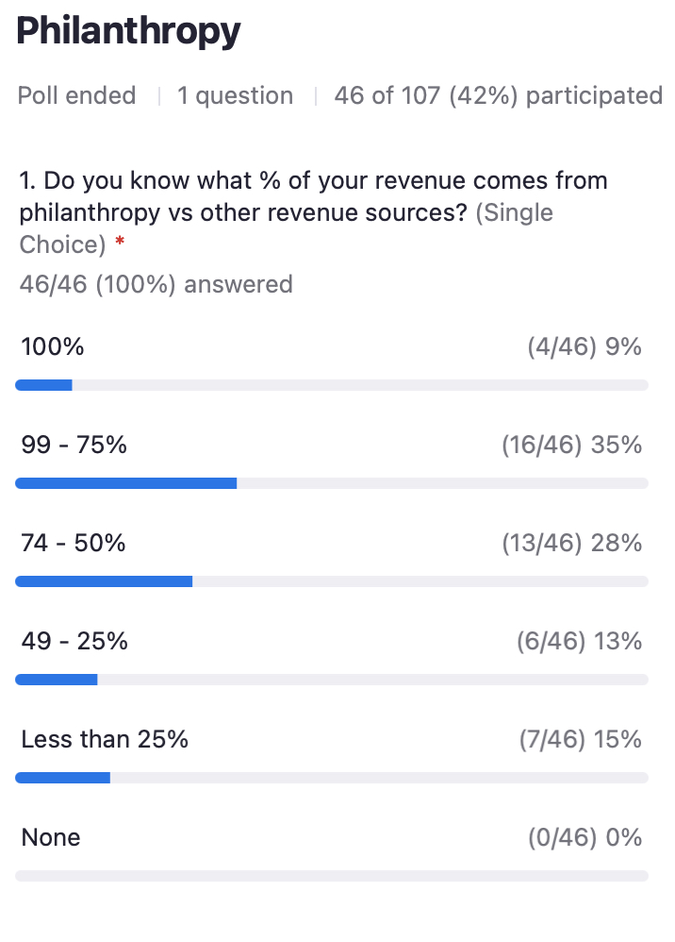
08:44:16 From Alison Gibson to Everyone:
HASS Supporters -scroll down the webpage
https://www.humananimalsupportservices.org/

08:45:11 From Mary (she/her) @ Maddie's Fund to Everyone:
Stephanie just gave us our first lesson in philanthropy - thank everyone as many times as you can. You can never say thank you enough!

08:45:23 From Bobby Mann to Everyone:
+1 Mary!!!

08:45:31 From Bobby Mann to Everyone:
Thank YOU for mentioning that ;-)

08:45:37 From Alison Gibson to Everyone:
HASS Philanthropy Working Group https://www.humananimalsupportservices.org/hass-working-group/fundraising/

08:45:40 From Kathy Duncan to Everyone:
True that @Mary!!!

08:46:12 From Brian Daugherty to Everyone:
Becca's presentation also showcased the importance and power of philanthropy. It's donors big and small that are making that work, and our collective work possible.

08:46:26 From Alison Gibson to Everyone:
Culture of Philanthropy webinar tomorrow at 5pm Central hosted the by the HASS Philanthropy Working Group: ‘Tis the Season to Fundraise: How to Build Your Village of Support:
https://us02web.zoom.us/webinar/register/WN_KFzBNCW7QJ22nzNjFIdyuQ

08:47:01 From Alison Gibson to Everyone:
5 PM Central!

08:47:04 From Alison Gibson to Everyone:
HASS Philanthropy Toolkit
https://www.humananimalsupportservices.org/toolkit/philanthropy-toolkit-development-fundraising/

08:49:34 From Bobby Mann to Everyone:
Please email bobby.mann@americanpetsalive.org to join the Job-Alikes group for Philanthropy

08:50:07 From Kathy Duncan to Everyone:
Totally sending this info to @HumaneCanada’s Director, Donor Relations & National Engagement!!

08:50:54 From Alison Gibson to Everyone:
Tami Gosheff, Corporate and Donor Engagement Manager, Baltimore Animal Rescue & Care Shelter, Inc. (BARCS)
https://www.barcs.org/

08:59:35 From Alison Gibson to Everyone:
Culture of Philanthropy webinar tomorrow at 5pm Central hosted the by the HASS Philanthropy Working Group: ‘Tis the Season to Fundraise: How to Build Your Village of Support:

https://us02web.zoom.us/webinar/register/WN_KFzBNCW7QJ22nzNjFIdyuQ

08:59:59 From Cailin Quinn to Everyone:
This was great, thank you all!

09:00:06 From Jon Dunn to Everyone:
Great call this week!

09:00:11 From Patty Caffrey to Everyone:
Thank you so much! Great information.

09:00:38 From Stephanie Rambo to Everyone:
I will def see you tomorrow... I am on our rescue's philanthropy team so see you then

09:00:39 From Jon Dunn to Everyone:
As always, thank you to Maddie’s for hosting these.

09:00:40 From Gaelan de Wolf to Everyone:
Thank you!

09:00:42 From Kathy Duncan to Everyone:
Great call everyone!!! You are all rock stars!

------------------------end-----------------------

