Example of a white board used at the end of a kennel row to list each kennel and the activity and enrichment that dog received for the day:
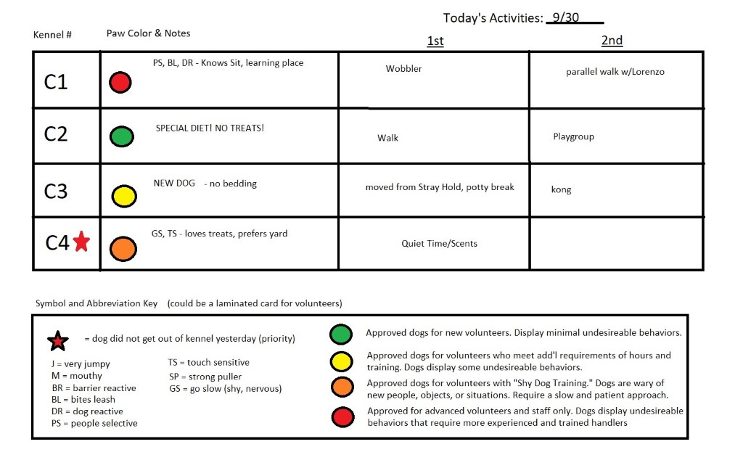
Example of only In-Kennel (hands off) enrichment rotation:

Sun. Mon. Tues. Wed. Thurs. Fri. Sat.
A | Kongs | Scents:  cardboard, fleece ropes, or bedding | food puzzles | Nylabones / chews | Nosework  (scattered food, snuffle mats, food in boxes) | New Toys | Quiet Time:  aromatherapy, music, new bedding
B (puppies) | Quiet Time:  aromatherapy, music, new bedding | Kongs | Scents:  cardboard, fleece ropes, or bedding | food puzzles | Nylabones / chews | Nosework  (scattered food, snuffle mats, food in boxes) | New Toys
C (little dogs) | New Toys | Quiet Time:  aromatherapy, music, new bedding | Kongs | Scents:  cardboard, fleece ropes, or bedding | food puzzles | Nylabones / chews | Nosework  (scattered food, snuffle mats, food in boxes)
Strays | Nosework  (scattered food, snuffle mats, food in boxes) | New Toys | Quiet Time:  aromatherapy, music, new bedding | Kongs | Scents:  cardboard, fleece ropes, or bedding | food puzzles | Nylabones / chews
Isolation | Nylabones / chews | Nosework  (scattered food, snuffle mats, food in boxes) | New Toys | Quiet Time:  aromatherapy, music, new bedding | Kongs | Scents:  cardboard, fleece ropes, or bedding | food puzzles

Replace activities as appropriate (co-housed dogs may not be able to have food enrichment, a dog may ingest toys, etc). These are only examples.

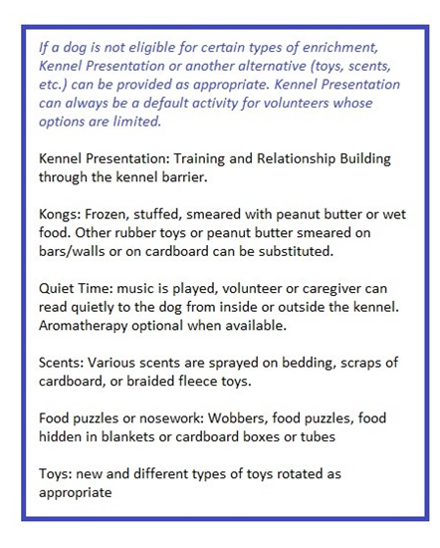

Kennel Presentation:
Volunteers or staff can practice walking up and down the kennel rows and reward dogs for: keeping four paws on the floor, being quiet, making eye contact, sitting, lying down, or approaching the front of the kennel.
- Wait for desired behavior (a lure can be used as needed)
- Say “Yes!” or click a clicker ONCE
- Give a treat by sliding under door or using a stick-like jerky treat or biscuit.
- If fingers in the kennel are a concern, a PVC pipe can be added as a chute.
- Visitors may be encouraged to “play along” if given instructions on how to do so appropriately.
- Dogs in extra need of kennel presentation practice can have signs added to their kennels (“I need help making positive associations with people – please toss me a treat!” OR “Can you help me learn good manners by tossing a treat in if I can keep four paws on the floor and be quiet? Woof and thanks!”), along with a treat pouch or bowl attached to their kennel.

Sample Dog Toy Protocol

Toys are not only important as a source of enrichment for dogs, but they increase the public’s perception of the dog as “adoptable.” In a scientific study of shelter dogs, the highest predictor of a dog that would NOT be adopted was one that ignored the person’s invitation to play. Other studies have found that simply having toys in a kennel, regardless of whether or not the dog played with them, made the dog seem more appealing.

So… toys are important. How do we use them in a way that’s safe?

Keep or Toss?
- Caregivers should sort through donations before washing or storing toys.
- KEEP: high quality, durable toys
- TOSS: thin/flimsy materials, cheap (bargain bin), worn out toys. Any time a toy has wear that could be chewed off and ingested, it’s time for it to be thrown away.

Storage
- Toys should be kept organized according to type in an area not accessible by animals and limited to designated storage bins. Overflow toys should be used, given away, or thrown out.
- Toys should be separated by: Stuffed, Rope, Ball, Rubber/Plastic, Hard Chew Toys, and Puppies/Small Dogs ONLY.

Who Gets What & When?
A list should be kept near toy storage noting any exclusion for particular dogs (i.e. no stuffed or rubber toys, no tennis balls, extra tough toys only, etc.). Notes should be added in PetPoint for dogs’ toy preferences and exclusions, particularly if a dog is known to destroy and ingest them.

Any dog that is observed to have resource guarding with toys should have “NO TOYS” noted on the whiteboard in their cottage row.

SQUEAKY TOYS: any toy that squeaks is for supervised use only outside in the Green Room or Yard or during supervised Kennel Enrichment time. Even if a dog is non-destructive with a squeaky toy, but squeaking it obsessively, it can be frustrating and over-stimulating for other dogs in the same row. Dogs that are gentle and generally quiet with squeaky toys may keep them in their kennel at all times.

Puppies/Small Dogs Only: items in this bin would be considered choking hazards for a dog over 25 lbs. Dogs that share a kennel may only keep toys after supervised play where no resource guarding is observed. There should be multiple of each type of toy left in kennels occupied by more than one dog.

Hard Chew Toys: can remain in kennels with dogs at all times
Rope Toys: can remain in kennel with dog if it’s not fraying
Balls: Supervised Yard or Green Room use only

Stuffed Toys: Supervised use only (initially). Dogs that have proven to be gentle with stuffed toys may keep them in their kennels.
Rubber/Plastic Toys: Supervised use only. Durable rubber toys (Kong type material) may be left in kennel with dogs that have proven to be non-destructive with them.

SAFETY PROTOCOL
Caregivers should check on toy usage in kennels during morning cleaning, spot cleaning, and during closing duties to ensure safety. Toys that are being destroyed (stuffing coming out, pieces being chewed off and ripped apart, ends fraying) should be removed from the kennels immediately and discarded.

Notes should be made in PetPoint, on the Exclusions List by toy storage, and on the whiteboard (i.e. tough toys only, select toys only, no toys in kennel).

HANDING OUT TOYS (STAFF)
Toys should only be added to kennels during enrichment specific hours (usually 1 -2 PM). The dogs may have toys to destroy, but caregivers should monitor dogs during this time to ensure the safety of the dogs (not ingesting pieces) and volunteers/staff (watch for signs of guarding).

The exception to this would be hard chew toys, thick and durable rope toys, and other durable rubber/stuffed toys for dogs that are already known to be non-destructive. Regular safety checks would still occur as a part of standard Safety Protocol (see above).

Puppies and small dogs housed singly may also have appropriate toys added at any time.

VOLUNTEERS AND TOYS
Volunteers should understand the following when picking out toys for dog playtime:

STAY SAFE, AVOID BITES.
Accidental bites/injuries that break skin require a dog to spend 10 days in Isolation for Bite Quarantine for Rabies Observation; this is an LA County law. With that in mind, please follow these safety guidelines when playing with toys with our dogs:

- Never remove a toy from a dog’s mouth.
- Always trade the dog for another toy or treat.
- If the dog will not relinquish a toy, they may take it back to their kennel, but the volunteer MUST inform staff immediately.
- Any signs of guarding should be reported to staff immediately. Do not attempt to take the toy away.
- Take TWO of every kind of toy used to most effectively teach a dog “Drop It.”

- Fetch is the preferred type of play. Trade toys for similar toys or food. If a dog has no interest in balls, the volunteer should try using rope, rubber, or stuffed toys to get a dog interested.
- Do not touch dogs while they are enjoying a toy on their own.
- Dogs may destroy toys, but watch carefully to make sure they aren’t ingesting pieces or guarding.
- Tug o’ War play is DISCOURAGED. Dogs may try to gain a better grip and overreach or become overstimulated. We don’t want to risk a bite.
- Always consult the list of exclusions (dogs that aren’t allowed certain toys) and choose toys that are size and durability appropriate.
- Toys should go to the laundry room or kitchen sink after use to be washed.

Volunteers should check in with staff to receive toys. For our Gray Paw volunteers, they will have free access to toys once reviewing and signing the Toy Protocol Acknowledgement Form.

Most importantly we want volunteers to HAVE FUN playing with our dogs! We welcome any feedback you experience when interacting with our dogs during play to help ensure everyone stays safe and healthy.

