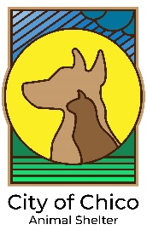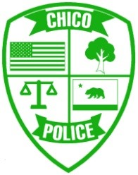
City of Chico Animal Services
2579 Fair St.
Chico, CA 95928
Shelter: 530-894-5630
Animal Control: 530-897-4960
December 22, 2020

Dear Veterinary Staff,
The primary purpose of a microchip is to serve as a form of ID to reunite pets with their owners, with the added benefit of serving as proof of ownership. A chip reassures the owner that if their pet goes missing or is stolen, the chip will provide the information needed to get their pet back home.
Recently we have encountered several situations where a pet was found and taken to a veterinarian for vaccinations, elective surgery or medical treatment. During the visit, it was discovered that the animal was microchipped to someone other than the client. In these situations, it’s important to give the client/finder accurate information. Not just to find the original owner, but also to legally transfer ownership if the original owner can’t be found.
Pets are considered legal property of their owner. Finding a pet does not entitle the finder to keep, sell or give away the animal, nor does it automatically convey ownership to the finder, even after a specific number of days. Penal Code 485 states: "One who finds lost property . . . without first making reasonable and just efforts to find the owner and restore the property to him, is guilty of theft."

A reasonable effort always includes scanning for a chip and contacting the local animal control agency, regardless of how long ago the animal was found. As microchips become more common and pet owners rely on them to ensure the safe return of their pets, it’s very important that all found animals are scanned for a chip.

Chico Animal Services takes the human-animal bond seriously and prioritizes reuniting pets with their owners. Shelter staff have tools not available to the general public to help search for owners. And if an owner does not come forward, staff can ensure the proper procedures for creating a legal path to ownership for the finder can be followed.
Enclosed please find a letter from the California Animal Welfare Association outlining recommendations for microchip scanning for California veterinarians.
Please feel free to contact me or the CAWA if you have any questions.

Sincerely,

Tracy Mohr
Animal Services Manager

