Ordinance Number ACHB-20 18
GCID: 2018-0784

GWINNETT COUNTY BOARD OF COMMISSIONERS LAWRENCEVILLE, GEORGIA

ORDINANCE ENTITLED: An Ordinance to Establish an Animal Control
Hearing Board

READING AND ADOPTION: July 17,2018

At the regular meeting of the Gwinnett County Board of Commissioners held in the
Justice and Administration Center Auditorium, 75 Langley Drive, lawrenceville, Georgia.

Name Present Vote

Charlotte Nash, Chairman | YES | YES
Jace Brooks, District I | YES | YES
Lynette Howard, District 2 | YES | YES
Tommy Hunter, District 3  John Heard, District 4 | YES  ABSENT | YES  ABSENT

On motion of Commissioner Hunter, which carried 4-0, the Board of Commissioners hereby enacts an Ordinance establishing an Animal Control Hearing Board by amending Chapter I 0 of the Gwinnett County Code of Ordinances to add a new Article Ill, Division 3 entitled "Animal Control Hearing Board".

WHEREAS, pursuant to Article IX, Section II, Paragraph Ill of the Constitution of the

State of Georgia, Gwinnett County has the authority to regulate animals; and

WHEREAS, the Official Code of Georgia Annotated § 36-1-20 authorizes counties to adopt ordinances for the governing of the unincorporated areas of the county; and

Ordinance Number ACHB-20 18
GCID: 2018-0784

WHEREAS, Gwinnett County first adopted an ordinance governing animals on

December 18, 1973 and repealed and adopted new versions of the ordinance on January 16,

2007, March 17, 20 15, and April I I, 20 17, respectively; and

WHEREAS, the County's current ordinance provides definitions of "dangerous dog" and "vicious dog", respectively; and
WHEREAS, the Georgia Responsible Dog Ownership Law (hereinafter the "Law"), codified as O.C.G.A. § 4-8-20 et seq., provides that the owner of a dog has a right to request a hearing from an authority when a dog control officer determines that the dog is subject to classification as a dangerous or vicious dog; and
WHEREAS, the Law defines the "authority" as an animal control board or local board of health, as determined by the governing authority of a local government; and
WHEREAS, Gwinnett County's ordinance defines "animal welfare board" as the County Board of Health or any board constituted and appointed by the Board of Commissioners to perform the duties of the animal control board; and
WHEREAS, the Gwinnett, Newton, and Rockdale ("GNR") County Board of Health has served as Gwinnett County's animal welfare board for dangerous dog or vicious dog hearings, and
WHEREAS, the strict timelines that the Law imposes for dangerous dog and vicious dog hearings to be scheduled and a decision to sustain, modify, or overrule the dog control officer's classification of the dog as dangerous or vicious have placed a tremendous burden on the Board of Health to establish a quorum of its members for such hearings; and

GCID: 2018-0784

WHEREAS, the Board of Commissioners has determined that it is in the best interests of Gwinnett County to establish and appoint an Animal Control Hearing Board for the limited purpose of hearing appeals of dangerous dog and vicious dog classifications.

NOW, THEREFORE, BE IT RESOLVED that the Gwinnett County Board of Commissioners hereby establishes, constitutes, and appoints an Animal Control Hearing Board as follows:

Section I 0-114. Composition

The Animal Control Hearing Board shall be composed of five (5) members, to be appointed as follows:
One member appointed by the Commission Chairman
One member appointed by Commission District I One member appointed by Commission District 2
One member appointed by Commission District 3
One member appointed by Commission District 4

Section I0-1 15. Term

Members of the Animal Control Hearing Board shall each serve a one-year term beginning August I, 20 18 and must reside in the district that they represent. Members serve at the pleasure of the Board of Commissioners and may be removed by a majority vote of the Board of Commissioners at any time.

Section I 0-1 16. Responsibilities

The Animal Control Hearing Board shall:

o Receive dangerous dog and vicious dog hearing requests from dog owners;
o Schedule a hearing within 30 days after a request for same is received;
o Notify the dog owner and the County's animal welfare division manager in writing by certified mail or statutory overnight delivery of the date, time, and place of the hearing, and the notice shall be mailed to the dog owner at least ten days prior to the date of the hearing;

o Select one of its members to serve as chairman to preside over hearings;
o Hear testimony and receive evidence at hearings as reasonably necessary to make a determination either to sustain, modify, or overrule the animal control officer's classification of the dog as dangerous or vicious;
o Within ten days after the date of a hearing, notify the dog owner and the County's
animal welfare division manager in writing by certified mail or statutory overnight delivery of its determination on the matter. If such determination is that the dog is a dangerous or vicious dog, the notice shall specify the date upon which that determination is effective; and
o Perform other duties as prescribed by the Board of Commissioners.

Section I 0-117. Compensation

Animal Control Hearing Board members are not compensated, but actual expenses incurred in the performance of their duties will be reimbursed by the County.
Section I 0-1 I 8. Quorum

A quorum shall consist of three members of the Animal Control Hearing Board.

BE IT FURTHER RESOLVED that this Ordinance shall be effective on August I, 2018.

BE IT FURTHER RESOLVED that all ordinances, regulations or parts of the same in conflict with this Ordinance are hereby repealed to the extent of said conflict.
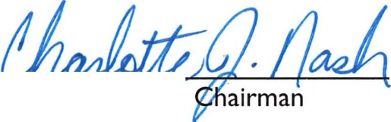
GWINNETT COUNTY BOARD OF COMMISSIONERS By:----r-----
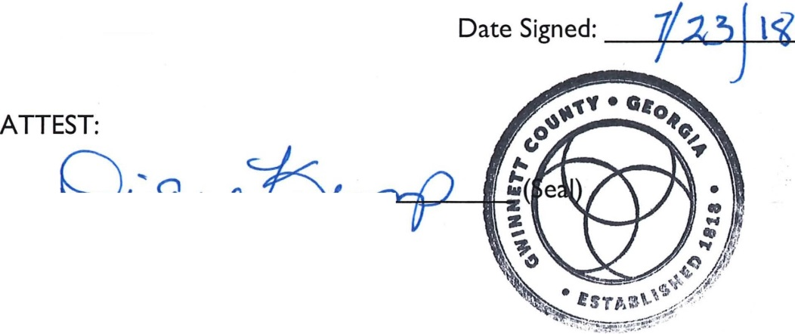
Charlotte J. Nash,

By: b
Diane Kemp, County Clerk

APPROVED AS TO FORM:

Tuwanda Rush Williams
Senior Assistant County Attorney

