Past Recordings on Maddie’s Pet Forum
https://forum.maddiesfund.org/communityconversations

This meeting: ABBREVIATED CHAT AND NO RECORDING POSTED (REQUEST FROM KRISTEN)
https://bit.ly/awleadershiproundup92421

Friday meeting registration page
https://us02web.zoom.us/meeting/register/tZEud-2orzMrHtLTuNo0GbrSNeCQlQkdWKAp

Monday meeting registration link (for shelter staff and committed volunteers)
https://us02web.zoom.us/meeting/register/tZUqc-6spj0jHtES3GWxrpaG6L3HcbMh_dCu

Agenda Sharing ideas for how we can collectively stand against violence towards animal welfare leadership. We'll hear from a few folks who have faced various types of attacks and share our best ideas for how to quickly come up with solutions to keep our colleagues safe.
“I’m scared someone is going to kill me.”
Discussed whether we should record – we will record and share privately on request. Alison will turn off recording when asked by those sharing.

- Welcome – Kristen Hassen, Director, American Pets Alive! -
Kristen.hassen@americanpetsalive.org
bobby.mann@americanpetsalive.org

- Mary's Motivation – could not be here today
- National updates
  - Happy birthday, Chris Fitzgerald!
  - Valerie Robinson, Terrebonne Parrish Animal Shelter, on the situation in Louisiana: impact of Hurricane Ida – asks for help with transports – people are displaced, living in tents, pets are running loose
TO HELP: contact Valerie Robinson
Terrebonne Parish Animal Shelter
100 Government St.
Gray, LA
vrobinson@tpcg.org
985-790-3264
Julie Levy shared their Facebook pages of the ongoing devastation. https://www.facebook.com/Terrebonne-Parish-Animal-Shelter-112553058770782
Valerie Sheppard: If your organization can receive animals from the Hurricane Ida-ravaged areas, complete this form detailing your placement availability: https://airtable.com/shrxw3xhNR4ZaYSH7
GreaterGood.com https://greatergood.com/
Kathleen at Animal Adoption: Let me know what we can do to help, I am in NJ and I am partnered up with Brandywine Valley SSPCA pulling from Louisiana. Kathleen@animaladoption.com
Kelly Duer shared Terrebonne Parish AS Amazon wish list: https://www.amazon.com/hz/wishlist/ls/NX39LRSWA7AM/ref=nav_wishlist_lists_1?_encoding=UTF8&type=wishlist&fbclid=IwAR3owqudtCJl5HWd8e5MDPicTTYht2k8Iw8-t9VOo6hJd7F7ywMbz5-MRp4

- Summer Dolder Dir Ops, ACCT Philly, speaking re Aurora Velazquez, CAWA, Executive Director’s post http://www.acctphilly.org/

- Sarah Aguilar shared Jonno White, author of Step Up or Step Out: How to deal with difficult people, even if you hate conflict
Founder and Principal Consultant at Clarity
https://www.linkedin.com/in/jonno-white-983486136/

- Dr. Katja Guenther, author, The Life and Death of Shelter Dogs
- Mike Kaviani, Best Friends Chief Program Officer, https://bestfriends.org/events/best-friends-national-conference/speakers/mike-kaviani

228 attendees

List of resources referenced during today’s call
Enneagram Personality Test (Jamie Case posted)
https://www.truity.com/test/enneagram-personality-test?ppcga=fixed&gclid=CjwKCAjw7rWKBhAtEiwAJ3CWLN_DwIo7z1cWamqX2oJC4D34tqgiJX6JV_itD_adwcIGyhgB7QbvLBoCHvcQAvD_BwE

Blogs/books/conferences/podcasts/events

AAWA Going Through Hell? Keep Going! Series
https://learning.theaawa.org/products/going-through-hell-keep-going-series

The Life and Death of Shelter Dogs by Katja M. Guenther, MD

Liam Hughes shared that NAMI can help with stress management https://nami.org/Home

Nina Stively webinar: Hashtags and Hate Mail - https://learning.theaawa.org/p/hashtag

POLLS FOLLOW BELOW
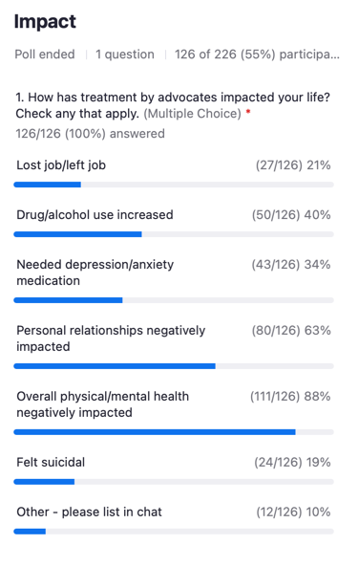

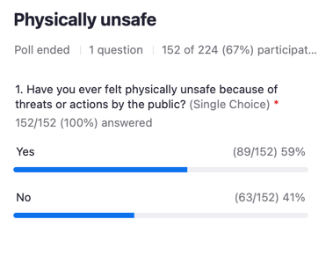
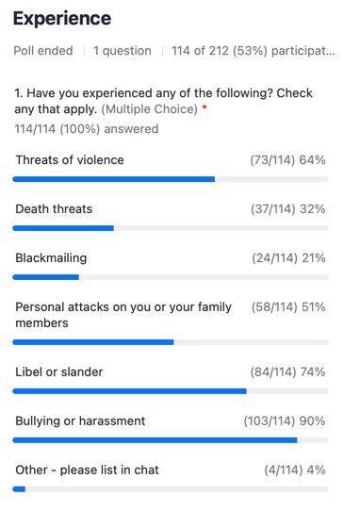

------------------------end-----------------------

