Meeting Recording now on Maddie’s® Pet Forum
https://forum.maddiesfund.org/communityconversations

Maddie’s Box link to recording file:
https://maddiesfund.box.com/s/lirkwiqljf0k4qid51vi4iu9uy3pe4fp

Meeting registration link (Mondays)
https://us02web.zoom.us/meeting/register/tZUqc-6spj0jHtES3GWxrpaG6L3HcbMh_dCu

Passcode = Mondays
Meeting ID = 817 4748 6945
This group’s FaceBook page: American Pets Alive! Shelter and Rescue Support https://www.facebook.com/groups/AmPAShelterRescueSupport

Catch up on Monday recordings and chat resources on Maddie’s Fund® Community Conversations webpage: https://www.maddiesfund.org/community-conversations.htm

113 attendees

Today’s Agenda

- Welcome - Bobby Mann, Director of Human Animal Support Services
- National updates
- Mary’s Monday Motivation –Terrorism: there are no easy answers, even though there are many platitudes with potential solutions. We need to ask ourselves, “What is that thing that keeps us moving? What is the primary function of animal welfare?” For Mary, the primary function is to maintain the support and the strength of the bonds between animals and people. Put people and pets in our vocabulary, our protocols, in our approach to the work we do. Without it, we are doomed. Talk about the things that do not work. Be honest. Believe in yourself, operate with the strength of your convictions, and know you have answers here on these calls - we can handle the obstacles together. SURTHRIVAL -mmeting lifes unwelcome challenges with gusto existential heroes
- Bethany Heins, Best Friends - Best Friends Conference Highlights
- Raul Rodriguez, Animal Control Manager, LA County Appointment system, County of Los Angeles – Palmdale ACC
- Kaycey Adair, Greenville County Animal Care & Liana Moss, Human Animal Support Services - Self Supported Rehoming and Keeping Families working groups: pilot program Together Rest, Reset, Respite Care
- Close: Mary Ippoliti-Smith: new word! SURTHRIVAL: meeting life’s unwelcome challenges with gusto. You are all my existential heroes!

Resources referenced in today’s call
Maddie’s Fund® Contest! Win a chance for a $50 gift card! Invite a friend to the National Calls contest
https://forms.gle/M8N2L87e1dsVLL469

Maddie’s® Candid Conversation Special Edition with Gabrielle Chapman and Justin Marceau – watch on Maddie’s® Pet Forum
http://bit.ly/candidconvochapmanmarceau

https://www.youtube.com/watch?v=Vsj4cUjxsxo

Human Animal Support Services
Keeping pets with family working group https://www.humananimalsupportservices.org/hass-working-group/keeping-pets-with-family-program-development/

Self-supported rehoming working group https://www.humananimalsupportservices.org/hass-working-group/rehoming-without-a-kennel/

Home to Home https://home-home.org/

Events/books/podcasts/research

HeARTs Speak - Caitlin Quinn
New blog related to marketing pets right now if intake is up, and specifically drawing attention to long-stay pets through live-streaming (with thanks to Heidi from Guilford County for guest blogging)
https://heartsspeak.org/livestream-longstay-pets/

Kathy Duncan shared a new blues album by Robert Finley
“Sharecroppers Son” https://robertfinley.bandcamp.com/album/sharecroppers-son

Peter Wolf: National Feline Research Council – exploring the science behind free-roaming cats and kittens
https://www.felineresearch.org/

Upcoming virtual events
June 8-10, 2021: The Association for Animal Welfare Advancement Spring Conference
https://theaawa.org/event/2021Spring

June 17, 2021: Humane Canada’s Mini Event - The Future of Sheltering
https://humanecanada.swoogo.com/minievents/1177765

June 23-24, 2021: Best Friends National Conference
https://bestfriends.org/events/best-friends-national-conference

July 9-11, 2021: The ASPCA® Cornell Maddie’s® Shelter Medicine Conference
https://www.aspcapro.org/splash/aspca-cornell-maddies-fund-shelter-medicine-conference

07:49:52 From Alison Gibson to Everyone:
Good morning! This call is being recorded. Find the recording link and a copy of the resources from this chat within 24 hours on Maddie’s Pet Forum
https://forum.maddiesfund.org/communityconversations

07:53:11 From Mary @ Maddie's Fund to Alison Gibson(Direct Message):
Thanks Alison. You should have seen it 20 minutes ago. I took a walk with the dogs with wet head and came home to frizz. The wonders of a curling iron.

07:53:35 From Mary @ Maddie's Fund to Everyone:
Good morning! I love people who show up early.

07:53:45 From Kathy Duncan to Everyone:
Morning Everyone - Alison finds the BEST videos!!!

07:53:59 From Alison Gibson to Everyone:
@Kathy ahahahah thank you

07:54:28 From Alison Gibson to Everyone:
So how was everyone’s weekend?

07:55:07 From Kathy Duncan to Everyone:
Pretty good - weather was gorgeous here, so spent lots of time outdoors!!

07:55:18 From Alison Gibson to Everyone:
Nice!!

08:00:36 From Kathy Duncan to Everyone: CBC Listen: Q with Tom Power (podcast)
https://www.cbc.ca/listen/live-radio/1-50/clip/15848783

08:00:39 From Peter Wolf to Everyone:
Thank you, Kathy!

08:00:42 From Alison Gibson to Everyone: Kathy Duncan shared a new blues album by Robert Finley
Sharecroppers Son https://robertfinley.bandcamp.com/album/sharecroppers-son

08:00:46 From Mary @ Maddie's Fund to Everyone:
Thanks, Kathy. Appreciate the hopeful message.

08:00:56 From Rebecca Marsh to Everyone:
Thank you, Kathy, for your heartfelt talk and some inspiration to help all of us

08:01:11 From Kelly Clardy to Everyone:
Thank you for sharing, Kathy!

08:01:17 From Kathy Duncan to Everyone:
Thank you so much for the opportunity and for all of the support we all get on these calls.

08:01:18 From Peter Wolf to Everyone:
What Rebecca said^^^

08:01:28 From Sharon Fletcher to Everyone:
Thank you Kathy for sharing. Sending lots of healing and light to our Canadian friends for the recent tragedies.

08:02:20 From Tammi Barrick to Everyone:
Thank you Kathy for your talk. It was so hard to hear let alone talk about this horrific situation. Hugs and unite as we move forward

08:03:35 From Kathy Duncan to Everyone:
Thank you so much everyone. Hugs all around.

08:03:36 From Tasha Haug to Everyone:
Thank you, Kathy, for sharing - sending healing thoughts

08:05:11 From BJ Andersen to Everyone:
Amen, Mary!
Our mission statement for the last 6 years: WHS is dedicated to establishing, maintaining, and enhancing the bond between pets and people in our two counties.

08:05:44 From Mary @ Maddie's Fund to Everyone:
Ah BJ - that’s beautiful

08:05:51 From Shelly (she/her), Maddie's Fund to Everyone:
That’s awesome, BJ!

08:06:19 From Kathy Duncan to Everyone:
Wonderful BJ!!!

08:06:32 From Sharon Fletcher to Everyone:
Fantastic BJ - thank you

08:06:39 From Kelly Clardy to Everyone:
That’s awesome, BJ!! Love it!

08:07:19 From Mary @ Maddie's Fund to Everyone:
Don’t forget to sign up for the Best Friends Conference June 23 and 24. And the ASPCA Cornell Shelter Medicine Conference July 9-11!

08:07:33 From Alison Gibson to Everyone:
June 23-24, 2021: Best Friends National Conference
https://bestfriends.org/events/best-friends-national-conference

08:07:38 From Peter Wolf to Everyone:
National Feline Research Council—because there’s so much misinformation out there about community cats…
https://www.felineresearch.org/

08:08:36 From Alison Gibson to Everyone:
July 9-11, 2021: The ASPCA® Cornell Maddie’s® Shelter Medicine Conference
https://www.aspcapro.org/splash/aspca-cornell-maddies-fund-shelter-medicine-conference

08:08:36 From Monica Frenden to Everyone:
This is a great resource!

08:09:20 From Peter Wolf to Everyone:
Thanks, Monica!

08:09:27 From Alison Gibson to Everyone:
Maddie’s Fund® Contest! Win a chance for a $50 gift card! Invite a friend to the National Calls contest
https://forms.gle/M8N2L87e1dsVLL469

08:09:30 From Christy Alford to Everyone:
Me

08:09:34 From Caryn Fugatt to Everyone:
I'm new

08:09:35 From Linda Lea to Everyone:
This is my first call!

08:09:36 From Mary @ Maddie's Fund to Everyone:
Welcome Jonathan

08:09:37 From Will LeHardy to Everyone:
I’m new

08:09:38 From Jonathan Whistman to Everyone:
I’m new today

08:10:06 From Peter Wolf to Everyone:
Hello, Jonathan!

08:10:13 From Raul Rodriguez to Everyone:
I'm a guess of Bobby's today

08:10:16 From Christy Alford to Everyone:
Me...I got the information from the Maddie's

08:10:21 From Christy Alford to Everyone:
Tallahassee, Fl

08:10:27 From Christy Alford to Everyone:
Its Meow or Never

08:10:30 From Wendy Frink to Everyone:
If you are new here, please fill out this short form to be entered to win a $50 Amazon gift card! https://forms.gle/SyofCitHpULs7Bgz5

08:10:46 From Wendy Frink to Everyone:
And don’t forget to include who told you about the call

08:11:01 From Sharon Fletcher to Everyone:
Welcome everyone - thank you to all who are sharing information with your partners and colleagues

08:11:20 From Cailin Quinn to Everyone:
I don’t have my microphone today but HeARTs Speak has a new blog related to marketing pets right now if intake is up, and specifically drawing attention to long-stay pets through live-streaming (with thanks to Heidi from Guilford County for guest blogging) https://heartsspeak.org/livestream-longstay-pets/

08:11:34 From Alison Gibson to Everyone:
June 17, 2021: Humane Canada’s Mini Event - The Future of Sheltering

https://humanecanada.swoogo.com/minievents/1177765

08:12:03 From Sharon Fletcher to Everyone:
Will - I am the Marketing and Communications Director at Maddie’s Fund - feel free to reach out anytime. Fletcher@maddiesfund.org

08:12:21 From Alison Gibson to Everyone:
June 23-24, 2021: Best Friends National Conference
https://bestfriends.org/events/best-friends-national-conference

08:13:10 From Peter Wolf to Everyone:
So many great sessions at the BF conference! (And I’m doing one, too.)

08:13:27 From Kathy Duncan to Everyone:
Signed up for the Best Friends Conference!! Can’t wait!!!!

08:13:38 From Sharon Fletcher to Everyone:
I got a sneak peek at the platform - it’s really cool!!

08:13:54 From Peter Wolf to Everyone:
Pro tip: If you’re attending my session, bring Kleenex.

08:14:06 From Bobby Mann to Everyone:
AMAZING!!!

08:14:10 From Kathy Duncan to Everyone:
I will make a point of it @Peter!!!

POLL #1
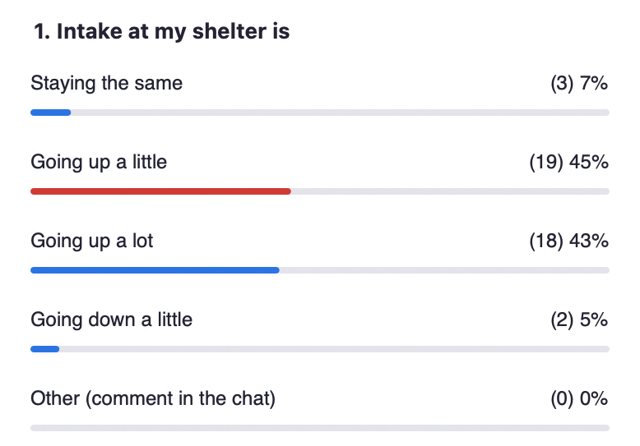

Poll #2
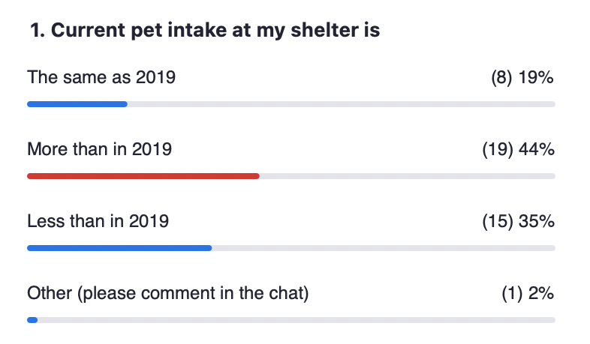

Poll #3

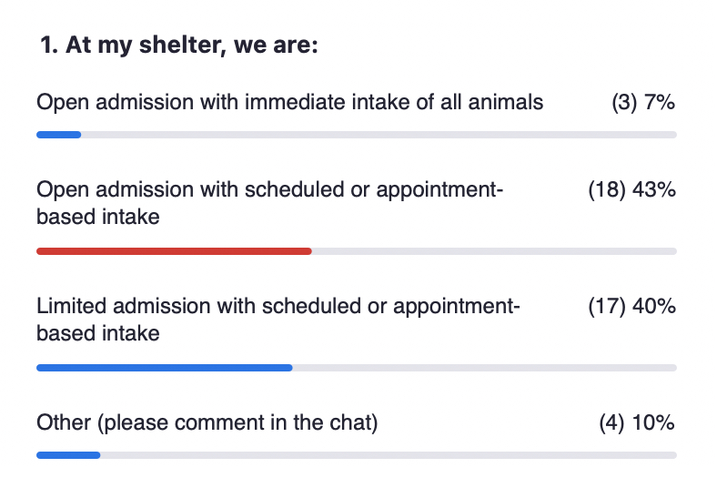

Poll #4
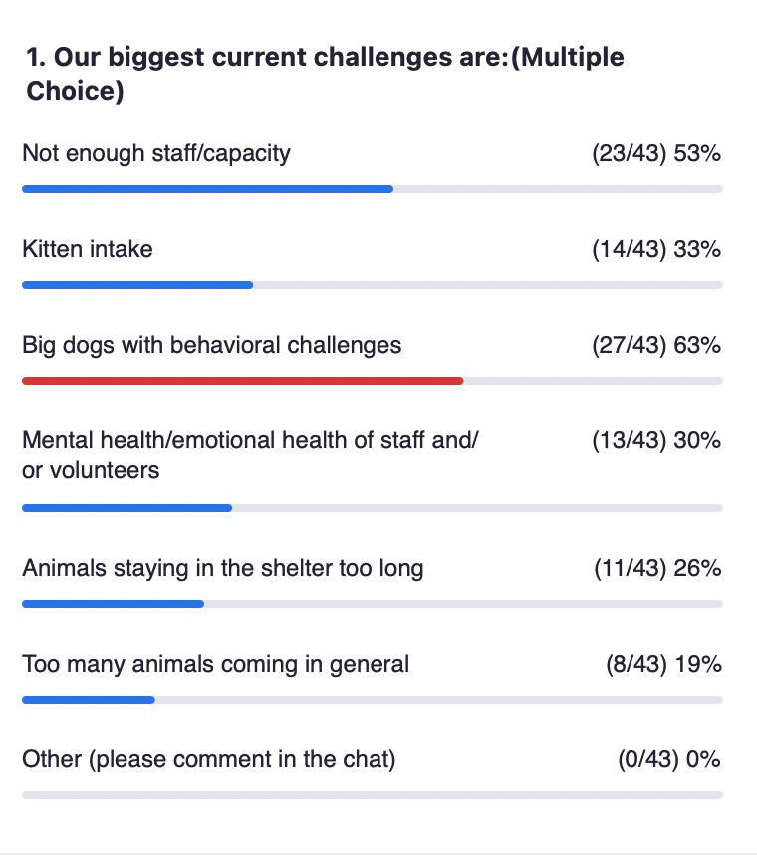
Bethany Heins gave away one free admission to the Best Friends’ Conference to whoever could name the stuffed toy that Jane Goodall (who will be a special guest at the conference) got as a kid

08:14:48 From Sharon Fletcher to Everyone:
Goat

08:14:55 From Karen Smith to Everyone:
Pig

08:14:55 From Sharon Fletcher to Everyone:
Bird

08:15:03 From Linda Lea to Everyone:
Mr. H.

08:15:16 From Donna Casamento to Everyone:
Mr. H

08:15:24 From Linda Lea to Everyone:
Mr. H. a stuffed monkey.

08:15:54 From Sharon Fletcher to Everyone:
There will be Yoga too!!

08:16:06 From Linda Lea to Everyone:
YAHOOOOOOO!

08:16:11 From Kelly Clardy to Everyone:
Congratulations Linda!

08:16:21 From Sharon Fletcher to Everyone:
Congratulations Linda

08:16:22 From Kathy Duncan to Everyone:
Way to go @Linda!!!

08:16:44 From Bobby Mann to Everyone:
Congrats, Linda! Where are you from?

08:18:45 From Bobby Mann to Everyone:
https://www.youtube.com/watch?v=Vsj4cUjxsxo

08:18:53 From Alison Gibson to Everyone:
Maddie’s® Candid Conversation Special Edition with Gabrielle Chapman and Justin Marceau – watch on Maddie’s® Pet Forum
http://bit.ly/candidconvochapmanmarceau

08:18:59 From Bethany Heins to Everyone:
Congrats, Linda! My email is bethanyh@bestfriends.org

08:19:13 From Linda Lea to Everyone:
I’m a volunteer with Big Bones Canine Rescue in Northern Colorado.

08:19:14 From Cailin Quinn to Everyone:
That was such a wonderful conversation — definitely a watch of the week!

08:19:26 From Alison Gibson to Everyone: Maddie’s Pet Forum – find our Community Conversations here:
https://forum.maddiesfund.org/communityconversations

08:19:58 From Alison Gibson to Everyone:
Raul Rodriguez, Animal Control Manager
LA County - Palmdale ACC
https://animalcare.lacounty.gov/

08:24:18 From Brandy Buie to Everyone:
Immediate intake with appointment-based owner relinquishment

08:24:35 From Phillip Zimmerman to Everyone:
Open-admission with scheduled and drop-in

08:25:16 From Tasha Haug to Everyone:
private non-profit with intake by appointment when space/fosters are available

08:27:30 From Bobby Mann to Everyone:
We will have time for questions! Feel free to drop them in the chat

08:30:11 From Bobby Mann to Everyone:
I always wondered if barking complaints would go up or down with people being home. 1. More people home to hear barking 2. More owners home, so less dogs left alone.

08:33:53 From Kathy Duncan to Everyone:
So exciting @Raul!!!

08:37:54 From Sharon Fletcher to Everyone:
Thank you Raul!

08:38:17 From Peter Wolf to Everyone:
Question

08:39:15 From Peter Wolf to Everyone:
Gotcha—thanks!

08:41:11 From Liana Moss to Everyone:
LA County - Agoura Animal Shelter inspired me as a child to get into animal welfare! Thanks Raul! :)

08:41:20 From Alison Gibson to Everyone:
Kaycey Adair, Greenville County Animal Care Services

08:41:30 From Alison Gibson to Everyone:
Liana Moss, Implementation Coordinator, American Pets Alive!

08:41:47 From Alison Gibson to Everyone:
HASS Keeping pets with family working group https://www.humananimalsupportservices.org/hass-working-group/keeping-pets-with-family-program-development/

08:44:53 From Alison Gibson to Everyone:
Home to Home https://home-home.org/

08:45:44 From Bobby Mann to Everyone:
Kaycey is a ROCKSTAR!!

08:45:52 From Mandy Evans to Everyone:
Kaycey- You're a Rockstar!

08:47:34 From Mandy Evans to Everyone:
Home To Home is free to onboard and for one year for HASS Shelters #ThankstoMaddies home-home.org

08:48:00 From Bethany Heins to Everyone:
wow, these stats are AMAZING

08:48:01 From Alison Gibson to Everyone:
Greenville County (SC) Animal Care Services
https://www.greenvillecounty.org/

08:48:39 From Kathy Duncan to Everyone:
Excellent!! Go Kaycey and Team Greenville!!!!

08:48:42 From Andrea Giorgio to Everyone:
Incredible!

08:49:19 From Cailin Quinn to Everyone:
These numbers are incredible

08:50:17 From Mandy Evans to Everyone:
Whoop, whoop...Home To Home rocks and all our network shelters work hard to help pets stay out of shelters. home-home.org

08:55:43 From Kathy Duncan to Everyone:
This sounds AMAZING!!!!!!

08:56:06 From Mary @ Maddie's Fund to Everyone:
Thank you, Kaycey and Liana!

08:56:33 From Alison Gibson to Everyone:
HASS Self-supported rehoming working group
https://www.humananimalsupportservices.org/hass-working-group/rehoming-without-a-kennel/

08:56:34 From Cailin Quinn to Everyone:
So exciting, thank you both

08:59:24 From Tammi Barrick to Everyone:
WOW great information! Loved the interaction with home to home to divert admissions

-----------------------------end----------------------------

