Central Arkansas Rescue Transport (“CART”)
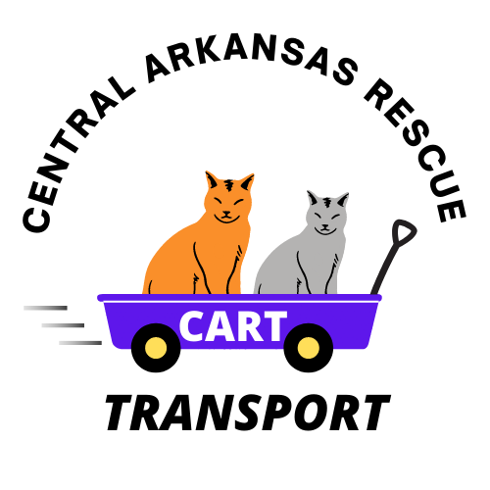

Sponsorship – Funding for Transported Animal
centarkrescuetrans1@gmail.com / 501-288-9548

Delivery Date: |  |  | Sponsorship Amount:
Receiving Organization:

Cat Info
Names: |  | Age:
Breed/Color: |  | Sex:

*[name] may need more time in a foster home or may need to be adopted from the foster home; he may be able to move to an Adoption Partner of [Receiving Organization] if deemed appropriate, after sufficient decompression time.

*Bonded Pair Siblings: CART has provided a foster sponsorship for [names] to ensure they are adopted together. They can go to an Adoption Partner of [Receiving Organization] but only if they will only be available for adoption as a bonded pair. If [names] are not adopted within 3 months, an extension of the sponsorship can be discussed with CART.

The group designated above as the ‘Receiving Organization’ is accepting responsibility for this animal under a sponsorship arrangement with Central Arkansas Rescue Transport (CART). The ‘Receiving Organization’ acknowledges that this animal may require additional time in a foster home setting to prepare for adoption and will keep the animal in a foster home setting. CART has provided a check (or sent through PayPal) for the amount noted above for this sponsorship in exchange for up to 3 months of extended foster care of said animal. The ‘Receiving Organization’ can offer said animal for adoption as soon as the ‘Receiving Organization’ deemed the animal is ready for a permanent home.

If said animal is offered for adoption and the animal is not adopted within the three-month period after the delivery date noted above, the ‘Receiving Organization’ may choose to contact CART concerning the animal’s current situation to determine the best options of the animal. However, the said animal must be available for adoption for a minimum of 30 days within that three-month period.

The sponsorship payment, as well as all adoption fees earned from the adoption of said animal, remains the property of the ‘Receiving Organization’, regardless of the timeframe between delivery and said animal’s successful adoption.

Acceptance

By depositing the check that accompanies this document (or acceptance of PayPal), the receiving organization accepts the fostering requirements noted above.

