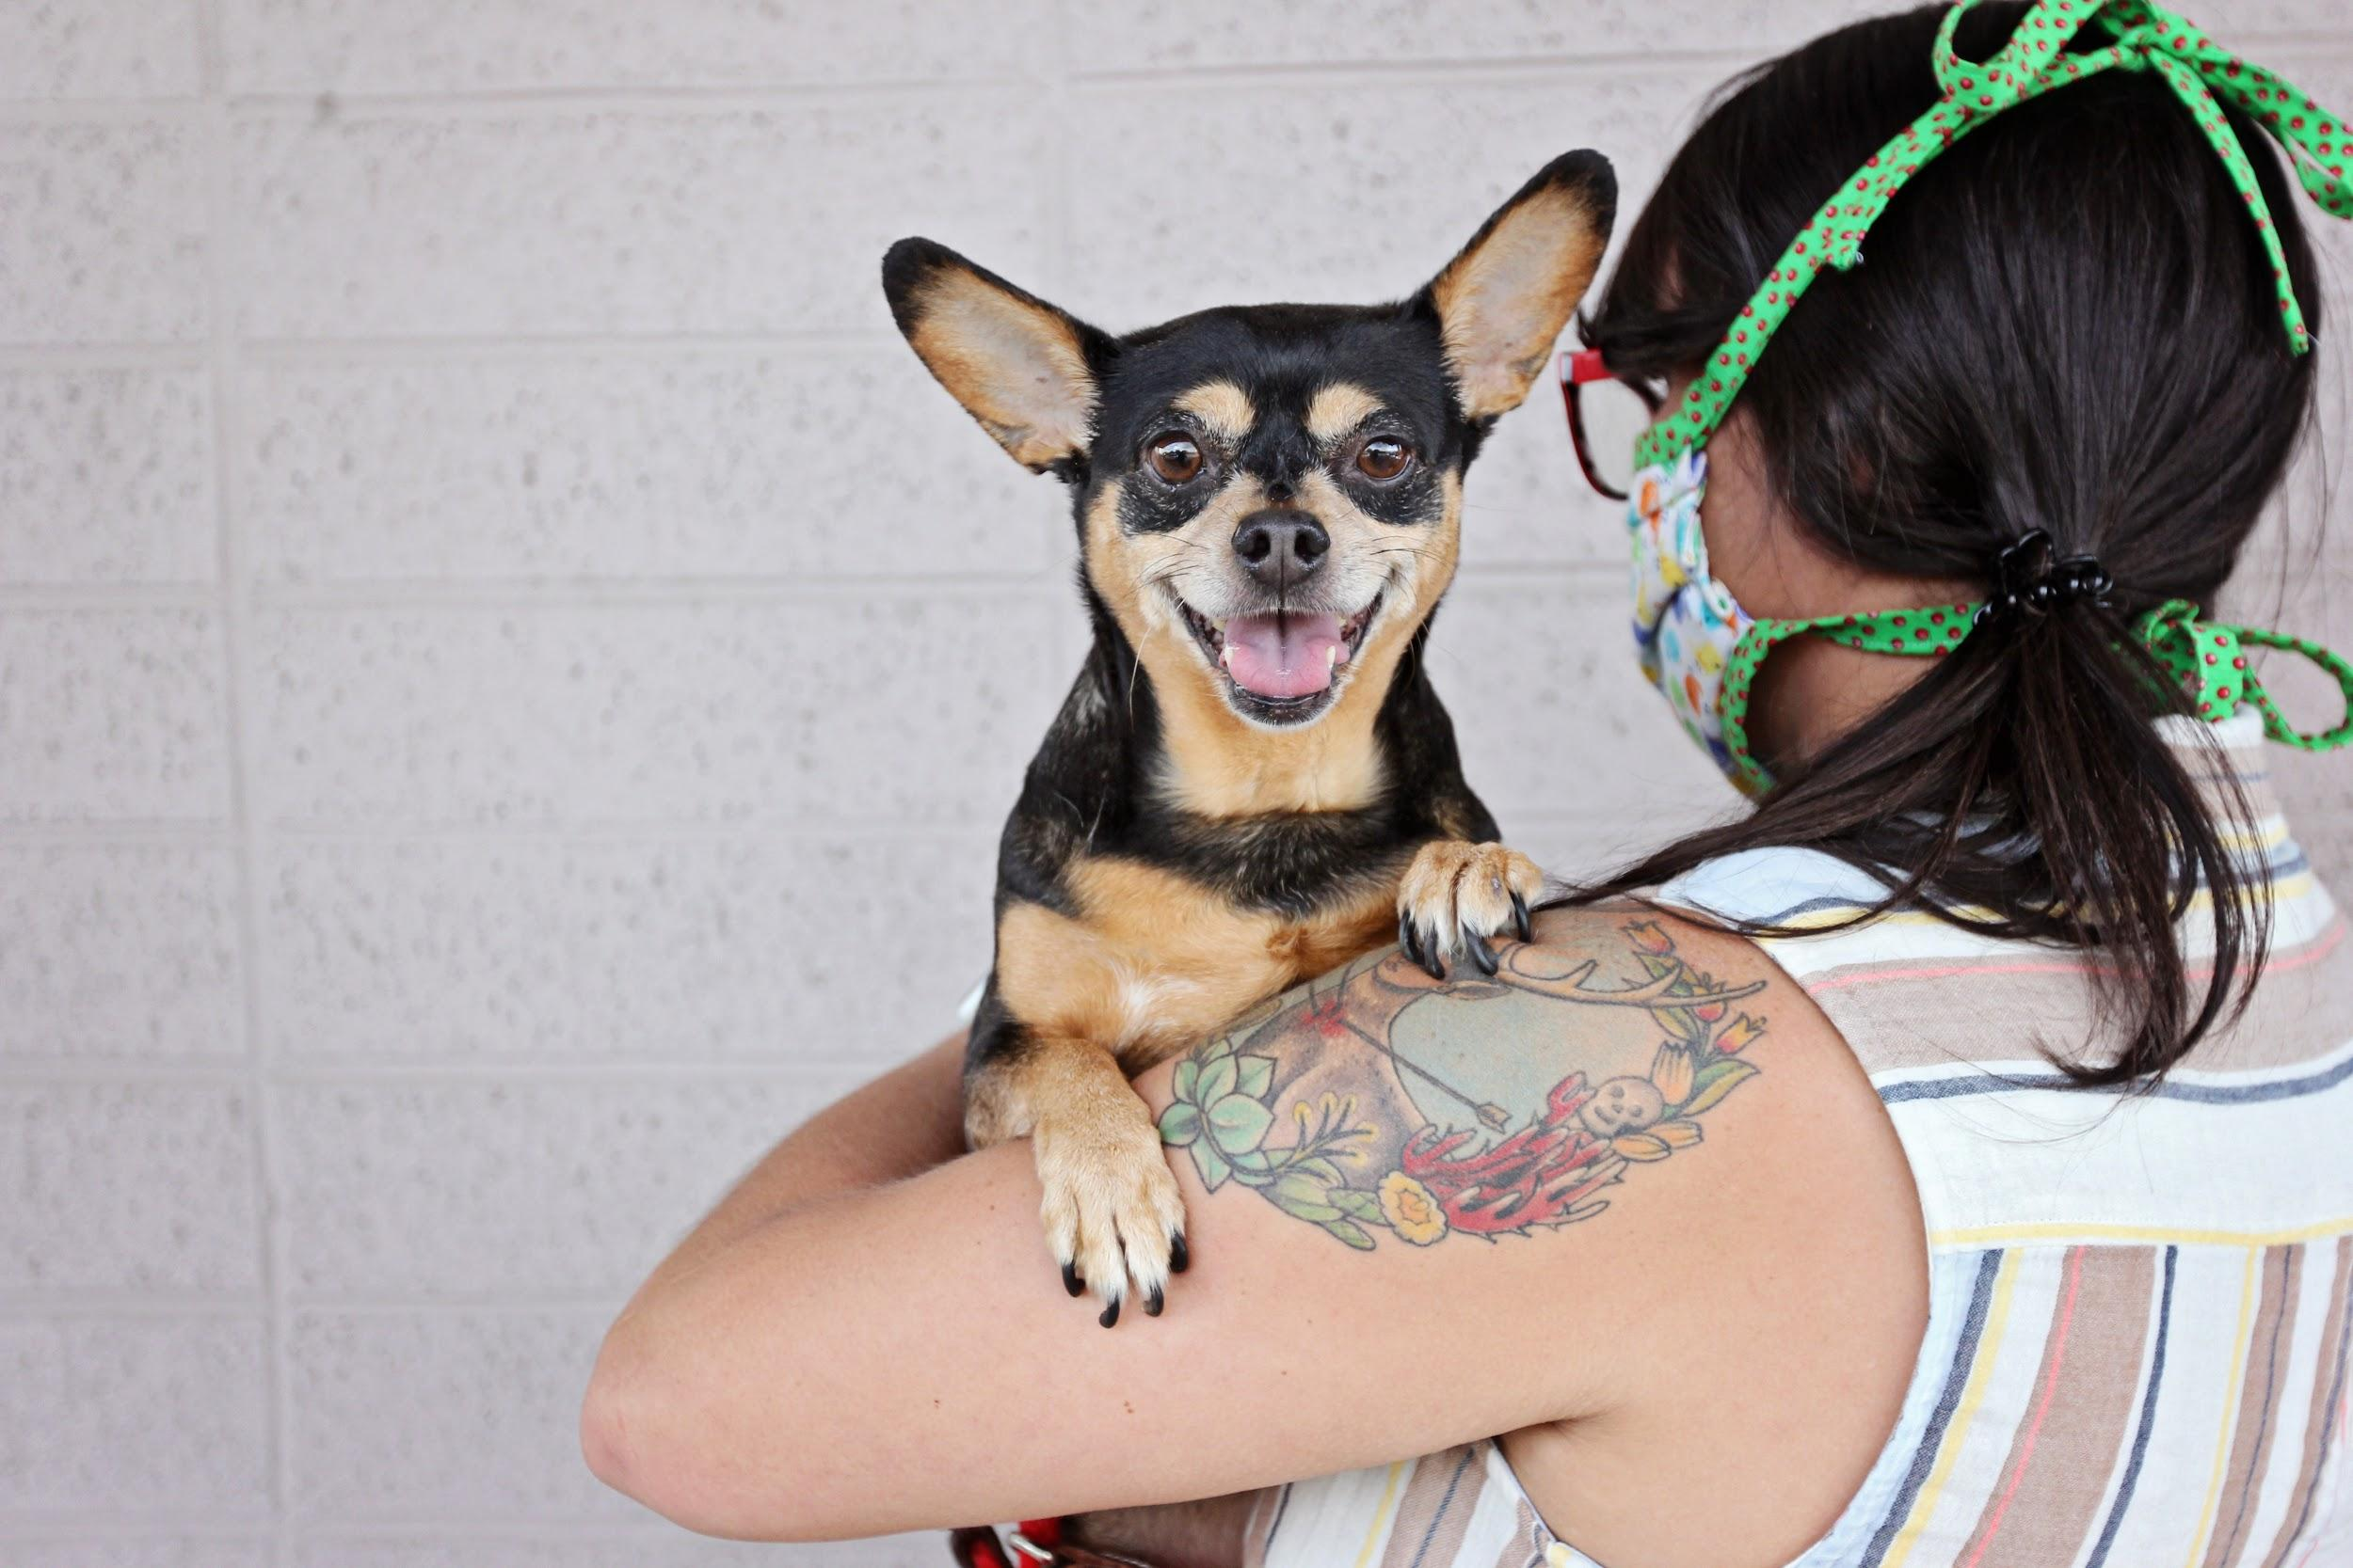

Foster Guide for Dogs
1370 South 400 West  Salt Lake City, UT 84115  www.ruffhaven.org | FOSTER CONTACTS:  Caitlin Lisle: 801-808-7746  Emergencies: 801-251-6765 (text)
Table of Contents

Overview & Contact Information . . . . . . 3

Foster Expectations . . . . . . . . 4

What is an Emergency? . . . . . . . 5

Before the Foster Comes Home . . . . . . 6

Your Foster’s First Day . . . . . . . 6

Dog Fostering 101 . . . . . . . . 7-8

Many thanks to Lost Our Home Pet Rescue in Tempe, AZ for providing the basis for this foster guide.
Thank you for fostering with Ruff Haven Crisis Sheltering.

Ruff Haven could not exist without a network of dedicated, compassionate fosters. Our mission is to provide a temporary safe haven for companion animals in order to keep pets and their people together in times of crisis, increase pet retention, and decrease the number of animals entering the shelter system.

Ruff Haven volunteers and fosters treat the people and pets we serve with kindness and dignity. We strive to provide a non-judgmental environment where people feel safe entrusting their pets into our care.

We hope this foster guide prepares you for what to expect when you bring home a Ruff Haven foster dog. While it may not hold all the answers, Ruff Haven volunteers are always happy to help and we are only a phone call, text, or email away.

Contact Information

Your Foster Sitter Coordinator: Caitlin Lisle
Cell: 801-808-7746 (call or text)
Email: foster@ruffhaven.org

Your Fellow Foster Sitters:
Join the Ruff Haven Foster Sitter Facebook group!

In Case of Medical Emergency: 801-251-6765 (text is best)

Maddie’s Pet Assistant App

You aren’t in this alone. Nothing sets up a foster for success more than a powerful communication tool and immediate response. The Maddie’s Pet Assistant app gives caregivers the opportunity to submit questions, photos, and videos and take surveys. When you foster your first Ruff Haven pet, you will receive an email with instructions on setting up the Maddie’s app.
What to Expect as a Ruff Haven Foster

The Ruff Haven Crisis Sheltering program is for pet owners in Utah who are temporarily unable to care for their pets. There is no cost to the pet owner seeking RHCS services. All pets that enter the program are vaccinated and sterilized. The program allows for up to 60 days of sheltering, though extensions may be granted.

A foster home shall provide a warm, clean, and loving environment for the foster dog. Food shall be provided and medications given as directed. A foster home will bring the foster dog into the facility (Dogs All Day) or veterinarian as scheduled for medical care and vaccinations. A foster home will only allow the foster dog outside under proper supervision. A foster home will also monitor the health of the foster dog and immediately contact Ruff Haven leadership in the event of questions or concerns about the health or safety of the foster dog.

In the event that the foster dog is commingled with other animals in the foster home and illness or injury results, veterinary expenses shall be the sole responsibility of the foster home.

Foster dogs are released into the possession of the foster parent and cannot at any time be given to another person without prior authorization from Ruff Haven Crisis Sheltering.

Foster Supplies

Ruff Haven will provide foster families with the following items for foster dogs: food, collar, and a leash. Please anticipate providing bowls, beds, blankets, kennels/carriers, etc. If we have these items available via donation, we will provide them as we are able.
Any items you acquire for the care of the foster dog are NOT the property of Ruff Haven nor the foster dog’s owner. Ruff Haven cannot reimburse fosters for the purchase of supplies. Thank you for understanding.

Check Ins/Photos

If you are fostering a dog, our foster coordinator will reach out at least biweekly to check on both you and the foster. You are welcome to reach out any time with questions, concerns, or updates.

♡ We LOVE photos and videos to share with pet owners! ♡ Please make sure any photos/videos you send are anonymous (no identifying information such as your face or address) so that we can send them to the pet owners.
Examples of Emergency Medical Symptoms

- Blood from any orifice/opening  - Blood in vomit or vomit that is dark in color  - Blood in the urine, or if the foster animal is unable to urinate at all  - Blood in the stool, especially with diarrhea  - Congestion, wheezing, or labored breathing  - Fever (often accompanied by lethargy)  - Diarrhea in neonates/underweight animals for more than 24 hours | - If an accident has occurred and the foster animal appears to be injured  - Lameness that appears severe and painful  - Pain -- irritability when handled or touched, particularly if it seems out of character for that animal.  - Seizures or convulsions  - Trouble eating, mouth pain, or drooling  - Lethargy or decline in activity level normal for your foster animal for more than 24 hours

Examples of Non-Emergency Medical Symptoms

- Any change in appearance of the eye: squinting, winking, tearing, swelling, redness, or yellow, green, or crusty discharge  - Coughing for less than 24 hours  - Diarrhea/loose stool (in adult animals and for less than 48 hours)  - Excessive drinking for more than 48 hours  - Increased appetite for more than 1 week, especially when accompanied with weight loss  - Weight loss is observed over a 48 hour period, especially with kittens, puppies, or nursing mothers -- when weight loss is accompanied by normal to more-than-normal food intake | - Increased scratching at any part of the body, including head shaking  - Increased urination or sudden accidents in the house, difficulty urinating, and straining for less than 24 hours  - Nasal discharge -- white, yellow, or green  - No apparent weight gain, especially with puppies and kittens during a 72-hour period  - Poor appetite for more than 48 hours  - Sneezing for more than 24 hours  - Unexplained lameness that does not improve with rest within 24 hours  - Hair loss  - Vomiting less than three times

Better safe than sorry!

If you have any concerns (emergency or not) about the health of your foster pet, please text or email an explanation and/or photos to Ruff haven program leadership at 801-251-6765 or info@ruffhaven.org.

Ruff Haven leadership (Kristina, Marisa) MUST authorize veterinary care before services are rendered.

Unauthorized veterinarian expenses are the responsibility of the foster home.
Dog-Proofing Your House: Before the Foster Comes Home

When dogs are in a new situation (like your home!), they may act in ways that the owner could never imagine or forewarn Ruff Haven volunteers or fosters about. This includes chewing, scratching, and soiling when they don’t have a history of doing so.

Dog-proofing your home ensures that an anxious, stressed, or mischievous foster dog does as little damage as possible to your home and themselves.

Consider the following:
- Put away shoes in closets and clothes in hampers or dressers.
- Make sure that children’s toys are put away or in rooms with closed doors.
- If your home has a fence, walk your fence line and ensure there are no opportunities for escape.
- Make sure that kitchen counters are clear of snacks or treats.
- Ensure that trash cans (in your kitchen and bathrooms) have lids or are put away where a dog can’t get into it.
- Make sure houseplants that are toxic to dogs are out of reach.
- Check that wires are tucked away behind and under furniture.
- And more -- walk around your house and consider what is at “dog height” and make changes accordingly.

Your Foster Dog’s First Day Home

Your foster may be excited to meet you and want to explore your home as soon as they arrive. They may also be shy, timid, and want to hide under your dining room table. Be flexible! Be prepared to take the first day at your foster’s speed.

Your foster dog may eat their first meal at your home without a problem. They may also turn up their nose at food and that is OK. If your foster still hasn’t eaten anything (not even treats) after 24 hours in your home, please notify your foster coordinator.

Even if you are fostering an adult dog, plan to take your foster dog outside to potty every few hours (or more frequently) for the first few days. Even a house broken adult dog can have accidents when in a new home. Your foster dog may have diarrhea or loose stool for the first few days, which is common when adjusting to a new environment or diet.

For the first day in your home, bond with your foster with lots of play, cuddles, and treats. Take your foster dog for a walk around your neighborhood and begin to build their new daily routine. A routine is the most important thing you can give your foster dog after your unconditional love!
Dog Fostering 101

Socialization and Playtime
- Lots of human contact (petting, cuddling, and even just sitting together) is important for dogs in a new place.
- Attention and playtime is a reward for your foster dog. Be sure to give your foster dog several minutes of playtime periodically throughout the day.

Exercise
- Foster dogs should be exercised every day, rain or shine. The old adage, “A tired dog is a happy dog,” holds true for foster dogs. Most foster dogs will need at least two 15+ minute walks a day to release excess energy.
- If your foster dog is an adolescent, you may need to step up the activity level to include regular runs, hikes, or brisk walks. A dog that is exercised regularly will tend to sleep when you are not at home. A sleeping dog cannot do undesirable things such as bark or chew.
- Your foster dog should never be left outside unsupervised, even in your own fenced yard. It may be unknown if the dog is an escape artist and they could easily go over or under a fence without your knowledge.
- When your foster dog is off of your property, they should ALWAYS be leashed and wearing a well-fitted collar with our Ruff Haven ID tag.

Housetraining and Schedule
- Be patient with your foster dog. Even house trained adult dogs will make mistakes, especially if they’ve been boarded for a long time and have been eliminating in their kennel. It’s important to establish a routine for potty breaks to cut down on potential accidents.
- The best method is: let your foster dog out when they wake up, after they eat or drink, after a play session, or at least every 2 hours. Stand with the dog for 5 minutes. If the dog eliminates, reward them with treats and praise. If the dog doesn’t go in 5 minutes, take them back inside and try every 15 minutes until they potty. Every time they go, reward them!
- Accidents happen! If there are smells in your house from another dog or cat, some foster dogs may “mark” out their territory. This action should be re-directed immediately with a calm “Ah ah!” and escort the dog outside to finish. You will want to use an odor neutralizer on the areas a foster dog has “marked” to ensure they will not mark that area again.
- If the dog goes in the house while you are not paying attention, don’t correct them, it is not their fault. Clean it up and go back to your schedule. NEVER put the dog’s face in the mess or yell at them. The dog will not understand and you will only teach the dog to fear you!
Grooming
- Once your foster dog has had time to explore and adjust to your home, they may need some grooming. This could include cleaning their ears, trimming their nails, giving them a bath, or brushing their coat.
- When trimming their nails, be careful not to cut too close to the pink veins. To be safe, simply clip off the curved tips carefully.
- When cleaning their ears, be careful not to go too car into the ear canal as this could be painful and cause internal damage.
- If giving a bath, use a simple and gentle shampoo with no added fragrance. You do not want to irritate their skin. Make sure to rinse the shampoo thoroughly.

Introductions
- When introducing your foster dog to pets in your home, make sure your foster dog is on a leash. Allow your foster dog to greet your dog for the first time outside. It is your dog’s home, and they may be concerned that a new dog is suddenly inside.
- If you have cats, make sure your foster dog cannot corner them. Ensure your cat has ample space away from the foster dog. Even if they are fine with your current dog, they may need time to adjust to a new dog.
- If you have children, make sure they understand that while a new foster dog is fun, they need time and space to feel safe. Too much noise or “crowding” the dog can make them nervous and scared.

Adventuring
- Foster dogs have owners and should never be taken to a place where they could potentially be injured or lost.
- Off-leash dog parks, pet stores, and doggie day cares are off-limits for Ruff Haven foster dogs.
- You may walk your on-leash foster pet in your neighborhood, at nearby parks, or on trails.
- Never use an extendable leash, a damaged leash, or item never intended to leash a dog. Extendable leashes can not only put your foster dog at risk, but they are often easily breakable and can be torn from your hand if the foster dog is running at high speeds.

Additional Resources
Chill Out! Decompression Tips For New Foster Dogs

How to Be the Best Dog Foster Parent

Crate Training & House Training Tips

