Breaking down and storing Crates SOP
Purpose:
To help maintain a clean and organized supply of carriers and crates for our pets, so staff and volunteers can easily access clean items of an appropriate size when needed.
Special Notes:
- The RVSPCA Intake and Foster Coordinator, Carrie Maness, is your staff contact for this shift.
  - You can reach her at cmanness@rvspca.org or 540-339-9508
- RVSPCA staff on the Animal Care and Enrichment team wash and sanitize our crates and carriers by the loading dock at the back of the building. Dirty items are placed directly behind the loading dock and clean items are placed to side of the building to dry.
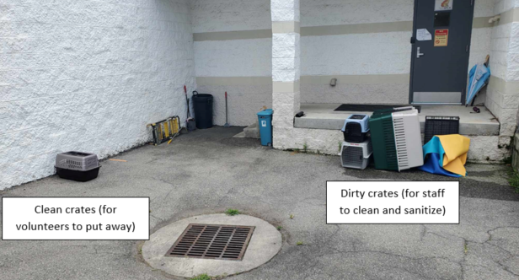
Procedures:
- Check the crates in the clean area to see if they dry enough to put away. You may need to grab a towel from the Laundry room to finish drying them. Please do not put away items when they are wet!

- The two-doored carriers, also called top-loading carriers, are used daily in the shelter. They should be stored on the shelf in the playyard.
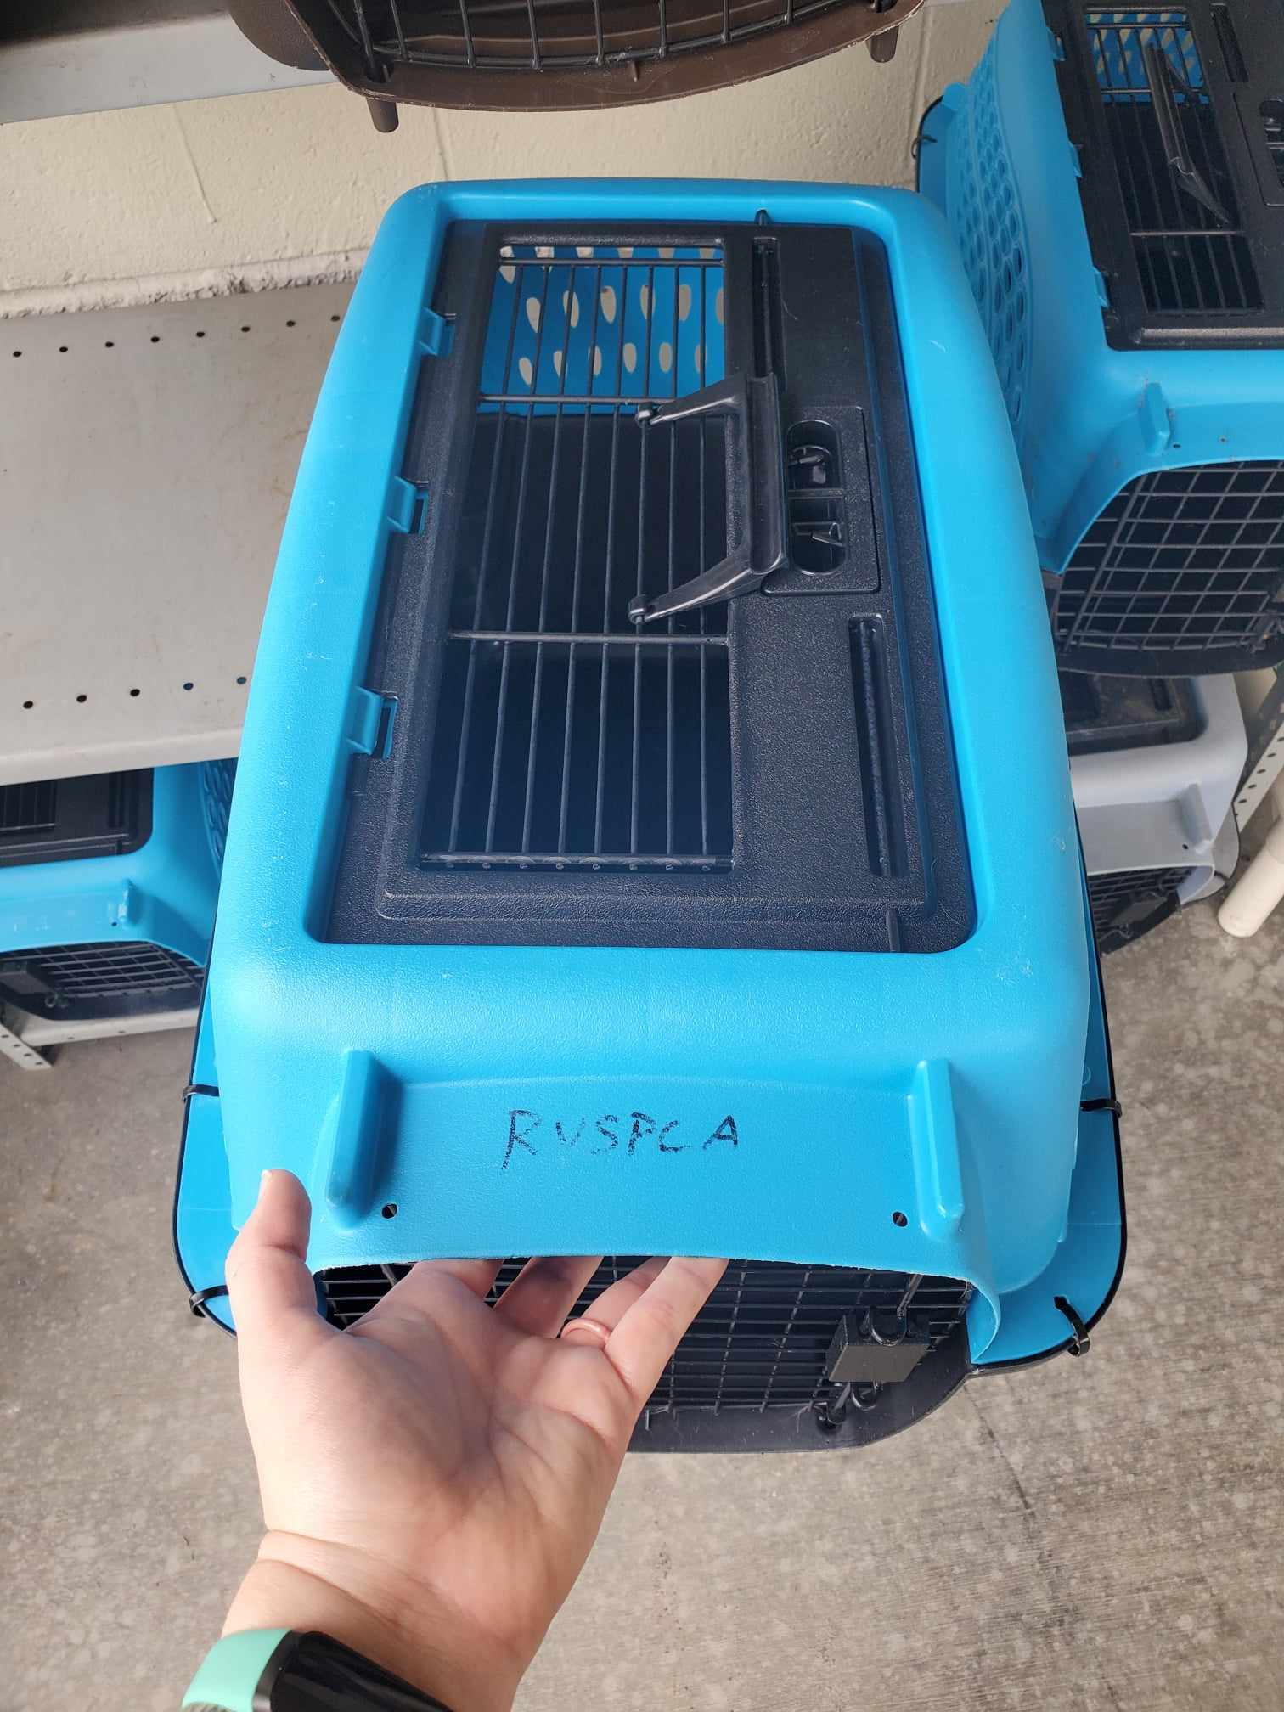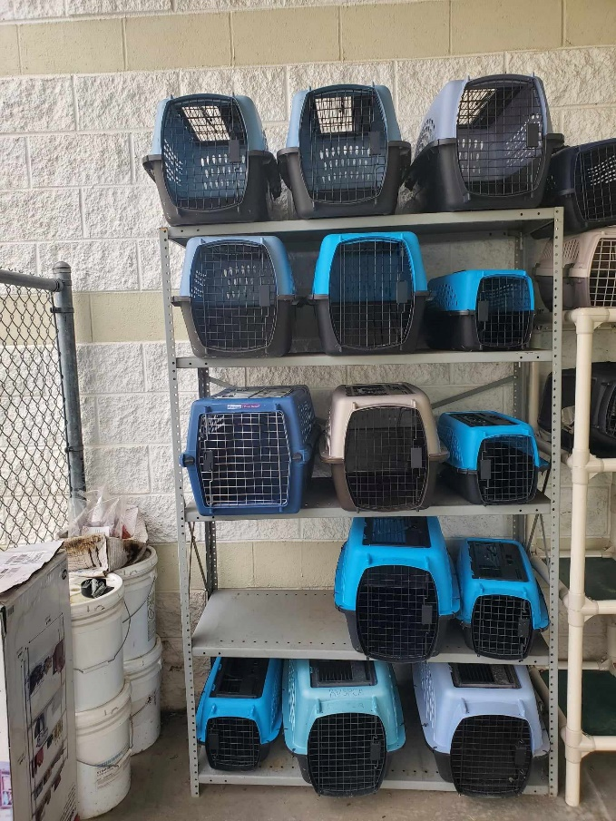

- Grab the Volunteer clippers from Carrie’s mailbox right outside her office to remove the zip ties on crates. Zip ties are a quick and easy way for our staff to assemble crates; since we have to build and take apart crates often, the screws that come with the crates are not a realistic option for us!
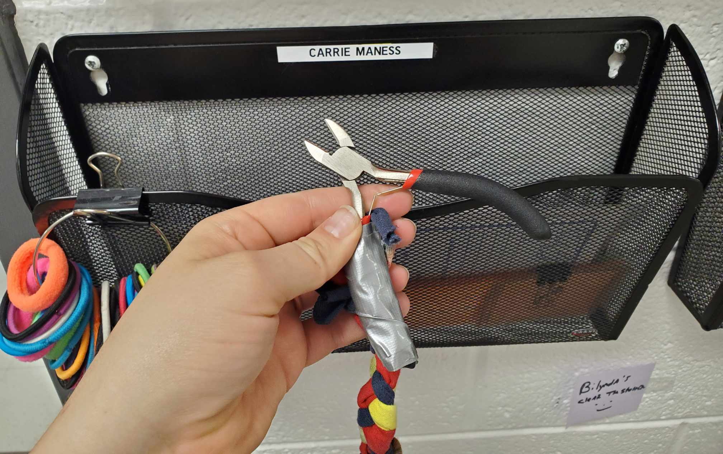

- Grab the Shelter Supply Shed key from the RVSPCA key box. You can ask a staff member to assist you if needed.

- The Shelter Supply shed is the white shed closest to our building on the left side of the back parking lot. Use the key to unlock the Supply shed door.

- For single door crates, use the clippers to cut and remove the zipties that are tying the two halves of the crates together. The cut zipties should be thrown away in the dumpster or trash can.

- After the zipties are removed, you can take the crate apart. Crates should be stacked in the following order:
  - Bottom half
  - Front door
  - Top half (filled upside down)
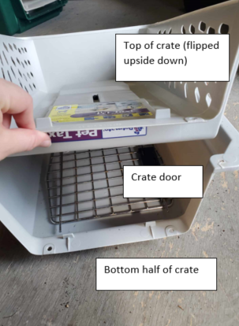

- The stacked crates go into the Shelter Supply shed on the right side. Please add the crates to the stack where it makes sense for their size. You may need to pull some (or all!) of the crates out from the shelves to fit in the new crates appropriately.

- The crates that have orange tape on the top are designated as small/cat carriers.
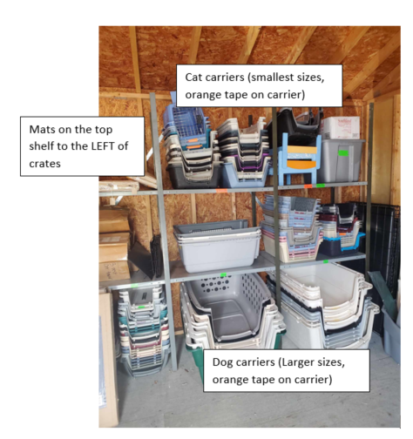
- Any mats should be rolled up and store don the top shelf to the left of the crates in the Shelter Supply Shed.

