Past Recordings on Maddie’s Pet Forum
https://forum.maddiesfund.org/communityconversations

This Meeting’s Recording
Recording on Maddie’s Pet Forum:
https://maddies.fund/awleadershiproundup52022
Maddie’s Fund Box Link to Recording File:
https://maddiesfund.box.com/s/65vvw3290jqihulhkuhx1fpb4wdd6ik9

Friday meeting registration page
https://maddies.fund/Register_AWLeadershipRoundup
https://us02web.zoom.us/meeting/register/tZEud-2orzMrHtLTuNo0GbrSNeCQlQkdWKAp

Monday meeting registration link (for shelter staff and committed volunteers)
https://maddies.fund/Register_ShelterRescueSupport
https://us02web.zoom.us/meeting/register/tZUqc-6spj0jHtES3GWxrpaG6L3HcbMh_dCu

230 Attendees

Agenda
- Host: Kristen Hassen, Director, American Pets Alive!

- Question of the Day: Do you think this summer is going to be the same, better, or harder than 2019?

- National Updates:
  - Maddie’s Fund Monthly Giveaways: https://www.maddiesfund.org/friday-community-conversations-may22-giveaway.htm

  - Jyothi Robertson, through the Journey You Own, will be hosting free, monthly meditation gatherings to create a shared, supportive space to explore grounding practices. These one-hour sessions will include a 15 minute guided meditation, along with time to learn more about grounding practices and share experiences. The first ever session will be held via zoom on Thursday, May 25th at 5pm PST. Everyone is welcome. Link to register is here: https://jyo.world/meditation-gathering/

  - CARE series for AAPI Heritage month. Next topic: Transracial Human and Animal Adoption, Monday, May 23rd 7pm EST with Alice Stephens, Author; Susan Ito, Editor and Author; Mi Ok Song Bruining, Artist, Therapist and Author. Registration Link: https://us02web.zoom.us/meeting/register/tZIqcO-hqj4rHdYSaY3GyD11qADnbF0oOWmi

  - From Lexis, PhD Student @ UBC Animal Welfare Program: Looking for staff to help us learn more about how we input shelter data into shelter software during (dog) intake. If you are a staff who deals with intake, please take our survey: https://ubc.ca1.qualtrics.com/jfe/form/SV_9yvyF8YLAgpubMW

  - Calls for Proposals:
    - 2022 Access to Veterinary Care (AVC) Conference: Call for Speakers due May 23rd; conference held from October 17-19th, 2022 in Minneapolis, MN. Anyone engaged in AVC is encouraged to apply. Aspcapro.org/avcspeakers

    - 2022 ASPCA-AAWA Research Forum-Call for Proposals; for new research relating to community and shelter animal welfare; forum held online November 9, 2022. https://airtable.com/shrvIfd9gCPWVkryq

  - Open Funding Opportunities:
    - Access to Veterinary Care Research Grants: supporting research that advances knowledge toward expanding animals’ access to veterinary care. https://airtable.com/shraDAHboTgrT3KK3

    - Applied Behavior Research Seed Grants: supporting research that advances knowledge in responding to behavior problems in animal shelter populations. https://www.aspcapro.org/grant/2022/03/22/applied-behavior-research-seed-grants-2022

---
TOPIC 1: Beth Steinhorn, President of VQ Strategies, will join us to discuss the importance of volunteer integration within an organization and how a Service Enterprise can strengthen the capacity of organizations to strategically and effectively engage volunteers to address organizational and community needs.

Beth Steinhorn, President of VQ Strategies: https://vqstrategies.com/vq-team/vq-bios/

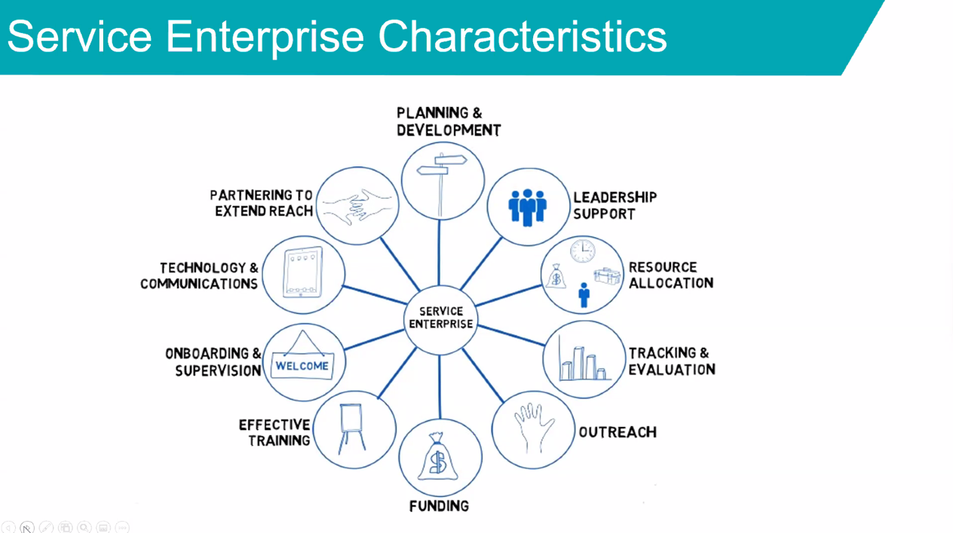

---
TOPIC 2: Dr. Jessica Hekman, one of the authors of the "Ancestry-inclusive dog genomics challenges popular breed stereotypes", will join us to discuss research showing that dog breeds are not directly correlated with specific behaviors. Sound familiar? It should! This research has been featured in The Atlantic, The New York Times, NPR, and many more news publications since its release just a few short weeks ago. An excerpt from The Atlantic states, "The point, then, isn’t to discount breed’s influence over dogs, but to rethink its sway over us. People who go after particular dog breeds may do so under the pretense that their new pets will act a certain way. And then they treat them as such, emphasizing and exaggerating the very behaviors they wanted out of their dogs in the first place, while suppressing others. They teach a “clever” dog more tricks because they assume that the animal will learn them; they give an “aloof” dog more space because they figure their pet needs the time alone. Stereotypes become “self-fulfilling prophecies,” Bekoff, of CU Boulder, told me. Dog behaviors are what we breed them to be, but also what we expect them to be. “How much of how breeds behave is how we behave toward breeds?” Alonso, of the International Association of Animal Behavior Consultants, said. “That is the million-dollar question.”

Dr. Jessica Hekman: http://www.dogzombie.com/

Ancestry-inclusive dog genomics challenges popular breed stereotypes
https://www.science.org/doi/10.1126/science.abk0639

What’s in a Name? Effect of Breed Perceptions & Labeling on Attractiveness, Adoptions & Length of Stay for Pit-Bull-Type Dogs https://journals.plos.org/plosone/article?id=10.1371/journal.pone.0146857

New York Times: https://www.nytimes.com/2022/04/28/science/dogs-breed-behavior-genes.html

NPR: Your dog is a good boy, but that's not necessarily because of its breed:

https://www.npr.org/2022/04/28/1095390872/dog-breeds-behavior-study

The Functional Dog Collaborative: https://functionalbreeding.org/

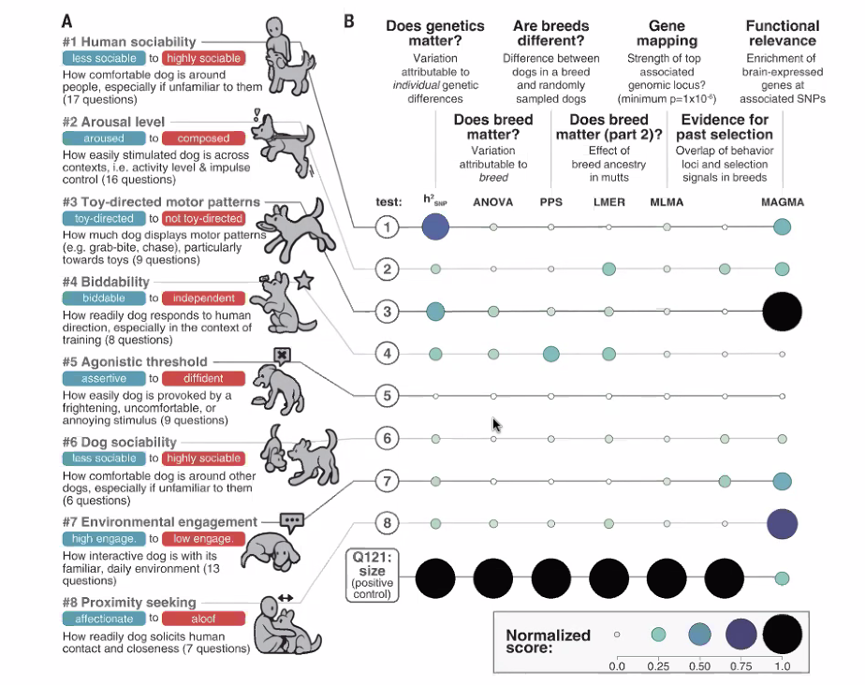
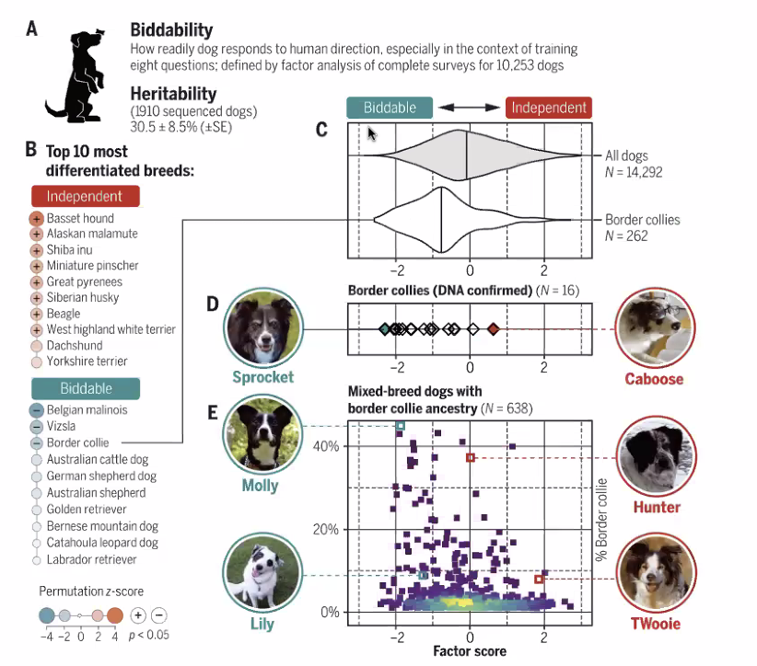

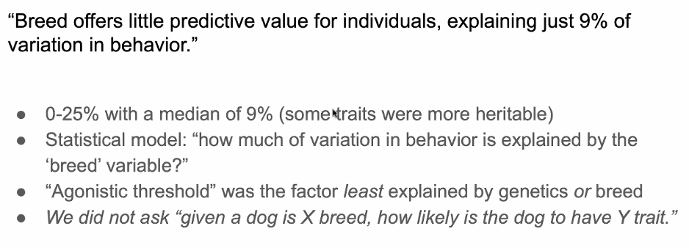
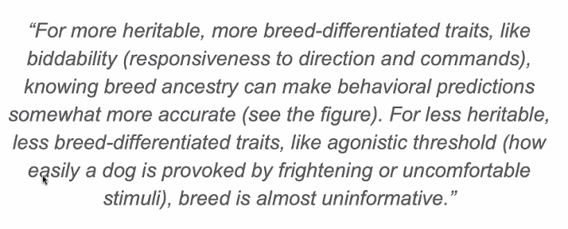

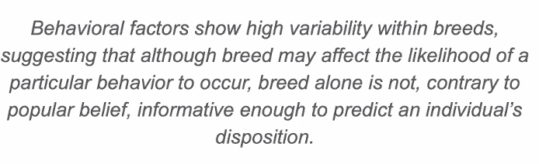

---------------------------------
CHAT:

10:56:28 From Michelle Russillo to Everyone:
Hello,
10:56:53 From Crystal Enojos to Everyone:
Good morning! I am Crystal Enojos, Deputy Director for Maricopa County Animal Care and Control. This is my first call :)
10:57:00 From Michelle Russillo to Everyone:
I am Michelle Russillo, WAGS in Southern California
10:57:04 From Lauralei Combs to Everyone:
Hello! Lauralei Combs from El Paso County, Texas.
10:57:05 From Amber Freiwald, Maddie's to Everyone:
Hi everyone! if you’re new to this call let us know who you are and where you’re from 🙂
10:57:11 From Amber Freiwald, Maddie's to Everyone:
Welcome!!
10:57:24 From Helen Cotton to Everyone:
I’m Helen Cotton. I’m the new Special Projects Manager for Pawmetto Lifeline in South Carolina.
10:57:30 From Tracy Brad to Everyone:
Welcome!!
10:57:44 From Peter Wolf to Everyone:
MCACC in the house!
10:57:52 From Kirsten Lindsay to Everyone:
I’m Kirsten, from Last Chance Ranch in Quakertown, PA
10:58:18 From Michelle Russillo to Everyone:
Working on Behavioral Enrichment Training
10:58:18 From Helen Cotton to Everyone:
We are having our Kitten Palooza adoption event today.
10:58:51 From Nancy Cullins to Everyone:
Nancy from Bella Vista Animal Shelter, Arkansas
10:58:52 From Jamie Case to Everyone:
That’s wonderful!
10:59:02 From Kathy Duncan to Everyone:
@Helen, I hope Kitten Palooza goes well!!
10:59:10 From Dylan Moore to Everyone:
Dylan Moore Director of Shelter Operations from the Santa Fe Animal Shelter. Right now, we are trying to manage our higher than expected intake (14 months and running) and the largest wildfire in our state's history at the edge of our service area and surrounding counties.
10:59:16 From Sarah, Little Traverse Bay Humane Society, MI to Everyone:
Hi, I am Sarah from Little Traverse Bay Humane Society in Michigan! We are currently in the process of developing a behavior and training program within our shelter as well as a complete revamp of our foster/volunteer programs!
10:59:27 From Christopher Sikes to Everyone:
Christopher Sikes, Executive Director, Hardin County Animal Services
11:00:24 From Amber Freiwald, Maddie's to Everyone:
This meeting is being recorded. Find past recordings and links from the chat within 24 hours on Maddie’s Pet Forum: https://forum.maddiesfund.org/communityconversations.
11:01:10 From Amber Freiwald, Maddie's to Everyone:
Hi everyone! if you’re new to this call let us know who you are and where you’re from 🙂
11:01:30 From Tracy Brad to Everyone:
How are you defining "harder?"
11:01:36 From Michelle Russillo to Everyone:
FAR MORE DIFFICULT - dog intakes are way higher
11:01:39 From Amber Freiwald, Maddie's to Everyone:
Question of the day: Do you think this summer is going to be the same, better, or harder than 2019?
11:01:42 From Nancy Cullins to Everyone:
This year will be harder. We have so many more animals coming in
11:01:43 From Ondrea Johnson to Everyone:
We already have 150 kittens in foster.
11:01:55 From Ondrea Johnson to Everyone:
Staffing is a killer, even in key leadership positions
11:01:59 From Mary Ellen Houghtaling to Everyone:
Harder due to economy
11:02:02 From Sara Price to Everyone:
Tougher - people are tired and drained, and we're seeing backlogs in alteration
11:02:06 From Lynne Stott to Everyone:
Harder All resources are exa
11:02:17 From Robert Gruhl to Everyone:
Much, much harder … the eviction crisis is hammering us in Dayton, Ohio
11:02:19 From Katie Pemberton to Everyone:
Harder. Many issues but all would be improved by better staffing levels
11:02:21 From Lynne Stott to Everyone:
Exhausted
11:02:24 From Christopher Fitzgerald to Everyone:
harder for staffing, similar for animal intakes, more requests for pet support
11:02:25 From Susan Britt to Everyone:
Harder - climate issues are worse and kitten mountain in LA is bigger than ever.
11:02:26 From Tracy Brad to Everyone:
Harder. 2019 wasn't impacted by the current supply chain / resource / staffing / economic / pandemic issues.
11:02:30 From Albert Yau to Everyone:
we are definitely in a foster crisis. More dogs/cats on intake wait list and we have fewer fosters than we have ever seen
11:02:30 From Michelle Russillo to Everyone:
We are at 200 kittens and not enough foster families
11:02:33 From Renee Gutierrez to Everyone:
Good morning, Renee from Solano county in Fairfield Ca. More challenging than 2019 due to staffing, large dogs with behavior problems coming in and kitten season.
11:02:35 From Alexis Pagoulatos to Everyone:
Staff is also just feeling exhausted and burnt out
11:02:37 From Christopher Sikes to Everyone:
For us is extremely harder, lack of funding, lack of employees, our Vets are about 9 months out for spay/neuter,
11:02:47 From Nancy Cullins to Everyone:
Fewer donations, yes more big dogs just two in this morning, and need more staff
11:02:48 From Jenn Danks to Everyone:
Financial and staffing issues bigger this year
11:02:50 From Julie Levy to Everyone:
The shelters we are working with across the South have more puppies, pregnant dogs, etc., that normally would have been transferred, but now receiving shelters are full.
11:03:10 From Dylan Moore to Everyone:
Harder than 2019. We have higher intake (+20%) our staffing is challenging, especially in our medical (veterinarian and tech) services. Our adoptions haven't rebounded to the extent I would have hoped, and our state is getting brutalized by wildfires.
11:03:13 From Jennifer Williams to Everyone:
Hi everyone! I'm Jen, joining with Great Pyrs & Paws Rescue (GPPR). Great to be here. Thanks for doing this convo series!
11:03:21 From Michelle Russillo to Everyone:
Staff are exhausted with the large dog intakes which can be 2-3 dogs a day and that has never happened in 11 years.
11:03:25 From Kelly Clardy to Everyone:
Maddie’s Fund Monthly Giveaways! Enter here for a chance to win CA$H in a random drawing: https://www.maddiesfund.org/friday-community-conversations-may22-giveaway.htm. Open to all who are watching live or on-demand! Be sure to enter each week you attend!
11:03:28 From Amber Freiwald, Maddie's to Everyone:
If you have any national updates, please drop a description and link in the chat!
11:03:30 From Yolanda Morris to Everyone:
More kittens and puppies! Dogs with more behavioral issues. In-person efforts (volunteers not wanting to be in-person) still awkward and lots of unknowns impacting long term planning (do we pay for a venue for an event 6 months from now? etc.).
11:03:31 From Melissa Engerman to Everyone:
harder - staffing is down and staff is so tired at this point. We are also trying to go back to how we use to be, with some adjustments, and it is hard for everyone to continue to change what they got use to doing
11:03:41 From Elena Bicker to Everyone:
Staffing, especially medical. Recession and California fires. There used to be a fire season, now it is nearly year round.
11:03:56 From Dean Daubert to Everyone:
Harder- inflation is hitting consumers hard, creating headwinds to adoption.
11:04:18 From Amber Freiwald, Maddie's to Everyone:
Question of the day: Do you think this summer is going to be the same, better, or harder than 2019?
11:04:34 From Amber Freiwald, Maddie's to Everyone:
Beth Steinhorn, President of VQ Strategies: https://vqstrategies.com/vq-team/vq-bios/
11:04:42 From Robin Vincent to Everyone:
Jyothi Robertson, through the Journey You Own, will be hosting free, monthly meditation gatherings to create a shared, supportive space to explore grounding practices. These one-hour sessions will include a 15 minute guided meditation, along with time to learn more about grounding practices and share experiences. The first ever session will be held via zoom on Thursday, May 25th at 5pm PST. Everyone is welcome! Link to register is here: https://jyo.world/meditation-gathering/
11:04:56 From Yolanda Morris to Everyone:
Veterinary staffing shortage impacting spay/neuter in some regions of WA state, other regions have veterinarians wanting to do more SN-how do we not burn them out? And we need more trappers in those regions to keep up with the vets.
11:05:41 From Emily Gelb (ASPCA) to Everyone:
Some exciting opportunities from the ASPCA:
Calls for Proposals
•2022 Access to Veterinary Care (AVC) Conference: Call for Speakers due May 23rd: conference to be held from October 17-19th, 2022 in Minneapolis, MN. Anyone engaged in AVC is encouraged to apply! Aspcapro.org/avcspeakers
•2022 ASPCA-AAWA Research Forum-Call for Proposals: for new research relating to community and shelter animal welfare; forum to be held online November 9, 2022. https://airtable.com/shrvIfd9gCPWVkryq
Open Funding Opportunities
• Access to Veterinary Care Research Grants: supporting research that advances knowledge toward expanding animals’ access to veterinary care. https://airtable.com/shraDAHboTgrT3KK3
• Applied Behavior Research Seed Grants: supporting research that advances knowledge in responding to behavior problems in animal shelter populations. https://www.aspcapro.org/grant/2022/03/22/applied-behavior-research-seed-grants-2022
11:06:17 From Emily Gelb (ASPCA) to Everyone:
• Cruelty Research Seed Grants: supporting research that advances knowledge in preventing and responding to animal cruelty. https://www.aspcapro.org/grant/2022/04/05/cruelty-research-seed-grant-2022
• Psychological Trauma Research Seed Grants: supporting research aimed at developing or validating behavioral and biological markers of animals’ mental suffering due to cruelty. https://www.aspcapro.org/grant/2022/04/04/psychological-trauma-seed-grants-2022
• Open Access Publishing Fund: supporting the dissemination of results of innovative and impactful animal welfare research by subsidizing publication and processing fees for open access scholarly, peer-reviewed articles. https://airtable.com/shrY7dj80a61XvgtB
11:06:32 From kristen hassen to Everyone:
If you are a shelter director who wants to be part of communicating with other directors as a united voice, please drop me an email at kristen.hassen@americanpetsalive.org. The message we’re going to convert is “America’s shelters are in crisis” or something close to that - depending on the consensus of the group. We’re meeting early next week to strategize messaging.
11:07:11 From kristen hassen to Everyone:
We are not focused on any one particular issue but rather that the system is faltering due to impacts of covid - economic etc.
11:07:44 From Jenn Hazen to Everyone:
Hi all - new to the group, wonderful to be here. Director of Shelter Operations at Virginia Beach SPCA.
11:08:22 From Judy Calhoun to Everyone:
Kristen, I would like to be part of that conversation. Issues do vary by community and agency. A single message worries me but interested in hearing more from others. Thanks!
11:08:22 From Kimberly Pickens | DCDF to Everyone:
Welcome, Jenn!
11:09:08 From kristen hassen to Everyone:
Understood Judy - that’s why it’s important that is a joint statement only signed by individual community directors who share this sentiment
11:09:19 From Elisabeth Manwiller to Everyone:
I am seeing all of our team at the levels of burnout and fatigue that we would have after the summer season. This is super concerning to me as we start this season. I think there is something about coming off of a 2 year crisis among other volatile things that have been happening with equality and political climate. In addition to everything increasing in price recently. I am not sure how to combat this, but I am devoted to figuring it out for my team and hopefully others.
11:09:57 From Karen Walsh to Everyone:
Welcome Jenn!
11:09:58 From Sheila Kouhkan to Everyone:
Hi all! CARE is holding a series of events for AAPI Heritage month. Join us for our next one on Transracial Human and Animal Adoption on Monday!
Monday, May 23rd 7pm EST
Alice Stephens, Author
Susan Ito, Editor and Author
Mi Ok Song Bruining, Artist, Therapist and Author
Registration Link: https://us02web.zoom.us/meeting/register/tZIqcO-hqj4rHdYSaY3GyD11qADnbF0oOWmi
11:11:10 From Dr. Carley Faughn to Everyone:
This was great training I completed with the previous rescue I worked for. Happy to see it being shared here.
11:12:08 From Jamie Case to Everyone:
Agree Dr. Carley!!!!
11:13:31 From kristen hassen to Everyone:
Burnout and fatigue just keep coming up over and over again and what I’m wondering is if the staff in shelters now have, for the most part, not worked in shelters pre-pandemic and they just don’t have the institutional knowledge
11:14:32 From Alexis Pagoulatos to Everyone:
Most of our staff don’t have pre -pandemic nor other institutional knowledge. But even our seasoned managers are struggling too.
11:14:50 From Alexis Pagoulatos to Everyone:
I feel like it’s a mix.
11:14:58 From Jamie Nocula to Everyone:
yes, it's being recorded so we can access it later
11:14:59 From Eliza Torres to Everyone:
These are the slides! They will also be shared in Maddie's Forum
11:17:06 From Amber Freiwald, Maddie's to Everyone:
This meeting is being recorded. Find past recordings and links from the chat within 24 hours on Maddie’s Pet Forum: https://forum.maddiesfund.org/communityconversations.
11:17:13 From JESSICA ARNOLD to Everyone:
From a nationwide perspective, Petfinder's seven day average of pets posted on site is continually increasing. It topped 230,000 pets posted for adoption yesterday. It has not been at this level since 12/28/2021.
11:19:55 From Jeff Okazaki to Everyone:
Seems like a tough sell, larger shelters already have pretty robust volunteer programs and resources. 90% of the rest of us don't have $3-6k to spend on a consulting program
11:20:15 From Kelly Clardy to Everyone:
If you just joined, don’t forget to enter for a chance to win money from Maddie’s Fund! Fill in the contest entry form here: https://www.maddiesfund.org/friday-community-conversations-may22-giveaway.htm. Open to all who are watching live or on-demand! Be sure to enter each week you attend!
11:20:19 From Jamie Case to Everyone:
There are hubs throughout the country that can also be free and/or lower cost as well. However, like Beth said not all communities have a hub in their local area.
11:20:21 From Nancy McKenney, Marin Humane to Everyone:
anyone working on how to recruit volunteers to improve your diversity among volunteers?
11:20:25 From Krystyna Zarn-Langford to Everyone:
I agree with Jeff, and I see the 12-24 month commitment as a barrier to access as well.
11:20:40 From Lexis Ly to Everyone:
Yes!
11:20:57 From Jess Roper to Everyone:
The headlines were over-simplifying the study
11:20:58 From Julie Levy to Everyone:
The rebuttals in the comment section
11:21:06 From Peter Wolf to Everyone:
Everybody's talking about what we've said FOR YEARS!
11:21:09 From M S to Everyone:
I noticed that people took it to mean breed had nothing to do with personality, but it's more complicated than that
11:21:26 From Peter Wolf to Everyone:
@Julie: NEVER read the comments!
11:21:48 From Ondrea Johnson to Everyone:
Can someone post a link to the article?
11:21:48 From Augusta Farley to Everyone:
yes. Different understanding about the conclusions. Even the authors have a different read on them.
11:21:56 From Jamie Case to Everyone:
The length of time is for sure not an easy task, however it is a change management process versus a “best practice” type training. It is really an interesting process to go through and it has helped me as a leader think through how we manage big organizational change.
11:22:10 From Arin Greenwood to Everyone:
https://www.nytimes.com/2022/04/28/science/dogs-breed-behavior-genes.html
11:22:11 From Jessica Hekman to Everyone:
https://www.science.org/doi/10.1126/science.abk0639
11:22:20 From Arin Greenwood to Everyone:
https://www.science.org/doi/10.1126/science.abk0639?adobe_mc=MCMID%3D84642491739088231094049347991384876828%7CMCORGID%3D242B6472541199F70A4C98A6%2540AdobeOrg%7CTS%3D1651162390&_ga=2.218466969.1066386900.1651162373-689641651.1609118629
11:22:21 From Amber Freiwald, Maddie's to Everyone:
Dr. Jessica Hekman: http://www.dogzombie.com/
11:22:53 From Peter Wolf to Everyone:
Be sure to read the supplemental materials too—all 112 pages!
11:23:26 From Kirsten Letham to Everyone:
https://journals.plos.org/plosone/article?id=10.1371/journal.pone.0146857
11:23:40 From Kathy Duncan to Everyone:
@Peter - seriously????
11:23:58 From Hope Winograd DVM (she/her) to Everyone:
Go Gators!
11:24:01 From Peter Wolf to Everyone:
@Kathy—have you ever known me to joke about such things?
11:24:13 From Amber Freiwald, Maddie's to Everyone:
short link for sharing - Ancestry-inclusive dog genomics challenges popular breed stereotypes https://www.science.org/doi/10.1126/science.abk0639
11:24:20 From Kathy Duncan to Everyone:
@Peter… Welllll…
11:24:35 From Kriss Harrigian to Everyone:
I remember when the study first started and had seen a couple presentations by Elinor. I have 3 dogs that participated in the study.
11:24:43 From Ben Swan-Espanola Humane to Everyone:
https://www.science.org/doi/10.1126/science.abk0639
11:26:19 From Amber Freiwald, Maddie's to Everyone:
What’s in a Name? Effect of Breed Perceptions & Labeling on Attractiveness, Adoptions & Length of Stay for Pit-Bull-Type Dogs https://journals.plos.org/plosone/article?id=10.1371/journal.pone.0146857
11:26:31 From Emily Roberts (she/her) - Cortland County SPCA to Everyone:
I understand the reasons behind listing all breeds as “mixed breed” but has anyone had an issue when trying to find a familiar looking stray in their software? Searching “husky” is going to narrow down your list a lot more than “large breed dog” and we have a lot of repeat strays that aren’t chipped. Any suggestions?
11:27:26 From Julie Bank to Everyone:
I can’t seem to open the points of light presentation. Can you repost? Thanks.
11:28:39 From M S to Everyone:
Yeah Emily, I think that's another reason to keep putting breeds. Many dogs are NOT mixed breeds. And it helps people like me who prefer one breed to find those dogs (I always adopt huskies!)
11:33:30 From Peter Wolf to Everyone:
Very intriguing tool!
11:35:34 From Isabelle Côté to Everyone:
Even without genes linked aggression some dogs are stronger and more likely to cause harm if they bite then other dogs.
11:38:55 From Isabelle Côté to Everyone:
Is the mandatory neutering of perceived dangerous dog still justifiable? The argument used to make it mandatory was the heritability of aggressive behavior.
11:40:43 From Augusta Farley to Everyone:
Is anyone using this information to push back on breed bans by insurance companies?
11:41:50 From Nancy McKenney, Marin Humane to Everyone:
or use for convincing landlords about easing restrictions in their pet policies
11:42:12 From Elisabeth Manwiller to Everyone:
can we have these slides?
11:42:15 From Jessica Schleder to Everyone:
This information is so interesting. Talking about genetics and statistics can be hard for the lay-person. Is there a resource or a plan for a resource that can help us with more accessible ways to talk about this?
11:42:33 From Kriss Harrigian to Everyone:
My three dogs: 99% Golden Retriever, 60/40 Rottweiler/Golden Retriever, last dog was super mutt. All three rescue dogs. Two of the dogs had bite histories, guess who? The GRs
11:42:41 From Christopher Fitzgerald to Everyone:
great question, Jessica
11:44:12 From Isabelle Côté to Everyone:
Golden look ''friendly'' maybe there is a higher risk of unwanted interactions too. Strangers being less likely to approach a ''Dangerous looking'' dog? So many factors involved.
11:44:17 From M S to Everyone:
My current husky has a bite history. And because she looks so pretty and fluffy, everyone wants to touch her all the time....
11:44:24 From Shannon Glenn to Everyone:
@nancy a bunch of us are, including My Pit Bull is Family
11:44:33 From Johanna Humbert to Everyone:
Fascinating!
11:45:00 From Lynne Stott to Everyone:
Will there be a book?
11:45:18 From Brent Toellner to Everyone:
This is great research Jessica -- so interesting.
11:45:54 From Steve Marrero (Director of Liberty County Animal Services to Everyone:
Thank you
11:46:32 From Julie Levy to Everyone:
Health Breakthroughs for Every Cat: FIP and Beyond: a feline health symposium, on Friday, July 8th, and Saturday, July 9th, 2022, at the University of Florida’s College of Veterinary Medicine in Gainesville. This special event is also being held virtually. https://sheltermedicine.vetmed.ufl.edu/education/continuing-education/feline-health-symposium/
11:46:43 From Dylan Moore to Everyone:
Not really a question but a comment. My only argument for breed typing dogs in the shelter is to capture the way people shop for dogs, especially online. But it’s hard to overcome the behavior pre-suppositions people have based on their (perceived) breed type.
11:47:24 From Melissa Thibault to Everyone:
Agreed! Very strong visuals!
11:47:58 From Julie Levy to Everyone:
Yes - amazing data visualization in the paper in Science. Cover story too. Congratulations!
11:48:14 From Peter Wolf to Everyone:
So much information compressed into the data visualizations!
11:50:10 From Augusta Farley to Everyone:
How could we use this information as well as specific observed behaviors on kennel cards in a shelter to help potential adopters understand the suitability of the pet in front of them.
11:50:30 From Julie Levy to Everyone:
Cover of Science is a bucket list goal for scientists.
11:51:28 From Namiko Ota-Noveskey to Everyone:
In humans it is Big Five to describe personality, are these 8 test categories essential for dogs to describe their personality?
11:52:05 From Silja Schiller-Moumtzidis to Everyone:
This is one of the best pieces of research that has been carried out, and one of the most impactful. Thank you for leading this. I hope this will lead a lot of change to stop stigmatizing based on breed.
11:52:37 From Debra Fair to Everyone:
Agree Silja!
11:52:39 From Lynne Stott to Everyone:
Bill prohibiting Insurance breed discrimination passed AZ house today
11:53:28 From Amber Freiwald, Maddie's to Everyone:
that's great news @lynne
11:54:38 From Julie Levy to Everyone:
How can you study the influence of genetics on behavior without using guessed breed or appearance as the criteria? As you said, human personality has a high genetic influence, but breed is not a construct used in humane behavior.
11:54:41 From kristen hassen to Everyone:
We need to switch to visual searches
11:54:52 From kristen hassen to Everyone:
Great question Dr. Levy
11:55:46 From Peter Wolf to Everyone:
@Julie: Seems like this is helped by (1) using mixed-breed dogs, and (2) large sample sizes, no?
11:57:08 From Jess Roper to Everyone:
I saw a recent study Vekony and Pronik (2022)?
11:59:00 From Julie Levy to Everyone:
@Peter - agreed - most dogs are mixed breed, and many dogs might not have a purebred in their ancestry at all (dogs are >10,000 years old, breeds are only < 200 years old after all). We should stop trying to think what breed a dog looks like is what it is going to behave like.
11:59:43 From Alexandra Protopopova to Everyone:
Thank you, Jessica! Wonderful presentation and work!
11:59:53 From Julie Levy to Everyone:
Fantastic presentation!
12:00:00 From Kelly Clardy to Everyone:
Remember to enter for a chance to win money from Maddie’s Fund! Complete the entry form here: https://www.maddiesfund.org/friday-community-conversations-may22-giveaway.htm
Open to all who are watching live or on-demand! Be sure to enter each week you attend!
12:00:09 From Arin Greenwood to Everyone:
This was really great - thank you!
12:00:22 From Peter Wolf to Everyone:
This was great—thank you!
12:00:31 From Dr. Carley Faughn to Everyone:
Thank you!
12:00:32 From Kathy Duncan to Everyone:
Amazing info - thank you!!
12:00:37 From Kirsten Letham to Everyone:
Thank you!!!!
12:00:41 From Shelley Joaquin to Everyone:
Loved the presentations:)
12:00:43 From Lexis Ly to Everyone:
Hi folks! I’m Lexis (PhD Student @ UBC Animal Welfare Program). We’re looking for animal shelter and rescue staff to help us learn more about how we input shelter data into shelter software during (dog) intake! If you are a staff who deals with intake, please consider taking our survey (and share it with others!) https://ubc.ca1.qualtrics.com/jfe/form/SV_9yvyF8YLAgpubMW
Thank you ☺
12:01:03 From Lexis Ly to Everyone:
Have a good long weekend!

----------------END---------------

