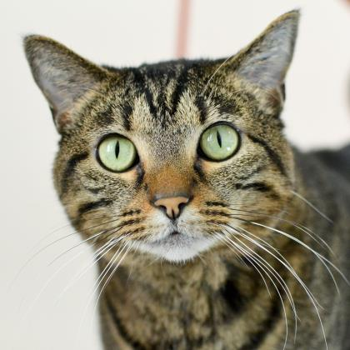

Name: Chloe
Age: 5Y 0M
Gender: Female
Chloe has all the things one looks for in a cat. She is very affectionate, has a nasally nonstop purr, and makes muffins when she is happy. Chloe will be there to say hello when you arrive home from work and will want to tell you all about her day. She loves to play and is very good at stalking the noodle toy. She will insist on lap time each day too. She just loves to be loved. Chloe needs to be the only furry feline in your home since she doesn't play well with other cats and would do best in an adult only home. Come by and meet this wonderful gal soon. She will be waiting for you!
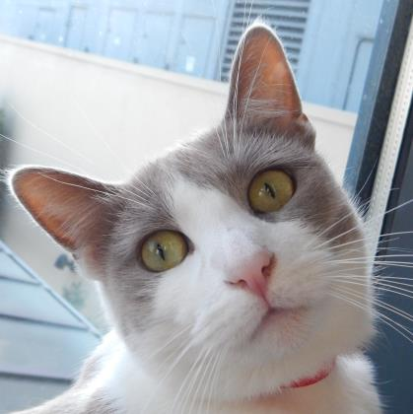
Name: Katya
Age: 1Y 11M
Gender: Female
You can find Katya perched by a window soaking up the rays. She loves the sun! She is here with her sister Lubja (a bonded pair) and they need a new forever home. Katya does chat some and will tell you what her and her sister has been up to that day. You can win her over by giving her behind the ear scratches, which she loves. Wouldn't she look good next to you on the couch? Katya and Lubja are looking for an adult’s only home with possibly older, mature children. They need people who are willing to give them time to adjust. Come by and pay them a visit soon.

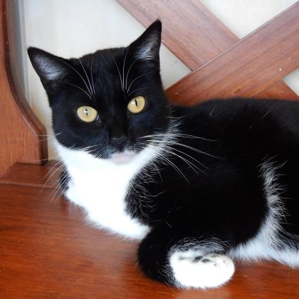
Name: Lubja
Age: 1Y 11M
Gender: Female
Say hello to Lubja. She is black and white girl with a scrappy personality. You'll immediately notice her athletic prowess and marvel at her bug and snake catching skills, oops were those your fingers? Lubja just needs a new forever home with her sister Katya (a bonded pair) where she can feel safe and loved. Once she feels secure you will see the sweet girl that is in there come pouring out. Lubja and Katya need a home with adults only, and possibly with respectful, mature children. If you're a patient person who's looking for a slow-burning, everlasting love, come by and meet these girls today!
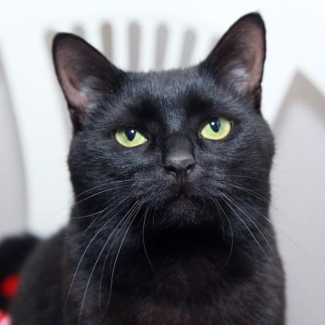
Name: Maximus
Age: 1Y 6M
Gender: Male
Are you ready for maximum fun, maximum love and maximum cuteness? It's time to meet Maximus. A name befitting this gentle giant of a feline, Maximus is as beautiful as he is scintillating. He's young and fun and ready for action. Maximus would enjoy a home where he gets lots of playtime and attention -- he's not one to stand on the sidelines. Expand your horizons of love to one appreciative dude, to the max!

Name: Penny
Age: 5Y 6M
Gender: Female
Breed: Labrador Retriever Mix

Penny is a big fan of: long hikes in the quiet country with her human friend & toys. Not a fan of: other dogs, unfamiliar people, cats, being left alone, kids, cars and loud noises. Special features: only one ear, house broken, loves treats, approaches people she knows and is very affectionate with them. Dream home: Penny is looking for a warm cozy home in the quiet country where she can be all alone with her human friend. She enjoys going on long and easy walks. If she had it her way you would never leave her side!

Name: Sasha
Age: 1Y 1M
Gender: Female
Breed: Chihuahua Mix
Sasha will make you life with her silly and fun antics! She loves to be the center of attention at any party. She is hoping for an active family who will get her out and about so she can bask in the glory of all her friends. Sasha is required to go to a home that has another dog, as she will benefit greatly from a companion animal!

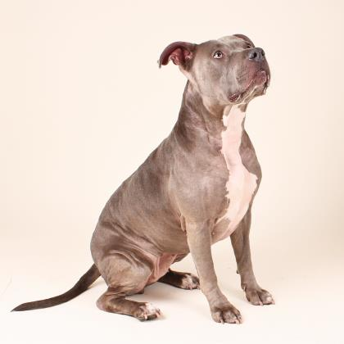

Name: Sky
Age: 4Y 0M
Gender: Female
Breed? Terrier, Pit Bull Mix
Sky is a beautiful and affectionate girl who would love to be your dog copilot. She is great on leash and loves to meet and play with other doggie friends. Sky is treat motivated, already knows "sit", and is eager to attend training classes to sharpen her manners. She has lived with older children previously and may be a good match for a family with respectful teens.

Name: Toby and Max
Ages: 8Y and 4Y
Gender: Males
Breed? Yorkshire Terriers
Toby and Max are active little guys that will need training, plenty of daily exercise, chances to play with other dogs and lots of daily affection. Toby and Max are best friends and a bonded pair. They will need to go home together. Do you have room in your heart and your home for these two adorable fluff balls?

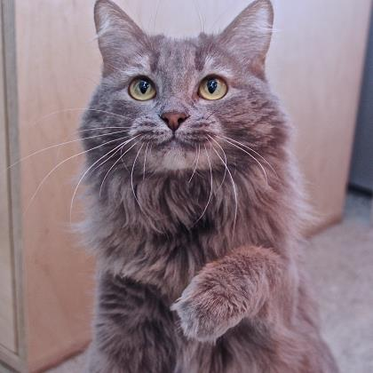 Name: Xenia
Age: 3Y 0M
Gender: Female
Are you looking for the purr-fect companion? Well say hello to Xenia. She has a fluffy tail that she wears proudly. Xenia chats a bit and has the cutest little meow. She does play some, but she is really more of a love bug than anything. Xenia is happy to lie by your side and keep you company. Why don't you pay her a visit and see if she is a good match for your family? A sweet girl awaits you!

