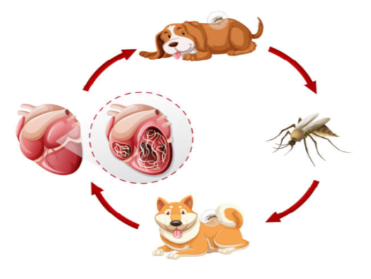
- Pet is diagnosed with heartworms (Pets can still receive heartworm prevention)
- Placement staff schedules Heartworm injection 60 days from the start of Doxycycline.
- Pet starts 30 days of Doxycycline (1st step in treatment. Doxycycline is an antibiotic. This antibiotic disrupts the transmission of heartworms)
- After antibiotics, 30 day break
- 61st day, 1st injection
- 62nd day, 2nd injection
- After 2nd injection, pet starts exercise restriction for 6-8 weeks
- Retest 9 months after last injection

After each heartworm treatment monitor for any side effects:
Injection site swelling, pain, coughing, labored breathing, lethargy, decreased appetite, vomiting or diarrhea. If you see any adverse side effects, please alert DVM immediately.

Restrictions:
Do not allow the pet to run, jump, climb stairs, or play rough with other dogs or children. Pets must be crated when unsupervised.

